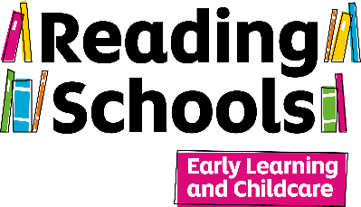
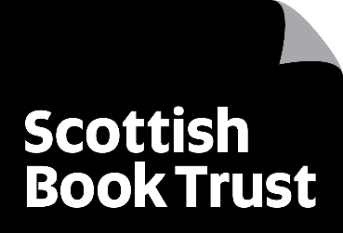
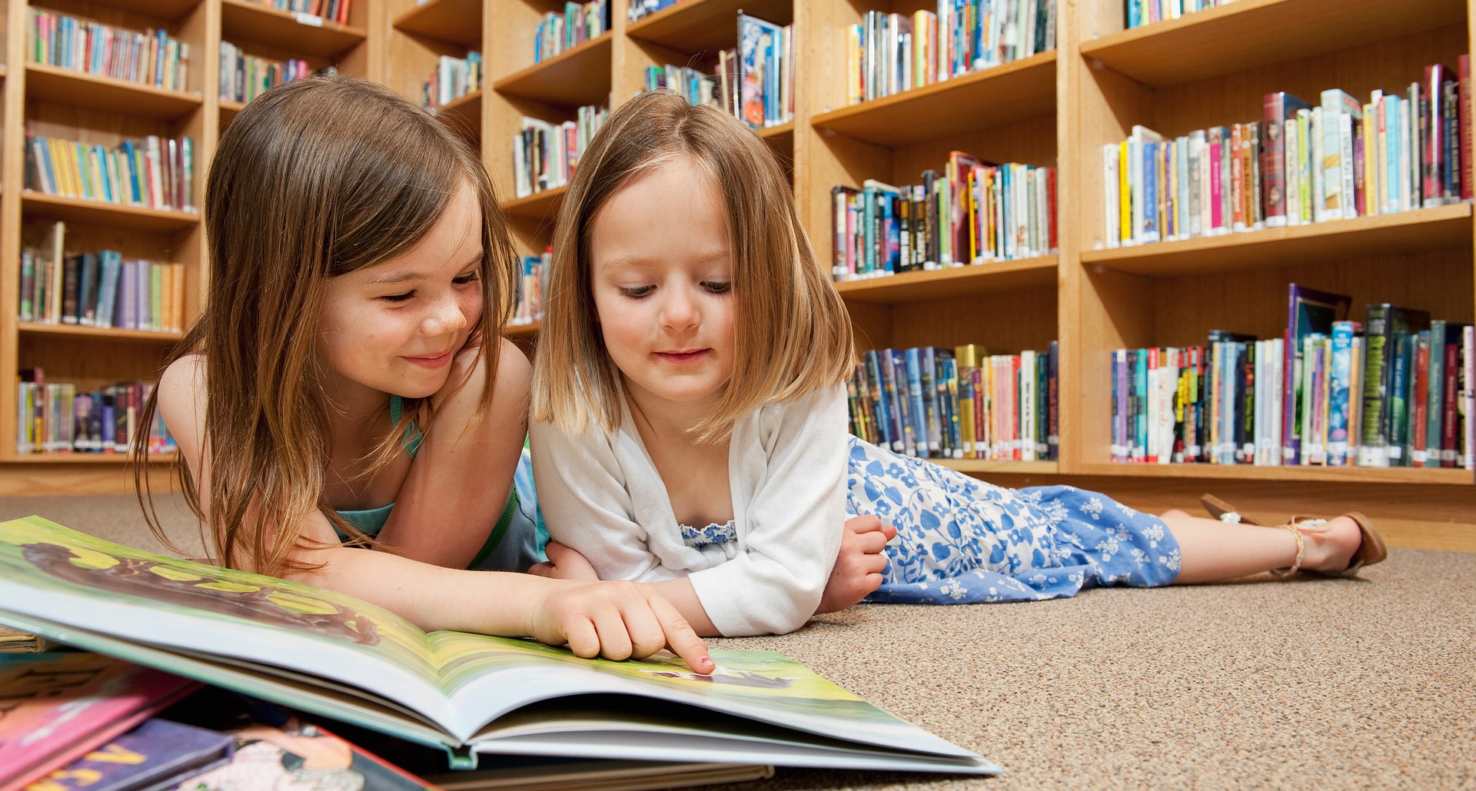
Communicating your Reading Schools Early Learning & Childcare (ELC) achievements
A resource to support the ways in which you can communicate your achievements and celebrations.

Key Area: 4.4 – Celebrating progress and recognising personal achievements.

Resource created by Scottish Book Trust.

scottishbooktrust.com

  - Scottish Book Trust is a registered company (SC184248) and a Scottish charity (SC027669).

  - Contents
About this resource 1
How to write a press release 3
Appendix 4
Example press release 6

About this resource
This resource has been created by Caroline Young, Marketing and PR Manager at Scottish Book Trust.
We know that you want to shout about your success with Reading Schools ELC, and contacting your local paper or broadcaster is a great away to demonstrate to your local community all that you have achieved. By sharing your stories, you can also help encourage other ELC settings to follow your lead and achieve their accreditation too.
This guide is designed to help you put together your information on Reading Schools ELC, with tips on how to ensure your wording is correct when you communicate your accreditation publicly. You can also find some tips on sending out photographs and how to structure a press release.

What is Reading Schools ELC?
When you are putting together your communications, use the following to describe Reading Schools ELC:
‘Celebrating the incredible work taking place in Early Learning and Childcare settings and supporting the development of further strategies, Reading Schools Early Learning & Childcare (ELC) aims to build and embed the joy of books, stories, songs and rhymes in the settings for children, staff and their families
The Reading Schools programme, developed by Scottish Book Trust, is an accreditation programme for schools that are committed to building a reading culture for their learners and communities.
The programme supports schools to build a reading culture, where every pupil is encouraged to feed their imagination through books.
Currently, a small number of Early Learning and Childcare settings are involved in the pilot of the Reading Schools ELC pilot.
About Scottish Book Trust
When communicating about Reading Schools, you should give credit to Scottish Book Trust.
We should be styled as ‘Scottish Book Trust’ not ‘The Scottish Book Trust’ and referred to as ‘Scotland’s national charity changing lives with reading and writing.’
We should also be described as ‘a national charity that transforms lives through reading and writing.’

Types of communication
You can get in touch with the council press office in your local authority who can advise on contacts with local press. It’s a good idea to keep them aware and involved in any comms for your ELC setting.
If you know of a local paper that may be interested, you can send an email to the editor or education reporter with a brief paragraph on what news you believe would be of interest. This could be about achieving your Reading Schools ELC accreditation, your setting being visited by an author or storyteller, or hosting a special reading event.
If you have a special event happening, you could ask the local paper to send a photographer or a reporter to the event to speak to learners.
You could also submit some photos, as long as the appropriate permissions are in place, to see if they would be interested in covering your event.
To formalise your communications, you could put together a press release to send to local media, which will provide them with all the relevant information so that they can publish it as is. This would be a great way of promoting your setting’s accreditation.

How to write a press release
At the top of the email write ‘PRESS RELEASE’ in block capitals, followed by ‘FOR IMMEDIATE RELEASE’ if this is the case, or ‘EMBARGOED UNTIL’ plus relevant date and time.
Write a short, catchy headline without exclamation marks or exaggerations.
Your press release should be around 400 to 500 words and written in the third person. The following structure is a good guideline:
Summarise the release in the first line – include the who/what/when/why/whereas relevant.
One or two paragraphs with further details and context, e.g. information about your ELC setting and the Reading Schools ELC programme, and what you have been doing to achieve your trophy.
A short quote or two – one from a member of the Senior Leadership Team or staff member leading on Reading Schools ELC, as well as another member of staff who has been involved in the programme, and at least one of your learners on their experiences of books, stories, song and rhyme.
At the end of the release, write ‘ENDS’ and then insert Notes to Editors at the end of the release. This is information about your organisation and about Scottish Book Trust. (Please find this information in Appendix 1 and 2).
Do not forget to include clear contact details, such as an email address and the setting’s website if you have one.
Distributing your press release
It is best to paste the text of the press release into the body of the email rather than sending it as an attachment. Find out the publication day and print deadlines of your local papers and send them the release in plenty of time beforehand.
If you would like a list of press contacts in your local area, please email caroline.young@scottishbooktrust.com.

Photography
Don’t overcrowd them with too many elements or have excessive branding.
Taking photos outside often comes out better, otherwise make sure the room is well lit.
Do not send anything larger than 4mb (ideally 1 or 2 mb as they will ask if they need a larger file).
Include a photo caption to be included, e.g. ‘Learners from [ELC name] celebrating achieving their Reading Schools ELC accreditation.’
As ever, make sure you have appropriate permissions from your learners’ parents or carers before sharing photography with press.

Appendix

Appendix 1 – wording on Reading Schools
The Reading Schools programme, developed by Scotland’s national charity changing lives with reading and writing, supports schools and Early Learning and Childcare settings to build a reading culture, where every pupil is encouraged to feed their imagination through books.

Appendix 2 – Note to Editors
Include this information on Scottish Book Trust in your Notes to Editors section, when you are sending out a press release.

Scottish Book Trust
Scottish Book Trust is a national charity that believes everyone living in Scotland should have equal access to books. Our work provides opportunities to improve life chances through books and the fundamental skills of reading and writing. Access to books and a love of books bring many important benefits from family bonding and advancing children’s learning, to unlocking creativity, helping employability and improving mental health and wellbeing. Scottish Book Trust aims to support all communities across Scotland, with particular focus on those who are vulnerable and under-represented.

Our programmes and outreach work include:
- Gifting books to every child in Scotland to ensure families of all backgrounds can share the joy of books at home, through Bookbug and Read, Write, Count
- Working with teachers to inspire children to develop a love of reading, creating innovative classroom activities, book awards and author events such as Authors Live with BBC Scotland
- Supporting and nurturing Scotland's wide-ranging literary talent, both emerging and established through our training, awards and writing opportunities including New Writers Awards
- Creating events to share books and connect writers with communities, including Book Week Scotland
- Providing support to people living with dementia and their carers through Reading is Caring

In addition to the funding we receive from the Scottish Government and Creative Scotland, we need the constant support of trusts and foundations, corporate sponsors and individual donors.
Find us online at scottishbooktrust.com. Follow @scottishbooktrust on Instagram, @scottishbooktrust.bsky.social on Bluesky, or like Scottish Book Trust's Facebook page.

Example press release

FOR IMMEDIATE RELEASE
Renfrewshire nursery first to be named as a Reading Schools ELC
Bridge of Weir Early Learning and Child Care class in Renfrewshire Council has become the first ELC to achieve Reading Schools ELC accreditation, both in a Scottish Book Trust pilot project and within their local authority.
The successful Reading Schools programme, developed by Scotland’s national charity changing lives with reading and writing, supports schools to build a reading culture, where every pupil is encouraged to feed their imagination through books. The new Reading Schools ELC programme builds upon the success of this by supporting ELCs to build an environment and opportunities for young learners to develop a love of books, stories, songs and rhymes.
Reading for pleasure is central to supporting wellbeing, improving attainment across the curriculum, and boosting critical thinking, creativity, empathy and resilience. Whilst songs and rhymes support the development of early language development and promote a fun and inclusive approach to learning.
Bridge of Weir Early Learning and Childcare Class is one of 45 nurseries across Angus, Glasgow City and Renfrewshire Council to have participated in the 2025/26 pilot project.
A spokesperson for Bridge of Weir Early Learning and Childcare Class said: ‘We are so excited to be recognised as the first accredited Reading Schools ELC in Scotland. Our whole learning community is so proud of our achievements. We are also absolutely delighted to represent Renfrewshire in such a positive way!’
Marc Lambert, CEO of Scottish Book Trust, said: ‘We are thrilled that Bridge of Weir Early Learning and Childcare class has achieved the honour of being the first in the 2025/26 pilot project, and within Renfrewshire, to be accredited as a Reading Schools ELC setting.
A Reading Schools ELC accreditation is a fantastic accomplishment for learners, staff and families, and achieving this status is a way of recognising and celebrating the ELC’s commitment to making the most of books, stories, songs and rhymes and the many benefits that these bring to our youngest learners.’
- ENDS

Notes to editors
Please direct all media requests to Caroline Young, Marketing and PR Manager at Scottish Book Trust at caroline.young@scottishbooktrust.com or on 07846 195 905.

Scottish Book Trust
Scottish Book Trust is a national charity that believes everyone living in Scotland should have equal access to books. Our work provides opportunities to improve life chances through books and the fundamental skills of reading and writing. Access to books and a love of books bring many important benefits from family bonding and advancing children’s learning, to unlocking creativity, helping employability and improving mental health and wellbeing. Scottish Book Trust aims to support all communities across Scotland, with particular focus on those who are vulnerable and under-represented.
Our programmes and outreach work include:
- Gifting books to every child in Scotland to ensure families of all backgrounds can share the joy of books at home, through Bookbug and Read, Write, Count
- Working with teachers to inspire children to develop a love of reading, creating innovative classroom activities, book awards and author events such as Authors Live with BBC Scotland
- Supporting and nurturing Scotland's wide-ranging literary talent, both emerging and established through our training, awards and writing opportunities including New Writers Awards
- Creating events to share books and connect writers with communities, including Book Week Scotland
- Providing support to people living with dementia and their carers through Reading is Caring
In addition to the funding we receive from the Scottish Government and Creative Scotland, we need the constant support of trusts and foundations, corporate sponsors and individual donors.
Find us online at scottishbooktrust.com. Follow @scottishbooktrust on Instagram, @scottishbooktrust.bsky.social on Bluesky, or like Scottish Book Trust's Facebook page.

