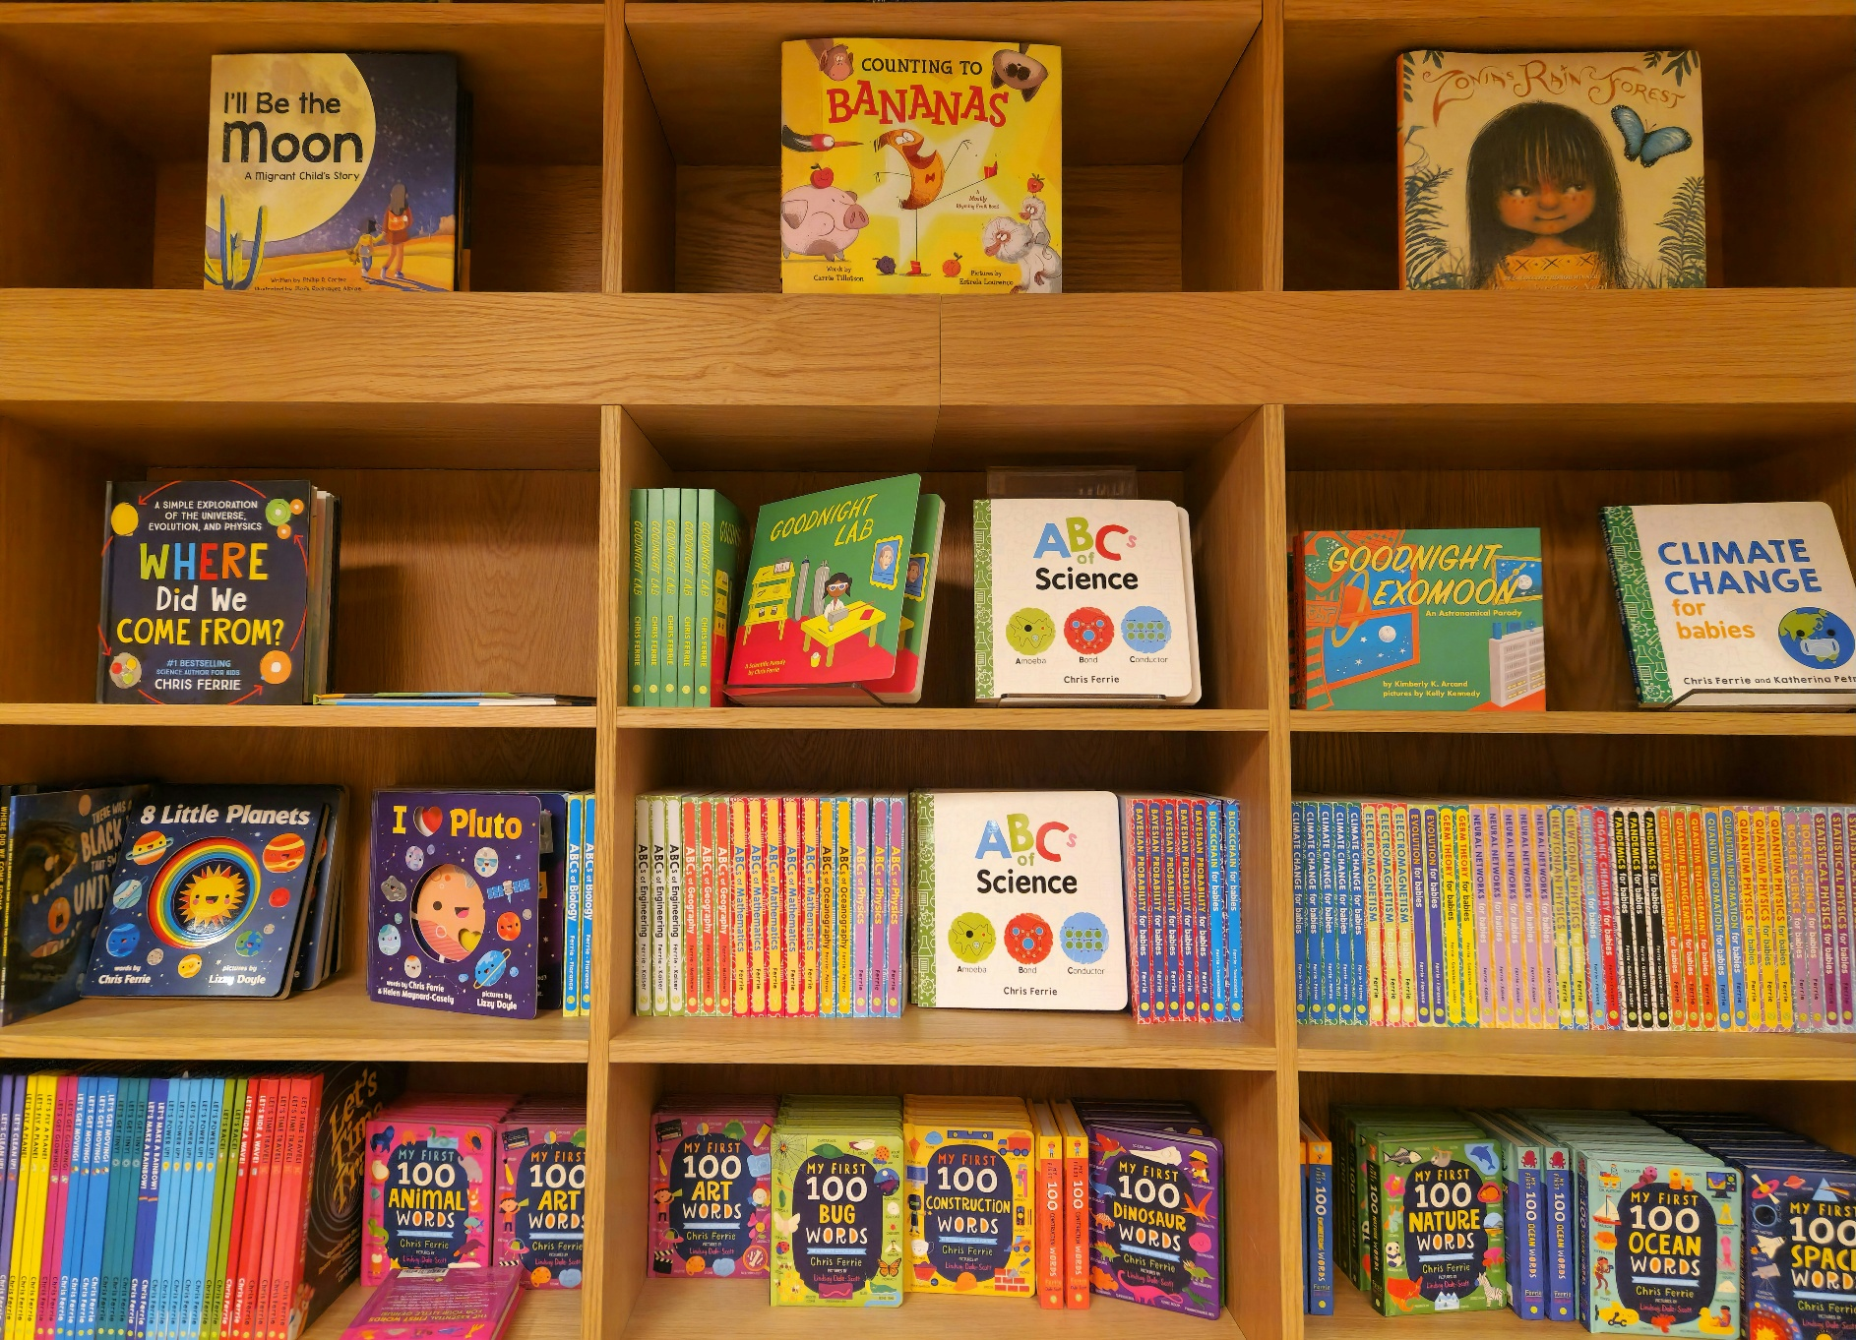

Achieved Reading Schools ELC Accreditation: What Next?
This resource is to support ELC settings continue their reading adventures, following accreditation and in preparation for reaccreditation.

Key Area: 1.4 Monitoring change and impact


Resource created by Scottish Book Trust

scottishbooktrust.com


Scottish Book Trust is a registered company (SC184248)
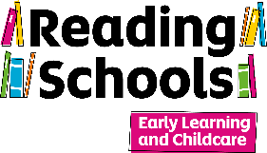
and a Scottish charity (SC027669).

Contents
About this resource 2
Celebrating what you have built 3
Embedding reading for pleasure as an ongoing priority 3
Reflecting with compassionate questions 4
Strengthening community and connection 5
Further resources 5
Reflection resource template 6

About this resource

Achieving Reading Schools ELC accreditation is a moment to celebrate. You have laid a strong foundation for reading for pleasure within your setting, creating rich opportunities for children to enjoy books, stories, songs and rhymes as part of their everyday experiences. Now it is about nurturing that culture, so it continues to flourish with every new cohort of children, families and staff.
It is also a good opportunity to reflect on what has worked well and identify areas you would like to develop further. This article offers supportive ideas and gentle reminders to help your setting sustain and strengthen its reading culture over the next three years... and beyond!

Celebrating what you've built

Recognition is important. Take time to acknowledge the collective effort that has contributed to your accreditation journey, including practitioners, children, families and community partners.
Celebrate the ways children have engaged with books, stories, songs and rhymes, the relationships that have been strengthened through shared reading experiences, and the opportunities created for families to become involved. Taking time to recognise these achievements helps everyone feel proud of what they have built together.
You might choose to share your success through newsletters, displays, family events or social media. Sharing your journey can inspire others and help celebrate the value of reading for pleasure in the early years.

Embedding reading for pleasure as an ongoing priority

Achieving accreditation is not the end of the journey. Rather, it is an opportunity to further embed reading for pleasure, and a love of books, stories, songs and rhymes, within the life of your setting.
Your accreditation is valid for three years, but the approaches, relationships and routines you have established can continue to support children long into the future. Small, intentional actions can help ensure that books, stories, songs and rhymes remain a valued and visible part of everyday experiences.
As new children join your setting, consider how they will be welcomed into your reading culture. Think about how each child will have opportunities to explore stories, express their preferences, revisit favourite books and discover new texts that reflect their interests, identities and experiences.
Maintaining strong links with families is also important. Continuing to share ideas, resources and opportunities for reading at home, and generating excitement around books, stories, songs and rhymes, can help children to enjoy these across different environments and relationships.

Reflecting with compassionate questions

Reflection helps maintain momentum and celebrate impact. You may find it helpful to explore questions such as:
- Which books, stories, songs or rhymes generated the most enjoyment, curiosity and engagement among children?
- How have children's interests influenced the reading experiences, resources and opportunities offered within the setting?
- In what ways have families engaged with and contributed to your reading culture?
- How have books, stories, songs and rhymes supported children's learning across different areas of the curriculum?
- Are there any children, families or communities whose experiences and voices could be represented more fully within your reading provision?
- What would you like to continue, develop or introduce over the next year?

Treat reflection as a collaborative conversation rather than a checklist. Children's views, staff observations, family feedback and ongoing dialogue can all provide valuable insights into the impact of your work.
To support this process, we have developed a reflection resource to help you explore the successes, challenges and impact of your accreditation journey, while identifying opportunities for future development.

Strengthening community and connection

A thriving reading culture grows through relationships. Sustaining your Reading Schools ELC journey is a shared endeavour that involves children, staff members, families and the wider community.

Consider how local partnerships might continue to enrich your reading culture. Libraries, schools, authors, storytellers and community groups can all help create meaningful reading experiences for children and families.
Connecting with other Reading Schools ELC settings can also provide fresh ideas, inspiration and reassurance. Sharing practice with colleagues across Scotland helps strengthen the wider community committed to supporting reading for pleasure from the earliest years.
By celebrating achievements, reflecting thoughtfully and continuing to place books, stories, songs and rhymes at the heart of children's experiences, your Reading Schools ELC accreditation can continue to inspire curiosity, connection, creativity and joy for years to come.

Related resources
- Use our reflection resource to reflect on the impact of your journey and identify priorities for future development.
- Explore our programme of CLPL and other training opportunities.
- Continue to keep up to date on news, resources, training and other opportunities through the Reading Schools ELC Padlet page. This is also a great platform to connect with practitioners, share practice and access ongoing support.

Reading Schools ELC reaccreditation/reflection audit

This document is designed to support reflection on your Reading Schools ELC journey, helping you celebrate successes, evaluate impact and identify opportunities for further development.
At the heart of the Reading Schools ELC programme is creating a sustainable reading culture where books, stories, songs and rhymes are woven throughout children's everyday experiences. Sustaining your Reading Schools ELC status means ensuring that effective practice can be maintained, adapted and strengthened year after year, so that every new cohort of children and families can benefit from a rich culture of reading for pleasure.
Use this document alongside the Reading Schools ELC Framework to reflect on your progress, review how your ongoing practice continues to meet the key area criteria and identify priorities for future development. This can then be used as a working action plan to support the continued growth of your setting's reading culture.
This document is for your own use and reflection. You will not be asked to submit it as part of your evidence for reaccreditation.

Key points to consider

Sustainable
Can your approaches be maintained and developed over time?
Special events can generate enthusiasm around books, stories, songs and rhymes and help raise the profile of reading for pleasure. However, sustainable reading cultures are built through regular, meaningful experiences that become part of everyday practice. Consider how successful activities can be embedded, repeated and adapted to meet the needs and interests of future cohorts of children and families.

Child-centred and responsive
Do children continue to play an active role in shaping your reading culture?
A strong reading culture is built upon children's interests, preferences, ideas and curiosities. Continue to observe, listen to and engage with children, ensuring that the books, stories, songs, rhymes, resources and experiences you provide reflect and respond to their views, identities, interests and needs.

Shared ownership
Is reading for pleasure supported across the whole setting community?
Creating and sustaining a reading culture is a collective responsibility. Consider how practitioners, leaders, children, families and community partners contribute to and influence your work. Think about how you will continue to communicate successes, involve new staff, learners and families, and build shared ownership of reading for pleasure as your setting evolves. Where possible, consider how a focus on books, stories, songs and rhymes for enjoyment and engagement can remain visible within improvement planning and ongoing setting priorities.

Monitoring impact
How will you capture progress and understand the difference your work is making?
Regular reflection can help you understand the impact of your reading culture on children, families and staff. Consider how you gather and record evidence through observations, children's voice, family feedback, practitioner reflections and participation in reading experiences. You may also wish to consider the wider impact on areas such as language and communication, relationships, wellbeing, engagement and children's developing interest in books, stories, songs and rhymes.

1. Leadership
Key areas:
Key Area 1.1 – Staff as readers across the setting
Key Area 1.2 – Staff understanding of the impact of reading for pleasure
Key Area 1.3 – Staff knowledge of contemporary children’s literature
Key Area 1.4 – Monitoring change and impact
Key area | What we did | What worked | What didn’t | Next steps
Notes:

2. Children thrive and develop in quality spaces

Key areas:
Key Area 2.1 – Reading-rich settings
Key Area 2.2 – National events and celebrations
Key Area 2.3 – Access to authors
Key area | What we did | What worked | What didn’t | Next steps
Notes:

3. Children play and learn
Key areas:
Key Area 3.1 – Peer role modelling
Key Area 3.2 – Access to high-quality reading materials
Key Area 3.3 – Regular opportunities to read and share books for pleasure
Key Area 3.4 – Interdisciplinary book projects
Key Area 3.5 – Modelling reading behaviours
Key Area 3.6 – Opportunities for learners to respond to what they’re reading
Key area | What we did | What worked | What didn’t | Next steps
Notes:

4. Children are supported to achieve
Key areas:
Key Area 4.1 – Reading leadership group
Key Area 4.2 – Staff meaningful conversations around stories, songs and rhymes
Key Area 4.3 – Raising the profile of reading and book sharing with families
Key Area 4.4 – Rewarding progress and recognising personal achievements
Key area | What we did | What worked | What didn’t | Next steps
Notes:

