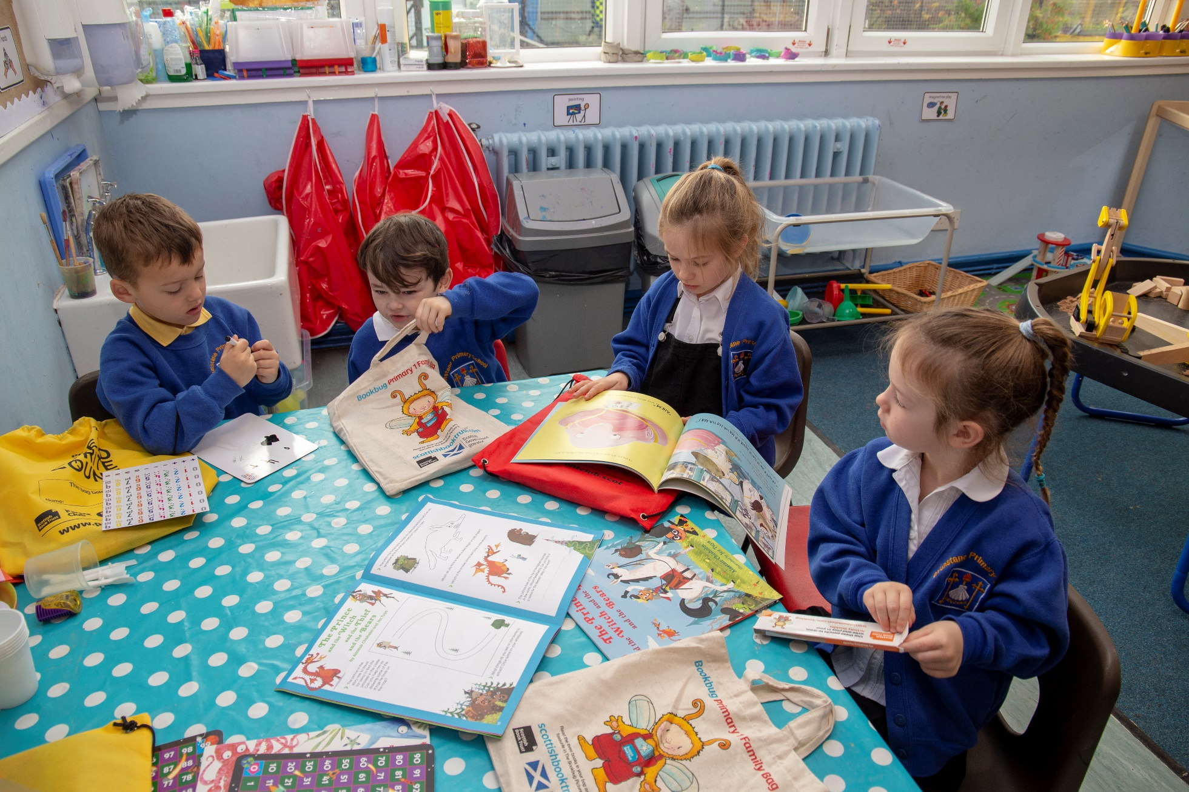

**Learner role modelling**

Key area: 1.2.2

Level: Core

Resource created by Scottish Book Trust





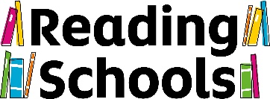

**About this resource**

We expect Reading Schools to show how learners visibly promote reading and recommend books to one another.

Peer role modelling is incredibly important − young people take notice of what their peers are doing and listen to their recommendations. Reading is a social act and supporting that peer-to-peer interaction is key for a Reading School at any level.

This resource contains activity suggestions for Core level.

**Core**

For Core level, we expect schools to provide evidence of one of the following activities or a similar activity:

**Wear ‘Ask me what I’m reading’ badges**

“Ask me what I’m reading” badges or lanyards are a simple but effective way to encourage peer-to-peer book recommendation and discussion. You can make the badges and lanyards together in class − perhaps encouraging pupils to add drawings or images of their favourite literary characters − then pupils can wear them throughout the school day.

**Talk about books in assembly**

Assemblies (or other whole school occasions) are a great opportunity for pupils to share books they have particularly enjoyed. You could make book sharing a regular feature of your assemblies and ask a pupil from each class to share a book they have particularly enjoyed that week.

**Recommendations wall**

Create a recommendations wall. This should be interactive so pupils can write recommendations to each other. One quick and effective wall display is to write pupils’ names on a paper cup and staple them to your display. When pupils finish a book, encourage them to write a recommendation to a peer on a slip of paper and pop it into that person’s recommendation cup. Pupils can check their cups to find their next read!

You could also get pupils to write recommendations of children’s books for staff to read, perhaps on a particular theme.

Another option would be to start the year with an empty bookshelf wall display or outline of a tree and add leaves or book spines (slips of paper) as your class finish books. They can add a short comment and give it a star rating out of five. As the year goes on, their tree will flourish with lots of leaves and their bookshelf will grow. Encourage your class to look at the display to get ideas for what they would like to read next.

**Recommendations bookmarks**

Another great way for pupils to share their thoughts on a book is through creating their own recommendations bookmark. This could be an illustrated decorated bookmark − making it individual to each pupil − or a template that everyone uses (so that pupils do not know whom the recommendation is from). Encourage pupils to write one or two sentences on the bookmark reflecting their thoughts and feelings on the story they have just read. They can then insert the bookmark back into the book, and either pass it to someone to read or return it to the library or classroom library for someone else to find!

**Shelf labels**

Shelf labels are another great and easy way for pupils to share their thoughts on a book. Many bookshops have them, usually from a bookseller or members of a book club. They are a short review, usually written on a card, and their aim is to encourage you to pick up and read that book. You can ask pupils to write shelf labels for a book they have especially enjoyed (it does not need to be every book they finish) and display them next to the book in your library or classroom library.

**Recommendations video**

Book recommendations videos are a fun way for pupils to tell others about books they have enjoyed and help develop digital skills. You could perhaps record videos between different classes or a partner school to share what you have been reading. If you have a school social media channel, you could share these videos with the wider community too. For tips on creating videos, explore our resource made in partnership with [Into Film](https://www.scottishbooktrust.com/learning-resources/book-reviews-and-trailers-on-film).

**Create a book trailer**

A book trailer is another great way to encourage peer-to-peer recommendations. A book trailer is similar to a film trailer; it gives you a sense of the book, theme and plot without giving too much away. You can work with pupils to create book trailers individually, or in small groups. Then share trailers at a special red-carpet event for pupils.