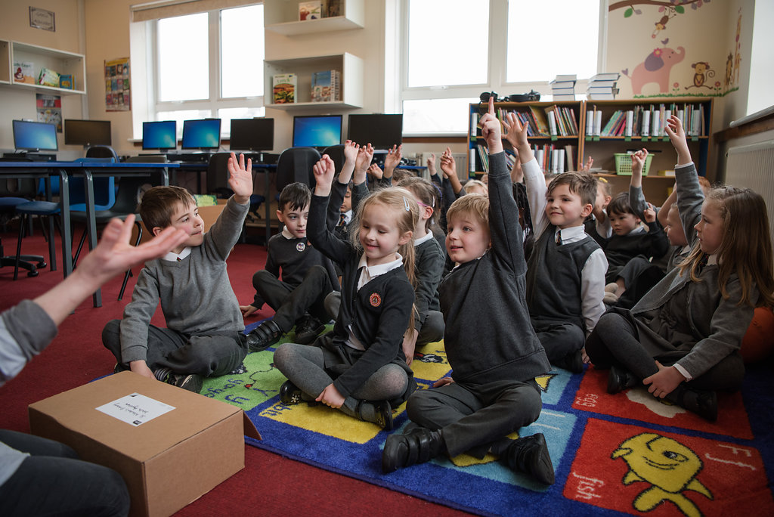

School Environment

Core, Silver and Gold level activity ideas to help you create spaces to read in the school environment

Key Area: 1.3.2

Level: Core, Silver, Gold

Resource created by Scottish Book Trust

scottishbooktrust.com
Scottish Book Trust is a registered company (SC184248)
and a Scottish charity (SC027669).
Contents

About this resource 1
Core activity ideas 2
Silver activity ideas 4
Gold activity ideas 6
Resource templates 7

About this resource
We expect Reading Schools to show how they have provided appealing and comfortable spaces to read in the school environment and make reading visible.
Creating spaces in schools can be challenging, especially when considering budget pressures and space constraints, however this resource offers practical and affordable ideas, together with examples of making reading visible across school settings. A rich reading environment for learners is key for a Reading School at any level.
Within this resource you will find ideas for Core, Silver and Gold level. We’ve also included tips on how to use the editable and printable resource templates also available on our website.

Core

For core accreditation, schools should provide appealing and relaxing reading areas in collaboration with learners, and use displays to promote reading in their setting.

Decorate your classroom
If you don’t have a school library and rely on using your classrooms for reading and storing books, why not decorate the space to create a wonderful reading environment for your learners. Simple things like bright book-related wall displays, book recommendation posters and imaginative wall art can bring a space to life and really broadcast that reading for pleasure message.
If you store your books in your classroom, why not have your learners help to categorise and label the bookshelves, making the book selection process fun and interactive.

Pick a theme
We have seen many schools associate their ERIC and DEAR time with a theme, such as a Magical Woodland. When the whole-school call is made for all learners to drop everything and read, a forest soundscape is played across the school tannoy system, transporting the learners to a peaceful forest to read in. The use of audio is a great way to ‘set the scene’, creating a fun atmosphere for reading. You can enhance this further by including lighting effects, such as lamps, fairy lights and projected images.

Lower your wall displays
A simple and cost effective way to jazz up your classroom is simply to lower your wall displays. We found a number of schools adjusted the height of their wall displays, bringing them down to desk level, as opposed to the upper half of the wall. In doing so, they created a lovely backdrop for their learners’ reading time whilst also making their displays interactive, with learners responding to what they were reading in real time.
It would be great to get your learners involved in the creation and placement of displays; why not tie them into a class project and find a selection of books and stories to compliment the theme.

Make it comfortable
Reading for pleasure comes hand in hand with comfort and creating relaxing, comfortable reading spaces is a great way to promote the benefits of a good book. If you have the budget, procuring beanbags and soft furnishings for your school can really elevate your learners’ reading experience, whether that be in a designated space or room (a book nook, perhaps), in your school library or in a corner of your classroom.
We understand that there is not always the budget to buy furniture, but we have hears of schools scouring local ‘freecycle’ groups and charities for second hand furnishings for their school. In one example, parents even volunteered to help reupholster a second hand sofa, to brighten up their reading corner.
If space is a problem, there are some simple changes you can make to spice up your learners’ reading time. Like Airth Primary School, you could take a desk chair, turn it upside down, add a cushion and create a fun ‘recliner’ that your learners can prop themselves against with a good book. Another fun idea is to use battery operated fairy lights; string them underneath the desks in the classroom and let your learners escape into their own little reading dens.

Make it visible
With your Reading Leadership Group and any reading ambassadors, make sure that reading is visible everywhere. This can be from your learners wearing badges and lanyard, to book-related door displays, showing that reading is prominent across the whole school.
Corridor displays, papier-mâché sculptures and the use of visual display units throughout your setting really sends the message that reading is part of the fabric of your school.

Silver

At silver level Reading Schools should sustain their core activity, but also create opportunities to take reading out of the classroom and even outdoors.
We would also like to see Reading Schools incorporate reading into existing activities, such as clubs and celebration events.

Take it outside
There is absolutely nothing wrong with reading at a desk, but why not shake things up a little and have regular outside reading time. You could use your playground as a simple, but effective change from the norm. Some schools have procured outdoor furniture for this, while others have sourced tree stumps and created wonderful outdoor reading circles. Knightsridge Primary School created their very own outdoors library, having a selection of books available in the playground and encouraging reading during break time.
You could even combine this with a forest schools activity, reading a story or poem as part of the session.
If you want to be really adventurous, why not source a second hand caravan and create your own reading den in your playground. Your learners could help design and decorate the caravan, with the result being a really fun and comfortable space for your whole school to enjoy.

Clubs
Why not incorporate reading into your breakfast and after school clubs. Making books and reading available out with the normal classroom environment really promotes reading for pleasure and gives your learners the opportunity to delve into stories at every opportunity.
Schools have married this activity with existing paired reading projects, where older learners will read aloud to younger learners. This is a great was to thread reading for pleasure and your other reading initiatives together. If you want to know more, Scottish Book Trust has a full paired reading toolkit to help you run a project like this.

Going digital
We have seen a massive increase in schools using digital resources to promote reading, whether that be through ebooks, audiobooks or personalised readings over video conferencing platforms like Zoom and Microsoft Teams. Why not create an online Literacy Lounge like Bridge of Allan Primary School, where pupils recorded themselves reading stories which could then be accessed by scanning a QR code on a mobile device. This is a great way to make reading and storytelling available to learners outside of school, especially at home.
Dedridge Primary School similarly created a Digital Reading Den, where teachers recorded themselves reading stories for their learners to access using the website Thinglink.

Celebrations
Including reading in your school celebrations is a really simple way to keep reading on the agenda. Big celebrations, such as World Book Day and Book Week Scotland, as well as holidays like Easter and Christmas are great for promoting and enjoying stories.
Perhaps your community celebrates a local festival or tradition; why not seek out stories to compliment your activities, or celebrate local history through tales and poetry.

Funding
There are a number of funds you can apply for to help build and enhance your school environment for reading, most notably the Scottish Library and Information Council’s School Library Improvement Fund; Bridge of Allan Primary School used their SLIC funding to create an EAL library and Reading Café!
Hallglen Primary School opted to use a portion of their Pupil Equity Fund (PEF) monies to support their library stock.
We have heard from many schools about their fundraising efforts, often through their parent councils, enabling unrestricted purchases of things like soft furnishings, book storage and even bespoke websites to host digital libraries.

Gold

At gold level we expect Reading Schools to sustain their core and silver level activity, but build on this by taking reading out into the community.

Spread the word
By now your school is promoting reading widely and your learners’ environment is rich and exciting, so now you can pay that forward into your local community.

Pavement quotes
A simple but really effective idea is to have your learners write quotes from books on pavements across your area. Using chalk, they can create literary walkways for your whole community to enjoy. Working in collaboration with your local library can be a great way to encourage your whole community to read for pleasure, one paving slab at a time.

Story trails
Using local history can be a great way to uncover stories about your area. We have seen a number of story trails from schools, where learners have discovers local stories and poems and created trails by attaching laminated tales and artwork to lampposts. This is a fun and interesting way to engage with your community and to share that love of reading.
You can create trails through your local park, or nearby forest, even your village or town centre. Working with a local historical society or library can be a great way of finding stories about where you live and how it came to be. This can also be a great to include it your school projects and interdisciplinary activities.

Book fairies
You learners can become book fairies by leaving books across your local community and encouraging the public to take them home to read. Combined with social media, this can be a great way to promote reading across your area and engage with members of your community.
This is also a project that can be run virtually, by creating social media channels and leaving book recommendations for community groups or having a podcast where your learners read and recommend books for others.
Local media outlets, such as newspapers and radio, can be great partners for promoting a book fairies project and communicating with your wider community.

Reading Schools resource templates

You can edit and download each of the following printable resources from the Reading Schools website.

Book club membership badges
Why not use these template membership cards when signing up members to your book or reading clubs?
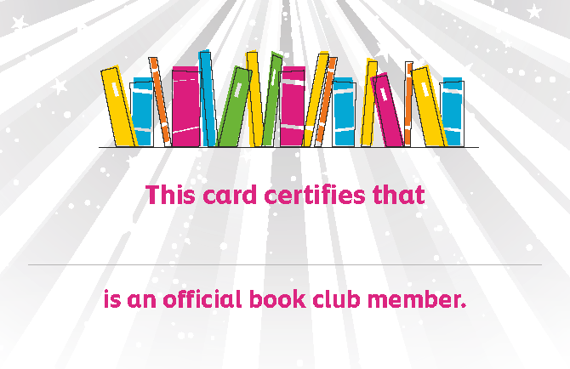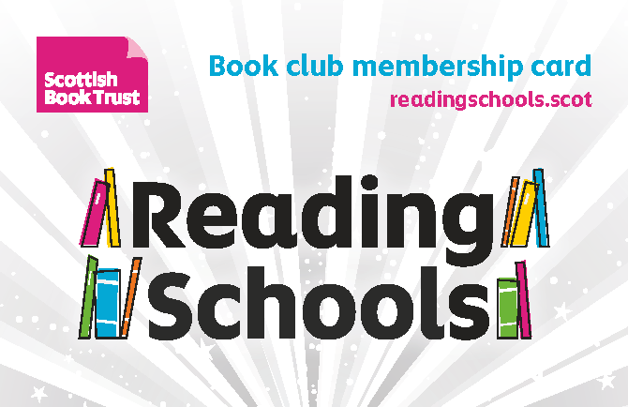

Reading Schools door sign
Why not decorate your doors with these fantastic door signs. If you print and laminate them, they can be used over and over.

Reading Schools shelf shouter
Entice your learners with snazzy shelf labels, to help them find interesting titles, genres and authors recommended by their peers!

‘Ask me what I’m reading’ badges
Generate loads of fun book chat between you learners and staff with these great badges.

Reading Schools reading notes
Help your learners keep track of and share their favourite books by using these handy reading notes sheets.

