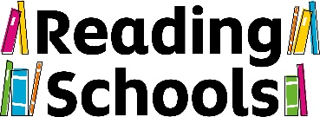
Staff attitude survey

Do you enjoy reading?

Very much | Quite a lot | A bit | Not at all

How often do you read for pleasure?

 | During term time | During the school holidays
Daily
A few times a week
About once a week
A few times a month
About once a month
Rarely
Never

Who is your favourite author?

What is your favourite book?

Which of these do you enjoy reading? Circle as many as you like.

Humour | Horror | Crime | Literary fiction
Romance | Mystery | Sci-fi | Fantasy
History | Biographies | Classics | Thriller
Fiction books | Non-fiction books | Comics / graphic novels | Poems
Audiobooks | Ebooks | Newspapers | Magazines
Other:

Do you ever use your local library? Tick all the answers that apply.

Yes, I go to the local library
Yes, I borrow books from the local library in person
Yes, I borrow ebooks or audiobooks from the local library online
No, I don't use the local library

How important do you think it is that learners read for pleasure?

Very important | Quite important | Not very important | Not at all important

How confident are you about recommending books to your learners that you think they will enjoy?

Very confident | Quite confident | Not at all confident

Do you ever read books for children / teens?

Yes | Occasionally | Never

In general, how much do you think the learners in your class(es) enjoy reading?

Very much | Quite a lot | A bit | Not at all

What could help you to support learners to read for pleasure?

For schools to use if they wish:

School:
Role:
Staff member's initials:
Date:

