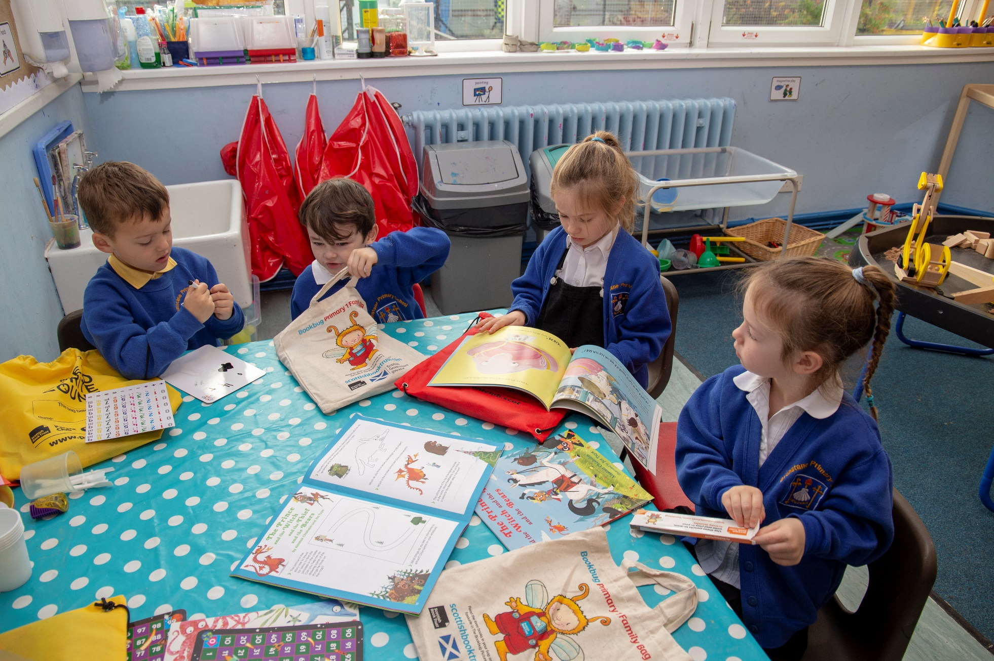

Learner Role Modelling
We expect Reading Schools to show how learners visibly promote reading and recommend books to one another.

Key Area: 1.2.2 Learner Role Modelling

Level: Core, Silver, Gold

Resource created by Scottish Book Trust

scottishbooktrust.com
Scottish Book Trust is a registered company (SC184248)
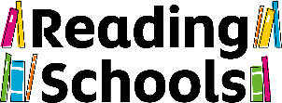
and a Scottish charity (SC027669).

Contents
Core 2
Silver 3
Gold 4

About this resource
We expect Reading Schools to show how learners visibly promote reading and recommend books to one another.
Peer role modelling is incredibly important - young people take notice of what their peers are doing listen to their recommendations. Reading is a social act and supporting that peer-to-peer interaction is key for a Reading School at any level.
This resource contains activity suggestions for Gold, Silver and Core level.

Learner Role Modelling: Core
For core level, we expect schools to provide evidence of one of the following activities, or a similar activity:

Wear ‘Ask me what I’m reading’ badges
“Ask me what I’m reading” badges or lanyards are a simple but effective way to encourage peer-to-peer book recommendation and discussion. You can make the badges and lanyards together in class- perhaps encouraging pupils to add drawings or images of their favourite literary characters- then pupils can wear them throughout the school day. You can also use our printable ask me what I’m reading badge templates.

Talk about books in assembly
Assemblies (or other whole school occasions) are a great opportunity for pupils share books they have particularly enjoyed. You could make book sharing a regular feature of your assemblies, and ask a pupil from each class to share a book they have particularly enjoyed that week.

Recommendations wall
Create a recommendations wall. This should be interactive so pupils can write recommendations to each other. One quick and effective wall display is to write pupils’ name on a paper cup and staple them to your display. When pupils finish a book, encourage them to write a recommendation to a peer on a slip of paper and pop it into that person’s recommendation cup. Pupils can check their cups to find their next read!
You could also get pupils to write recommendations of children’s books for staff to read, perhaps on a particular theme.
Another option would be to start the year with an empty book shelf wall display or outline of a tree, and add leaves or book spines (slips of paper) as your class finish books. They can add a short comment and give it a star rating out of five. As the year goes on, their tree will flourish with lots of leaves and their bookshelf will grow. Encourage your class to look at the display to get ideas for what they would like to read next.

Recommendations bookmarks
Another great way for pupils to share their thoughts on a book is through creating their own recommendations bookmark. This could be an illustrated decorated bookmark- making it individual to each pupils- or a template that everyone uses (so that pupils do not know whom the recommendation is from). Encourage pupils to write one or two sentences on the bookmark reflecting their thoughts and feelings on the story they have just read. They can then insert the bookmark back into the book, and either pass it to someone to read or return it to the library or classroom library for someone else to find!

Shelf labels
Shelf labels are another great and easy way for pupils to share their thoughts on a book. Many bookshops have them, usually from a bookseller or members of a book club. They are a short review, usually written on card, and their aim is to encourage you to pick up and read that book. You can ask pupils to write shelf labels for a book they have especially enjoyed (it does not need to be every book they finish) and display them next to the book in your library or classroom library. We have created a printable template of shelf labels that you can use.

Recommendations video
Book recommendations videos are a fun way for pupils to tell other about books they have enjoyed, and help to develop digital skills. You could perhaps record videos between different classes or a partner school, to share what you have been reading. If you have a school social media channel, you could share these videos with the wider community too. For tips on creating videos, explore our resource made in partnership with Into Film.

Create a book trailer
A book trailer is another great way to encourage peer-to-peer recommendations. A book trailer is similar to a film trailer; it gives you a sense of the book, its theme and plot, without giving too much away. You can work with pupils to create book trailers individually, or in small groups. Then share trailers at a special red-carpet event for pupils.

Learner Role Modelling: Silver
At silver level, we expect to see core level activities sustained, as well as learners supporting one another in ways that are more formal. This could be one of the activities below, or a similar activity:

Take part in a paired reading project
Running a paired reading project is a great way for pupils to support one another, and to share their reading lives and experience. If you are working in a primary school, this might involve pairing upper primary pupils with pupils lower down the school to read together. If you are in secondary, you might do something similar, perhaps targeting your less confident readers. Secondary schools could also collaborate with feeder primaries to run a paired reading project, with secondary pupils supporting reading and transition. Scottish Book Trust has a full paired reading toolkit to help you run a project.

Share storytelling videos
In core level (see below), we give ideas for creating book recommendation videos, or for creating a book trailer. This can be taken one-step further, with pupils creating storytelling videos for a peer or reading buddy. Pupils can create a video read-along of a book they know their friend will enjoy or create their own, unique story based on their buddies interests and record it for them. They could add images and graphics too. You can how to share and tell stories digitally in this resource.

Be a reading mentor
If you work in a secondary setting, creating a reading mentor programme is a great way to support pupils reading for pleasure, making connections across year groups and supporting your less confident readers. It can also develop leadership skills in mentors, as well as building confidence in mentees.

Lead a reading club
Reading clubs are a great way to support reading for pleasure, especially for pupils who enjoy a specific author or genre. They also offer a great opportunity to support pupil leadership. Support pupils to plan activities for the reading club, as well as plan books they would like to share and read together. If you are in secondary, you can use the Scottish Teenage Book Prize as a starting point for a reading club.
In a primary setting, you might like to work with pupils to plan activities for a reading club. Cowie Primary run a Crafty Characters club, a club that shares art and craft activities inspired by pupils favourite books, with older pupils designing and leading the activities.

Learner Role Modelling: Gold
At gold level, we expect schools to sustain core and silver-level activity (see below) and support learners to act as reading role models through interactions with members of the wider community in one of the below ways, or in another way that suits your setting.

Creating pupil role models
It is important that you involve pupils as reading role models. Pupils can act as reading ambassadors and share books in reading assemblies, wear “ask me what I am reading” badges, or act as reading mentors.
When selecting pupils to be part of your reading committee, remember to include your reluctant readers as well as keen readers. Involving reluctant readers will boost confidence and help pupils start their reading journey. Reluctant readers can also offer insights into areas for improvement for your school and help address questions of why they are not engaging. For example, does your library stock need refreshing? Are there different formats you could introduce for reluctant readers which other readers would enjoy too? Which authors would they like to invite into school?
Once you have established a pupil group, you can get them involved in a variety of activities. For example, they can be involved in the planning of activities for World Book Day or Book Week Scotland, they could run a reading club, or plan a reading flash mob.

Put on a reading flashmob
A flashmob is a public stunt of some description, captured on video and often circulated on the Internet. Pupils always have fun with flashmobs, and as the following examples show, they can be done very simply!
- Reading flashmob- pupils read their books aloud, starting with just one pupil and more and more join the group.
- Recreating a scene- Why not get your pupils to do a flashmob recreating an iconic scene from a book?
- Book dominoes– book dominoes is a great stunt for your pupils to plan. Here’s an example from Book Week Scotland to show to your pupils and get them talking and inspired.
- Flash read- a flash mob does not always need to be captured on video. Dunbar Primary pupils went into their local ASDA to read aloud from their favourite books at various parts of the store – ASDA staff joined in too!

Book Doctors
This works especially well if you have a school social media account. Your pupils can act as book doctors- answering prescriptions for book recommendations from members of the community. You can answer on behalf of pupils, or video pupils sharing 60-second-sell videos about why this book is just the treatment a reader needs!

Reading podcasts
A reading or book podcast is a great way to develop pupils’ interview and literacy skills, as well as confidence and digital skills. Pupils can run and edit the podcast, choosing whom to interview. This could start with interviewing other pupils and staff to find out about their reading lives, but could expand to include members of your local community and inviting them to share their reading journey and stories. These podcasts can then be shared with the community online. As an example of a children’s book podcast, why not explore In the Reading Corner.

Create reading videos for the community
Reading videos, either book recommendations, pupil reading journeys or book trailers, can be shared with your wider community. This could be online via the school website or social media channels, or through a film celebration night, with members of the local community invited to the reading videos premiere.

Community window displays
A great way to create a sense of a reading community across the local area is through window displays. This could start with pupils putting books or ‘I am currently reading’ signs in windows at home, but can expand to work with local businesses and community centres to create reading displays with them and for their windows.

Working with local community media
Working with a local newspaper or radio station is another way to support learners to act as reading role models within the community. This could be through reviews or recommendations articles in a local newspaper, or by sharing a weekend or holiday reading recommendation on a local radio station.

