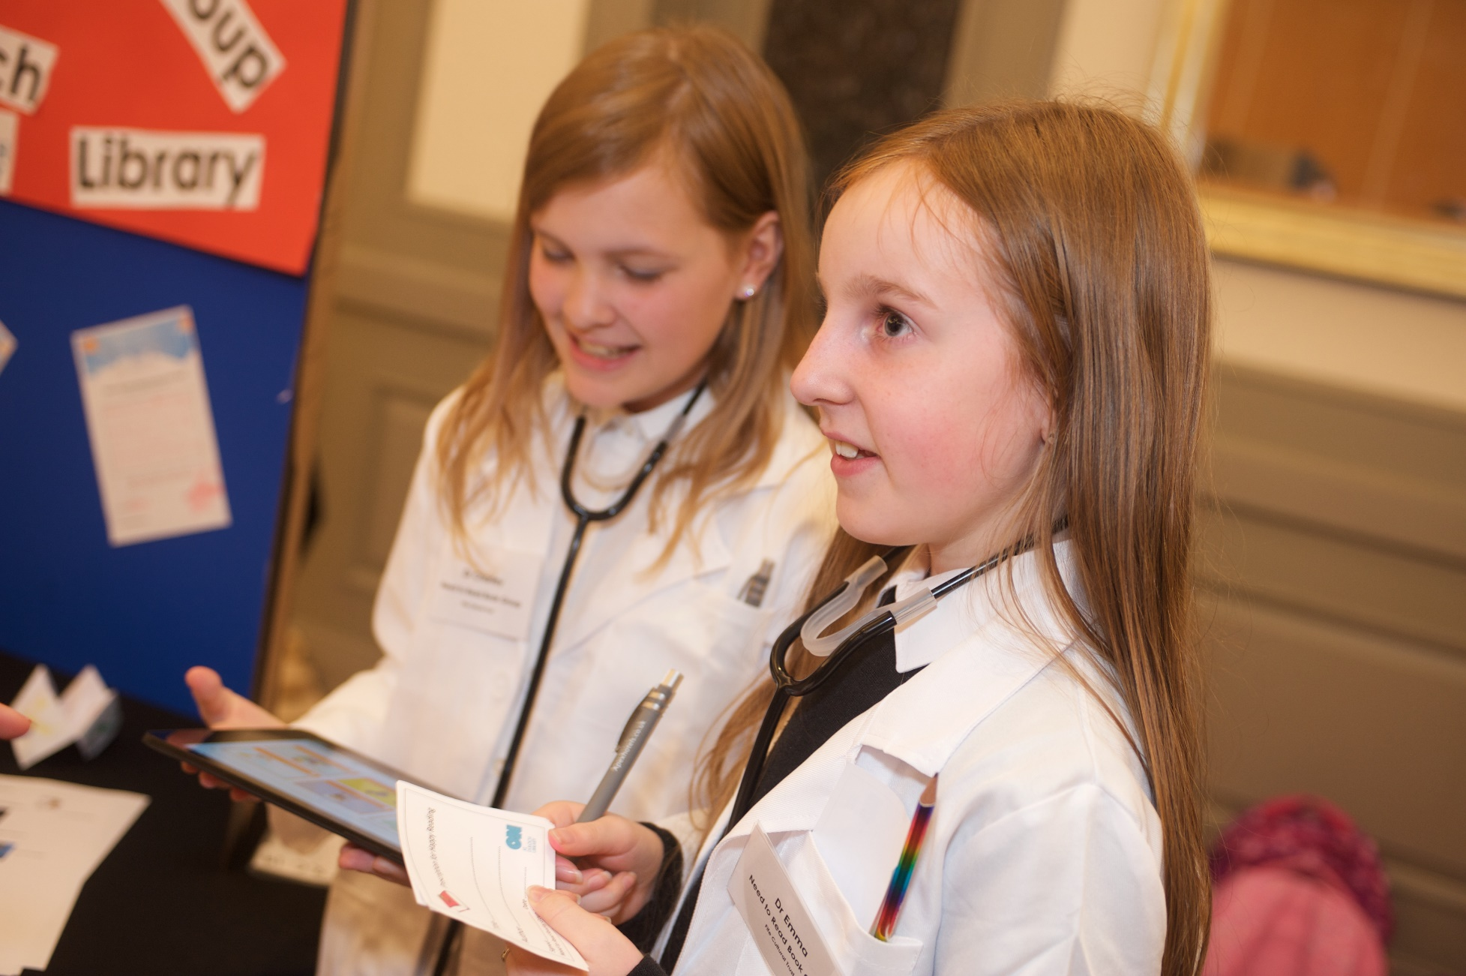

Partnerships within local community

Gold level activity ideas to help you connect with your local area

Key Area: 2.7.1

Level: Gold

Resource created by Scottish Book Trust

scottishbooktrust.com
Scottish Book Trust is a registered company (SC184248)
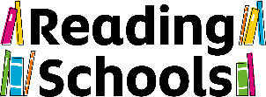
and a Scottish charity (SC027669).
Contents

Gold activity ideas 3

About this resource
We expect Reading Schools to build sustainable partnerships in the local community sharing the expertise they have built over the course of their journey.
Developing your reading culture in school will pave the way to promoting reading for pleasure across your local area, drawing your whole community into your Reading Schools activities.
Creating a reading community beyond the school gates can be so impactful. Often local businesses and shops are really keen to get involved and it echoes what your local library does; we've seen some incredible practice in this area and great examples of meaningful and long lasting partnerships.
This resource contains activity suggestions for Gold level.

Gold

Schools should build sustainable partnerships within their community, sharing expertise in one of the below ways, or in another way that suits their setting:

Working with your local public library
Your local public library is a great place to start when exploring partnerships in your community and can provide fantastic opportunities to promote reading widely. You can approach your library directly, or through a local authority contact; you may even have a school librarian that could create inroads. Involving your community council can help hone a project and gather more interested parties to join you on your Reading Schools journey.
Whitburn Academy partnered with their local library with pupils dressing as ‘Book Doctors’, handing out recommendation ‘prescriptions’ to library users dressed as doctors.
Cowie Primary School’s partnership with their local library resulted in a fantastic project to engage parents outwith the school day, which also say a marked increase in library use, win-win!
If your school it’s own library, joint activities with the local public library can be a great way to engage whole families and promote the joy of reading across the whole community.
To encourage role-modelling in the community, ask guest speakers to talk about reading at assemblies. Invite librarians in to talk to the children and, to foster that
personal connection, follow this up with a class visit to your local library. Making sure every child has a library card will make a big difference, and it can help give pupils and parents the confidence to visit the library on a regular basis.

Partnering with a local bookshop
There have been some wonderful examples of schools working alongside their local bookshops, promoting a love of reading together. Knightsridge Primary School invited their local bookshop owner to sit on their Reading Leadership Group, involving them in their planning processes and undertaking a number of fun reading activities.
We have seen many examples of similar partnerships, with bookshops helping to inform teachers about upcoming books and pupils being able to browse and draw inspiration on what to read next.

Working with a local business
Why not make contact with local businesses to promote your Reading Schools activities. We have seen great examples of partnerships between schools and businesses, such as supermarkets. Supermarkets can be great places to promote reading, either through bulletin boards, displays or even ‘in-store’ readings.
We have even seen examples of schools reading stories and poems over supermarket tannoy systems.
Aberlemno Primary School forged strong links with local business, together with their local church and PTA to support literacy and foster a love of reading across the community.
Elphstone Primary School secured funds to pay for a local storyteller to work the school over a whole year, creating a wonderful project called ‘Elphy Tales’, a celebration of stories from local area and experiences from lockdowns.

Partnering with a college or university
Contacting a neighbouring college or university is a great way to broaden your reading activities while also bringing the concept of further education into the school community. We have seen college and university staff sitting on Reading Leadership Groups, students involved in joint reading projects and celebration events hosted in partnerships between schools and further education settings.
Joint campaigns are also a great way of partnering with a local college or university, such as ‘outdoor reading’ or community-wide DEAR time, promoted by both settings.

Working with a third sector organisations and local authority services
There are many third sector organisations that have benefitted from partnering with a Reading School and vice versa.
Bridge of Allan Primary School partnered with a local charity to deliver digital literacy and family learning through their fantastic Literacy Lounge.
Beancross Primary School pupils read stories to residents in local sheltered accommodation as part of a community-wide DEAR event. They also worked with a new parents group, with weekly ‘Once upon a story’ sessions.
Working with a local care home can be a great way of embarking on an intergeneration project. With blended learning we have also seen this happen remotely, with schools provided recordings of pupils reading stories for the residents and sharing written stories through letters and emails such as Dunfermline High School.
We have seen reading activities incorporated into fundraising drives for local charities, where the power of reading can be used to help support vulnerable communities and those in need.

