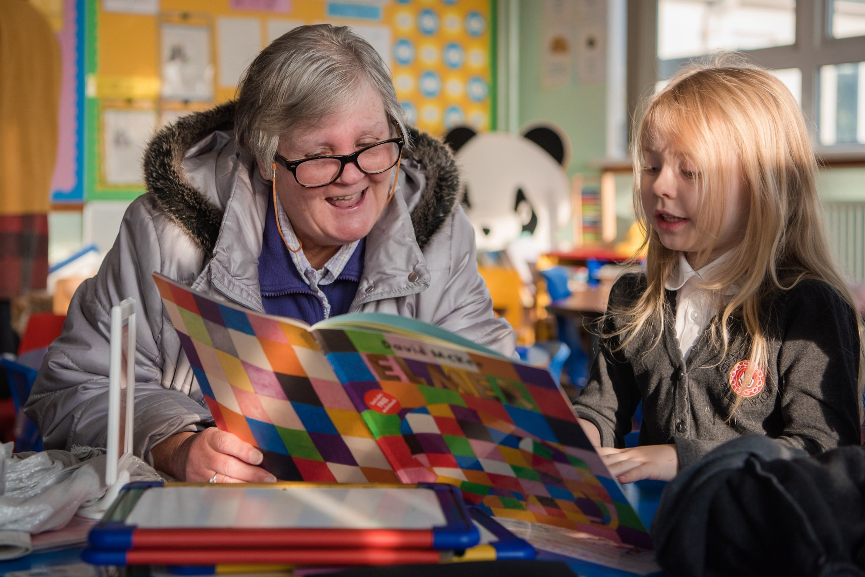
Intergenerational project
A guide to help your pupils work and write with older people in the community

Key Area: 2.7.1

Level: Gold

Audience: Primary, Secondary

Resource created by Scottish Book Trust

scottishbooktrust.com
Scottish Book Trust is a registered company (SC184248)
and a Scottish charity (SC027669).

Contents
What is intergenerational practice? 2
Partners you can work with 2
How to run an intergenerational project 3
Sharing and celebrating the stories 6

About this resource
This resource is designed to help you:

- Support your pupils to build relationships with older people in the community by visiting and interviewing them about their lives.
- Support your pupils to use these interviews as the basis for a piece of creative writing.

What is intergenerational practice?
Intergenerational practice was defined by the Beth Johnson Foundation in 2009 and Generations Working Together follow the same definition of:
‘Intergenerational practice aims to bring people together in purposeful, mutually beneficial activities which promote greater understanding and respect between generations and contribute to building more cohesive communities. Intergenerational practice is inclusive, building on the positive resources that the younger and older have to offer each other and those around them.’

Benefits
The benefits of bringing generations together in learning activities are numerous. Intergenerational practice can challenge ageism: it helps create relationships and community cohesion and can increase civic participation.
Intergenerational practice can help pupils develop the skills outlined in Building the Curriculum 4: Skills for Learning, Skills for Life and Skills for Work, particularly those relevant to working with others and leadership.

Intergenerational learning
One of the most important things to remember is that true intergenerational learning has learning outcomes for each generation. The activities in this resource encourage pupils to interview older people about their lives. Pupils can develop listening, questioning and writing skills. Older people can learn from the pupils’ use of technology during the interviews.

How can you go about it?
Intergenerational practice can be done in all sorts of ways. You can arrange for pupils to visit a community setting such as a residential home, but you can also arrange for grandparents or older members of the community to come into school. Pupils can also interview relatives in their own homes.
For a comprehensive introduction to intergenerational practice, you can read this resource from Generations Working Together. Generations Working Together is an organisation that provides information, delivers support and encourages involvement to benefit all of Scotland’s generations by working, learning, volunteering and living together. The Generations Working Together website is full of useful information.

Partners you can work with
You can approach different organisations, groups, and networks to find people to work with and ask for advice about your intergenerational project.

- If you decide that you want your pupils to visit and work with older people in the community, then local residential homes are great settings to work in. Of course you may decide to ask pupils to work with older relatives at home too.
- Generations Working Together has 22 local intergenerational networks across Scotland. Contact your local network co-ordinator.

- Men’s Sheds is a movement that brings together people in a shared space where they can pursue practical activities. Have a look on their website to see if there’s a local group you could work with.
- The Women’s Institute is a voluntary women’s organisation with branches across the country. It plays a unique role in providing women with educational opportunities and the chance to build new skills, take part in a wide variety of activities, and campaign on issues that matter to them and their communities.
- U3A (The University of the Third Age) is a movement that provides retired or semi-retired people opportunities to develop their interests and continue their learning in a friendly and informal environment.

How to run an intergenerational project

Preparing your pupils
The advice in this section will help you get pupils interested in other people’s lives and develop their interview skills. You can also find suggestions, lesson plans and case studies on the Oral History Society website.

Preparing your pupils – exploring preconceptions
It’s really important to prepare your pupils well for an intergenerational project. Pupils may have preconceptions about the age group they’re working with, but they also may have preconceptions about the activity. For instance, pupils may assume that they are there to learn from older people when in fact a good intergenerational project should result in both age groups learning and benefitting.
First, explore pupils’ preconceptions by giving them post-it notes and asking them each to write down a word or phrase that comes to mind when they think of older people. Ask pupils to stick these on the board and then gather round. See if there are any common answers.
If the answers are largely positive, that’s great! If the answers are more mixed, discuss this: do pupils think that all older people fit these descriptions? After this, introduce pupils to the concept of stereotyping. Put some statements on the board about young people, for example:
‘All young people do nowadays is play computer games and watch TV.’
‘Nowadays young people don’t contribute anything to their communities.’
Do pupils feel these statements are true? How do the statements make them feel? Explain the concept of stereotyping, and ask pupils what they think the dangers of stereotyping are. How could their lives be negatively affected by people believing the statements?

Preparing your pupils – practical considerations
When working with older people, pupils may need to be aware of their possible needs and how these can be supported. Pupils should not be expected to provide the necessary support, but it’s beneficial for them to be aware of any potential challenges experienced by the people they’ll be working with.
It’s highly recommended that you meet with staff from the setting you’ll be visiting before the project starts as they will be able to explain any arrangements that might need to be made.
Dementia is one issue that you can explore with pupils. Generations Working Together have an extremely useful dementia awareness resource for schools to help you explore the issue with Level 2 pupils.

During the visits
The activities below can all be done together. Pupils can gather stories from the older people, and vice versa. This is a great opportunity for the two groups to learn from each other.
It’s recommended that you have more than one session involving the younger and older people. The first session should be about establishing rapport, and the second should be used for interviews. Ideally, a third should be held so the stories can be shared and celebrated.

Choosing a topic for discussion
Our examples are on the theme of rebel to initiate discussion and conversations between the generations. However, you can adapt these activities to suit whatever theme you are focusing on as part of your intergenerational project. It could be what we mean by home, to changing technology, or everyday objects.
If you are looking at everyday objects and how life has changed across the generations, explore the House of Memories project for inspiration on using ordinary objects as conversation starters.

During the visits – breaking the ice
These activities can be used as a fun way of putting everyone at ease when your pupils meet the older people. Many of these activities appear in this booklet of intergenerational activities by PennState College.

Icebreaker 1 – did you ever…?
- The ‘did you ever’ activity gives pupils and the older people some fantastic questions to get to know each other. You can find this activity on page 14 of the PennState Intergenerational Activities Sourcebook.

Icebreaker 2 - the M&M game
- In this activity, participants pick out an M&M from a bowl and answer a question determined by the colour of the M&M. For instance, a red M&M could require them to answer the question, ‘tell us something that you do well’ or ‘tell us something you can’t live without.’
The Pennstate book has full details of the M&M game on page 16. In this version, participants answer questions about their neighbourhood. There are lots more ideas out there – just search online for ‘M&M icebreaker game’. You can modify the questions to suit the group. Here are some suggestions:
Favourites – favourite places, foods, hobbies, sports, memories, jokes
Facts about yourself – something you do well, something you can’t live without, something you learned this week, something you’re reading or watching.

Icebreaker 3 – two truths and a lie
- This activity challenges everyone to come up with three facts about themselves, two of which are true and one of which is false. In pairs or groups, others are invited to guess which statements are true and which is false. One of the advantages of this light-hearted activity is that it can be prepared in advance. You can find full details of the two truths and a lie game on page 19 of the PennState book.

Icebreaker 4 – the minister’s cat
- If you’re looking for a simple, fun icebreaker, this game is ideal to play with small groups. Everyone sits in a circle and the first person says, ‘The minister’s cat is an atrocious cat.’ The next person says the same thing, but must substitute the adjective ‘atrocious’ with a word beginning with B, for example, ‘The minister’s cat is a brilliant cat.’ The game continues, with each new person using a different adjective until you’ve gone through the whole alphabet.

Developing interview skills
To conduct an interview successfully, your participants will need to be able to come up with questions.
It’s important to try and stay away from questions with a simple ‘yes’ or ‘no’ answer. To model this, ask your pupils to ask you or each other the following questions:
- What is your name?
- Where were you born?
- When is your birthday?
- Do you like pizza?
- Do you like football?
- Do you like cartoons?
Do participants feel that this is a good interview? Did they get to know much about you/each other during this process? Explain that the purpose of an interview is to find out more about people’s experiences rather than basic facts about their life. How could your participants adapt the questions above to find out more about a person’s experiences in life?
Now tell participants that they are going to interview each other. Ask them to think of five questions that will help them get to know more about the person’s life experiences.
To help make sure that participants have enough material to write about after the interviews, try and make sure they think of questions encompassing the following from the other person’s story of rebellion:
- How did the interviewee feel during the experience?
- Where did events take place? What was that place like?
- How does the interviewee feel looking back on the experience?

How to record the conversation
Finally, your pupils will need to have a means of recording the conversation. It’s much easier if they are able to record the audio, so they are able to completely focus on speaking to the interviewee rather than having to take notes.
You can find an in-depth guide to recording interviews at the Oral History Society website.
If you have access to tablets or smartphones, a cheap solution is to use the voice recording app on these devices. As the Oral History Society page points out, there are potential issues with using pupils’ smartphones, so it’s better if you use tablets belonging to the school.
You may have to do a little bit of research or testing to find out whether the pre-loaded voice recording app on your device has enough capacity to record for the length of time your pupils will need to conduct their interviews. Often, the app will record until the recording has taken up all the available storage space on your device: therefore, if you make sure there is plenty of storage space available, this helps to ensure your pupils can record interviews.
If your pre-loaded app has limitations, there are lots of free third party apps available. At the time of writing in January 2019, these apps are rated highly:
- Smart Recorder (for Android devices)
- Voice Recorder and Audio Editor (for Apple devices)
- Free recorder (for Windows devices)

Sharing and celebrating the stories
Once your pupils have conducted their interviews, you may choose different formats for pupils to write them up. A piece of prose writing is always a good medium, but you can also consider the following:
- A digital story with text or a voiceover – pupils can use video editing programs to piece together a slideshow with images to accompany the story and record a voiceover or use text to narrate it. If you’re using Windows, then Windows Movie Maker is no longer available to download, but there are other video editing software available.
- If you want to challenge pupils to create digital stories, you may find our resources on how to create a book trailer helpful. These are available to view and download from the learning section of the Scottish Book Trust website. Although these resources are designed to create book trailers, they contain general advice about sourcing images, giving appropriate credit (this is very important) and editing.
- A diary entry can work really well, as can a letter or a poem.
- Your pupils could produce scripts based on their interviewee’s words and dramatise these. This idea comes from Reading Rockets.
- Having a real life audience for their work can be really motivating for pupils, and you have a ready-made one in the group of people they have worked with. You can organise a follow up event at school or at a residential home where the pupils can read their work aloud or give written copies to the older people. This is a good opportunity for the older people to perhaps find out more about each other as well – remember, it’s important that both parties can benefit from your project.
You may want to ask the older people to share the younger people’s stories in some way too, but this of course depends on how comfortable your pupils are with their experiences being shared.

