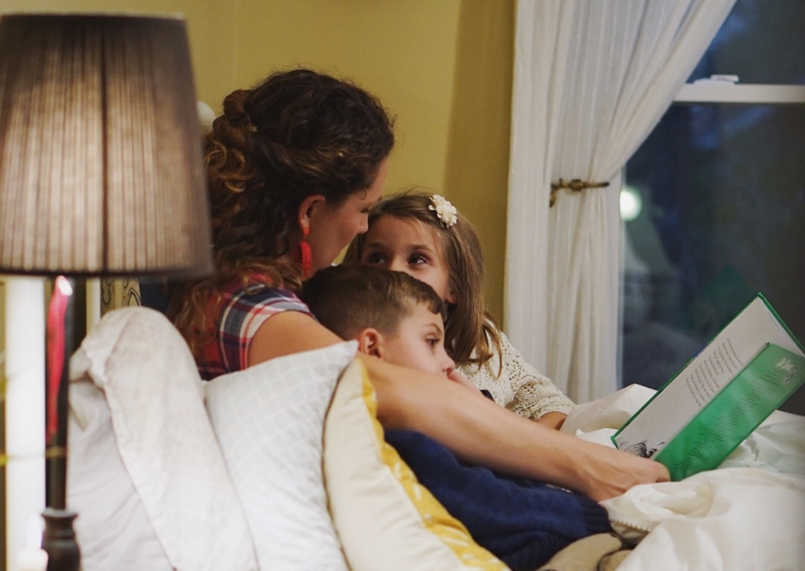

Reading challenges for families at home – primary

Ideas for reading challenges for families with primary school aged children at home

Key Area: 2.3.2, 2.3.4, 2.5.1

Level: Core

Resource created by Scottish Book Trust

scottishbooktrust.com
Scottish Book Trust is a registered company (SC184248)
and a Scottish charity (SC027669).

Contents
Create a reading den 2
Create a digital story 2
Round the world trip 2
Story starters 2
Postcard stories 3
Book explorers 3
Bake a story 3
Plan for the future 3

About this resource
Reading offers us an escape, a way to travel without leaving our homes, visit impossible places and live countless lives. We hope that young readers can travel far and wide inside their books, and that these activities will inspire them on their journey.
There’s lots you can do to celebrate books and reading! We’ve gathered a number of different creative activities which can be completed from home.

Create a reading den
Making a comfy, cosy space to read can be a great activity to help young people get excited about reading again, particularly if they are in the routine of reading in a welcoming environment like the school library.
It can be as simple as using blankets and cushions to create a cosy space. If you want to go that bit further, you could get creative and add little touches that remind you of a particular book, such as pixie dust from Peter Pan’s Neverland, magic wands from Harry Potter and a tea-set from Wonderland.
For an added activity, the children can design their very own bunting to hang up at home. Take inspiration from a theme, e.g. places books take us, or encourage them draw some images from their favourite book and cut up old posters and magazines.

Create a digital story
Challenge the children to think about the places books have taken them. Create these settings by drawing, digitally sketching, creating animations or finding photos online to put together a digital story. They could be inspired by their favourite series or a particular fictional world, or they can choose to focus on settings as an escape. Record the stories together with a phone or tablet, and use our digital storytelling resource for support. Whatever they decide, you will end up with a variety of digital stories that can be enjoyed by the whole family and shared with other relatives too.

Round the world trip
Ask the children to pick a character to take a trip around the world with. This could be a character from a book they’ve read, one you’ve read as a family or a historical figure. What would happen on their trip? What places would they visit, fictional or real? They could write a story, create a storyboard or complete a comic strip of their journey.
If you’re wondering where to start, we’ve asked cartoonist Malcy Duff to help inspire you. Watch Malcy Duff’s video explaining how to create your own comic strip.

Story starters
Get the children to watch an online video of a children’s author of your choice reading a book aloud. Try using the #UnitedByBooks hashtag on Twitter for inspiration. There are so many authors taking part, so why not try a book or writer the group haven’t come across before? Challenge them to discuss what they think will happen next and write their versions of the story. You could even share the children’s stories with the author online and see how they respond!

Postcard stories
Postcards are a great way of staying connected with others. Use a postcard template to get the children to create their own Postcard Stories. Draw the story on the front of the postcard, thinking carefully about the event you want to portray. Write the story of what is happening on the other side, using appropriate language and content in the limited space. You could also get involved with the Postcards of Kindness initiative which sends postcards to people in nursing homes to cheer up vulnerable groups in isolation.

Book explorers
Discover the places books can take you from the comfort of your own home! Challenge the children to imagine themselves as explorers ready for their next adventure. What happens when they find a secret door leading to the setting of a book they’ve read e.g. Narnia or Hogwarts. What can they see there? What creatures might they run into? Are there any dangers to be aware of? They can act this out in their home or garden and get family members involved as characters. For an extra activity, write a travel log of your expedition.

Bake a story
A celebration is never complete without a suitable snack! Try your hand at baking some Marmalade muffins inspired by Paddington, or go for a healthier option and put together a platter full of the fruit The Very Hungry Caterpillar would love to eat. Get the children and their families to share photos of their creations to encourage others to try them out too.

Plan for the future
Where would your pupils like to go next on their reading journey? You could have a brainstorming session for project ideas. This will help the young people you work with to be creative, communicate with each other and reflect in a meaningful way on past projects, what they love most about sharing books and how they want things to be in future. An idea or two might even come up that you can start straight away!
Encourage the sharing of ideas however works for you and your group, and please get in touch if you would like any support or advice as your ideas take shape. For home-learning ideas in the meantime, check out our home activities hub on the Scottish Book Trust website.
Remember to share your photos and responses with us on Twitter during this stage of your reading journey – we can’t wait to see how you get on. Happy reading!

