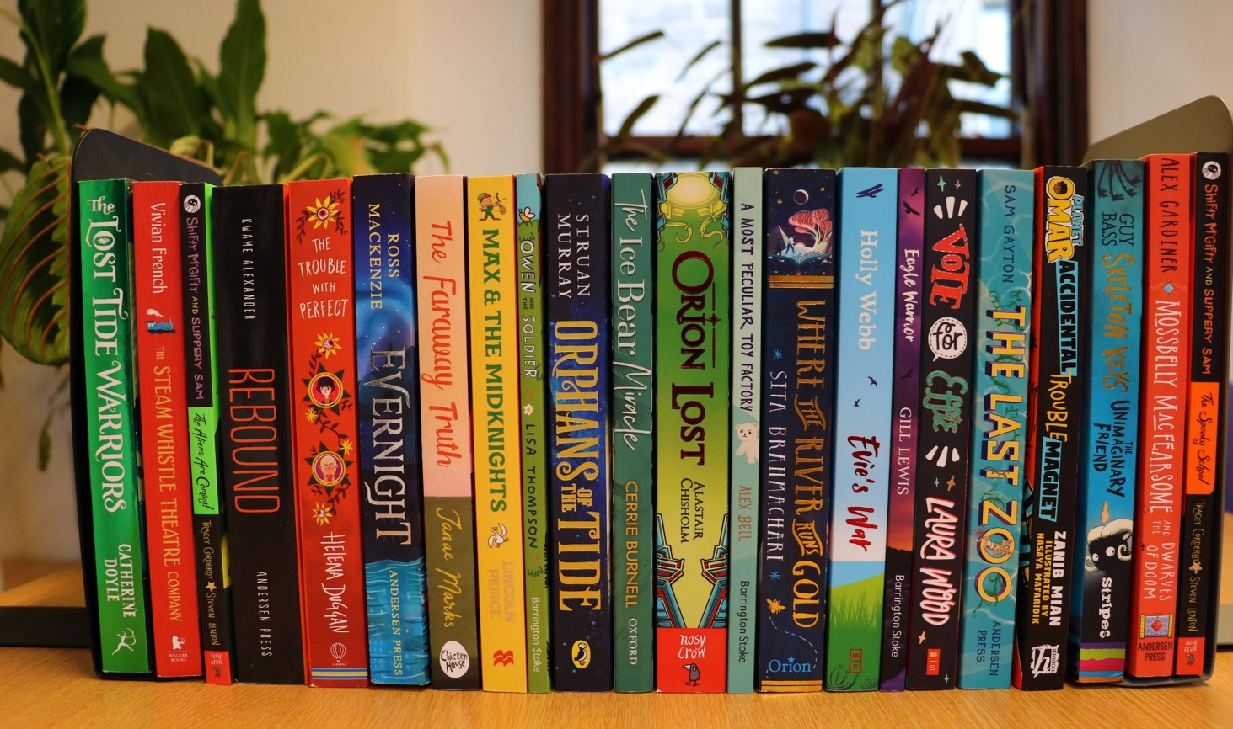

Reading Schools Framework to support blended learning
Key area: All areas

Level: Core, Silver, Gold

Resource created by Scottish Book Trust

scottishbooktrust.com

/scottishbktrust

@scottishbktrust

Ideas and adaptions for your Reading Schools action plan

Contents
About this resource 1
1.2 Leadership of Learning 2
1.3 Leadership of Change 5
1.5 Management of resources to promote equity 7
2.2 Curriculum 8
2.3 Learning, Teaching and Assessment 10
2.5 Family Learning 14
2.7 Partnerships 15
3.2 Raising Attainment and Achievement 16

About this resource
The Reading Schools framework details the Key Areas that we consider crucial to building and sustaining a whole-school reading culture. The Key Areas are mapped against How Good is Our School? 4. Under each of the Key Areas we detail the actions necessary to become a Reading School and advance to silver and gold level.

Following the same format as the original framework this resource details examples of actions that you can do whilst schools are subject to restrictions caused by the ongoing coronavirus pandemic, including suggestions for home learning during lockdown, blended learning for pupils in school hubs and for recovery planning as pupils return.

Other resources that you may also find helpful are:
- Keeping your reading culture alive in lockdown
- Encouraging reading during lockdown

1.2 Leadership of Learning
Key Area 1.2.1 – Reading Leadership Group
We expect Reading Schools to form a reading leadership group who input into your action plan and meet regularly to discuss progress and ideas.

Reading School | Reading School: Silver | Reading School: Gold
- Use digital platforms for meetings  - Meet in smaller groups but continue to consider impact on whole school once back.  - Plan displays/events to make focus of reading across school.  - Think about splitting into groups to cover different ideas/activities. |  | - Make plans now for who might be included from community – begin to write letters.  - Consider including local authors/illustrators, dads and male role models, librarians and bookshop staff if possible.

Key Area 1.2.2 – Learner role modelling
We expect Reading Schools to show how learners visibly promote reading and recommend books to one another.

Reading School | Reading School: Silver + | Reading School: Gold+
- Wear ‘What I’m reading’ badges/lanyards in online lessons  - Display what they are reading on screens eg. Have current book beside them, put up ‘What I’m reading’ poster, create digital reading background  - Add ‘What I’m currently reading’ into footer on homework tasks or email signatures  - Contribute book recommendations to weekly e-bulletin  - Create and share book trailers  - Take photos of books their enjoying on a shelf to create photo display when in school  - Set reading challenges for others | - If pupils have a reading partner in younger year- record themselves reading for their reading friend  - Write and share a story with their buddy (our Paired Reading toolkit gives ideas)  - Create book trailer videos for younger reading buddies  - For ambassadors keen to connect with peers, offer them an online space where they are able to talk about books as a group  - Host a virtual reading café  - Share reading in a fun way- use Sway or suitable platform | - Display books that they are reading in windows.  - Make posters for shop windows – book covers and short review  - Continue to communicate with community through local radio or local newspaper– recommendations or interviews  - Reading Pen Pals – begin book related letter writing with people in their community  - Create a short TikTok style video of pupils book throwing (catch book with right hand/pass on with left)throughout the community or reading in different places  - Involve different age groups and family/friends e.g.  ‘What Our Street Are Reading...’  - Create reading podcasts /videos to share with the community via social media

Key Area 1.2.3 – Visible staff role modelling across the school
We expect Reading Schools to demonstrate how all staff in the school show that they are readers.

Reading School | Reading School: Silver | Reading School: Gold
- Continue ‘I am currently Reading’- wear larger badge
- Create digital reading posters – use as background in online learning
- Include your current read in correspondence with pupils/families, add to email signature
- Share photos of staff reading in various places :e.g. reading outdoors/reading with a pet
- Varied reading – model reading of other texts if finding concentration during lockdown difficult eg. recipes, instructions, poems, magazines, podcasts
- Highlight reading old favourites whilst libraries remain closed
- Share reading modelling online through twitter, blogs etc. – guess the reader, reading challenges, share your favourites, staff interviews and recommendations

Key Area 1.2.4 – Staff development
We expect Reading Schools to show how staff have invested in their reading for pleasure culture.

Reading School | Reading School: Silver: | Reading School: Gold: +
- Continue to become familiar with SBT resources and activities.  - Use Twitter/ Facebook etc. to build knowledge of good practice happening across other school communities | - Continue reading research around literacy and reading to gain knowledge of current developments.  - Lockdown reports – awareness of impact of lockdown on reading habits to support next steps | - Use Twitter/Facebook to work in partnership with other schools – come up with your own local hashtags or chat about books  - Staff attend SBT CLPL webinars

Key Area 1.2.5 – Staff knowledge of contemporary children’s literature
We expect Reading Schools to support staff to develop their knowledge around reading for pleasure.
Reading School | Reading School: Silver | Reading School: Gold
- Continue to signpost to new book lists and other appropriate resources such as our book discovery guide | - Invite local librarian to online staff meeting or to record a video for staff on new books to share  - Share book ideas with staff through digital channels | - Online/ virtual staff book clubs (possibly link with local librarians) – our staff book club resource can help  - Register for SBT Book Discovery sessions – Primary and Secondary themes  - Join and take part in SBT #ChildrensBookChats or start your own

1.3 Leadership of Change
Key Area 1.3.1 – Whole-school action plan
We expect Reading Schools to submit an action plan detailing their aims for progressing their reading culture.

Reading School | Reading School: Silver | Reading School: Gold
- Use this resource to adapt your action plans in line with current restrictions and continue on your journey.

Key Area 1.3.2 – School environment
We expect Reading Schools to show how they have provided appealing and comfortable spaces to read in the school environment and make reading visible.
Reading School | Reading School: Silver | Reading School: Gold
- Encourage learners to find a relaxing space at home to read in – make a reading den/nook with cushions and blankets, upturn their chair and lean against it with cushions. Share ideas with others  - Design their own perfect/ideal reading space for when back in school  - Move book recommendations wall online eg. Software like jambo board to use sticky notes.  - Classroom/Home Door challenge – Make a book door of favourite book. Staff model activity by doing so in school and sending photos to pupils. Pupils take photographs of doors at home for school. Design one for the classroom and class can vote for favourite to do when back.  - Create book displays at home - Put a book in their window or create rainbow book stack. Draw their own book covers and display in window. | - Reading Cafes:can be moved online through digital reading cafes/nooks  - Get pupils reading outdoors, in the park/garden/shed. Set challenges like ‘Extreme reading’ where they photograph themselves reading in unusual spaces  - Filming a book throwing video outside | - Laminate posters and display on school fence or at bus stops/lamp posts around the community (you could include some bags with bookmarks, hot chocolate sachets)  - Share Book Quotes around the community –chalk on pavements or laminate and share on lampposts/ fences/bus stops  - Create a community book trail  - Community campaign to enjoy reading outdoors in local places, within social distancing.

Key Area 1.3.3 – National events and celebrations
At silver and gold levels, we expect Reading Schools to build on reading routines to generate excitement around reading by taking part in national reading celebrations and prizes.
Reading School | Reading School: Silver | Reading School: Gold
- World Book Day – use WBD website for ideas
- Bookbug Picture Book Prize – gift bags virtually. Invite local librarian to record special Bookbug session, or get older pupils to record readings/make trailers for the P1s
- Scottish Teenage Book Prize -Discussions with pupils about finalists and encourage to vote digitally
- First Ministers Reading Challenge – virtual celebration events being planned, register and follow updates. Use celebratory ‘Places Books Take us’ resources.

1.5 Management of resources to promote equity
Key Area 1.5.1 – Access to high-quality books
We expect Reading Schools to provide up-to-date reading materials relevant to the needs, interests and experiences of all learners.

Reading School:Core | Reading School: Silver | Reading School: Gold
- Encourage use of online sites to browse books and audio books such Borrowbox, LoveReading4Kids and Audible  - Get pupils to create lists of what books they enjoyed during lockdown to add to school library when back in school  - Create book boxes for when in school. Have a box of books for each group of learners, changed each week and selected by pupils and their teacher in (socially distanced) collaborations; the books don't need to go home, but learners will need more time in school for reading and talking about books.  - Check out our guide to safe book borrowing in schools during covid-19. | - Ask local librarian to record a virtual tour of the library and talk for the pupils  - Personal shopping experience using library catalogues if learners know what they want or filling out a quiz for a surprise!  - Helping make library e-books and audio books accessible for children e.g. with tips on registering with the local library, downloading the app and selecting books.  - Techniques to help children to browse books without touching e.g. review cards displayed beside books

2.2 Curriculum
Key Area 2.2.1 – Regular opportunities to read for pleasure
We expect Reading Schools to ensure all learners have regular time to read texts of their own choosing.

Reading School | Reading School: Silver | Reading School: Gold
- Think about using reading to provide emotional support at the moment.
- Continue with DEAR or ERIC time. Why not try Read with me @ Quarter to 3 – set time for everyone reading at same time
- Read with the Heid – HT posting what their reading on Twitter etc.
- Use RWC/ Bookbug materials to support younger pupils - watch videos/ read together/ read with family
- Create a digital DEAR klaxon and sound it throughout week to keep pupils excited about reading

Key Area 2.2.2 – Interdisciplinary book projects
We expect Reading Schools to offer exciting and engaging projects based around books that will inspire learners to read.

Reading School | Reading School: Silver | Reading School: Gold
- Use SBT resources on specific authors or books to inspire book projects. Explore our home activities hub for activities suited to home learning.  - Use RWC resources to create cross curricular links using SBT resources –  - ‘Read to …. Challenge’ - Choose a destination to read to –(pages count as miles) could be Europe or completely different continent and then explore curricular learning opportunities around this.  - Activities day linked to book across different departments | - Share virtually what has been done, either to whole school or in stages – live or teachers create short videos/sways/displays for when back in school

2.3 Learning, Teaching and Assessment
Key Area 2.3.1 – Modelling reading behaviours
We expect Reading Schools to give all learners the opportunity to hear a text aloud to widen their experience of stories.
Reading School | Reading School: Silver | Reading School: Gold
- You can still read aloud live/ share recordings with pupils at regular intervals. Our legal guide to sharing books and stories online with help you.
- There are multiple online options to share/listen to books being read together: BBC School Radio has wide variety of dramatisations and podcasts to listen to.
BBC Sounds app –offers audiobooks for a limited time, as well as children’s podcast series: @Once upon a time in Zombieville.
The Book of Hopes, edited by Katherine Rundell, is free to share and read from the National Literacy Trust.
Stay at Home, edited by Joan Haig, is free to download as an e-book.-
- Encourage reading with a family member at home.
- Mystery reader photos/videos for learners to 'guess who' is reading

Key Area 2.3.2 – Meaningful conversations around books
We expect staff at Reading Schools to engage with all learners individually to support reading for pleasure.

Reading School | Reading School: Silver | Reading School: Gold
- Set aside dedicated time to talk to pupils about books asking what they are reading/enjoying and what they would like to read when back at school
- Encourage pupils to try out books by reading first chapters of books via websites such as LoveReadings4Kids.
- Teachers or librarians post new books with an interactive review and trailer to encourage pupils to reserve preferences for when back at school.
- Encourage use of Bookzilla app to help select books similar to what they’ve liked before.
- Could broaden conversations to include media texts and what pupils are watching as well as physically reading.

Key Area 2.3.3 – Creating social networks
We expect Reading Schools to facilitate learner social networks around reading to help them to discover their own reading identities.

Reading School | Reading School: Silver | Reading School: Gold
- 60 second sell – do during online literacy lesson or set as homework to do with family members  - Dedicated chat about books in online lessons  - First lines activity– discussing first lines from a selection of books can transfer to digital classroom.  - Use of Reflective Reading Framework | - Book clubs still possible continue clubs formed in school virtually or in bubbles  - Book club members can share book talks on digital platforms with recommendations, quizzes, competitions films to follow.  - Book club boxes for children to take home and comment in a shared notebook

Key Area 2.3.4 – Opportunities for learners to respond to what they’re reading
We expect Reading Schools to allow all learners to respond to what they’re reading in a variety of engaging ways that best suit their needs.

Reading School | Reading School: Silver | Reading School: Gold
- Continue to use FMRC digital passports to record reading and write reviews
- Pupils contributing book recommendations or reviews to school newspaper or e-bulletin
- Set curricular reading challenges around books and learning across the curriculum
  - Act out a scene from the book (Drama)
  - Create a sound using items from home for a character in a book (Music)
  - Filming a book review/trailer – our Into film resource will help with this (Technologies)-
  - Draw a book setting(Art)
  - Research a place where a book is set (Geography)
- 50 word fiction - Either use SBT example (for family writing prompt too) or do one weekly and link to different curricular areas you are working on as part of blended learning

Key Area 2.3.5 – Access to authors
At silver and gold levels, we expect schools to give all learners the opportunity to engage with authors (writers, illustrators or storytellers).

Reading School | Reading School: Silver | Reading School: Gold
- Watch AuthorsLive on demand or live sessions
- Watch Scottish Children's Friendly Book Tour-virtual events. Check out website to apply.
- Live Literature can fund remote author events.
- Virtual Book Festival – create a timetable for pupils to watch one event each day of the week. Or encourage to watch different events and discuss next time meet online.
- Engage with authors online – many have their own blog/website/twitter and some are offering weekly reads or releasing chapters of books throughout lockdown
- Take part in online book events/festivals eg. EIBF, Storycon

2.5 Family Learning
Key Area 2.5.1 – Raising the profile of reading with families
We expect Reading Schools to involve learners’ families in building their reading culture.

Reading School | Reading School: Silver | Reading School: Gold
- Rediscover RWC /Bookbug materials: Nursery to P3 bags include family learning resource/activities  - Share ideas/challenges families can do at home together e.g. build a reading den, share audio books together, make mini books  - Collecting stories - ask pupils to speak to family members about what they like to read and collect and share these stories together  - Run a mini social media campaign – with fun challenges for families | - Invite families to take part in online author events e.g. Authors Live/virtual book festival  - Hold a virtual reading event e.g. Reading café, pizza and pyjamas, bring along teddy/soft toys, outdoors  - Create family social media challenges and hashtags around events or themes across a time period e.g. #bigoutdoorread | - Encourage families to share their successes with others.  - EAL parents – create book covers for books they enjoy in own language  - Inviting families to join online staff book clubs  - Set Read, Write, Count home learning games/challenges for families  - Create recommended reading list for families. Consult with them on type of books they would like to try.

2.7 Partnerships
Key Area 2.7.1 – Partnerships within local community
At gold level, we expect Reading Schools to build sustainable partnerships in the local community sharing the expertise they have built over the course of their journey.

Reading School | Reading School: Silver | Reading School: Gold
- Community readers project - Ask members of community to share their reading journeys and reading life eg police officer, doctor, hairdresser – via videos or posters.
- Community podcast/ recommendation videos
- Pen pal projects with local care home or other local organisation
- Partnership with local newspaper – regularly share reading recommendations /reviews by pupils
- Supermarket – share book reviews, reading achievements of pupils on noticeboard, put a book borrow box in local supermarket
- Take part in a virtual Community Book Festival.

3.2 Raising Attainment and Achievement
Key Area 3.2.1 – Rewarding progress and recognising personal achievements
We expect Reading Schools to recognise and celebrate the reading achievements of all learners.

Reading School | Reading School: Silver | Reading School: Gold
- Reading Bingo Challenge linked to awarding house points or class awards.  - Digital stickers/certificate by emails  - Possibly link to class dojo system to reward good reading achievement. | - On various platforms, hold a reading assembly/day/party  - Organise photos, videos, and pictures etc. that allow different pupils/groups/classes to showcase their reading achievements as part of the whole school focus on reading across the chosen assembly or day. Could include fun activities with quizzes, dress as your favourite character, authors live sessions etc. | - Share learner achievements and prize-giving with families through digital platforms  - Celebrate learner achievements in community spaces, on the school website or through Twitter

