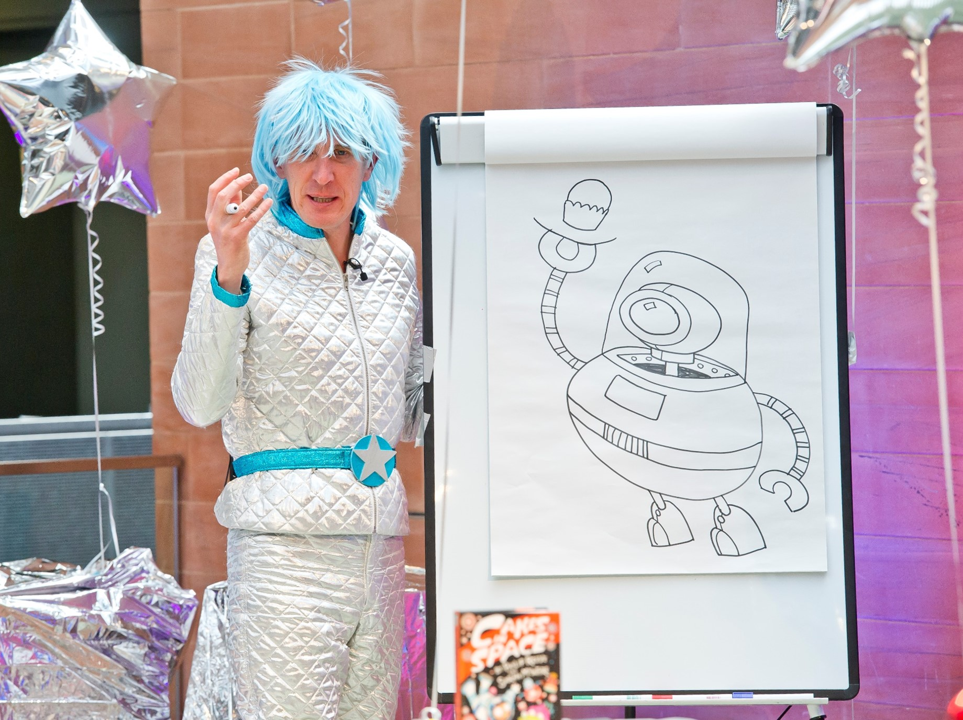

Exploring illustrated chapter books

Activities to explore illustrated novels in the classroom

Key Area: 2.2.2, 2.3.4

Level: Core

Resource created by Scottish Book Trust

scottishbooktrust.com
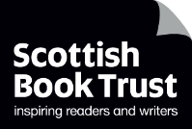
Scottish Book Trust is a registered company (SC184248)
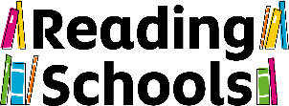
and a Scottish charity (SC027669).

Contents
What is an illustrated chapter book? 4
Activities 4
Worksheet: 1

About this resource
The activities in the resource will help you explore illustrated chapter books in the classroom. You could use one of the titles below as a class novel, and use the activities to as part of a class project. Alternatively, you can use the activities independently and dip in and out of this resource.
There are a range of exiting chapter books which use both illustrations and text to tell their story, and which are perfect for engaging upper primary pupils. Here are some suggested titles:
- Tom Gates by Liz Pichon
- Create Your Own: Superhero Epic and Create Your Own: Spy Mission by Chris Judge
- Baby Aliens got my Teacher by Pamela Butchart and Thomas Flintham
- Cookie and the Most Annoying Boy in the World by Konnie Huq
- Barry Loser by Jim Smith
- Diary of a Wimpy Kid by Jeff Kinney
- Pugs of the Frozen North by Philip Reeve and Sarah McIntyre
- Ottoline by Chris Riddell
- Dear Professor Whale by Megumi Iwasa and Jun Takabatake
- Magic Ink by Steve Cole and Jim Field
- Wonderstruck: A Novel in Words and Pictures by Brian Selznick

What is an illustrated chapter book?
Illustrated chapter books are novels in which the story is told predominantly by text but also through illustrations. The reader is required to read both the text and the images to understand the story.
Some books are also interactive, such as Chris Judge’s Create Your Own series or Jim Smith’s Barry Loser series. These books invite the reader to add colour, doodles, additional words, or even rip pages out of the book in order to continue the story.
Illustrated chapter books are highly visual and appeal to a variety of readers, including reluctant readers, and perfect for using with P4-7 pupils.

Activities

Exploring the books
LIT 2-09a, LIT 2-11a, LIT 2-14a, LIT 2-15a, ENG 2-19a
From your school or local library, collect together a selection of the suggested titles. Place a book or two on each of the tables in your class so that pupils can look at the book/s in small groups. If you have sufficient books, ask pupils to work in pairs. Ask pupils to look at the books together and read sections. Encourage pupils to ask questions of the book:
- What do they think of the book cover? What does it tell them about the book?
- Does the book cover match, or give a clue to, the illustrations inside?
- Do they notice any common factors between the books? For example, the language is often colloquial and directed at the reader.
- Are the books funny or serious?
- Is it easy or hard to read aloud?
- Do they like or dislike the layout? Why?
- What do they think of the illustrations?
- Is there a different author and illustrator or are they the same person?
- How are the text and illustrations laid out on the page?
- Are there any interactive elements? For example, do they need to colour anything in to continue the story?
Ask each pupil or group to take notes on their thoughts of the book and write down answers to these questions. Each group must then briefly present and explain their book/s to the rest of the class. Encourage pupils to give their own opinions on the book/s- did everyone in the group like it? Or did they disagree?
Finally, as a whole class discuss the groups’ thoughts on the titles and summarise the answers to these questions together on a white board or large piece of paper.

Art matters
LIT 2-10a, LIT 1-11a, LIT 2-14a, LIT 2-24a, EXA 2-03a, EXA 2-05a EXA 2-06a, HWB 2-01a
Put this quote from author and illustrator Chris Riddell up on your board:
“I love the way words and picture work together on a page. I have also noticed when wise words have visuals added to them, they seem to travel further.”
From Art Matters by Chris Riddell and Neil Gaiman
Do your pupils agree with this quote? Does the classroom or school have any quotes or “wise word” posters? Ask pupils to go around your school or classroom and make notes on the posters- what are the words or phrases and what images have been selected to go alongside them?
Pupils should also consider how this combination of words and image makes them feel. Ask them to select one of the posters they have seen. What do they feel the picture adds to the words? Does it make the message more meaningful? Do they think the right image was selected or would they have chosen a different one? Ask pupils to discuss their favourite poster in pairs and what they might change.
As an extension activity, ask pupils to think of a quote or phrase that means a lot to them. Ask them to write it onto a piece of paper (A4 or A3 depending on how much space you have to display them) and ask pupils to draw or doodle images around it that they feel adds meaning to their message. Alternatively, pupils could design their poster on the computer and add photographs.

What is an illustrator?
HWB 2-20a, LIT 2-05a, LIT 2-25a
Some illustrated chapter books are created by an author/illustrator, and some are created by an author and an illustrator working together.
Discuss the role of an illustrator with your class. Illustrators can work on children’s books, but also in a range of different settings. What other situations can your class think of that might require an illustrator? This article offers descriptions of the different types of illustrators.
Ask your pupils to research an illustrator and see what they can find out about their job and day-to-day work. Well-known illustrators such as Chris Riddell often talk about their work and daily practice, and pupils can watch or read interviews online. However, pupils could research lesser-known illustrators but who also have information about their work online. Perhaps ask pupils to choose an illustrator from one of the books you have looked at in the “Exploring the books” activity whose style and pictures they liked.
Ask pupils to find out:
- What materials do they use?
- How many books have they illustrated?
- Do they work on both chapter and picture books?
- What is their most well-known book?
- How long have they been illustrating?
- Do they have one author they regularly work with, or do they work with a variety of authors? Or do they illustrate their own work?
- What else do they illustrate beside books?
- What can you find out about the decision making process? How do illustrators choose which scenes to illustrate?
Pupils can also look at the Society of Authors website to find out more about the support and advice available for authors and illustrators during their career.

Watch an Authors Live broadcast
LIT 2-01a, LIT 2-04a
You can watch a number of authors who write illustrated chapters books talk about their work on our Authors Live Watch on Demand library. Both Liz Pichon and Konnie Huq talk about their process of writing and drawing. You can watch Chris Riddell explore illustration and the importance of drawing, and be inspired to do some creative writing by Pamela Butchart and Sarah McIntyre’s exiting events.

Importance of doodling
LIT 2-01a, LIT 2-04a, EXA 2-03a, EXA 2-05a, EXA 2-07a
In their Authors Live events, both Liz Pichon and Chris Riddell talk about the importance of doodling. They emphasise the importance of drawing regularly, and for pupils not to be concerned with how their works looks, nor how neat it is. For Liz and Chris, drawing is an enjoyable activity that pupils should not be afraid to try.
To help pupils build their confidence with drawing, you could introduce a “doodle a day” activity and ask pupils to draw a different subject each day. This will help pupils to worry less about the work they are producing, and improve their confidence and drawing skill. You can find books with suggested daily drawing activities such as A Doodle a Day by Chris Riddell or A Drawing a Day by Kirsteen Robson and Michael Hill, or you could invent daily activities.

Free Writing Friday
LIT 2-20a, LIT 2-24a, ENG 2-31a
Children’s laureate Cressida Cowell promotes Free Writing Friday, a weekly activity where pupils are able to write freely (without being marked) once a week, purely for their own enjoyment. You can decide on the time pupils write or draw for. You are welcome to look at their work and read their stories, but you never mark their notebooks or jotters.
Schools the Scottish Book Trust have worked with who have taken on Free Writing Friday found that pupils often began to incorporate illustration as well as writing into their stories creation. Without the worry of being marked, and knowing that the work they produced was only for themselves, pupils felt much freer to write and draw work that suited them.
Free Writing Friday is a great way to allow pupils to be creative and to begin to experiment with and explore ideas.

Write and illustrate your own chapter or short story
LIT 2-20a, LIT 2-23a, LIT 2-24a, LIT 2-26a, ENG 2-31a
If you have explored most of the previous activities, your pupils are now probably comfortable with the idea of an illustrated chapter book and understand how the images complement the text, and tell part of the story.
As a class, decide on a character for your story. You could create your own character, or write a sequel or “what-happened-next-story” to one of the books you have been looking at together as a class. Pupils will not have time to write a whole novel, so ask pupils to write either a chapter each or a short story about that character.
Remember to encourage pupils to plan the images that tell their story alongside their written text. They may find creating a storyboard (worksheet below) helpful in planning their story and laying out their key points in panels. They can draw a quick illustration to show what will accompany their text.
Once your pupils have written and illustrated their final piece of work, you could share it with the rest of the school in an assembly, or pair pupils together to read their stories to each other.

Worksheet
Use this worksheet as a template for a storyboard to plan and lay out key points in panels. Draw a quick illustration to show what will accompany the text.

