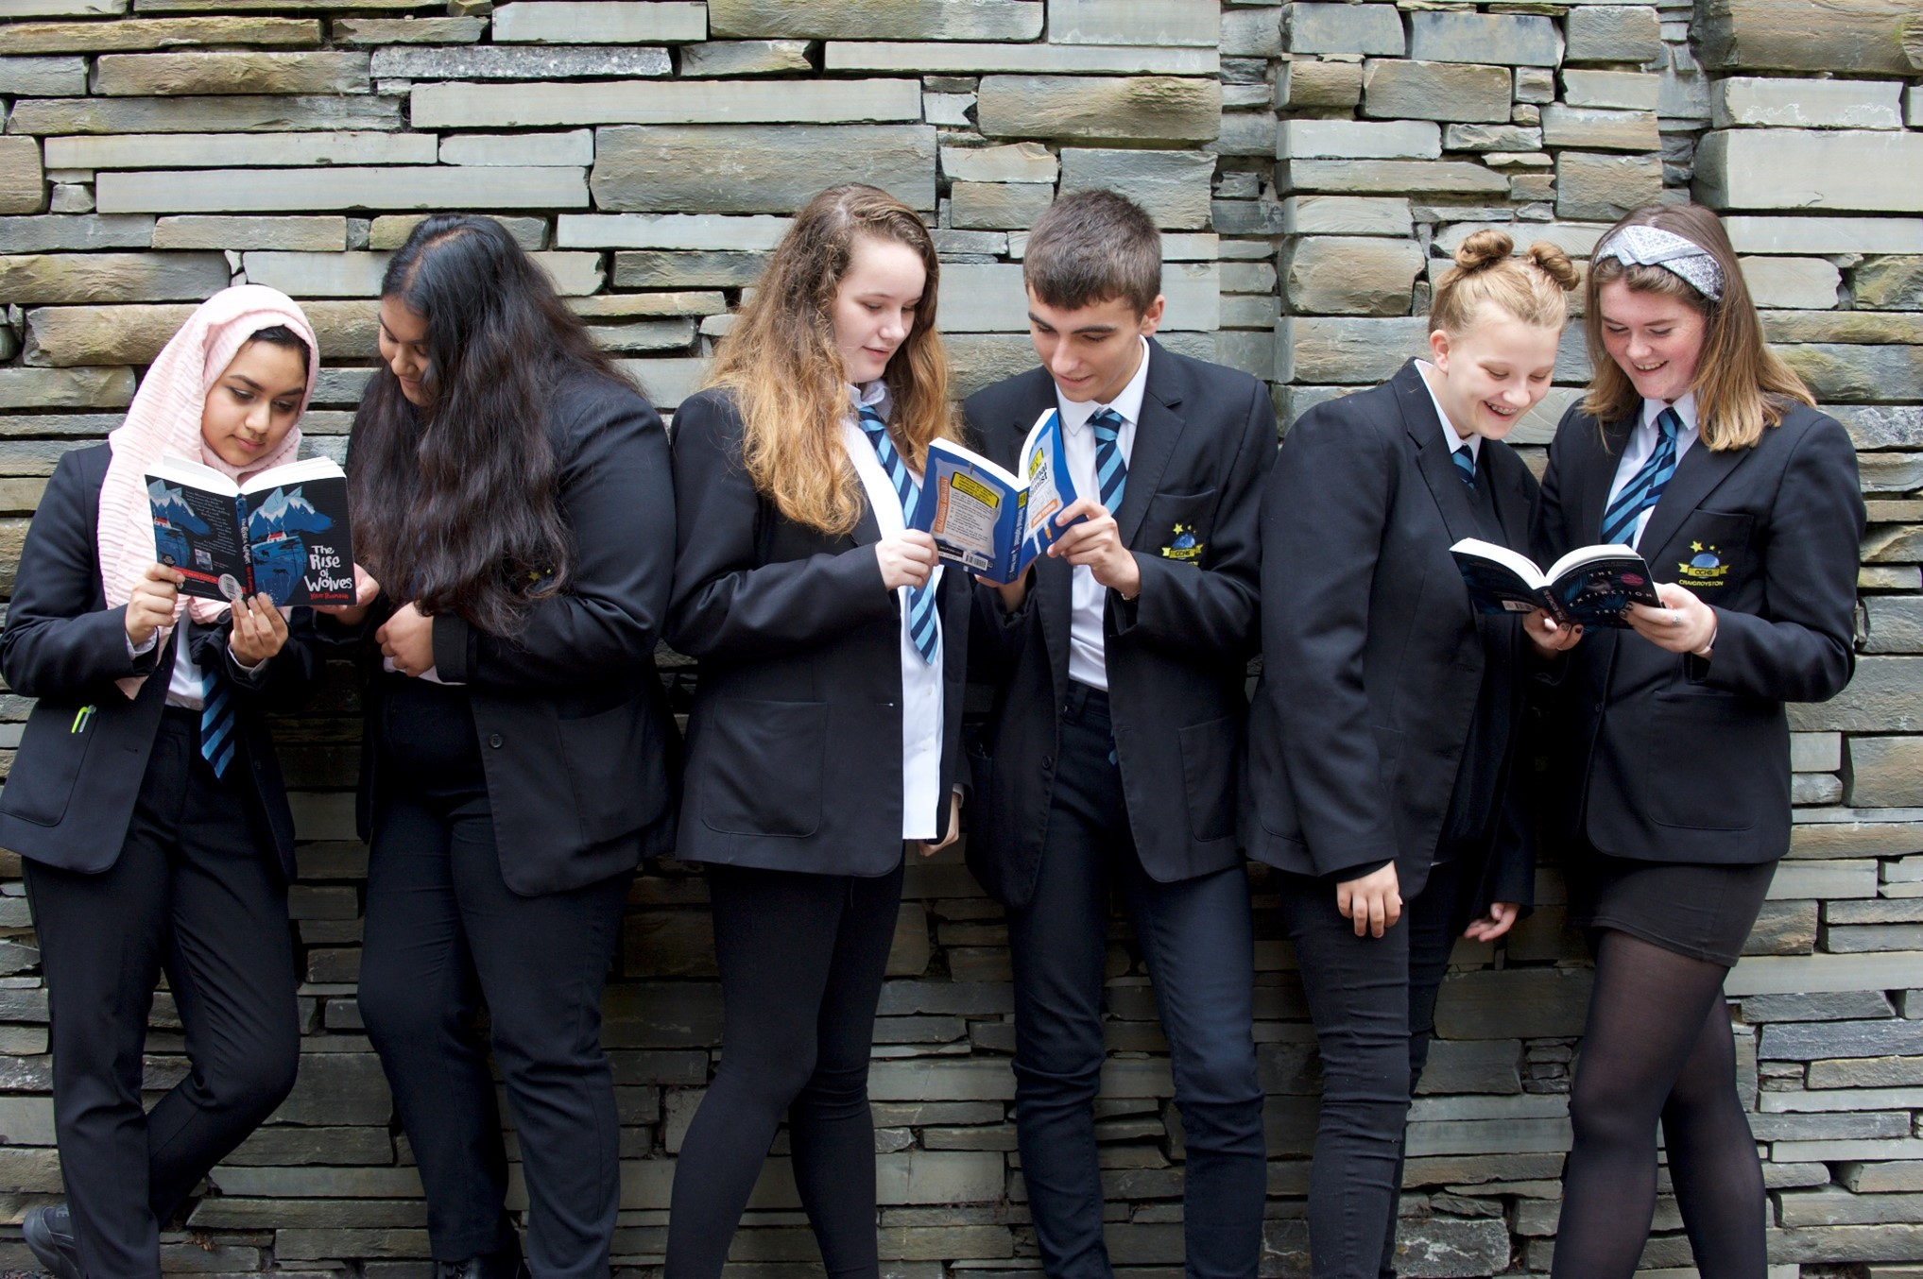

Top tips for engaging teenagers in reading
Ideas for sharing books in the home

Key Area: 2.5.1

Level: Core

Audience: Secondary

Resource created by Scottish Book Trust

scottishbooktrust.com
Scottish Book Trust is a registered company (SC184248)
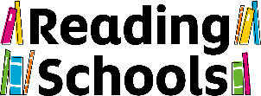
and a Scottish charity (SC027669).

Contents
If they don’t want to read, try to find out why 2
Look for books based on movies and computer games 2
Don’t be fussy about what they read 2
Connect their reading to their interests 2
Find out if their school is taking part in the Scottish Teenage Book Prize 3
Make sure they see you reading 3
The right book is out there 3
Bookzilla 3
Encourage them to create something new from their favourite books 4
Direct them to our Authors Live events 4
Help them find places to discuss books 4

About this resource
As your child enters their teen years, many of the approaches for encouraging them to read remain the same from ages 8–11. A whole world of exciting fiction opens up to them, and books can give them a safe place to explore complex feelings. Whether your child is a keen or reluctant reader, the tips below should be useful.

If they don’t want to read, try to find out why
In teenage years, reading is often seen as ‘uncool’. To overcome this, it can help if they see reading as something they can do to further their hobbies: how-to manuals are good, for instance.
If they’re a confident reader but have stopped reading, it’s possible they’ve become turned off by the reading they need to do for school coursework. As their school reading becomes linked to exam pressures, teens can begin to see reading as less fun than it used to be.
If they’re lacking in confidence, they might need some quick reads to boost their reading self-esteem, and technology can help as well. Children who aren’t confident readers might sometimes not want to admit this, but a quick check with their teacher can give you a clear picture of how they’re getting on as readers.

Look for books based on movies and computer games
If you’ve been caught up in a good story, you don’t want it to end! So if your child has enjoyed the storyline of a movie or computer game, investigate whether there are books based on it. It can be easier to get them interested in something they’re already familiar with.

Don’t be fussy about what they read
Here’s the key: reading is a habit, and as long as they’re in the habit of picking up something to read, it doesn’t really matter what they’re reading. So if they’re reading magazines, great – this can lead to further reading if you can establish what they’re interested in.
Also, remember that they need to see reading as a fun thing to do. Don’t worry if you feel that their personal reading isn’t challenging them – school takes care of that. Don’t force them to read anything – that’s a sure way to associate reading with pressure.

Connect their reading to their interests
If reading is seen as ‘uncool’, then many teens need an excuse to read. If they’re interested in pursuing a hobby, then a how-to manual can be a great way in to encourage reading. Seeing a library shelf full of books about their hobby can really be exciting and an eye opener for teens.
It’s also worth noting that certain types of reading will be seen as more ‘cool’ than others. Without wishing to generalise, biographies of people in the worlds of sports, music, fashion, film and other forms of popular culture can be seen as more attractive reading by teens.

Find out if their school is taking part in the Scottish Teenage Book Prize
The Scottish Teenage Book Prize is Scotland’s largest book award for teenagers. Teachers or librarians need to register teenagers to take part. After that, teens just need to read and discuss the three shortlisted books and vote for their favourite. Expressing an opinion about books can really help teens engage with reading!
The shortlist is announced every year near the beginning of September, and the voting deadline is around mid-February. Details about the Scottish Teenage Book Prize can be found here: scottishbooktrust.com/stbp/

Make sure they see you reading
If your child sees you reading, it lets them know that you find reading enjoyable and worthwhile. It’s not guaranteed to get them reading, but it certainly sends out the right message. And if you’re reading something you think your child might like, leave it lying around so they can see it: autobiographies are always good for piquing curiosity.

The right book is out there
Be patient as you try to find the book that engages your teen. Some teenagers have a preconception that reading is largely about fantasy and adventure, and has very little relevance to their lives. In actual fact, young adult fiction is full of gritty and realistic stories featuring relatable teen voices. And our advice is not to worry about the mature content often found in these books – teens are bound to encounter discussion of adult issues through school or friends, and books are actually a great safe place for teens to explore their feelings about these issues.
Here are a few great places to find book recommendations:
- Scottish Book Trust’s book lists for teens
- LoveReading4Kids website
- World Book Day parents’ book finder
- Common Sense Media

Bookzilla
If you are still looking for recommendations, download the Scottish Book Trust Bookzilla app (available on Android and Apple). Created with young people from across Scotland, the app offers reading recommendations, collections, reading dare activities and a book randomiser to help young people find their next read.

Encourage teens to create something new from their favourite books
Many keen teenage readers enjoy interacting with the content of their favourite books. One great way to do this is by writing fan fiction, which means writing something new which features some or all of the characters from a book. Good fan fiction sites include:
- hungergamesfanfiction.com
- www.twilighted.net
- www.squidoo.com/fanfictionsites

Direct them to our Authors Live events
It can be really exciting and interesting for a teen reader to watch an event with one of their favourite authors. Events give readers an insight into what the author was thinking when they wrote a book, and can also give keen writers some great advice to use in their own writing. Scottish Book Trust’s Authors Live events feature some top names like Jacqueline Wilson, Marcus Sedgwick, David Almond and Patrick Ness. You can watch these events at any time in our Authors Live on Demand library.

Help them find places to discuss books
It’s often the case that young people feel much more comfortable talking about books without adults in the mix, and there are plenty of websites available to help them do this – you’ll find a few suggestions below.
- Goodreads
- Epic Reads
This doesn’t mean you should stop talking about books with your teens – just that young people may appreciate a range of different people to share their thoughts with.

