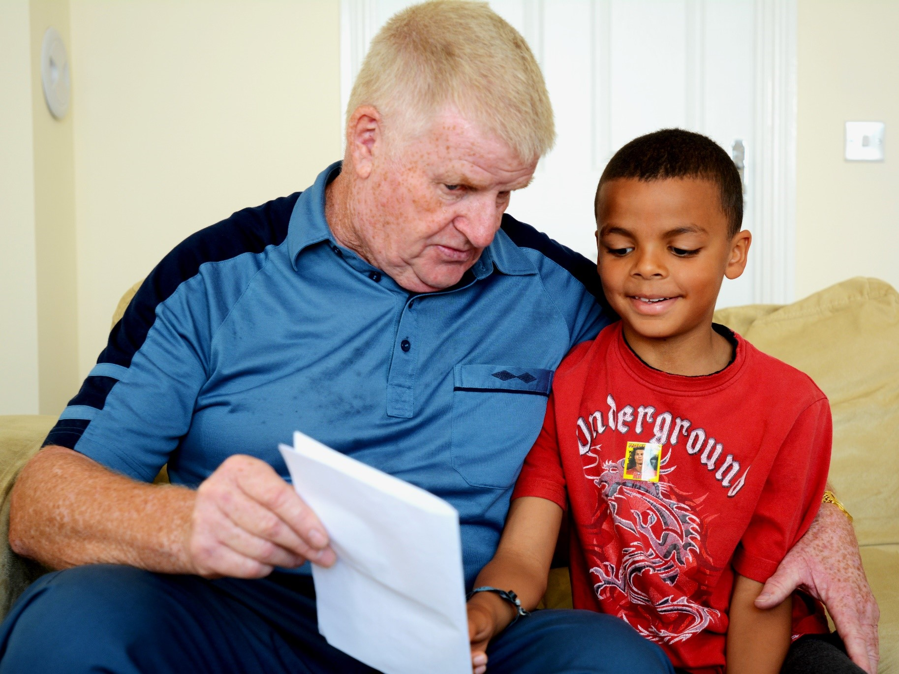

Tips for sharing picture books in the home
Ideas for sharing picture books in the home

Key Area: 2.5.1

Level: Core

Audience: Primary

Resource created by Scottish Book Trust

scottishbooktrust.com
Scottish Book Trust is a registered company (SC184248)
and a Scottish charity (SC027669).

Contents
Make time to share a story every day 2
Keep books within easy reach 2
Let your child choose a book 2
Share your own favourite stories 2
Look at the pictures 2
Bring the story to life 2
Talk about the story 2
Have fun 3
Read it again 3
Looking for ideas? 3

About this resource
Whether your child is a keen or reluctant reader, the tips below can help you encourage a lifelong love of reading. Remember, the key is not to force it too much this will really turn children off. Make sure that reading is seen as an enjoyable, relaxing activity. This is the first step in encouraging any young reader. Remember, reading is for entertainment and enjoyment!

Make time to share a story every day
You can enjoy books at any time of the day. Work them into your everyday routine. Some stories are gentle and calming, making them a great choice for bedtime. Others are more exciting and adventurous, and so would be better suited to when your child is awake and active.

Keep books within easy reach
Try leaving your child’s books on the lower shelves of a bookcase or in baskets on the floor. They can bring you a book when they’re ready for a story or choose to explore books on their own.

Let your child choose a book
Children will often be more excited and engaged with a story if they have been involved in choosing what to read. Sharing a book of their choice also lets them know that you value their opinion.

Share your own favourite stories
It’s also great to share your own favourites with your child too. Don’t forget to say why you like the story so much.

Look at the pictures
Before you start, spend time together looking at the cover. If the story is new to your child, you can ask what they think the story might be about. You could also chat about the pictures on each page and encourage your child to tell the story based on the pictures.

Bring the story to life
Use your voice to make sound effects or noises. Change your tone of voice and your facial expression to suit the emotion of the character in the story. If a character is really happy, then smile and use a happy voice. This helps your child to connect to the different emotions in the story and also helps their own emotional development.

Talk about the story
After you’ve read the story, ask your child what they thought about it. Encourage children to tell you why they did not like a book. Talk about what happened in the story, how a character might have been feeling or what they think might happen next. This will help deepen your child’s understanding of the story.

Have fun
Lots of books can be playful. Find ways for your child to join in – maybe with a repeated phrase, an action or even by copying what the character is doing. Join in with them and have fun.

Read it again
Your child may ask for the same book again and again. Each time you share it, they’re learning or noticing something new. Re-reading favourite books is a great way to develop vocabulary and understanding of the story.

Looking for ideas?
Explore activities related to The Bookbug Picture Book Prize. The three shortlisted picture books are gifted to every child in Scotland in the Bookbug P1 Family Bag during Book Week Scotland.
You can also watch brilliant author events for children in our Authors Live on Demand library.

