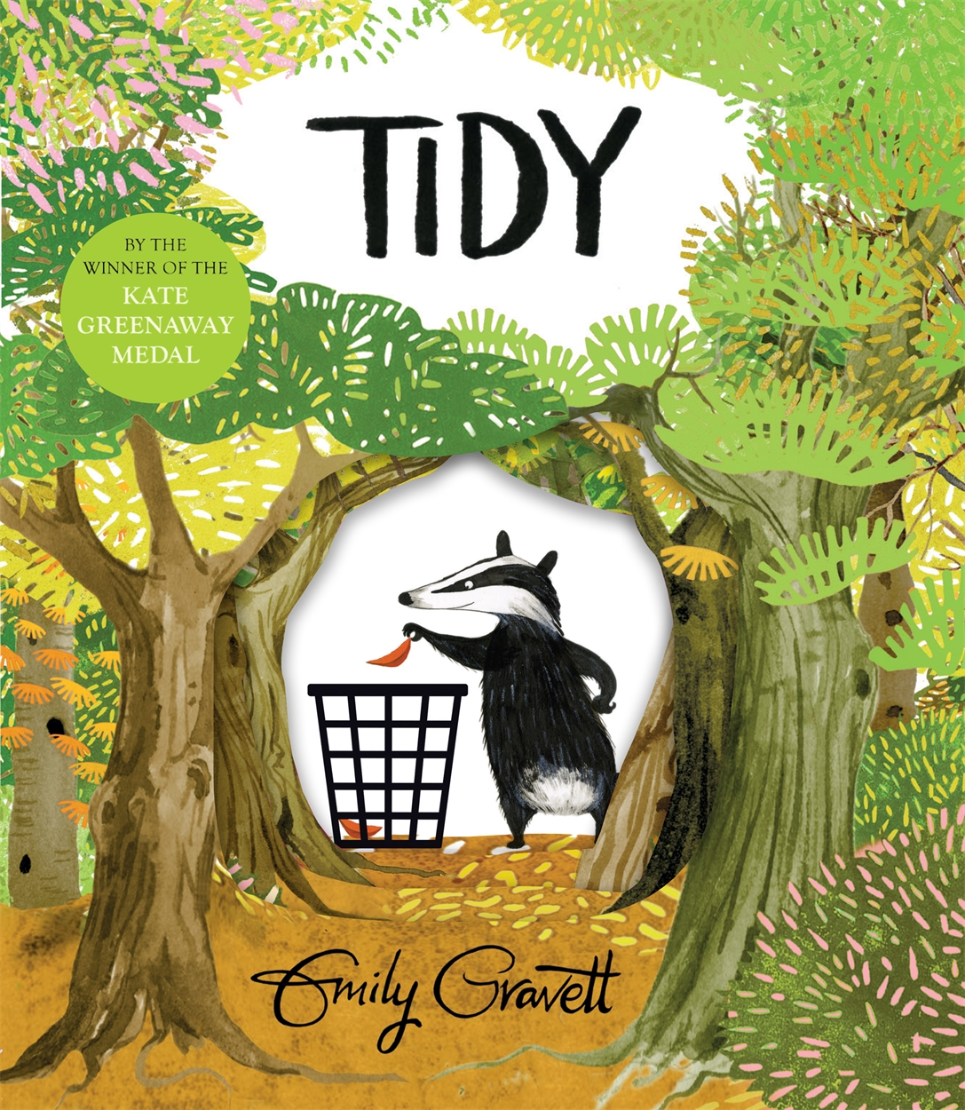

Tidy multi-disciplinary project
Whole school activities inspired by the picture book Tidy by Emily Gravett

Key Area: 2.2.2

Level: Core, Silver

Resource created by Scottish Book Trust

scottishbooktrust.com
Scottish Book Trust is a registered company (SC184248)
and a Scottish charity (SC027669).

Contents
About this resource 2
Getting Started 3
Tidy by Emily Gravett 3
Book launch 4
Literacy 4
Health and Wellbeing 6
Modern Languages/Gaelic 7
Expressive Arts 8
Science 8
Mathematics 9
Technologies 9
Social Studies 10
Religious and Moral Education 10

About this resource
The resource contains differentiated cross-curricular activities for Early, First and Second levels, adaptable to use as part of a whole school core book project involving ideas to support:
- Literacy
- Health and Well-being
- Modern Languages (French & Gaelic)
- Expressive Arts
- Sciences
- Maths
- Technologies
- Social Studies
- Religious and Moral Education

Getting Started
In developing skills to read, interpret and understand pictures a picture book can be used across the whole school to create a common thread to support and promote a school’s values.
Attractive picture books are accessible and inclusive for all learners. They are suitable for paired reading between older and younger pupils. They also provide opportunities for children to discuss what they see as they explore the pictures, thus building their listening and talking skills, their vocabulary and their ability to re-tell a story effectively. For children for whom English is a second language, high-quality picture books help build vocabulary and comprehension.
Picture books can also introduce young people to new themes, viewpoints and authors.

Tidy by Emily Gravett
In Tidy Emily Gravett tells the story of Pete the Badger, who is on a mission to tidy up all of nature in the forest – leaving everything neat and clean. Trees need to be chopped down, fellow creatures need to be scrubbed and bin bags need to be filled with the leaves that have fallen on the ground. Pete lays concrete over the whole forest to make it look very tidy but only then does he realise that he can no longer access his underground home or find anything to eat and so, recognising his mistake, he sets out to restore the forest to its more messy, natural state, with the help of all of his animal friends.
A funny and beautifully illustrated story, this provides the perfect starting point for discussion about how we need to live in harmony with nature and our environment.
The book can be shared as a whole school or individual class resource. There are, however, some key points to remember when sharing Tidy and other picture books:
- Teacher knowledge and preparation of the resource is vital to initiate learning.
- Establishing pupil prior knowledge of wordless books can be helpful.
- It is important that pupils can see the images clearly.
- Children need time to process what they see and accept suggestions offered.

Too Much Stuff by Emily Gravett
Too Much Stuff, published in 2020, is set in the same woodland with Meg and Ash the magpies, and Pete the Badger, and explores similar environmental themes to Tidy. This is an entertaining and humorous story of the dangers of consumerism and collecting too much stuff! It is the perfect companion to a Tidy book project and will compliment many of the activities outlined in this resource.

Book launch
To introduce the book Tidy as a whole school resource, make a copy available for every classroom.
- Hide the book itself and hide printed letters of the word “TIDY” around each classroom. Ask children to find the individual letters, make a word with them and then also find the hidden book of that name.
- Set up small reading groups so that older pupils can read the story to small groups of younger children.
- Hold a school assembly and show Emily Gravett reading Tidy. Ask each class to think of one thing they could do to improve the school environment. They may have a litter clean-up, tidy the school library or entrance area, create a recycling station within the school and work out how the materials can be transported to Recycling Centres, tidy their own desks or add planters to grow plants in the playground.
- Show pupils footage of Greta Thunberg talking about the challenges of climate change and what we need to do to respond to the crisis and set up a suggestion box so that pupils can come up with their own ideas for what can be done in school or at home. Consider how re-using, reducing and recycling can become part of the fabric of school life.

Literacy
Early/First
LIT 0-01c/LIT 0-02a/LIT 1-02a/LIT 1-04a
Clearly display the front cover, have younger children sitting around you or display the picture on a larger screen. Older pupils could have a copy of the cover in pairs or groups. Children need time to look at the image and process their observations.

Using open questions begin to gather their initial ideas:
- Let the children think about the one word title: Tidy
- What do they think the story might be about based on the cover alone?
- Are there any clues to help and do they hint at what might happen in the story?

As the story unfolds, begin to establish basic questions to use with each page. Allow the children time to study each picture and practise looking for clues.
(Questions could already be written on fans or cards to support using the book, possibly handed out to pupils across year groups at the assembly).
- What do you see? Look again, what else do you see?
- Are there any clues showing what the story might be about?
- Is there anything different or unusual?
Turning each page, discuss what they see. Encourage them to become picture detectives who need to look carefully at the pages. If new words are offered, record them for a word wall to support writing later. Include deeper questioning during discussion:
- How do you think Pete’s friends are feeling?
- What makes you think this?
- What do you think they could have said to Pete?

First/Second
LIT 1-02a/LIT 1-04a/LIT 2-02a/LIT 2-04a
Consider the story in pairs or groups:
- Do you think this book has a message for us? If so, what do you think it is?
Findings can then be shared and the different ideas discussed.
Prior to reading the book, pupils should already be starting to engage with the book and can offer suggestions from their own experiences about where the story might be headed. (Make a note of any suggestions that could support writing later).

The whole book could be looked through, with time to discuss and note observations as you go.
(A Smartboard display would enlarge the pictures to discuss in class).
- Groups/pairs could be given different frames with space to record observations for reporting to the class when ready.

Encourage deeper questioning and discussion, sharing knowledge, understanding, building confidence, vocabulary and scaffolding pupils who require more support.
(Prompt cards could be used or a sheet with questions for them to think about).
- How does the tidying of the forest make you feel?
- How do you think Pete’s friends are feeling? What makes you think this?
- Why do you think the illustrator filled the front and back outside and inside covers with pictures of trees?
- What sounds might you hear in a forest?

Introduce other books that consider the world and the role we have to play in it. If the school has already signed up to the First Minister’s Reading Challenge you can download Reading Passports to keep a record of the pupils’ reading journeys. If the school has not yet signed up to the First Minister’s Reading Challenge you can register on the Reading Challenge website.
Some suggestions for reading are:
Early
Bee and Me by Alison Jay
The Lonely Polar Bear by Khoa Le
The Lorax by Dr Seuss
George Saves The World By Lunchtime by Jo Readman

First
Too Much Stuff by Emily Gravett
How Many Trees? by Barroux (which features in the 2020 Read Write Count P2 bag with lots of associated resources for use in the classroom)
The Promise by Nicola Davies
Song of the Dolphin Boy by Elizabeth Laird

Second
Bloom by Nicola Skinner
Wilderness Wars by Barbara Henderson
We Are All Greta by Valentina Giannella
Tin Boy by Stephen Cole
Breaker by Annemarie Allan

In addition, a poetry book suitable for all ages with a nature poem for every day of the year is I Am The Seed That Grew The Tree edited by F Waters.

Health and Wellbeing
Early
HWB 0-01a/HWB 0-13a
As a class, discuss how you think Pete felt at the beginning of the book. How did he then feel once everything in the forest had been made tidy? What would you have done? Would you have done the same as Pete?
What could you do to make your school a happy, healthy and welcoming place for everyone? Think about the dining area, the play area, your classroom and the corridors.
First
HWB 1-01a/HWB 1-13a
The Sustainable Development Goals offer a shared blueprint to create a fairer, more sustainable world for everyone. Talk about how Pete sought to make the world better. Did he succeed in his goal? What can you do to bring positive change to your school and community?
There are 17 goals in total and The World’s Largest Lesson website has lots of ideas for learning about: Goal 3 – Good Health & Wellbeing

Second
HWB 2-05a/HWB 2-13a
Goal 13 of the Sustainable Development Goals is about Climate Action. What did Pete do to the forest? What were the consequences of his actions for our health and wellbeing? What can we do to protect our environment from harm? Find out more with the World’s Largest Lesson activities for Climate Action.

Modern Languages/Gaelic
Early/First/Second
EXA 0-07a/EXA 1-07a/EXA 2-03a/MLAN 1-01C/MLAN 2-11c/GAI 0-12a
Watch Emily’s draw along of Pete the Badger (available on the Scottish Book Trust webpage with this resource) so that children can draw their own version of a badger. They can then add their own trees, flowers and leaves to create a forest background, inspired by the pictures in Tidy.
Once pupils have drawn their own pictures they can talk about them and then label them in the modern languages being used by the whole school, e.g. in French. They could add short phrases to describe what is happening.
Pete – Pierre
The badger – Le blaireau
The bird - L’oiseau
The flower – La fleur
The tree – l’arbre
Pupils of all ages can create a collage of the forest using recycled materials and label the trees, leaves, animals etc. in Gaelic.

Expressive Arts
Early/First/Second
EXA 0-01a/EXA 1-01a/EXA 2-01a
At a whole school assembly first level pupils can narrate the story of Tidy which could be acted out by the younger children. This performance could be shared with pupils or the local community. You can get tips for performing picture books in our how to turn picture books into plays resource or quick activities for performing picture books resource.
Second level pupils could then share a drama-inspired presentation, showing how the school has developed the theme of working with nature and responding to the climate emergency. The presentation could offer ideas and suggestions to take action at home and in school to protect the planet for future generations. Pupils could use any medium they liked - Powerpoint, digital storytelling or display boards.
As part of the activities, the school choir (or whole school) could perform Michael Jackson’s Earth Song and the hall could be decorated with the pictures from Emily Gravett’s draw-along and the collage they have created collaboratively.

Science
Early/First
SCN 0-01a/SCN 1-01a/SCN 1-03a
For English and Gaelic learners you can use the Mission Explore: John Muir activities to follow in the footsteps of John Muir and connect with nature in simple ways.
Pupils could explore the differences between living and non-living things and sort living things into groups, explaining how they have sorted them. This could be done as a class activity and then children could create a list of living and non-living things they can find at home. You could discuss what living things need to survive – light, water, space – and what was happening to the forest as Pete covered it with concrete.
You could then grow plants in class or in containers in the playground and have a rota so that the plants could be watered regularly by different pupils. If there are any untended planting areas around the school, you could create seed bombs and have fun dispersing them to grow wildflowers and make good use of these areas as natural habitats for bees and insects. The Wildlife Trust has this great resource on how to make a see bomb.

Mathematics
Early/First/Second
MNU 0-20a/MNU 0-11a/MNU 1-20b/MNU 2-20b
We use Maths in myriad ways in our daily lives and we can identify where it features beyond the walls of the classroom – in patterns, measurement, making calculations, sorting etc.
You could chalk numbers 1- 20 on the playground and then the children can find different items to symbolically represent each of these numbers, e.g. 1 stick, 2 stones, 3 leaves etc. They may wish to discuss which items the can find most of before they begin.
Children could also try to find as many different kinds of leaves as possible and research them to identify the names of the trees from which they have fallen. They could then create a chart showing leaf, naming it and including its measurement – length and breadth – to show which tree has the largest/smallest leaf.
Give the children a picture of half of a flower or tree and ask them to fill in the missing half to show how symmetry occurs in nature. They could also fold a piece of paper in half, paint half of a tree or flower on one half of the paper and then fold over the clean half so that the wet paint will print the missing section to create a complete picture.
Creative Star has many great ideas for all stages for exploring Maths outdoors.

Technologies
Early/First/Second
TCH 0-05a/TCH 0-01a/TCH 1-01a/TCH 2-01a
Pupils can use digital storytelling to create a video with audio, sound effects and music to retell the story of Tidy. Digital storytelling offers a means of sharing stories by showing pictures accompanied by a soundtrack. It allows the story to be told from the viewpoint of the creators who script and edit it themselves.
Tidy is also great initial stimulus for thinking about machines and equipment that can solve problems or help us in different ways:
Early/First
TCH 0-05a/TCH 0-09a/TCH 1-09a
Consider the tools and equipment that Pete used to tidy up the forest
Design a tool/machine that would help to keep your playground tidy. Can you think of a way in which litter could be reduced, re-used or recycled in your playground and school?

Second
TCH 2-01a
Create a simple book trailer to inspire others to read the book. You can find out more in our book trailer learning resource. Think about what Tidy teaches us about nature and our relationship with it.

Social Studies
Tidy is open to individual teacher/pupil interpretation and has endless possibilities for further learning about Rethinking, Reducing, Recycling and Re-using waste.
First/Second
SOC 0-18a/SOC 1-18a/SOC 2-16c
The Practical Action resources set a challenge for school pupils to consider what we can do with plastics that can cause so much harm to creatures on land and in the seas.
The Our Forest Our Future resource produced by SCOTDEC is structured around a global citizenship framework by Oxfam to help teachers and pupils explore the interdependence of people and forests and the vital role forests play in sustaining a healthy environment.
Stay At Home! published by Cranachan is a book designed to give children the opportunity to reflect on their experience of Lockdown and to consider what that has meant for different people, places and communities and the wider world. You could use Stay At Home! alongside Tidy to think about the environmental impact of Lockdown.

Religious and Moral Education
RME 0-04a/RME 1-04a/RME 2-04a/RME 0-05a/RME 1-05a/RME 2-05a
Trees have great significance in many of the world’s religions. They can represent life and death, immortality, good and bad. One particular, special tree is central to the story of The Garden of Eden in Christianity and the Ficus Religiosa (Sacred Fig) tree is especially cherished within Hinduism, Buddhism and Jainism.
As a school you could create a 2D or 3D wishing tree with a message from each child and teacher stating the one thing they’d wish to see in our future world. The messages could be read out at assemblies throughout the year and children and staff could work together to consider they could make the wishes a reality.

