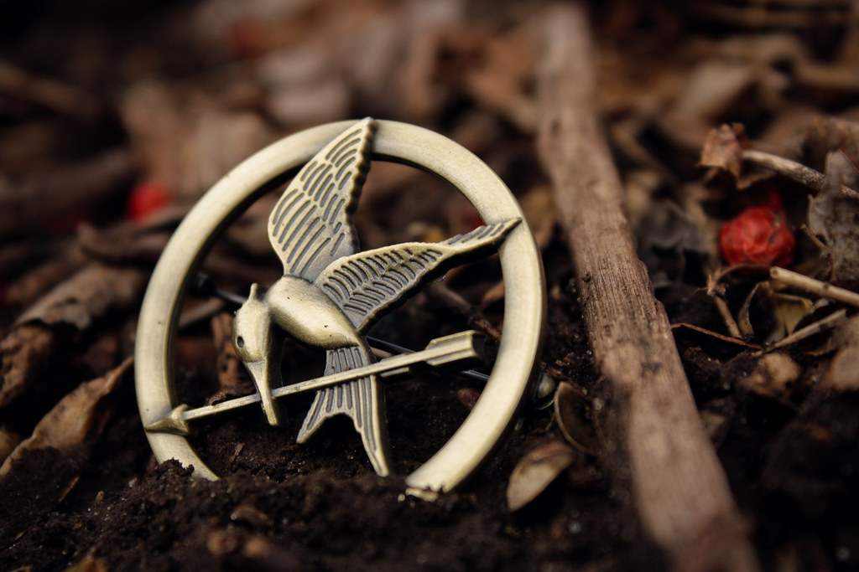

The Hunger Games multi-disciplinary project
How to use The Hunger Games by Suzanne Collins to support a multi-disciplinary book project

Key Area: 2.2.2

Level: Core, Silver

Resource created by Scottish Book Trust

scottishbooktrust.com
Scottish Book Trust is a registered company (SC184248)
and a Scottish charity (SC027669).

Contents
About this resource 2
The Hunger Games by Suzanne Collins 3
Pre-reading and reading activities 3
Literacy and English 4
Expressive Arts 5
Social Studies 5
Science 6
Numeracy and mathematics 7
Technology 8
Health and Wellbeing 8
Modern languages 9
Religion and Moral Education 9
Outdoor learning 9
Additional information 10
Appendix 1 11

About this resource
The aim of this resource is to support secondary staff to run a multi-disciplinary project, working towards Key Area 2.2.2 Interdisciplinary Book Projects of the Reading Schools Framework. The resource contains activity ideas for most curricular areas in the Curriculum for Excellence. The project can be run with:
- A targeted group of young people
- A class
- A year group
- A whole school

A multi-disciplinary project can be run as a yearlong project, across a term, or during an intense week or day of activities. Running a cross-curricular project is also a great way to introduce entrant students to their new setting. A multi-disciplinary project would be a great way to encourage bonding and peer-to-peer interaction in the first weeks of term.
Involving staff
To run the project across all curricular areas, you will need to involve faculty members from across the school. This resource includes activity ideas that can be shared with staff to get them excited about being involved. Not all staff members from every department will have the time to read The Hunger Games. However, it was adapted into a film in 2012 which will help those unfamiliar with the book to understand the story.

The Hunger Games by Suzanne Collins
The Hunger Games is the first in a trilogy by Suzanne Collins. A prequel to the trilogy, The Ballad of Songbirds and Snakes, was released in 2020. It is a dystopian adventure set in a post-apocalyptic world, where teens from different areas of Panem must fight to survive in an event known as the hunger games. The event is broadcast as a reality TV show. There can be only one winner.
Plot summary
The Hunger Games is set in North America, with the Capitol city located somewhere in the Rocky Mountain. It is surrounded by 13 districts (see appendix 1 for full). Prior to the events in the book, the 13 districts rose up against the Capitol in a revolution. They were defeated, and District 13 was destroyed. The hunger games happen annually, with two children from each district given to compete. The aim of the games is to remind the districts of the power of the Capitol.
After volunteering to take her sisters place, Katniss Everdene enters the hunger games with Peeta Millark. Katniss is resourceful, and fights to survive, doing anything to ensure she returns home to her family- including partaking in an on-screen romance with Peeta to fool the Capitol and win viewers favour. Survival is in Katniss’s nature; loving Katniss is in Peeta’s. However, when she and Peeta trick the game makers and both survive, things become dangerous and complicated for both.

Pre-reading and reading activities
Introducing the book
When using the book as a whole school project or across a year group, it is important to create an initial buzz of excitement, setting foundations for all to engage in the exciting activities. Think about holding an assembly or an event around a national celebration such as World Book Day to introduce the book.
Ways to create a buzz of excitement around the project could be:
- Post “save the date” posters around school with the date of the announcement, but do not give away what it is.
- Hide quotes or phrases from The Hunger Games. Can pupils find them and guess the book?
- Have a display with objects that hint to the book. Add one each day in the lead up to the assembly and “big reveal”.
- Create a puzzle or quiz for pupils to solve inspired by The Hunger Games. Those who crack the code or quiz could be given a clue to the book, but must keep it a secret until the big reveal.

You could also hold an assembly at the end of the project to celebrate pupil achievements and creativity during the multi-disciplinary project.
What do pupils already know about The Hunger Games?
Some pupils may already have read The Hunger Games, or watched the film. Before you read the book together, establish what pupils already know about the book and the story. Do they have any existing perceptions or opinions? For those who have not read it, what are their thoughts? Is it the type of story they would usually read? You could add these comments to a board or display and return to them after reading and activities to see if pupil thoughts have changed.
Read the book ENG 3-12a
There are different options for reading the book as a class or cohort. You could:
- Give pupils individual copies to read over summer
- Give pupils individual copies to read in term time
- Use class copies to read together
- Staff read aloud to pupils in class or form time
- Listen to an audiobook version together in class or form time

Whichever approach you take, it is important that all pupils have access to the story.

Literacy and English
Compare book and film LIT 3-02a, LIT 3-19a
It is a hotly debated topic; which is better, film or book? After reading the book watch the film adaption with pupils and hold a debate in class about which they think is better and why.
To encourage discussion, you could show a video or two of fans sharing their views about this topic. There are plenty on YouTube. How do these fans try to persuade viewers to support their opinion. Do your pupils agree?
Peeta fanfiction LIT 3-20a
The Hunger Games is written in first person narrative, so we only get Katniss’ opinion and experience. What if the story was written from Peeta’s perspective? What would the story be like and how would it differ from Katniss’ experience?
Ask pupils to imagine they are Peeta and to choose a favourite scene to rewrite the scene from his narrative viewpoint. If you are looking for examples to share, there is a lot of fanfiction available online.

Expressive Arts
Camouflage challenge EXA 3-02a, EXA 2-06a
Peeta excels at camouflage and successfully hides himself by a river when injured. Give pupils a range of different objects they must camouflage, and a range of art materials to complete their challenge. They must decorate and completely disguise their object so it cannot be found. They must think about:
- Where their object will be hidden
- How to achieve their chosen camouflage
- What would be the best technology or material to use

To test the camouflage, objects could be hidden around the school campus and another class or peer group asked to find them.
Drama EXA 3-12a
Ask pupils to imagine they are one of the characters left behind in District 12 whilst Katniss and Peeta enter the games. They could be Gale, Prim, Katniss’ mother or Peeta’s mother, father or brother, or one of the minor characters such as Madge or the Mayor. They will all be watching the games. How do they feel and react? Ask pupils to work in small groups to act out how their chosen characters reaction to some of the key moments in the games, such as Katniss’ injury, Rue’s death or Katniss and Peeta’s relationship. Pupils can perform their short scenes to each other or the class.
Mockingjays EXA 2-17a
In Panem, Mockingjays can copy human voices and songs and can repeat them. Rue and Katniss use this to communicate. Tell your pupils that one person will start, and everyone else will be Mockingjays. They can sing or whistle and the other pupils will repeat whatever they sing, matching pitch and tone like a Mockingjay. Extend this by singing in a round and adding in different pupils’ songs or whistles.
Sing a lullaby EXA 3-17A
When Rue dies, Katniss sings a local song from her district (see chapter 18). The song is a lullaby, an old song that her music teacher calls a “mountain air”. Look at other traditional songs and lullabies. What core themes or regular tropes appear? Working in pairs or individually, create a lullaby to come from one of the other districts.

Social Studies
History of Panem SOC 3-05a, LIT 3-24a
Katniss gives us a brief history of Panem in Chapter 1. However, the reader still knows nothing about the apocalyptic event that replaced North America with Panem and relatively little about the history of Panem. Look at extracts from the book, and ask pupils to fill in the gaps and answer the questions:
- What else happened in the history of Panem?
- What might Peeta and Katniss have learnt about in history class?
- What was the apocalyptic event?
- What was the initial impact on people’s lives?
- What was the lasting impact and how was society rebuilt?
- Why was the state divided into 13 districts?
- Who were the other leaders of Panem before President Snow?

Divide the class into pairs or small groups, and give each one a question to answer. They can be as inventive as they like! After 5-10minutes, ask each group to feed back to the class and record the answers on the board. The class now has a ‘complete’ history of Panem. Ask pupils to create booklet or page for a textbook that would be given out as part of a history class in the districts.
Democracy SOC 3-15a, LIT 3-02a
Panem has 13 districts that feed all their resources to the Capitol (see appendix 1). It is a dictatorship led by President Snow, not a democracy. Given how poor many of the districts are, and how affluent the Capitol is, it is perhaps hardly surprising that the districts rebelled.
Look at the list of districts in appendix 1 and what each provides to the Capitol. Is this a fair distribution of labour? Ask pupils, if you were going to create a democracy on a similar format, how would you divide the districts and what local government or structure would you put in place to ensure each district has a voice and is represented? How would the voting system work? How would candidates be selected and how would you ensure a fair system?
Divide the class into small groups to work on this activity. Allow plenty of time for debate and discussion on how their democracy would work. Ask each group to present their work to the class.

Science
First Aid SCN 3-12a, SCN 3-12b
Katniss and Peeta learn basic first aid to survive in the games, and Katniss’ sister and mother are healers and therefore know about the human body.
Run a basic first aid course for your pupils with the premise that in order to survive in the games, they must understand how to heal themselves and others, and therefore know about the human organ system.
Teach pupils about the respiratory, circulatory and skeletal systems, and give examples of first aid to treat minor injuries such as breaks, a cut or burn, or shock and shortness of breath. Also show pupils how to check their health fitness, tests which would have been carried out on all the tributes, including BMI and blood pressure.

Genetic modification SCN 3-03a
In Panem, genetic modification (GM) of crops and animals is commonplace. Perhaps most memorable are the Mockingjays and Trackerjackers which Katniss encounters in the games. Research different agricultural methods, including genetic modification to increase yield.
Genetic modification is a controversial topic and often divides opinion. The Scottish Government are currently opposed to the use of GM crops; however, in the US they are extensively used, with 94% of corn in 2018 coming from GM crops.
Split the class in two. Half will research the positives of GM foods and arguments fore, and half will explore the negatives and the arguments against their use. Hold a class debate highlighting the two sides of the argument. End the debate with a vote for which argument the pupils found most convincing.

Numeracy and mathematics
Travel and time MNU 3-10a
When travelling to the arena, Katniss can only guess how far and for how long they have travelled. Set pupils tasks to work out the time, speed or distance the hovercraft travels between two known points (the arena and the Capitol).
Mapping Panem MTH 3-17b
Panem is North America, with the Capitol located near the Rocky Mountains in Wyoming. Give pupils a map of North America and plan out Panem and its 13 districts. Katniss and Peeta travel by train across Panem. Ask pupils to create a scale plan of their journey from District 12 to the capitol.
Calculating water MNU 3-11a
Katniss has a small water bottle in the pack she grabs at the start of the games. Give pupils the measurements for a water bottle, and ask them to work out its volume. They must also work out how often Katniss will need to refill her bottle on an average day, as a small bottle will not keep her hydrated.
Location trackers MTH 3-19a
All of the tributes are fitted with trackers to track their location in the games. Give pupils a grid with some dots which represent tribute location. Give pupils coordinates to plot onto the map. Finally, ask pupils to describe where the tributes are in relation to each other.

Technology
Outfit design TCH 3-04a
For every TV appearance before and after the games, Peeta and Katniss appear in striking costumes designed and created by Cinna. At the end of the book, Peeta and Katniss return home before they begin their tour of the districts. Imagine you are on Cinna’s team, and must design a new outfit for each district visit and each TV appearance. Design an outfit for Katniss and/or Peeta. Things to consider:
- Do you dress them the same or in complimentary outfits?
- Do you create an outfit inspired by the district they are in?
- What materials will you use?
- Is it breathable and durable?
- How well can Katniss and Peeta move in it?

Health and Wellbeing
Create a nutrition plan HWB 3-32a
Whilst in the games, Katniss is resourceful to keep herself, Rue and Peeta well fed. This is vital, as Katniss is exerting huge amounts of energy in the games, similar to an athlete.
Research nutrition and athletes’ diets, and what they need to eat to stay fit and healthy. Create a meal plan for Katniss and Peeta when they are in the training centre preparing for the games.
An extension activity would be to write a meal plan for Katniss and Peeta whilst in the games, as their access to food supplies is drastically reduced. What could by forage or substitute to keep healthy?
Different movement and skills HWB 3-10a, HWB 3-21a
In the games, all the tributes have different skills and abilities. Peeta is strong, whereas Rue is good at climbing trees. Whilst at the training centre, the young people are given an opportunity to hone their skills, and develop new ones.
Set up a variety of different stations, similar to circuit training and allow pupils to move from station to station trying the different activities. This could be done freely, or as part of a timed exercise. Ensure there is a wide variety of different skills and tasks to try, and remind pupils that the aim of the session if to understand themselves better- to find what they are good at and what movement they enjoy.

Modern languages
Hot seating MLAN 3-05a
Hot seating is when a pupil embodies the role of a character and sit in the ‘hot seat’ to answer questions as if they are that character. This activity works especially well for minor characters, as there is no right or wrong answer. Using hot seating for a modern language is great way to facilitate conversation. Questions could be:
- How old are you?
- Where did you grow up?
- What is your favourite food?
- Tell us about your family- how many siblings do you have?
- What job do you do (in your district)?
If you wanted to take this activity further, ask one member of the class to act as interviewer Caesar Flickerman and run the hot-seat activity as an interview activity with pupils pretending to be tributes from different districts.

Religion and Moral Education
Life after death RME 3-09a
In the games, Katniss is faced with a moral dilemma: to kill or be killed. She does not want to take another’s life, but she desperately wants survive and to return home.
As a class, discuss what each of the religions you have been studying say about taking the life of another. What do these religions tell us about murder, killing and self-defence? Can Katniss turn to religion to help her with her moral dilemma? As a class, decide which of these teaching would be most helpful to tell Katniss.
Twenty-two of the tributes die in the games. Discuss what each of these religions says about life after death. Do you think any of these teaching would help Katniss? If so, which one/s?

Outdoor learning
When in the training centre, Katniss and Peeta spend their three days preparing for the games learning new skills that will help them survive in the outdoor arena, including starting fires, to camouflage, to making shelter and foraging (see chapter 7). Plan a morning or day where pupils learn about the outdoors and surviving outside. You could arrange different stations and classes/pupils rotate between the different areas.

Additional information
Further reading
Other books in the series:
Catching Fire by Suzanne Collins
Mockingjay by Suzanne Collins
The Ballad of Songbirds and Snakes by Suzanne Collins

Recommended titles:
Divergent by Veronica Roth
The Loop by Ben Oliver
The Maze Runner by James Dashner
Pet by Akwaeke Emezi
The Host by Stephanie Meyer
Burn by Patrick Ness
The Grace Year by Kim Liggit
Ready Player One by Ernest Cline
Pet by Akwaeke Emezi
Parable of the Sower by Olivia Butler
Parable of the Sower: A Graphic Novel by Damian Duff, John Jennings and Oliva Butler

Appendix 1
Districts:
The Capitol- the capitol city
Districts 1- Luxury- provides the Capitol with luxury items such as jewellery
District 2- Masonry and defence- provides the Capitol with stone and weapons
District 3- Technology- provides the Capitol with electronics and technology
District 4- Fishing- provides the Capitol with supply of Fish
District 5- Power- provides the Capitol with electricity and power
District 6- Transport- acts as a transport hub for Panem
District 7- Lumber- provides the Capitol with wood and paper
District 8- Textiles- provides textiles and material for the Capitol
District 9- Grain- provides the Capitol with grains and salt
District 10- Livestock- provides the meat for the Capitol
District 11- Agriculture- provides all other food (fruit, vegetables and herbs) for the Capitol
District 12- Coal- provides coal for the Panem
District 13- Graphite and Nuclear Weaponry- provided nuclear technology, graphite and emerging technologies for the Capitol. Destroyed.

