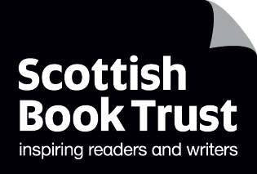

Book Blurb Quiz
Print this quiz for your middle-upper primary school pupils to test them on their ability to match a book’s blurb with its cover.
Ages: 7–11

scottishbooktrust.com

Scottish Book Trust is a registered company (SC184248)
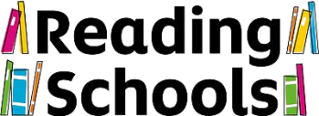
and a Scottish charity (SC027669).

About this resource
This resource can be used as part of your Reading Schools journey to involve learners in promoting and exploring the fun of reading with peers, staff and families.
Print this quiz for your middle-upper primary school pupils to test them on their ability to match a book’s blurb with its cover. Print pages 3-6 and distribute them to pupils. They can work through this resource on their own, or in groups.
You can also use this resource to discuss genre alongside our Using Bookzilla in Your School Lesson Plan which introduces Scottish Book Trust’s app, Bookzilla, to primary learners, allowing them to develop their understanding of genre and select some favourite books they may want to read.

Discussion Questions
Use the following questions to hold a discussion about books, covers and genre after pupils have completed the quiz.
- Which covers were easy to guess? Which were harder?
- What clues can you look for on a book cover to guess its genre or what it might be about?
- What styles of art on a cover – e.g. illustration, cartoon, photography, do you associate with different topics or genres?
- What colours do you associate with particular topics or genres?
Ask the pupils to go through the quiz again and note down what genre they think each book is, then look up their genres on Bookzilla.
- How many did they get right?
- How many books did they feel were more than one genre?

Book Blurbs
- Molly is in her final year of primary school, with secret dreams of becoming an Olympic swimmer.
- October and her dad live in the woods. They sleep in the house Dad built for them and eat the food they grow in the vegetable patches.
- Things aren't going great for Archie Albright. His dad's acting weird, his mum too, and he all he wants is for everything to go back to normal, to three months before when his parents were happy and still lived together. When Archie sees a colourful, crumpled flyer fall out of Dad's pocket, he thinks he may have found the answer.
- 11-year-old Stevie is an avid reader and she knows a lot of things about a lot of things. But these are the things she'd like to know the most:
1. The ocean and all the things that live there and why it's so scary
2. The stars and all the constellations
3. How phones work
4. What happened to Princess Anastasia
5. Knots
- A kid’s life in prehistoric times might sound like fun, what with all those woolly mammoths and massive stone circles, but actually life for kids could be pretty hard.
- Recruited as Mr Silver's apprentice, Daniel learns the secrets of the Emporium's vast labyrinth of passageways and rooms -- rooms that contain wonders beyond anything Daniel has ever imagined.
- 11-year-old Stella has returned home to Shetland to spend the summer with her Grandpa, but it's nothing like she remembers. Grandpa is lost in his grief for Gran, the island is bleak and Stella feels trapped, until she encounters an old woman, Tamar, who can spin rainbows and call hurricanes.
- Brimming with confidence, a young witch flies to the seaside village of Koriko and expects that her powers will easily bring happiness to the townspeople. But gaining the trust of the locals is trickier than she expected.
- Mafalda is a nine-year-old girl who knows one thing: some time in the next six months her sight will fail completely.
- Looking for more challenging tasks, Josie enlists her friends Wesley and Margot into her very own Scout troop, the Copseys, named after the street they all live on. Together they start their quest for their camping badge by sleeping out near to the abandoned factory behind their houses.
- 11-year-old Addie decides to campaign for a memorial in memory of the witch trials that took place in her Scottish hometown. Addie knows there's more to the story of these 'witches', just like there is more to hers.
- Starting at a new school is scary, even more so with a giant hearing aid strapped to your chest!
- This book features some of the best players of past and present for you to build your ultimate dream team!
- The longest ship ever built, the heaviest digger and the largest aeroplane, the world's first working motorcar, and its most expensive one.
- Jamie’s desperate to become Highwood School’s star football player (and in his dreams, Hawkstone United’s, too). But after he wrecks his chances at the trials, the pressure's on to prove himself.
- Under the grey Glasgow skies, twelve-year-old refugee Reema is struggling to find her place in a new country, with a new language and without her brother. But she isn't the only one feeling lost. Her Glasgwegian neighbour Caylin is lonely and lashing out.
- Using examples in nature like a giant anteater, a flat fish or even a cuddle with a puppy the book helps children reflect on their own life and their place in the world.
- Featuring 40 trailblazing black women in the world's history, this book educates and inspires as it relates true stories of women who broke boundaries and exceeded all expectations.
- Ash Yang dreamed of being a starfighter pilot. But when she crashes out of her final test - literally - she somehow lands the most powerful job in the universe.
- "Do you like chicken?" Oscar asked me. I nodded. "Then take a wing." Oscar offered me his arm and we linked each other into the school hall.
- Two dreams. Two lives. But one body. Grace and Tippi are conjoined twins, joined at the waist, defying the odds of survival for sixteen years.

Book Covers
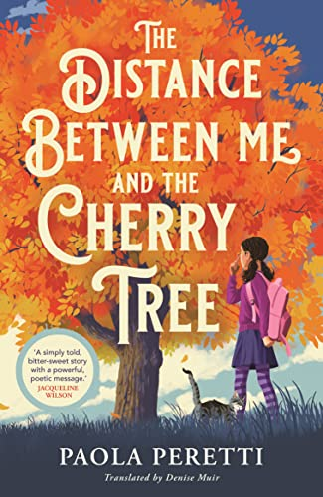  1. | 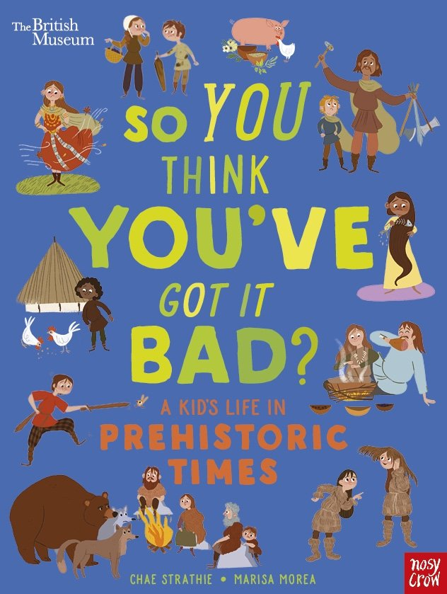  2. |  | 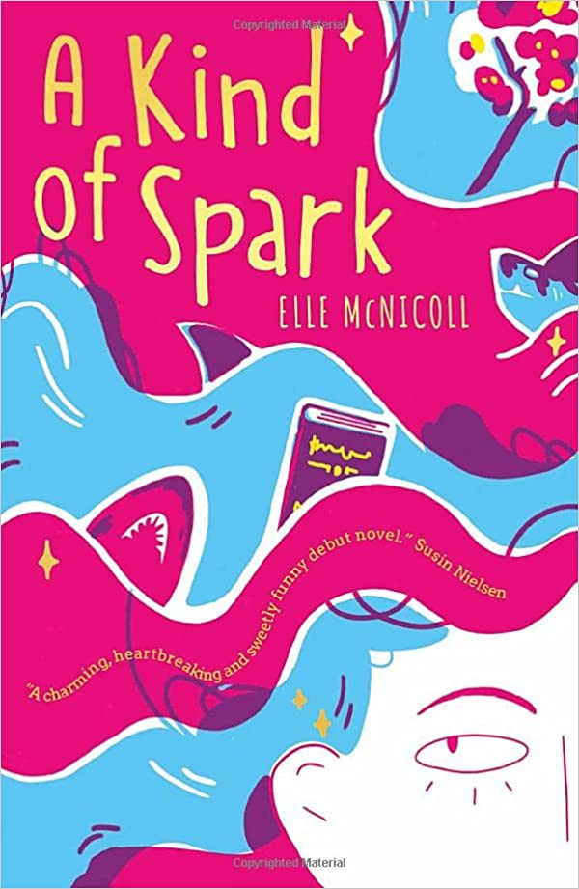  3.
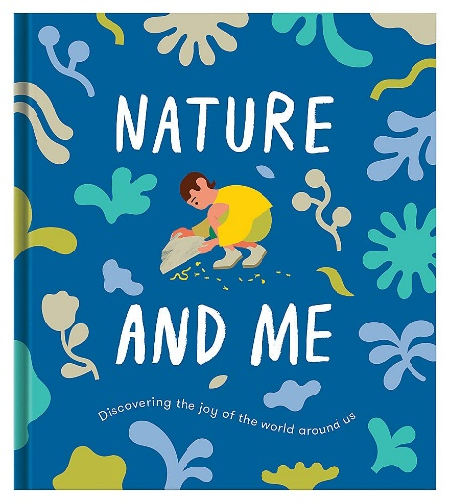  4. | 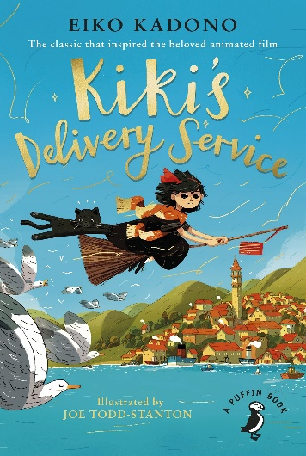  5. |  | 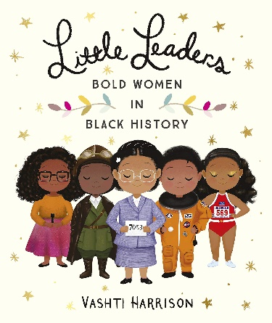  6.
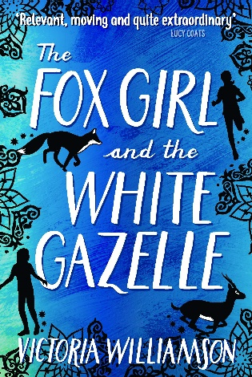  7. | 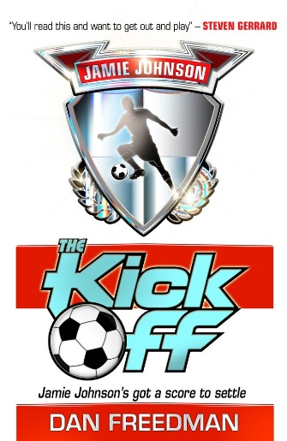  8. |  | 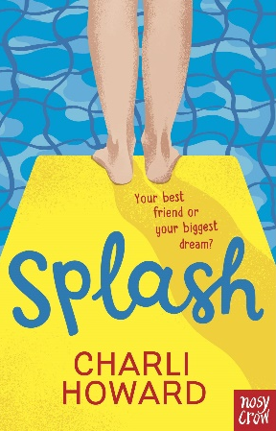  9.
10.  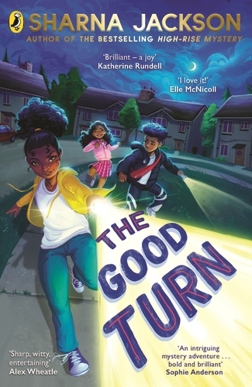 | 11.  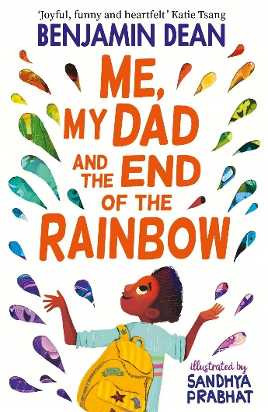 |  | 12.  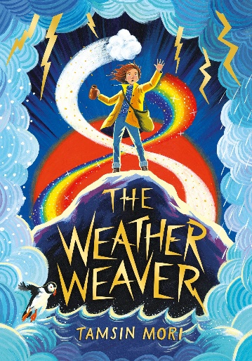
13.  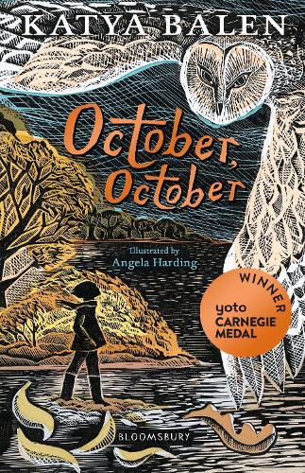 | 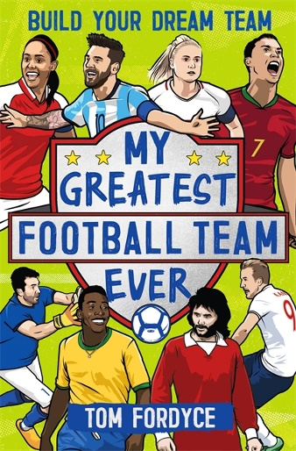  14. |  | 15.  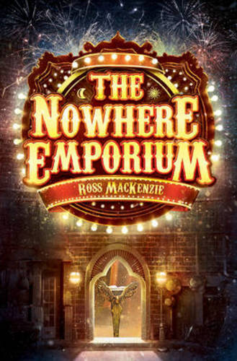
16.  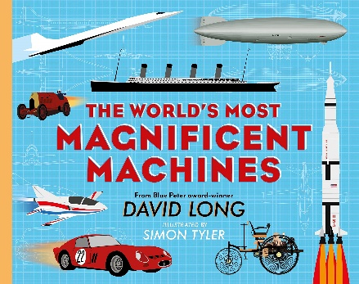 | 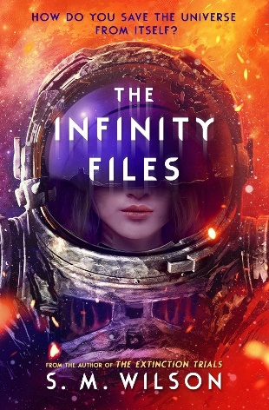  17. |  | 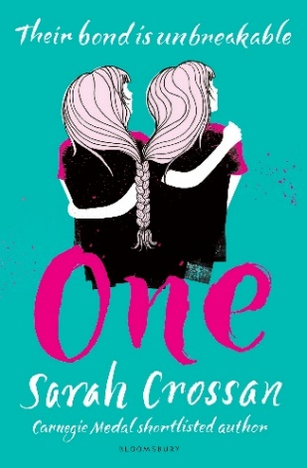  18.
19.  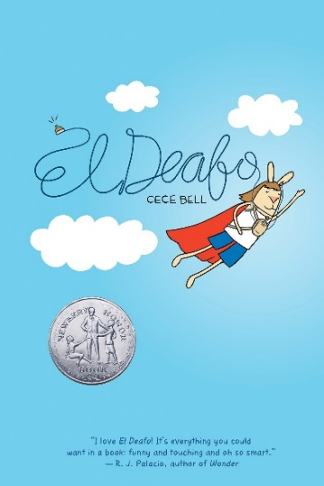 |  | 20.  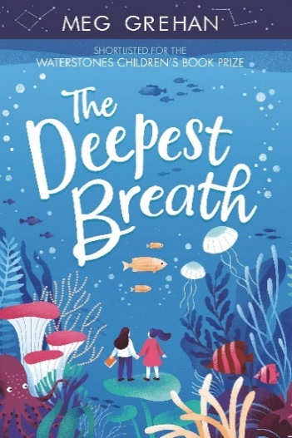

Finished the quiz? Here’s some other activities…
- Which cover is your favourite? Why?
- Which cover is least interesting to you? Why?
- Rank the books from which you’d most like to read to which you’re least interested in
- Write what you think each book’s genre(s) is based on its cover and title
- Pick five books and write what you think they’re about
- Pick one blurb and try and expand it. What do you think happens next? You can use the cover for clues!
- Design your own book cover and write your own blurb
- Look up the last book you read, either in class or at home. What genre was it?
- Write about your favourite genre and why it’s your favourite.
- See how many of these books you can find in your class/school library.

Answer Sheet
- I - The Distance Between Me and the Cherry Tree: Mafalda is a nine-year-old girl who knows one thing: some time in the next six months her sight will fail completely.
- E – So You Think You’ve Got It Bad? A Kid’s Life in Prehistoric Times: A kid’s life in prehistoric times might sound like fun, what with all those woolly mammoths and massive stone circles, but actually life for kids could be pretty hard.
- K – A Kind of Spark: 11-year-old Addie decides to campaign for a memorial in memory of the witch trials that took place in her Scottish hometown. Addie knows there's more to the story of these 'witches', just like there is more to hers.
- Q – Nature and Me: Using examples in nature like a giant anteater, a flat fish or even a cuddle with a puppy the book helps children reflect on their own life and their place in the world.
- H – Kiki’s Delivery Service: Brimming with confidence, a young witch flies to the seaside village of Koriko and expects that her powers will easily bring happiness to the townspeople. But gaining the trust of the locals is trickier than she expected.
- R - Little Leaders: Bold Women in Black History: Featuring 40 trailblazing black women in the world's history, this book educates and inspires as it relates true stories of women who broke boundaries and exceeded all expectations.
- P - The Fox Girl and the White Gazelle: Under the grey Glasgow skies, twelve-year-old refugee Reema is struggling to find her place in a new country, with a new language and without her brother. But she isn't the only one feeling lost. Her Glasgwegian neighbour Caylin is lonely and lashing out.
- O – The Kick Off: Jamie’s desperate to become Highwood School’s star football player (and in his dreams, Hawkstone United’s, too). But after he wrecks his chances at the trials, the pressure's on to prove himself.
- A – Splash: Molly is in her final year of primary school, with secret dreams of becoming an Olympic swimmer.
- J – The Good Turn: Looking for more challenging tasks, Josie enlists her friends Wesley and Margot into her very own Scout troop, the Copseys, named after the street they all live on. Together they start their quest for their camping badge by sleeping out near to the abandoned factory behind their houses.
- C – Me, My Dad and the End of the Rainbow: Things aren't going great for Archie Albright. His dad's acting weird, his mum too, and he all he wants is for everything to go back to normal, to three months before when his parents were happy and still lived together. When Archie sees a colourful, crumpled flyer fall out of Dad's pocket, he thinks he may have found the answer.
- G – The Weather Weaver: 11-year-old Stella has returned home to Shetland to spend the summer with her Grandpa, but it's nothing like she remembers. Grandpa is lost in his grief for Gran, the island is bleak and Stella feels trapped, until she encounters an old woman, Tamar, who can spin rainbows and call hurricanes.
- B – October, October: October and her dad live in the woods. They sleep in the house Dad built for them and eat the food they grow in the vegetable patches.
- M – The Greatest Football Team: This book features some of the best players of past and present for you to build your ultimate dream team!
- F – The Nowhere Emporium: Recruited as Mr Silver's apprentice, Daniel learns the secrets of the Emporium's vast labyrinth of passageways and rooms -- rooms that contain wonders beyond anything Daniel has ever imagined.
- N – The World’s Most Magnificent Machines: The longest ship ever built, the heaviest digger and the largest aeroplane, the world's first working motorcar, and its most expensive one.
- S – The Infinity Files: Ash Yang dreamed of being a starfighter pilot. But when she crashes out of her final test - literally - she somehow lands the most powerful job in the universe.
- U – One: Two dreams. Two lives. But one body. Grace and Tippi are conjoined twins, joined at the waist, defying the odds of survival for sixteen years.
- L – El Deafo: Starting at a new school is scary, even more so with a giant hearing aid strapped to your chest!
- D – The Deepest Breath: 11-year-old Stevie is an avid reader and she knows a lot of things about a lot of things. But these are the things she'd like to know the most:
1. The ocean and all the things that live there and why it's so scary
2. The stars and all the constellations
3. How phones work
4. What happened to Princess Anastasia
5. Knots

