Primary Reading Treasure Hunt
A fun book treasure hunt for your classroom
Suitable for: Primary schools, community groups, libraries

scottishbooktrust.com
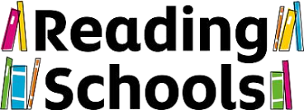
Scottish Book Trust is a registered company (SC184248)
and a Scottish charity (SC027669).

Contents
Lower Primary 2
Teacher Guide 2
Reading Treasure Hunt: Pupil Answer Sheet 4
Lower Primary Book Covers 6
Upper Primary 9
Teacher Guide 9
Reading Treasure Hunt: Pupil Answer Sheet 12
Upper Primary Book Covers 13
Further Activities 17

Lower Primary

Teacher Guide
This resource can be used as part of your Reading Schools journey to involve learners in promoting and exploring the fun of reading with peers, staff and families.
Print off the book covers on pages 6-8 and hide them around your classroom or school. Print off the letters and place one beside each book cover. Print the worksheet (either one per pupil, or group) on page 4-5.
The treasure hunt is based on picture books, however pupils may need support with reading the riddles – inviting older pupils to work together with younger ones is a great way to help with this.
Once they’ve matched the riddles to the book covers they have found and written down the letters, they can unscramble them to reveal a secret phrase…
Riddle 1: She wriggles, she squirms she jumps high and low… Remember tigers and ticklish too you know!
Book: Never Tickle a Tiger by Pamela Butchart and Marc Boutavant
Letter: k
Riddle 2: It’s lion o’clock, stay inside your house! But the lion has a secret, he’s scare of a mouse!
Book: The Lion Inside by Rachel Bright and Jim Field
Letter: o
Riddle 3: One wild night, Max crowns himself king… He shouts with glee, ‘let the wild rumpus begin!’
Book: Where the Wild Things Are by Maurice Sendak
Letter: v
Riddle 4: A pair of explorers all ready to go… There’s more to a back garden than you thought, you know!
Book: Lollipop and Grandpa’s Back Garden Safari by Penelope Harper and Cate James
Letter: I
Riddle 5: Look out! Pirates! Are they going far? All I can hear from here is a distant “Arrrrrr!”
Book: Ten Little Pirates by Mike Brownlow and Simon Rickerty
Letter: o
Riddle 6: Two robber dogs, all they do is take… Until they find out that life’s better when you bake!
Book: Shifty McGifty and Slippery Sam by Tracey Corderoy and Steven Lenton
Letter: e
Riddle 7: A witch’s cat named Wilbur chases a bee… More chaos and clatter than you ever did see!
Book: Winnie and the Witch by Valerie Thomas and Korky Paul
Letter: b
Riddle 8: What’s that? Surely not! You’re having a lark! The last thing you expect is a shark in the _ _ _ _!
Book: Shark in the Park by Nick Sharratt
Letter: s
Riddle 9: A fish takes a hat that doesn’t belong to him… Will anyone notice if he takes it for a swim?
Book: This Is Not My Hat, Jon Klassen
Letter: l
Riddle 10: Going for a walk? Get to know your bears… Read this guide to make sure you’re prepared!
Book: A Beginner’s Guide to Bear Spotting by Michelle Robinson and David Roberts
Letter: o
Secret phrase: I love books

Reading Treasure Hunt: Pupil Answer Sheet
There are 10 book jackets hidden around the classroom or school. Read the riddles and match them to the correct book jacket. Once you find the cover, you’ll see a letter beside it. Write this down next to the riddle. When you’ve collected all the letters, see if you can work together to make a secret sentence!
Riddle 1: She wriggles, she squirms she jumps high and low… Remember tigers and ticklish too you know!
Book: ___________________________________________________________
Letter: ___________________________________________________________
Riddle 2: It’s lion o’clock, stay inside your house! But the lion has a secret, he’s scare of a mouse!
Book: ___________________________________________________________
Letter: ___________________________________________________________
Riddle 3: One wild night, Max crowns himself king… He shouts with glee, ‘let the wild rumpus begin!’
Book: ___________________________________________________________
Letter: ___________________________________________________________
Riddle 4: A pair of explorers all ready to go… There’s more to a back garden than you thought, you know!
Book: ___________________________________________________________
Letter: ___________________________________________________________
Riddle 5: Look out! Pirates! Are they going fat? All I can hear from here is “Arrrrrr!”
Book: ___________________________________________________________
Letter: ___________________________________________________________

Riddle 6: Two robber dogs, all they do is take… Until they find out that life’s better when you bake!
Book: ___________________________________________________________
Letter: ___________________________________________________________
Riddle 7: A witch’s cat named Wilbur chases a bee… More chaos and clatter than you ever did see!
Book: ___________________________________________________________
Letter: ___________________________________________________________
Riddle 8: What’s that? Surely not! You’re having a lark! The last thing you expect is a shark in the _ _ _ _!
Book: ___________________________________________________________
Letter: ___________________________________________________________
Riddle 9: A fish takes a hat that doesn’t belong to him… Will anyone notice if he takes it for a swim?
Book: ___________________________________________________________
Letter: ___________________________________________________________
Riddle 10: Going for a walk? Get to know your bears… Read this guide to make sure you’re prepared!
Book: ___________________________________________________________
Letter: ___________________________________________________________

Lower Primary Book Covers
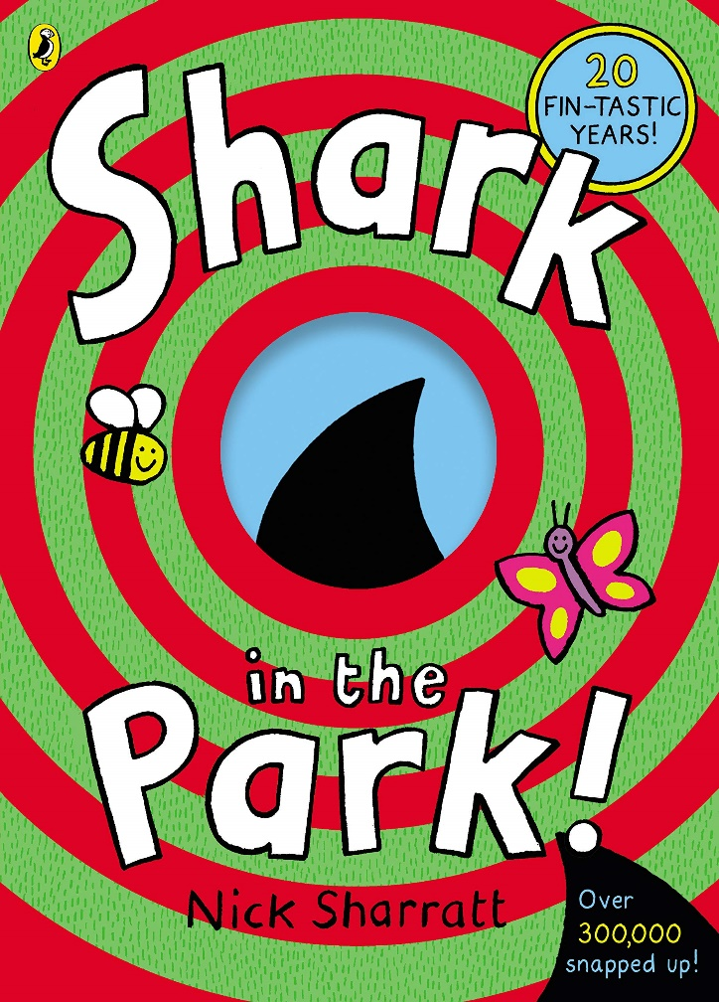
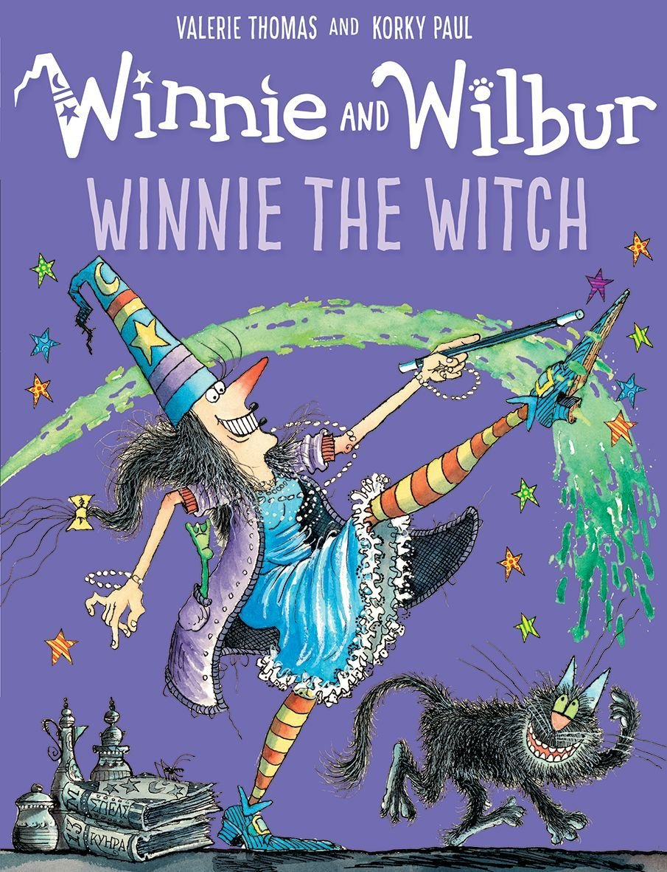
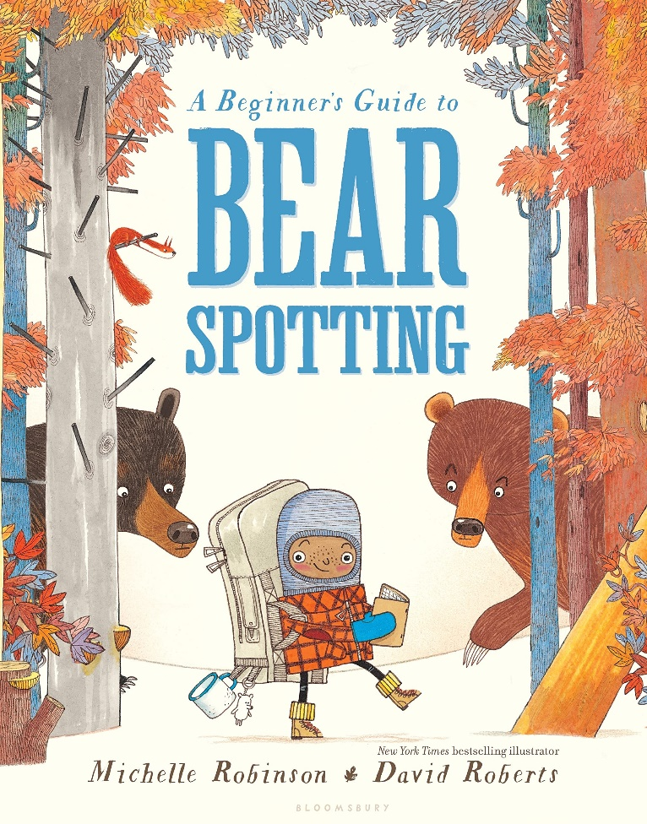
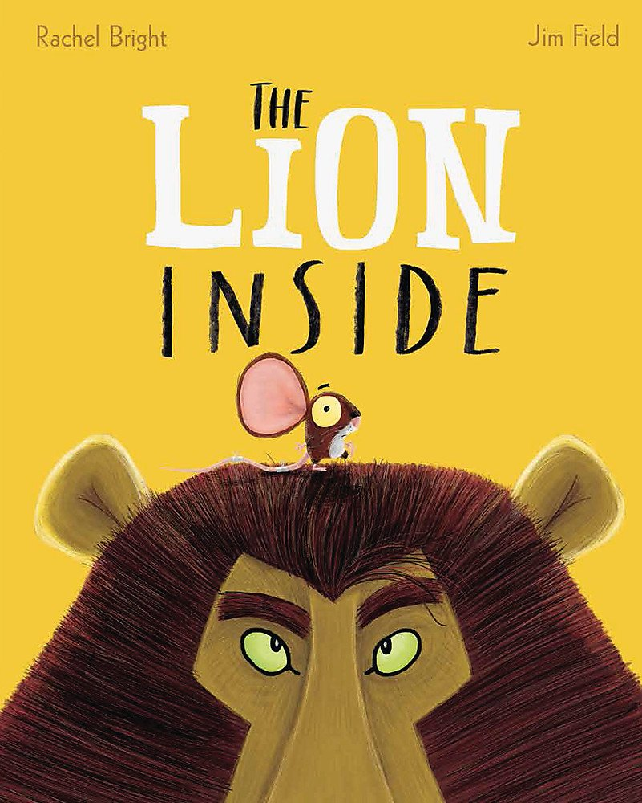
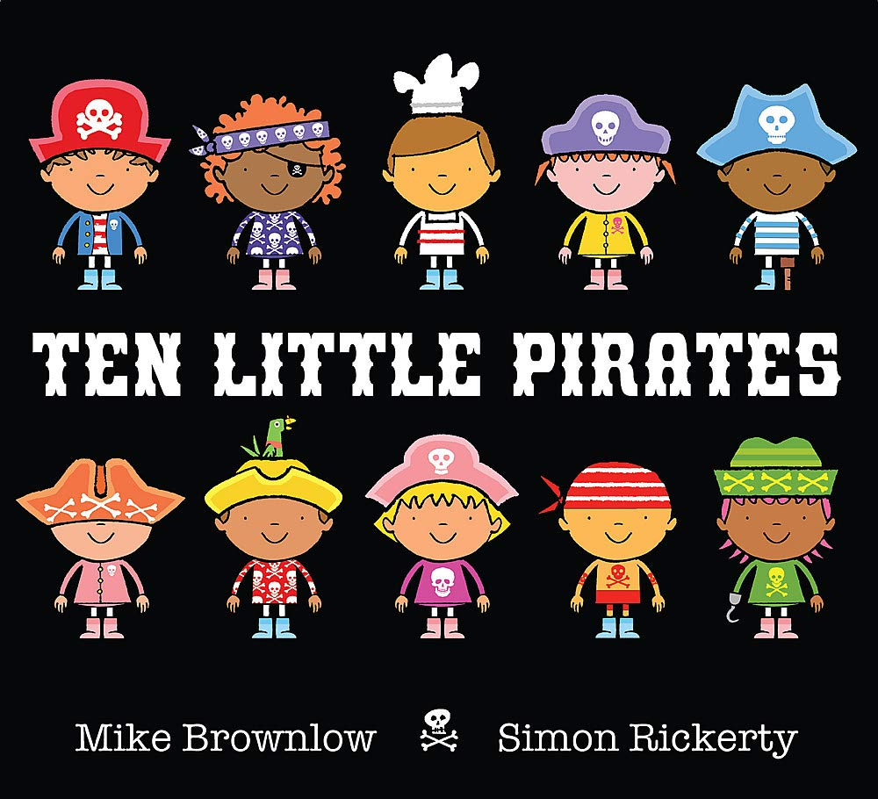
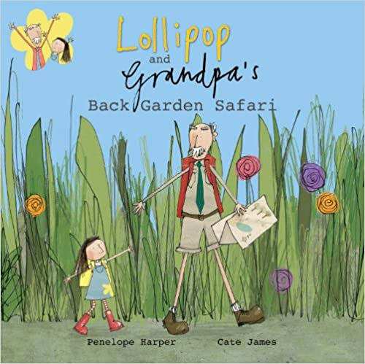
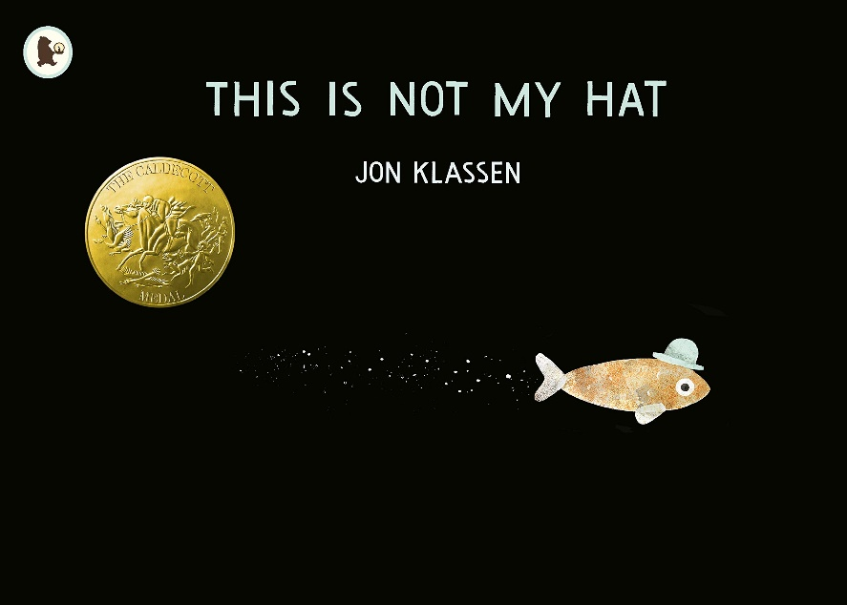
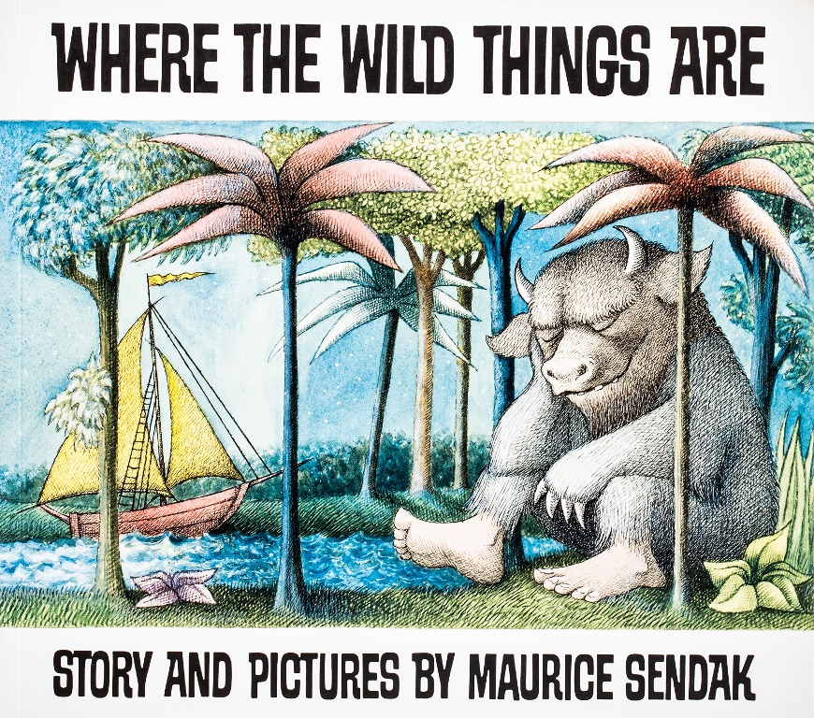

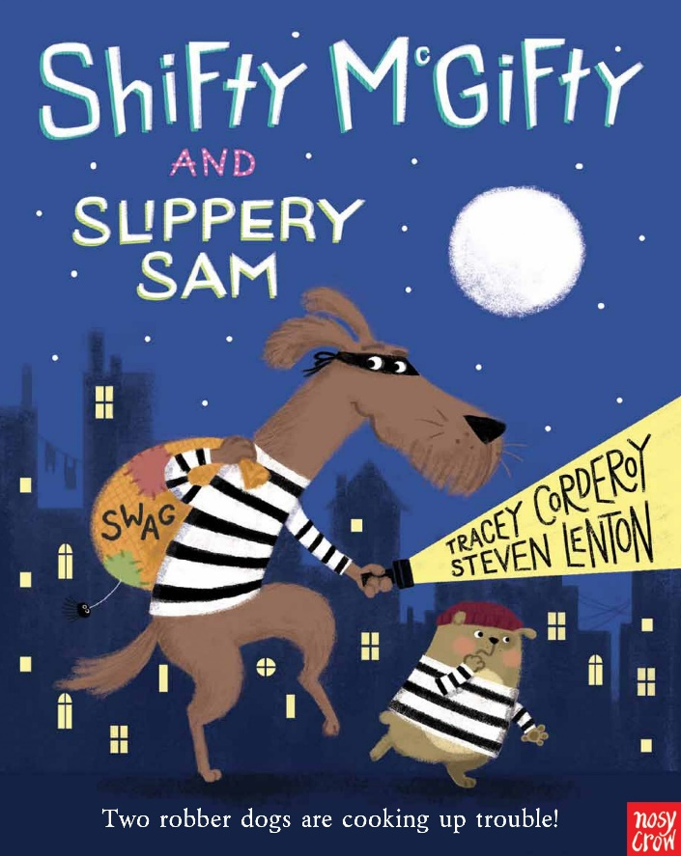

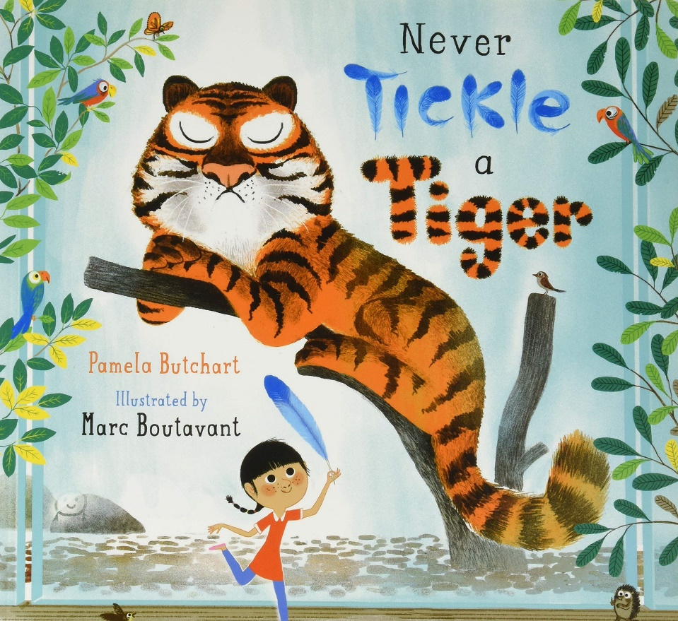

I love books

Upper Primary

Teacher Guide
Print off the book covers on pages 14-16 and hide them around your classroom or school. Print off the letters and place one beside each book cover. Print the worksheet on page 12-13 so there’s one per group. Pupils will need to work together to match the riddles to the book covers and fill in the answer sheet, including the letter they find next to each book cover.
Once they’ve matched the riddles to the book covers they have found and written down the letters, they can unscramble them to reveal a secret phrase…
Riddle 1: Her father said he’d never read out loud… but one night he does and out comes a crowd!
Book: Inkheart by Cornelia Funke
Letter: e
Riddle 2: Children asleep, on a giant adventure I’m bound… where frobscottle, snozcumbers and whizpoppers are found!
Book: The BFG by Roald Dahl
Letter: g
Riddle 3: Mythical creatures, don’t worry, for help is at hand! Join me for battles and a quest across the land…
Book: First Aid for Fairies and Other Fabled Beasts by Lari Don
Letter: o
Riddle 4: She has to leave home and learn how to be a witch… hopefully her plans go off without a hitch!
Book: Kiki’s Delivery Service by Eiko Kadono
Letter: i

Riddle 5: Don’t do it! Be careful! Leave that alone! The only safe pet to own is a stone…
Book: Danger is Everywhere by David O’Doherty
Letter: d
Riddle 6: Join a mouse on a walk in the deep, dark wood… Oh no! It can’t be! Or maybe it could…
Book: The Gruffalo by Julia Donaldson
Letter: i
Riddle 7: Her mum went out on a boat in the dark… hopefully she comes back soon with tales of a shark!
Book: Julia and the Shark by Kiran Millwood Hargrave and Tom de Freston
Letter: n
Riddle 8: Siblings unite! The universe needs to be saved! There’s an evil Nemesis who needs to be braved.
Book: My Brother is a Superhero, David Solomons
Letter: v
Riddle 9: Something strange is happening, something out of this world… for this school to survive the mystery must be unfurled…
Book: Baby Aliens Got My Teacher by Pamela Butchart
Letter: l
Riddle 10: Revolting! Repulsive! This is really gross! Though the facts in this book can help you diagnose…
Book: Disgusting Science by Glenn Murphy
Letter: r
Riddle 11: This boy is a prankster, he does love to jest. But we have to admit – his gags are the best!
Book: Horrid Henry’s Jumbo Joke Book, Francesca Simon
Letter: a
Riddle 12: She’s a fixer, a creator, a fantastic inventor! What this girl needs now is a really great mentor!
Book: Rosie Revere Engineer by Andrea Beaty and David Roberts
Letter: e

Secret phrase: I love reading

Reading Treasure Hunt: Pupil Answer Sheet
There are 10 book jackets hidden around the classroom or school. Read the riddles and match them to the correct book jacket. Once you find the cover, you’ll see a letter beside it. Write this down next to the riddle. When you’ve collected all the letters, see if you can work together to make a secret sentence!
Riddle 1: Her father said he’d never read out loud… but one night when he does – out comes a crowd!
Book: ___________________________________________________________
Letter: ___________________________________________________________
Riddle 2: Children asleep, on a giant adventure I’m bound… where frobscottle, snozcumbers and whizpoppers are found!
Book: ___________________________________________________________
Letter: ___________________________________________________________
Riddle 3: Mythical creatures, don’t worry, for help is at hand! Join me for battles and a quest across the land…
Book: ___________________________________________________________
Letter: ___________________________________________________________
Riddle 4: She has to leave home and learn how to be a witch… hopefully her plans go off without a hitch!
Book: ___________________________________________________________
Letter: ___________________________________________________________
Riddle 5: Don’t do it! Be careful! Leave that alone! The only safe pet to own is a stone…
Book: ___________________________________________________________
Letter: ___________________________________________________________
Riddle 6: Join a mouse on a walk in the deep, dark wood… Oh no! It can’t be! Or maybe it could…
Book: ___________________________________________________________
Letter: ___________________________________________________________
Riddle 7: Her mum went out on a boat in the dark… hopefully she comes back soon with tales of a shark!
Book: ___________________________________________________________
Letter: ___________________________________________________________
Riddle 8: Siblings unite! The universe needs to be saved! There’s an evil Nemesis who needs to be braved.
Book: ___________________________________________________________
Letter: ___________________________________________________________
Riddle 9: Something strange is happening, something out of this world… for this school to survive the mystery must be unfurled…
Book: ___________________________________________________________
Letter: ___________________________________________________________
Riddle 10: Revolting! Repulsive! This is really gross! Though the facts in this book can help you diagnose…
Book: ___________________________________________________________
Letter: ___________________________________________________________
Riddle 11: This boy is a prankster, he does love to jest. But we have to admit – his gags are the best!
Book: ___________________________________________________________
Letter: ___________________________________________________________
Riddle 12: She’s a fixer, a creator, a fantastic inventor! What this girl needs now is a really great mentor!
Book: ___________________________________________________________
Letter: ___________________________________________________________

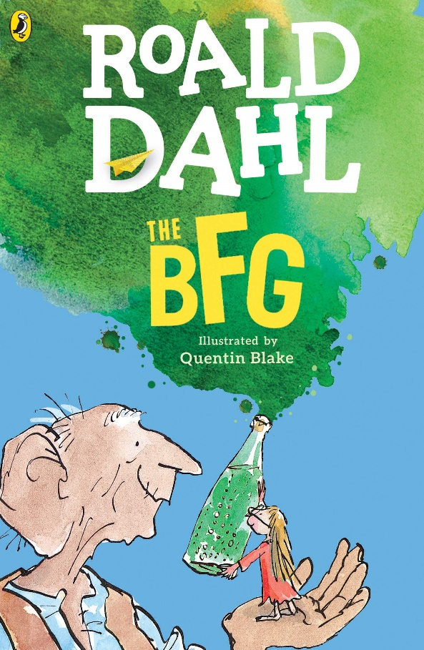
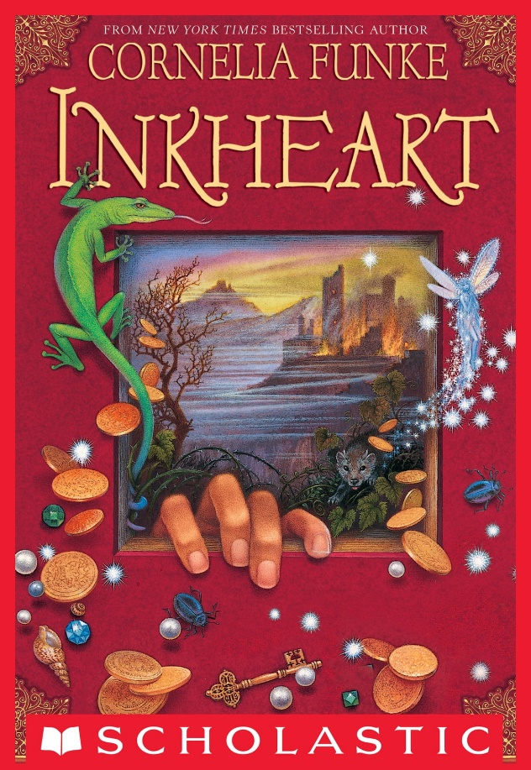
Upper Primary Book Covers

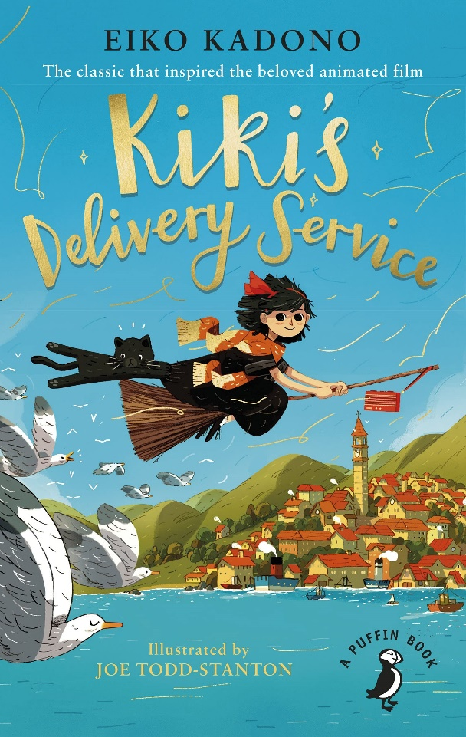
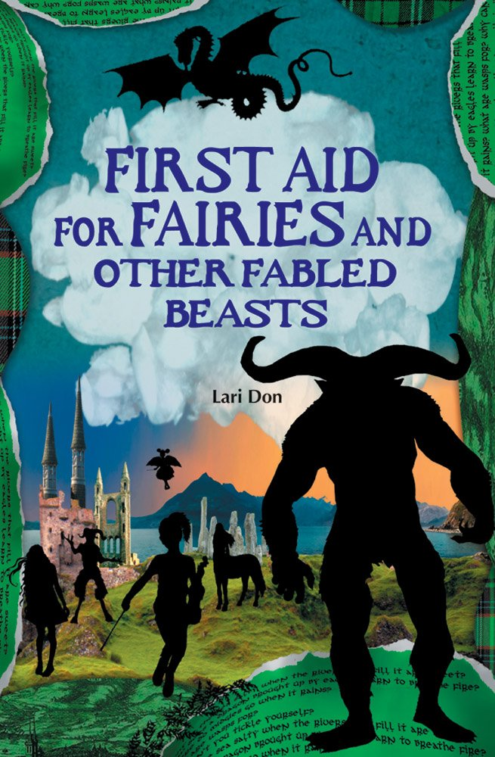

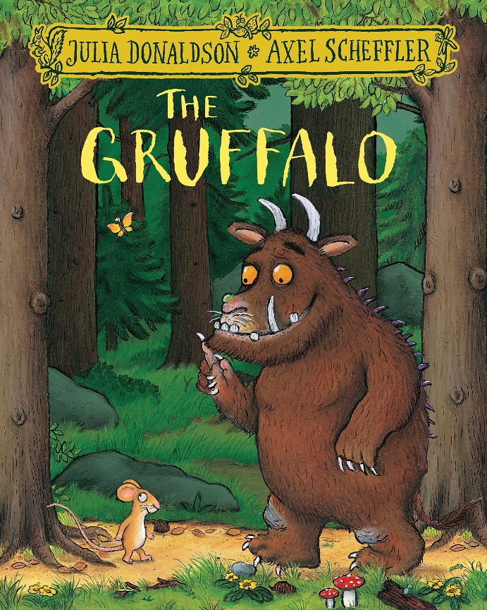
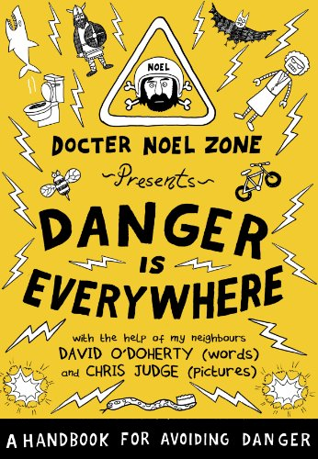

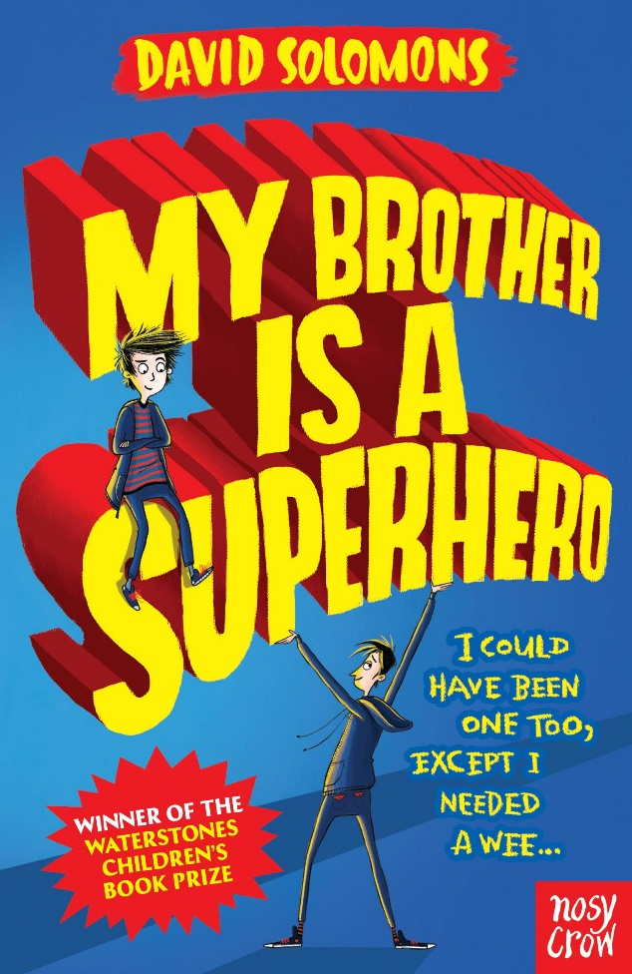
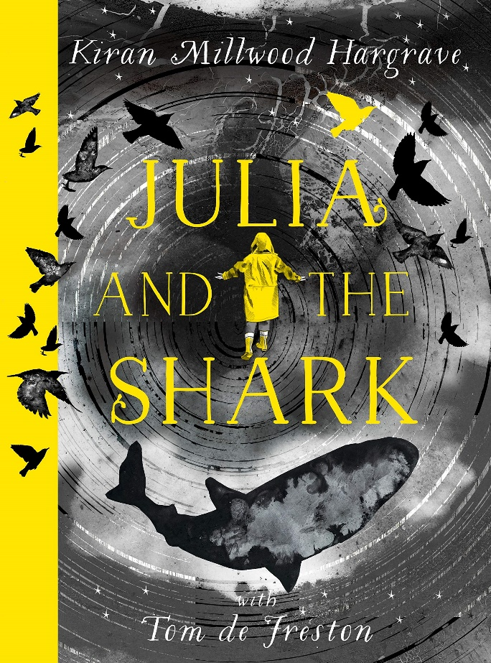

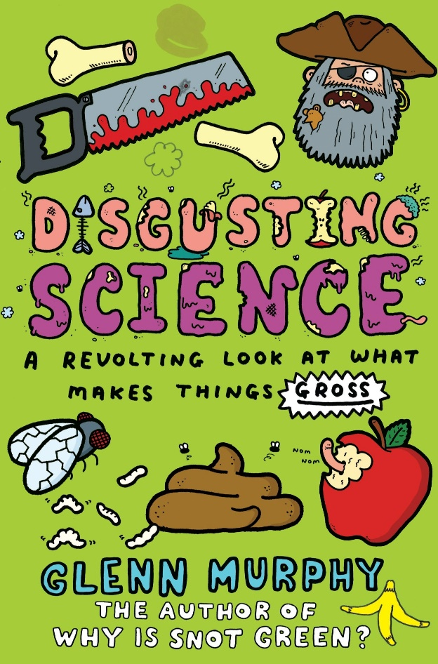
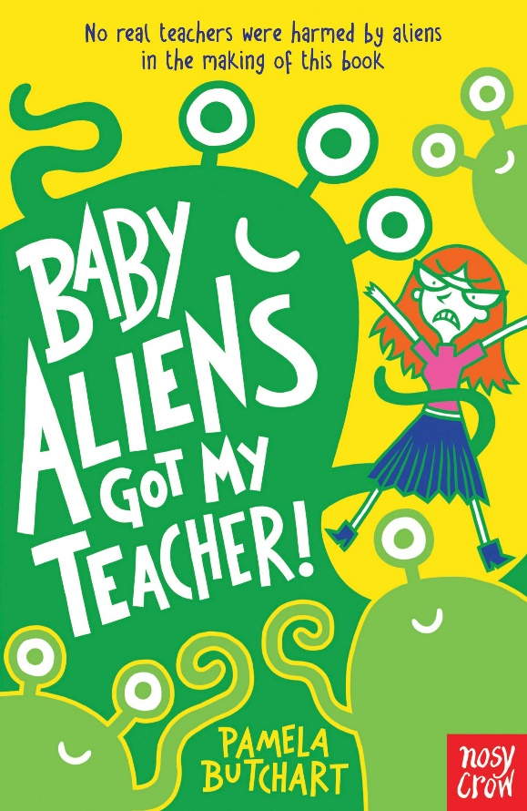

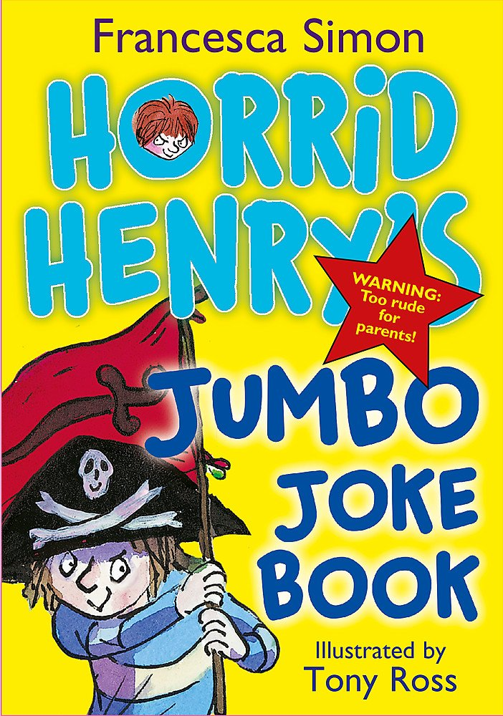
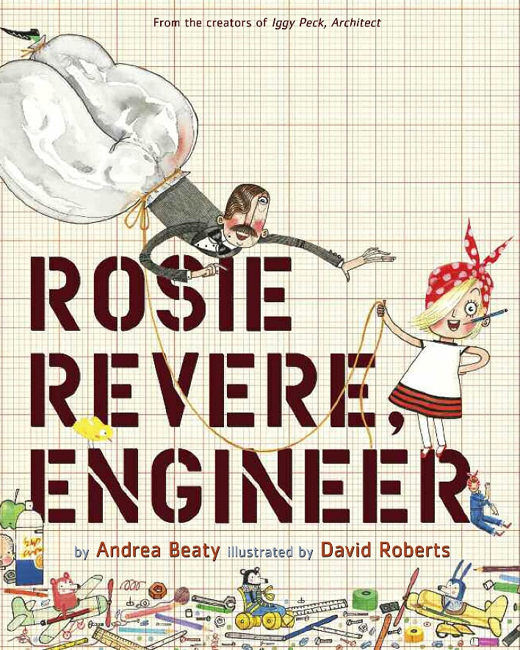

I love reading

Further Activities
If your pupils enjoyed this treasure hunt, here’s some other ideas to try!
- Create your own treasure hunt based on the books your class have enjoyed, then invite families to take part so they can learn more about what you’ve been reading.
- Get the pupils to plan a treasure hunt for another class based on their favourite books. This could be a great way to build excitement for a paired reading project.
- Download our app Bookzilla and search for the books on there. How many can they find? Are there any they want to save to read later?
- Use our Introduction to Bookzilla Lesson Plan to learn about genres. Can you guess the genres of the books in the treasure hunt?
- Visit your school or local library, or local bookshop, to see which of the books they have in stock.
- Let the pupils vote on which of the books they’d most like to read as a class. Once you have a copy, use our 10 Things to Do with Any Book resource to explore it together.

