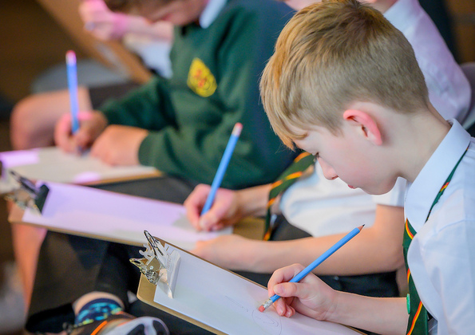

The Pilfered Quill: A mini escape room for the classroom
by Padlox Escape Rooms
The Pilfered Quill is a mini escape room created with the aim of promoting literacy.

Resource created by Scottish Book Trust and Padlox

scottishbooktrust.com
Scottish Book Trust is a registered company (SC184248)
and a Scottish charity (SC027669).

Contents
About this resource 2
Puzzle 1 5
Puzzle 2 9
Puzzle 3 10
Puzzle 4 11
Puzzle 5 12
Puzzle 6 13
Puzzle 7 14
Puzzle 8 15
Puzzle 9 – Page 1 16
Puzzle 9 – Page 2 17
Puzzle 10 18
Puzzle solutions and clues 19

About this resource
This resource can be used as part of your Reading Schools journey to involve learners in promoting and exploring the fun of reading with peers, staff and families.
Padlox Escape Rooms bring escape rooms to schools, offering a curriculum-focussed half day experience for groups of 30 pupils called “Escape The Classroom!” In teams, pupils rotate around five 30-minute activities on themes of science, literature, geography, enjoy a fully immersive ‘escape van’, and a make-your-own escape game workshop. The puzzles are designed to promote collaborative learning, creative thinking, problem solving and communication skills. Ages P6 to S4. For more info visit the Padlox website.
The Pilfered Quill is a mini escape room for the classroom with the aim of promoting literacy as well as teamwork and problem solving.
Storyline
‘Help! Somebody, anybody, please!
Professor Paige Turner here from the National Library of Scotland. Something truly terrible has happened - a sneaky trickster has stolen our Library’s most treasured possession – Robert Burns’ quill! He used it to write his world famous poems and it is worth 10 million pounds!
We simply must get it back. All I have to go on is this note left by the trickster:
‘Only the cleverest can solve my puzzles. Prove you are worthy of the quill by getting to the end of my trail and uncovering its secret hiding place’
I simply do not have the brains ….so the question is – can you help me?!’
How it works
To begin, split the class into groups of 4 pupils. When ready to start, read out the above storyline to the class to set the scene and define the overall objective. Each group must then work together to solve a linear trail of 10 escape room style puzzles. The teacher is the padlock – groups approach the teacher with proposed solutions to each puzzle, and if correct they are given the next puzzle in the trail to take back to their table.
After each group solves a puzzle, give them one or two of the series of letters which, once combined and put in order, spell out the location of the missing quill. Before starting, cut out the quill and stick it under your chair without the pupils seeing. Then cut out the ‘You have solved the puzzle and must find where the quill is hidden. It is under the teacher’s chair.’ letters and keep them secret. Give each group one letter after they complete each puzzle. After all pupils have completed the final puzzle, encourage the class to work together to put letters in order (they are numbered) to identify the location!
Each puzzle is designed to take 5-7 minutes each. The whole resource will take approx. 1hr and a half to complete. We suggest the pupils are initially not given any further instructions beyond what’s on the puzzle sheets. Optional clues are provided at the end of this resource, and we suggest these are given one at a time, with a 1-minute break between clues.
Resources needed
A full print out of Puzzles 1-10 (pages 5-17) multiplied by the number of groups. Place in ordered piles on the teacher’s desk to be handed out as and when each group solves each puzzle. Each group should also have access to pencils (and possibly erasers!), rulers and scissors.
Further support
Teachers may want to print out the book jackets of the following books. The book titles are the answers to some of the puzzles and can be available around the classroom as additional clues:
- The Lion, the Witch and the Wardrobe
- The Worst Witch
- The Nowhere Emporium
- War Horse
- The BFG
- Wonder
- Diary of a Wimpy Kid

To begin hand out Puzzle 1 to each group…

Puzzle 1
Print this page
Y  1 | O  2 | U  3 | H  4 | A  5 | V  6 | E  7 | S  8 | O  9 | L  10
V  11 | E  12 | D  13 | T  14 | H  15 | E  16 | P  17 | U  18 | Z  19 | Z  20
L  21 | E  22 | A  23 | N  24 | D  25 | M  26 | U  27 | S  28 | T  29 | F  30
I  31 | N  32 | D  33 | W  34 | H  35 | E  36 | R  37 | E  38 | T  39 | H  40
E  41 | Q  42 | U  43 | I  44 | L  45 | L  46 | I  47 | S  48 | H  49 | I  50
D  51 | D  52 | E  53 | N.  54 | I  55 | T  56 | I  57 | S  58 | U  59 | N  60
D  61 | E  62 | R  63 | T  64 | H  65 | E  66 | T  67 | E  68 | A  69 | C  70
H  71 | E  72 | R  73 | ‘S  74 | C  75 | H  76 | A  77 | I  78 | R  79

Print this page
Print this page
Can you work our this book title?
23 8 9 3 8 2 9 7 3 1 20 8 1 19 1 13 1 14 5 ?
23 8 15 13 1 11 5 19 16 15 20 9 15 14 19 9 14 1 3 1 21 12 4 18 15 14 ?
23 8 5 18 5 4 15 25 15 21 8 1 14 7 25 15 21 18 3 12 15 20 8 5 19 ?

Puzzle 2
Print this page. Use a ruler to complete the puzzle.
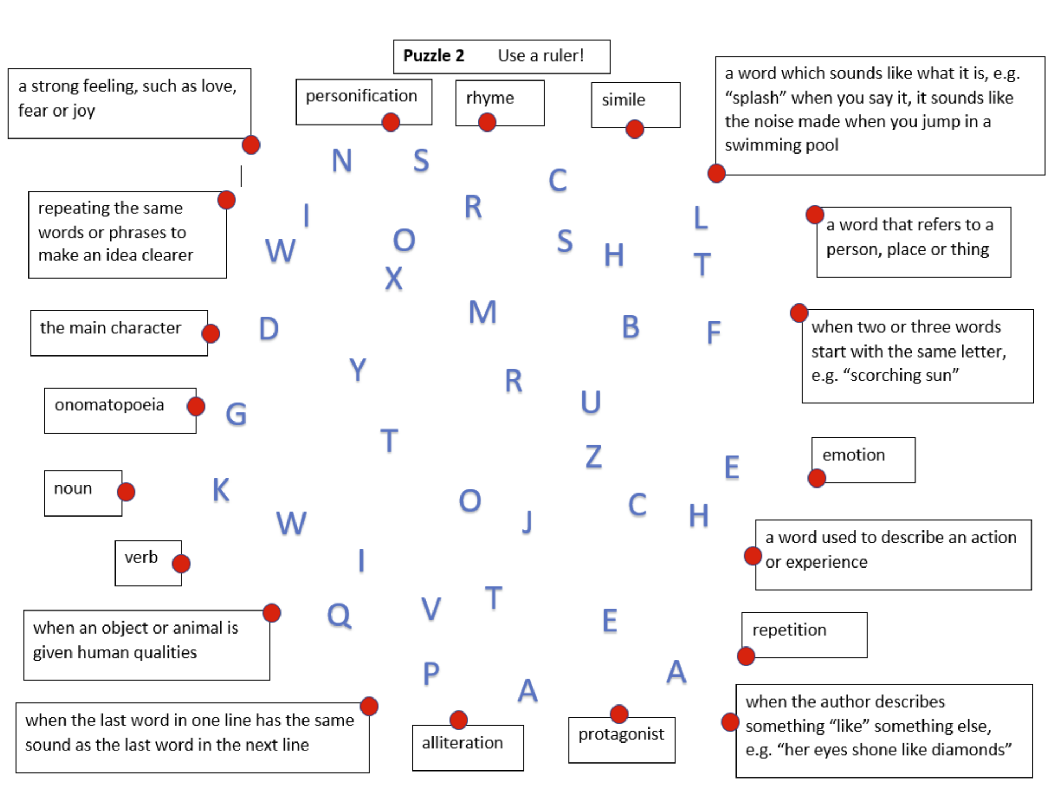

Puzzle 3
Print this page
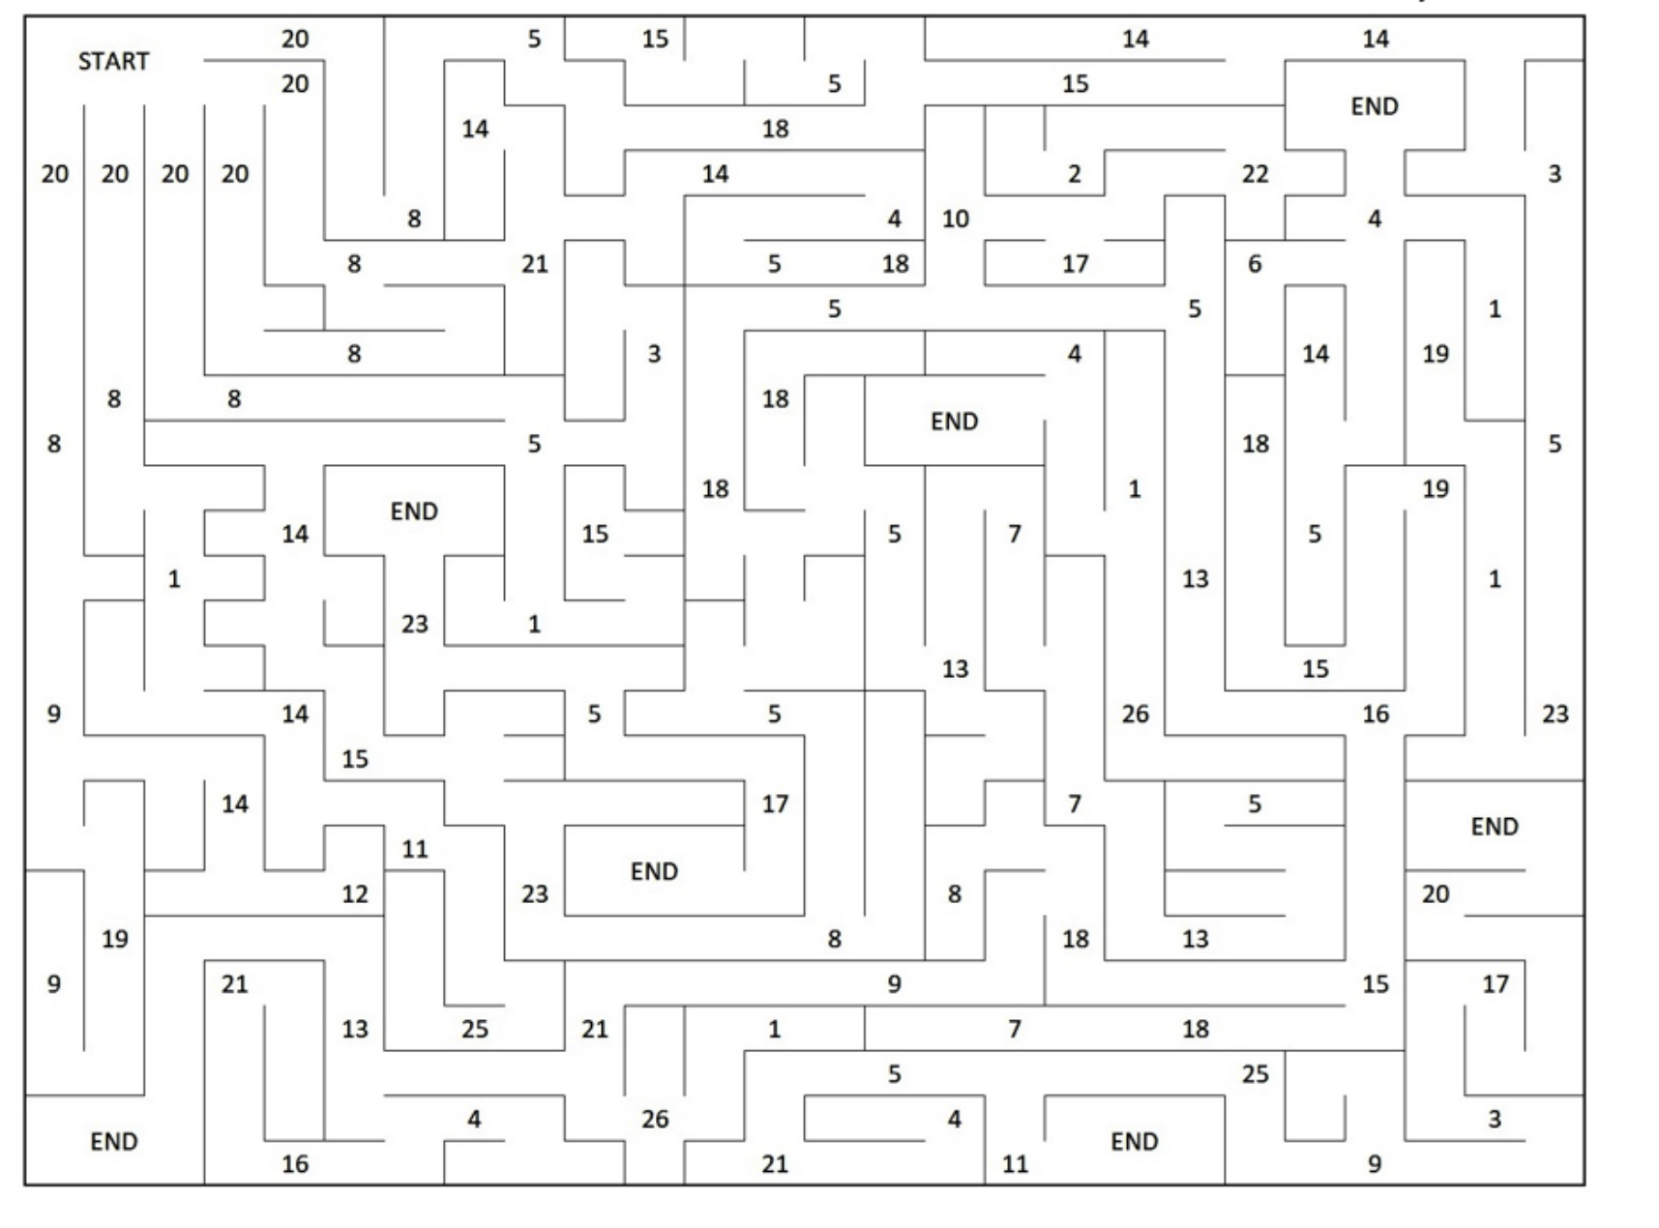

Puzzle 4
Print this page
Read the poem then decode the word for healthy food!
Grandpa’s Soup
Jackie Kay
No one makes soup like my Grandpa’s,
with its diced carrots the perfect size
and its diced potatoes the perfect size
and its wee soft bits –
what are their names?
and its big bit of hough, which rhymes with loch, floating
like a rich island in the middle of the soup sea.
I say, Grandpa, Grandpa your soup is the best soup in the whole world.
And Grandpa says, Och,
which rhymes with hough and loch,
Och, Don’t be daft,
because he’s shy about his soup, my Grandpa.
He knows I will grow up and pine for it.
I will fall ill and desperately need it.
I will long for it my whole life after he is gone.
Every soup will become sad and wrong after he is gone.
He knows when I’m older I will avoid soup altogether. Oh Grandpa, Grandpa, why is your soup so glorious? I say
tucking into my fourth bowl in a day.
Barley! That’s the name of the wee soft bits. Barley.
1, 7, 4 = N
19, 9, 7 =
7, 5, 5 =
9, 14, 3 =
3, 7, 2 =
2, 6, 7 =
17, 10, 1 =
8, 10, 2 =
11, 4, 3 =
21, 9, 4 =
Taken from The Scottish Poetry Library Website.

Puzzle 5
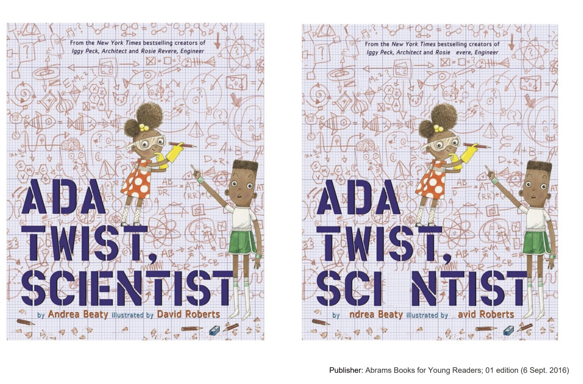

Print this page
Find someone who likes books!

Puzzle 6
Print this page
Decode the sequence to find the book title!
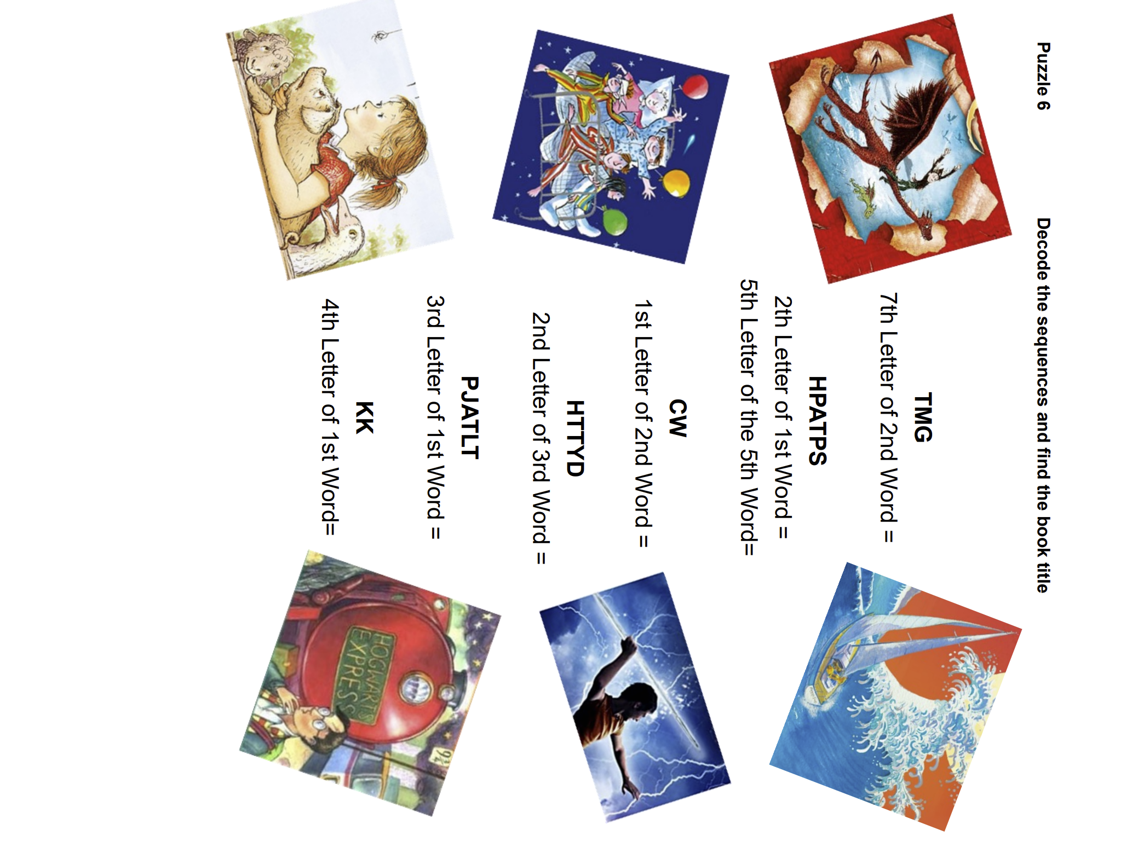

Puzzle 7
Print this page
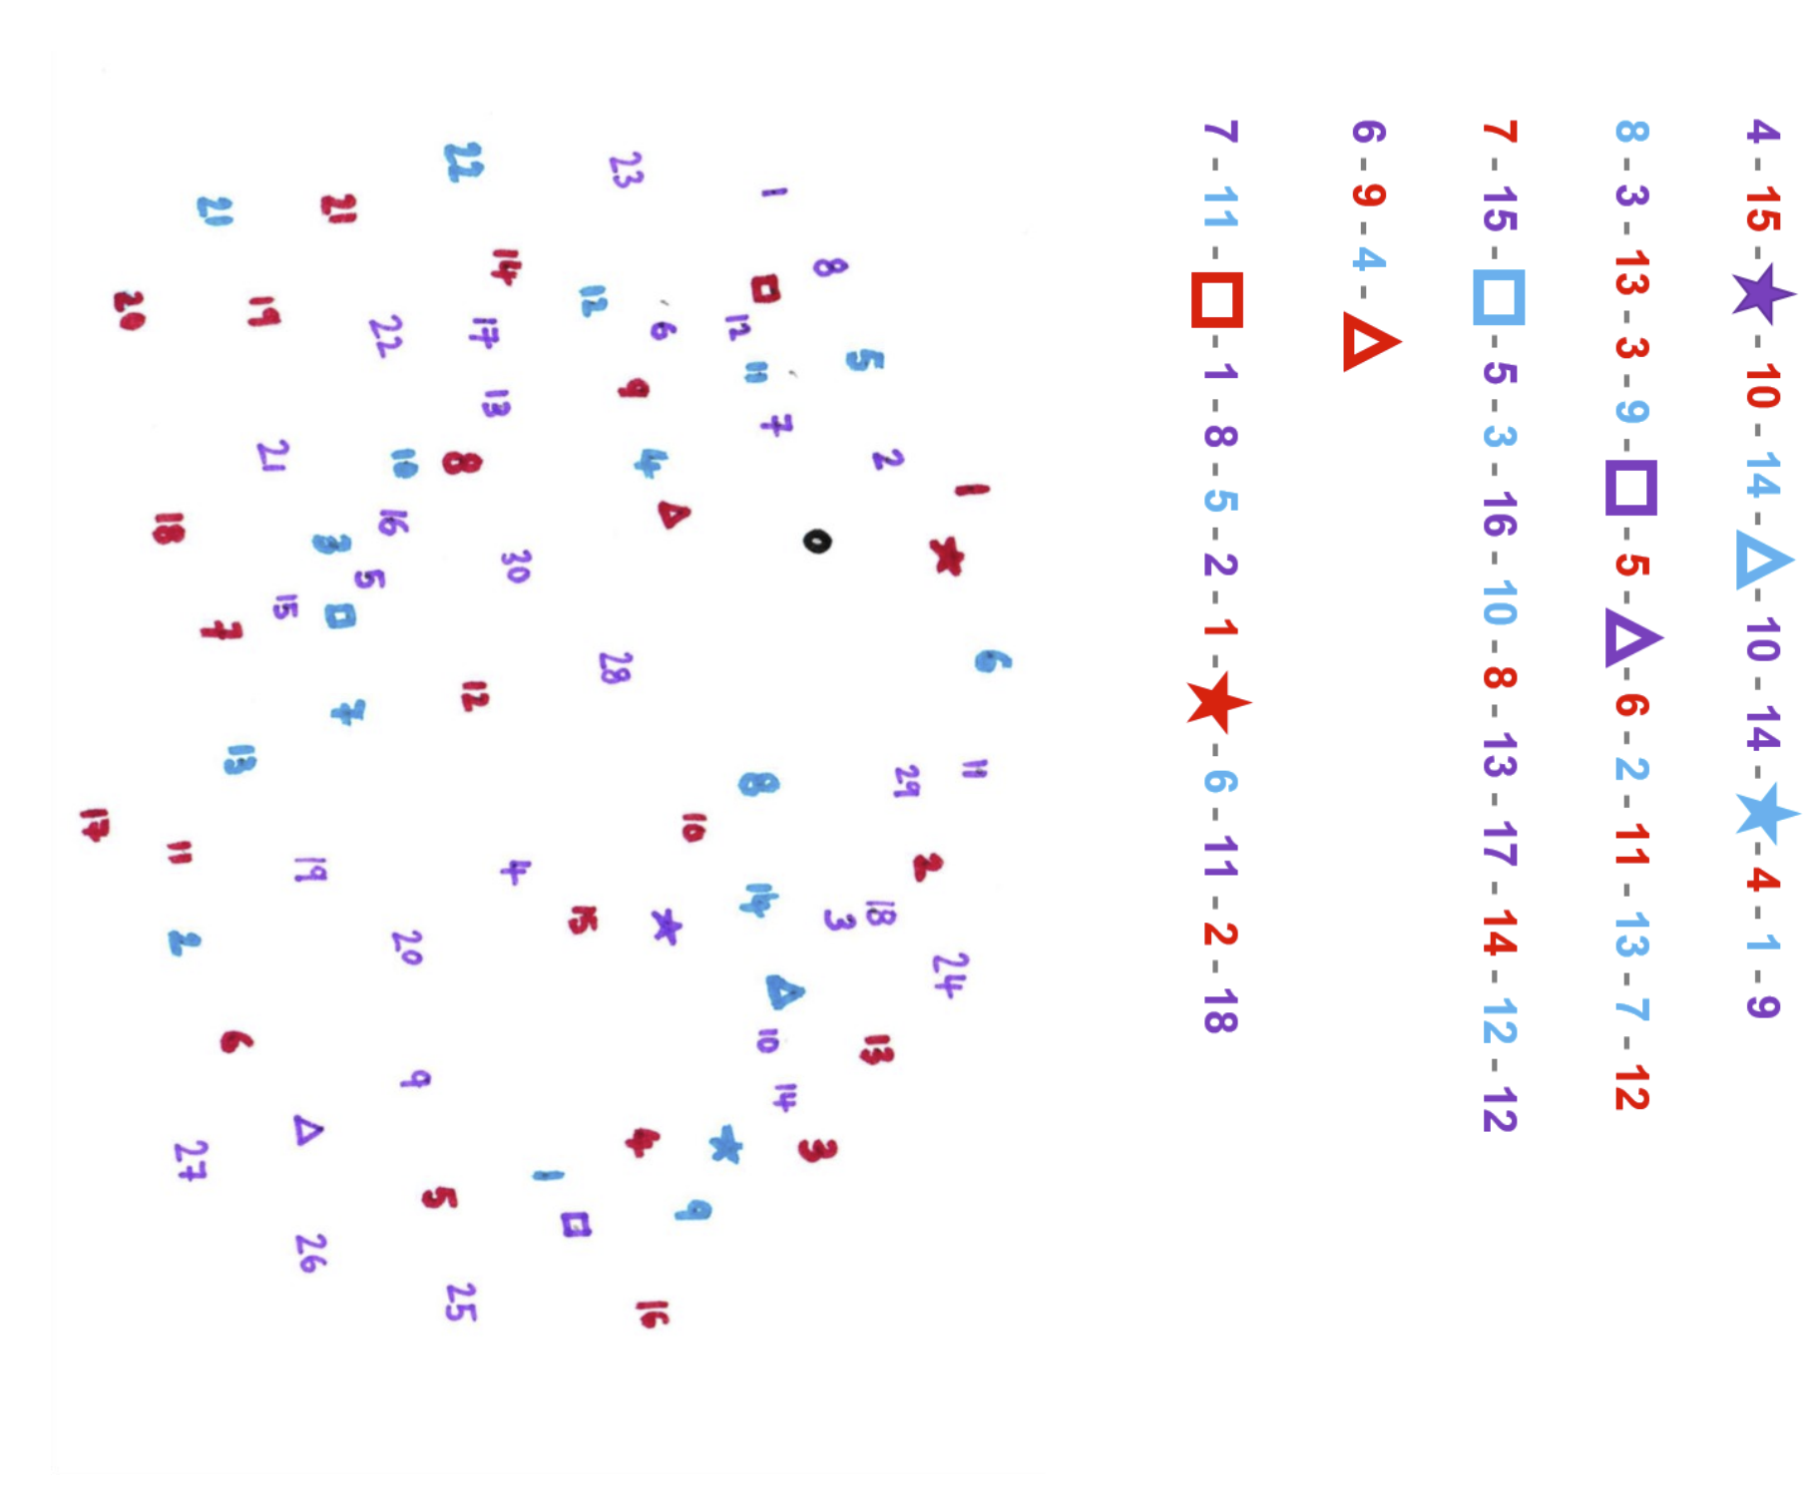

Puzzle 8
Print this page
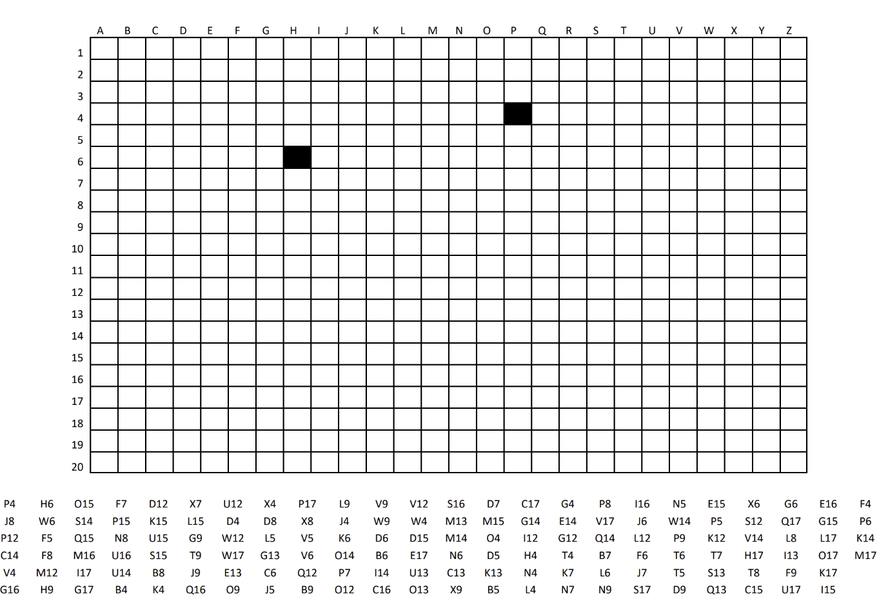

Puzzle 9 – Page 1
This puzzle is made of two pages. Cut along the dotted lines on page 2 and then stick each rectangle under the correct heading on page 1. Once they are all in the correct location, find a book title!
HERO | VILLAIN | OBJECT | PLACE
 | Miss Trunchball
Violet, Klaus and Sunny Baudelaire

 |  | Chickens
 |  |  | Wonderland
 | Grindelwald
 |  | Wardrobe
Lyra

 |  |  | India
 | Mr. Big

Puzzle 9 – Page 2
Print this page and cut along the dotted lines to cut out each rectangle. Then find where they fit on page 1. Once they’re in the correct location, find a book title!
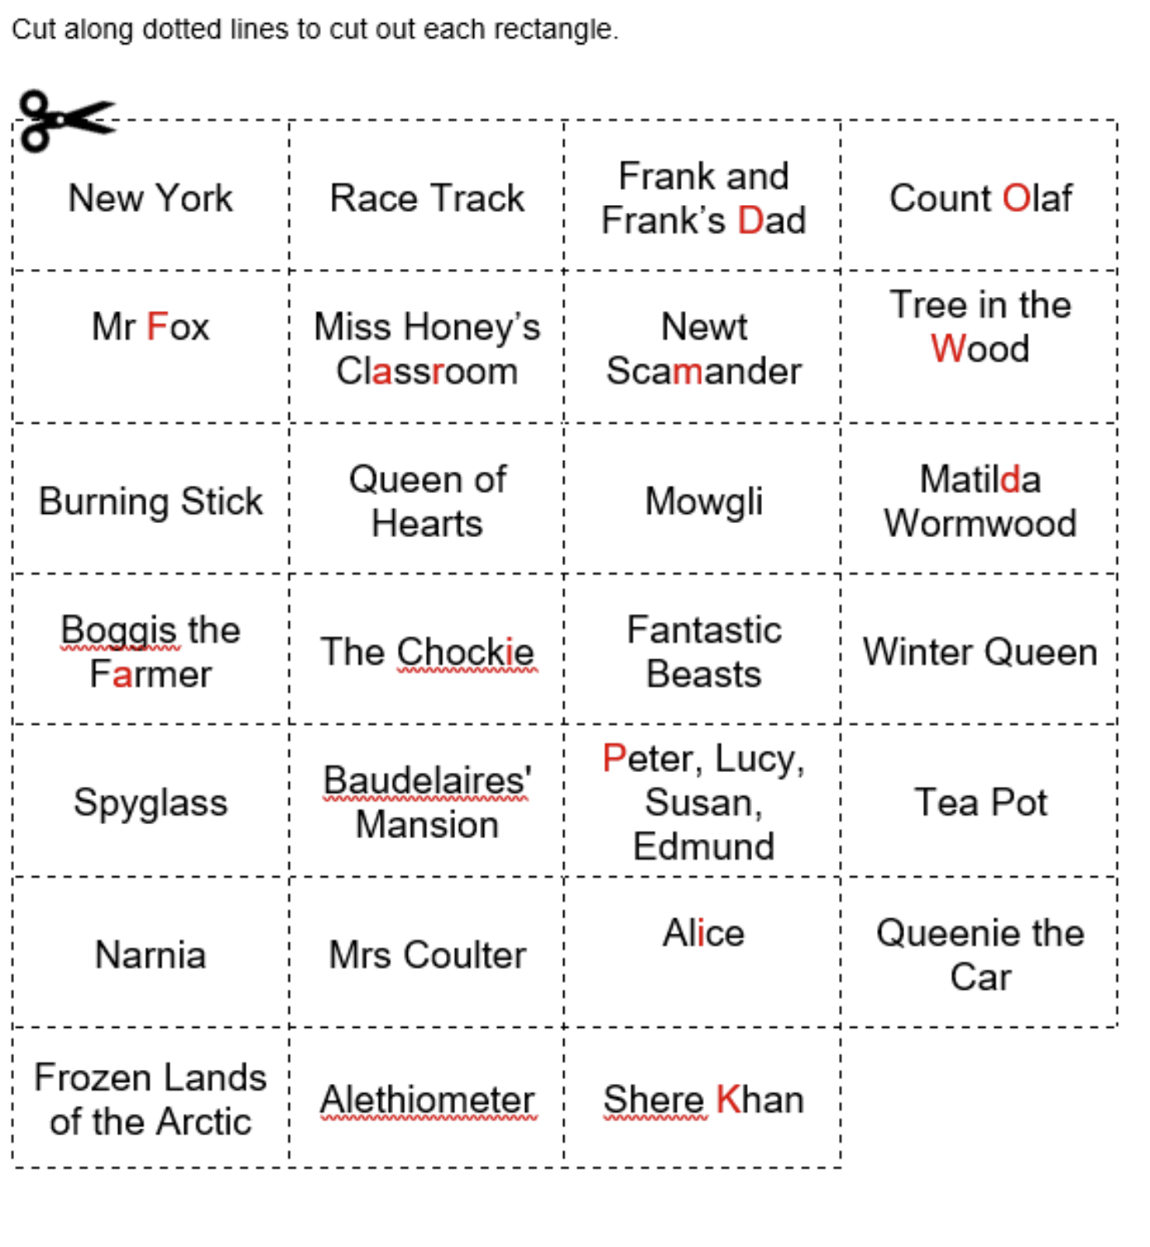

Puzzle 10
Print this page
Who said this? Cut carefully
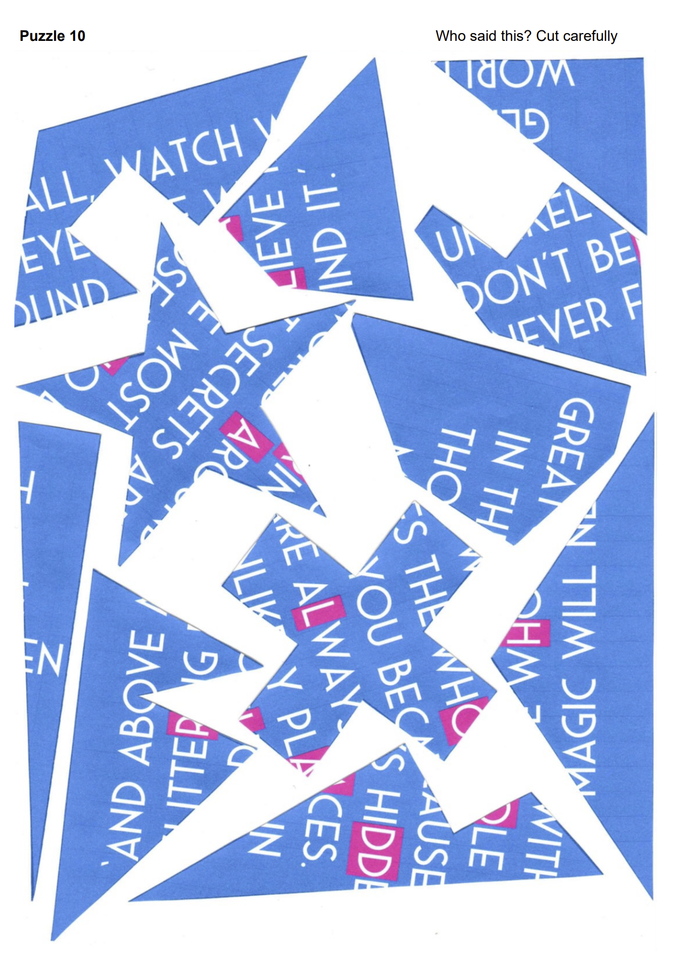

Puzzle solutions and clues
Puzzle 1: 1= A cipher
Solution: Intuit that 1=A, 2=B and so on; decipher the digits back to letters. The letters spell out three questions; the three answers lead to a book title, THE LION, THE WITCH AND THE WARDROBE.
Clues:
- 2a. Tell the pupils that 1=A.
- 2b. Tell the pupils that 2=B.
Puzzle 2: Definitions
Solution: Using pencil and ruler, link up the words with their definitions, making straight lines between the red dots. The lines run through 10 letters which lead to a book title THE WORST WITCH.
Clues:
- 3a. Check that each line drawn slices through only one letter.
- 3b. Draw a circle round each of those letters to help the book title pop out.
Puzzle 3: Maze
Solution: The only route to reach one of the ‘END’ spaces spells out the book title THE NOWHERE EMPORIUM.
Clues:
- 4A. A copy of the book cover could be made available in the classroom.

Puzzle 4: Line-word-letter
Solution: Each set of 3 digits identifies a line, a word on that line, and a letter in that word. Find all the letters and spell out the word NUTRITIOUS.
Clues:
- 1a. The first number tells you which line of the poem to look at.
- 1b. The second number tells you which word on that line to look at.
- 1c. The third number tells you which letter in that word to write down.

Puzzle 5: Spot the difference
Solution: Missing letters are R, E, A, D, E and R.
Clues:
- 5a. Six letters are missing in the right-hand picture.
- 5b. Unscramble the six letters to make the word for some who reads books

Puzzle 6: Sequences
Solution: Each sequence relates to one of the pictures. Identify the sequences then choose one letter from one of the words in the sequence, as instructed. The letters spell the book title WAR HORSE.
Clues:
- 6a. The capital letters are the first letters of a sequence of words, for example HTTYD is How to Train Your Dragon.
- 6b. Copies of the depicted book covers could be made available in the classroom.
Puzzle 7: Follow me
Solution: Using a pencil, link up the symbols in the order shown; beginning each of the five sets separately. Image emerges of THE BFG.
Clues:
- 7a. Make sure to begin each of the five sets of symbols separately.
- 7b. A copy of the book cover could be made available in the classroom.

Puzzle 8: Grid squares
Solution: Using a pencil, colour in the squares in the grid as indicated at the bottom of the page. Words emerge giving clue to book title WONDER.
Clues:
- 7a. Make sure to begin each of the five sets of symbols separately.
- 7b. A copy of the book cover could be made available in the classroom.

Puzzle 9: Hero-Villain
Solution: Cut out the squares on page 2 and place them in the order on page 1. In each row on page 1, one square indicates the book – place the squares in the correct row and column. Once in order, the red letters can be read (left to right) to spell out the book title DIARY OF A WIMPY KID.
Clues:
- 9a. If Lyra is the hero, who is the villain?
- 9b. Once your grid is in order, read the red letters starting at Matilda and going left to right.
- 9c. Copies of the book jackets could be made available in the classroom.

Puzzle 10: Jigsaw
Solution: Cut out the pieces and rearrange the quotation; the highlighted letters spell out the author ROALD DAHL.
Clues:
- 10a. Cut out the pieces, complete the jigsaw and write down the pink letters to find a famous author.

