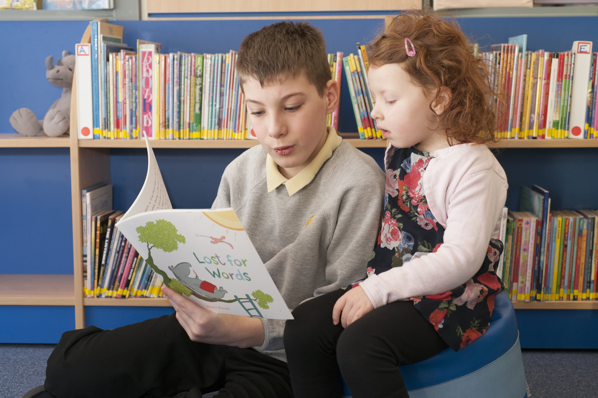
Resource created by Scottish Book Trust

Running a paired reading project
Key Area: 1.2.2

Level: Silver, Gold

A resource to help you run a paired reading project in your setting
scottishbooktrust.com

/scottishbktrust

@scottishbktrust

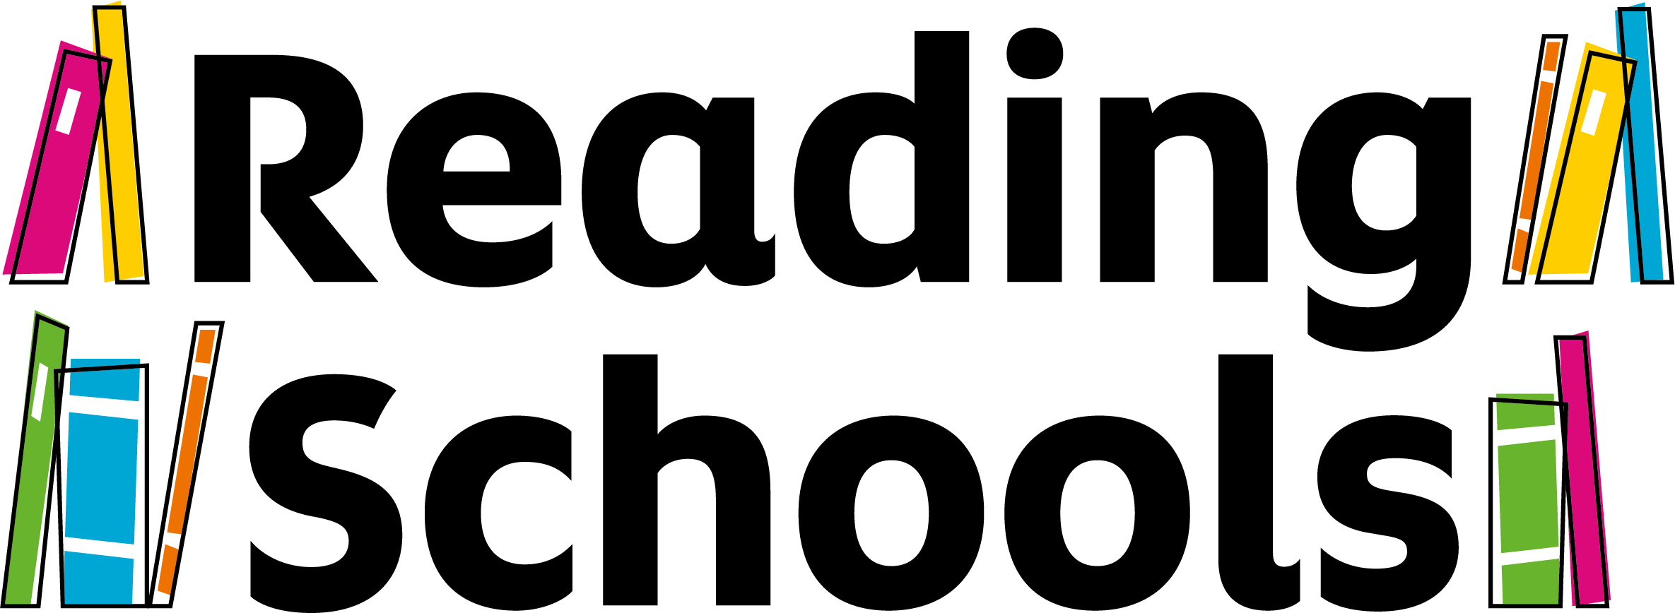

Contents
About this resource 1
Paired reading at a glance 1
The Bookbug Picture Book Prize 2
Project aims 2
Planning your project 2
Preparing your older pupils 3
Paired reading sessions 6
Appendix: reading skills 7

About this resource
If you are looking to promote reading for pleasure and improve literacy skills, running a paired reading project is a wonderful way to achieve these aims. It is also an excellent way to meet Key Area 1.2.2 Learner Role Modelling of the Reading Schools Framework. This resource provides a step-by-step guide to setting up and carrying out a paired reading project.
For the purpose of this resource, the activities have been created around older pupils reading to younger pupils. We often use the term “reading buddy” to refer to younger pupils.
However, if you are working with members of the local community, these activities are completely flexible and easily adaptable to your paired reading project.
Paired reading at a glance
- Paired reading is a simple model; it involves one individual reading to another, such as an older pupil reading to a younger pupil. This can work in a variety of settings from primary school to secondary, and can involve local community groups and parents too.
- The year groups involved are up to you. You could pair P7 with P1, or S6 with S2. The choice is yours. You could collaborate with other schools in your local area and work across primary and secondary levels.
- The readers spend some time preparing and developing their skills in reading aloud so they can bring books to life for their reading buddy during the paired reading sessions.

The Bookbug Picture Book Prize
Every year we select a shortlist of the best new Scottish childrens' books, and children across Scotland vote for their favourite as part of the Bookbug Picture Book Prize. The shortlist changes from year to year and many schools use the shortlisted titles as a core focus for their paired reading project. Both older and younger pupils can vote. You can register to take part and find out more information about the shortlist on our website, and can purchase the books at a discounted rate from the prize sponsor Browns Books for Students.

Project aims
The project will:
- Improve confidence in reading aloud and develop questioning skills.
- Develop nurturing and leadership skills in older pupils through the opportunity to act as role models.
- Develop a love of reading in all individuals involved.
- Enable all pupils to participate regardless of learning ability, allowing less confident pupils to shine.
- Encourage friendships between younger and older pupils and aid school cohesion.

Planning your project
Select one older class and one younger class to participate in the project.
Decide in advance when you would like to run your sessions and schedule them into your school calendar. You will need to consider how many paired reading sessions you want to run and over what time-scale: do you want to run a number of sessions over a term? Or will it be a full year project with sessions allocated at the same time each week? Alternatively, will it be a shorter project run during Book Week Scotland?
Book Week Scotland is a weeklong celebration of books and reading that takes place every November. During Book Week Scotland, people of all ages and walks of life come together in libraries, schools, community venues and workplaces to share and enjoy books and reading. It is an excellent opportunity to partner with other organisations in your local area to run a paired reading event or project.
If you are running paired reading with a community group or organisation, such as a local residential care home, you might choose to run the sessions over just one day.
Take time to read the resources and our paired reading toolkit. You will also need to decide on which books you would like to use for your paired reading project. If you are working with Primary 1 pupils, you could use the books shortlisted for the Bookbug Picture Book Prize. If you are working with Primary 2 and Primary 3 pupils, you could use the books included in the P2 and P3 Read Write Count bags, which are gifted to all Primary 2 and Primary 3 pupils during Book Week Scotland.
Alternatively, you could select books that relate to a school theme or topic, or use favourite books from your school or classroom library.

Preparing your older pupils
It is important that you prepare your older pupils for the project so they feel confident reading aloud and enjoy their paired reading sessions. Here are some ways you can develop your pupils’ storytelling skills.

Discussing the importance of reading
One of the ways in which we can develop our reading skills is to have fun with reading and to read for pleasure– once your pupils see that the project gives them responsibility for a young pupil’s enjoyment of a book, they are much more likely to be fully invested.
Explain to pupils that we all have to do a lot of reading. Whether we are reading novels or looking at bus timetables, we all need to do some reading every day. Give some examples from your own day if you want to, and ask the pupils for other examples. You could ask pupils to complete a 24 hour read; pupils record absolutely everything they read in a 24 hour period and share their findings with the class. This is a great activity to highlight to pupils how pervasive reading is to all aspects of life, and how important it is a skill.
This activity is recommended by the Open University as part of their Reading Rich Pedagogies project. You can find more information on their website.
Exploring how picture books appeal to readers
Provide pupils with a selection of picture books and ask them to browse through the books. After you have allowed them some time to do this, ask your group to feed back about the books they have read, focusing on the following questions:
- Which books did you particularly like?
- Do you think your reading buddy would like them?
- Which aspects of the book do you think younger pupils would enjoy – colours, illustration style, jokes, storyline, characters, setting etc.?
- How do you think a younger pupil would feel after reading the book?
- Which books would you feel most confident reading aloud to a reading buddy?

Practising reading aloud
This activity will help pupils think actively about how different picture books should be read aloud in different ways, developing their ability to perform an engaging reading of a book.
Get your pupils to read two different books and ask them for their thoughts. Did they like the book? What words would they use to describe it? What kind of reaction do they think the author might have been going for? Do they think younger children would like it?
After this, ask the pupils if they think all the books should be read aloud in the same way, or if they would take a different approach for each. Put pupils into pairs and give them different sections of the books, then ask them to prepare a reading, thinking about the following: tone of voice, pace, pitch, volume and any character voices they might put on.
You can find a help sheet at the end of this resource if you would like to explore tone, pitch, volume and rate in more detail with your class.

Author videos
Show pupils one or more of the author videos on our website. There are a number of different videos of authors reading their picture books aloud. Ask your pupils to discuss the reading and consider the following questions:
- What did they think of the reading?
- Did they notice any prompts or reading techniques that they liked?
- Would they have done anything differently?

Developing questioning skills
Once your older pupils have become more confident in their ability to read aloud, the next step is to develop their ability to ask their reading buddy questions and help them respond to a book. The best way to do this is to put themselves in a younger child’s shoes – the following activity should help them to do this.
This activity will help the older pupils see the number of questions which can be raised by a book’s cover, and will help them decide on some questions they might like to ask their buddy before they read the book to them.
- Make a photocopy of a picture book cover and ask older pupils to annotate it with their observations (I can see), their thoughts (I think, I want to know) and their questions (I wonder why?).
- Try a few different book covers for more practice.
- If everyone is working on the same book, come back together and share the questions and observations everyone has made. If working on different books, pupils can swap and add anything extra to their peers’ observations and questions.
Now, ask them to come up with two or three questions they might ask their reading buddy before they read the book with them. For instance, they might ask what they can see on the cover, why they think the characters on the cover are doing certain things or dressed in a certain way and what they think might happen in the story.

Pausing during reading
Ask older pupils to look through the book they have chosen to read and identify a point where it would be good to stop and ask their reading buddy what they think will happen next. They could also ask how they think a character is going to solve a problem or perhaps how they think a character feels at that point of the story.

After reading
Ask older pupils to come up with some questions they would like to ask after they have read the book.
The aim for most teachers will be to get the older pupils asking some higher order questions, but it can also be a nice experience for older pupils simply to ask some basic understanding questions too, asking younger pupils what they remember about the story, what a character was doing at a certain point, what was happening at the start etc.
Older pupils can come up with some higher order questions by encouraging younger children to connect with the book in some way. Questions of this nature might include:
- Connect with a character: Would you have done the same thing? Which character are you most like?
- Connect with an emotion: How do you think (character) felt? Have you ever felt like that?
- Connect with a place: What do you think it is like to live there? Would you want to visit this place?
- Connect with another story: This reminds me of another story we have read…
Paired reading sessions
Your older pupils should now feel confident and ready to start sharing picture books with their reading buddies.
It may be a good idea to allow the older and younger pupils to meet each other before they start sharing the books so that they feel comfortable with one another and start to become friends. Here is a great activity that Sunnyside Primary School in Clackmannanshire carried out to introduce their older and younger reading buddies to each other:
Ask your older pupils to devise a questionnaire for their younger reading buddy so they can find out more about them. For example:
- What kind of stories do they like?
- If they wrote a story, who would be their main character?
- Where would the story take place?
- What would happen in their story?
- The older pupils could also ask about their younger buddies other interests.

Get your older pupils to introduce themselves to their younger reading buddies and ask them the questions they have prepared. Your older pupils can take back the answers to their classroom and write a short imaginative story for their younger buddies, featuring some of the information they have gathered. The older pupils can read this story to their younger reading buddy before moving on to share your selected books.
As well as paired reading sessions, you could carry out craft, writing or other fun activities related to the books you are using as part of in your project. Our author videos often have quick activity suggestions at the end, and these might be good to look at with your class for activity inspiration. Your older pupils could design and lead activities with their reading buddies, developing their leadership skills.

Appendix: reading skills
Your voice is your single most important tool when telling a story.
When reading aloud, our facial expressions also help adults and children understand the meaning of the words, as well as increasing overall enjoyment and engagement.
Important things to consider: pitch, tone, volume and rate
Pitch
- The vibration of our vocal cords creates pitch (more vibration = higher pitch)
- Our voice will have a natural pitch
- We can raise or lower our pitch when we are reading or telling a story
- We tend to associate small with higher pitch, and big with lower pitch
- We adjust our pitch higher and lower to show growth or shrinking as well
Tone
- It’s not just what we say but how we say it
- Our tone needs to match the meaning of the words, and the feeling of the page/line of the book
- For example, you would not say ‘I’m very angry’ in a bubbly and happy voice- it does not convey the meaning
Volume
- Varying our volume makes the story more interesting, but again, it’s a great tool to use to create tension, mood, and to help convey the meaning
- When we read a story, our voice doesn’t need to stay at the same volume throughout
- Variation in volume throughout the story will increase listening – it’s more acoustically diverse
Rate
- This refers to the rate of speech – how fast or how slow we speak
- Again, this should vary - you want to speak slowly and clearly, but the variation makes the story more interesting
- This is particularly useful in building excitement
- Especially in books with lots of build-up, a faster rate of speech can help to depict this
- For a book where you’re trying to be quiet and calm, you adapt a slower rate of speech

