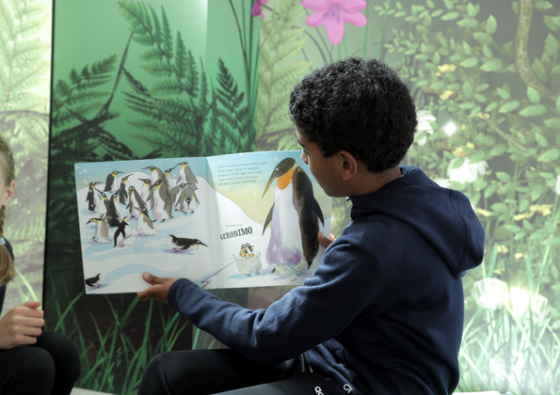

Reading Dares
Challenge your pupils with these dares for the whole class to try.
Ages: 5–10

scottishbooktrust.com
Scottish Book Trust is a registered company (SC184248)
and a Scottish charity (SC02766

Contents
How to choose your dare 2
Classroom Dares 3
Pupil Dares 5

How to choose your dare
This resource can be used as part of your Reading Schools journey to involve learners in promoting and exploring the fun of reading with peers, staff and families.
Challenge your pupils with reading dares! This resource contains two types of Reading Dare: ones you can do as a whole class, or ones pupils can do individually.
Here’s some top suggestions for how to choose your class dare:
- Use a random number generator such as random.org
- Nominate a pupil to roll a dice
- Make a calendar of dares, for example, do one each week
- Make a Dare Jar that for pupils to choose a number from
- Base them on the day of pupil’s birthdays
If pupils are doing dares individually, you can use these as a way for them to self-reflect on their reading progress. Small achievements are huge for building the motivation to read, so encourage pupils to pick dares that are achievable without being too easy for them, and note down how they accomplished them, and how that success felt for them! You can download and print Reading Passports from our website for pupils to track their progress.

Classroom Dares
- Create a list of everyone’s favourite books to display in your classroom.
- Ask some of your teachers to bring in photos of their bookshelves – you can then turn this into a quiz. Who can guess whose bookshelves are whose?
- Go on a class visit to your local library and ask for recommendations.
- Decorate your classroom door as your class’s favourite book cover.
- Organise a reading flashmob in your school.
- Watch one of Scottish Book Trust’s Authors Live events online.
- Start a book group.
- Go on a class visit to your local bookshop and ask for recommendations.
- Hold a class book swap.
- Take some Extreme Reading photographs – where’s the strangest place you can read?
- Hold a book lucky dip.
- Write some recommendations on our Shelf Shouter cards for your class library.
- Design and make your ideal book reading den in your classroom.
- Have a competition to design the best book cover and title in your class.
- Make a recommendation box for your classroom.
- Write your own book as a class – assign each pupil a chapter that picks up where the last one left off.
- Visit a younger class to read some books to them.
- Organise a reading treasure hunt or scavenger hunt.
- Cook or bake a recipe from your favourite book.
- Reorganise your classroom library.
- Take our Book Blurb Quiz! Who got the most right?
- Plan a DEAR (Drop Everything and Read) session.
- Build an outdoor reading den in your primary school.
- Make a box of books and activities for another class and deliver it to them.
- Write a book of poems based off your class’s favourite book.
- Take part in our Escape Room!
- Create a chalk mural of your favourite book cover in your playground.
- Put up a Currently Reading sign on your classroom door!
- Be a book fairy – find local benches, shops, parks or places to hide a book for someone else to find. If you’re worried about rain – laminate QR codes to audiobooks or eBooks!
- Hold a genre swap – team up with someone who loves a genre you don’t and swap recommendations.
- Create a play or dance based of your class’s favourite book. Who will play who?

Pupil Dares
- Sneak up to someone while they are reading a book and try and read a whole page without them noticing!
- Recommend your favourite book to a teacher or librarian.
- In the library, close your eyes (or use a blindfold), and ask a friend to spin you round and pick a book without looking. This is your next read!
- Find a poem that makes you laugh.
- Write a note to an anonymous reader, put it in a book you liked, then leave the book somewhere for someone else to find.
- Read a book that has a film adaptation, or watch a film based on a book.
- Share a book recommendation at assembly.
- Read the first page of five books and pick which one you like the most.
- Read a spooky story at night time.
- Download Bookzilla on your phone or tablet to start tracking and rating what books you read.
- Find a kind, funny or inspiring quote from a book you like, write it in your nicest handwriting and pin it somewhere you’ll see it every day.
- Dare a family member to read your favourite book, and read one they suggest.
- Read a magazine or newspaper article.
- Draw a picture of what you think your favourite character looks like.
- Hide poems or quotes around your school or class for people to find.
- Read instead of watching TV for a week!
- Volunteer to clean your class or school library.
- Put a currently reading sign on your desk.
- Look at a world map and pick five countries. Now, try and find a book to read that’s set, or from, each country!
- Start a book group.
- Read to your younger sibling for a week.
- Hold a book swap with your friends.
- Re-read a favourite book from when you were younger.
- Try and read a genre you normally avoid – poetry, graphic novels, science-fiction, fantasy, drama – try and find someone to recommend one to you!
- Visit the library and ask for a recommendation.
- Write a piece of fanfiction based on your favourite book.
- Make your own reading den at home or in your bedroom.
- Write a deleted scene from your favourite film, TV show or video game.
- Start a reading journal or diary to keep a track of what you read.
- Read a non-fiction book.
- Design an alternative book cover for one of your favourites.

