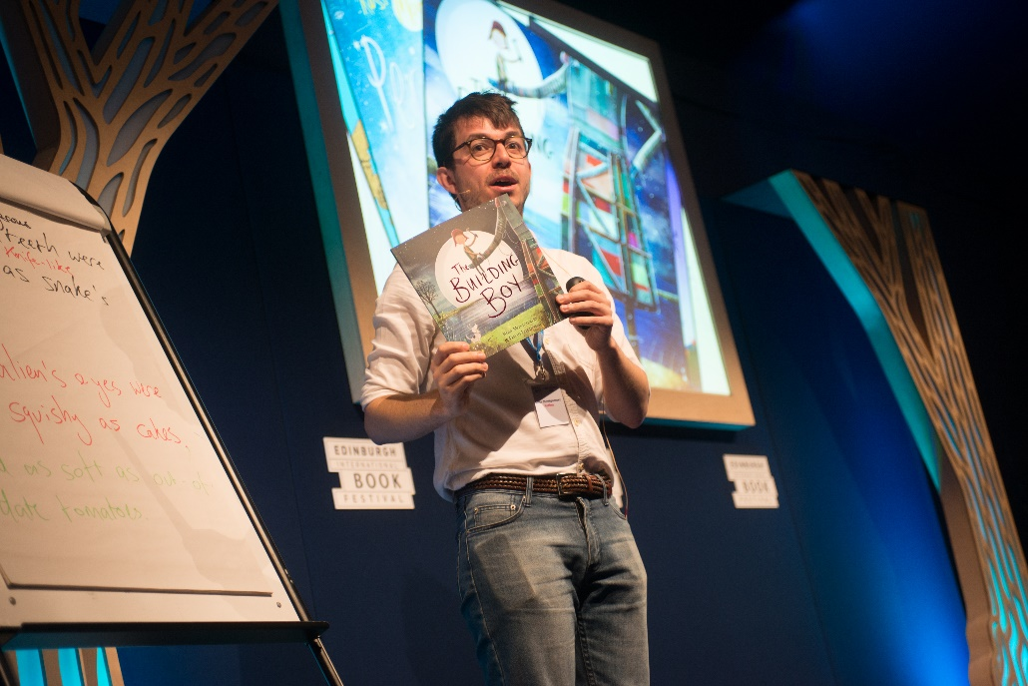

How to make the most of an author event
Key Area: 2.3.5

Level: Silver

Resource created by Edinburgh International Book Festival

This resource provides tips to help you make the most of an author event

scottishbooktrust.com

/scottishbktrust

@scottishbktrust

edbookfest.co.uk

Contents
Part 1: How to prepare for an author event 2
It’s all in the detail 3
Top tips from poet Georgi Gill 3
Other top tips 4
Part 2: Building on an author event 4
All CFE levels 5
Early level 5
First/Second level 6
Third level to senior phase 6
Top tips from poet Georgi Gill 8
Further information 9

About this resource
An author event is a great way to get children enthused about reading, writing and drawing. By making sure you and your pupils are prepared and excited about the author and event, you’ll ensure that they get the most out of the experience.
This resource explores things you can do in class before and after a writer event. For activity ideas to help you build on a writer event after its taken place, see the second half of this resource.

Part 1: How to prepare for an author event
Working with a writer is a fantastic opportunity to inspire children and develop your practice, and there are lots of different opportunities to set up an event and tailor it to your needs.
- Book festival
You can visit a book festival and go to an author event or workshop. There are lots of book festivals in Scotland, including the Edinburgh International Book Festival which includes the hugely popular Baillie Gifford Schools Programme, and its On the Road programme which takes author events around Scotland throughout the year. Some festivals also run schools outreach programmes, where authors come in to visit schools. Have a look to see whether there is a festival happening near you!
- Scottish Book Trust
The Scottish Book Trust provides opportunities for authors to visit your school through the Live Literature funding programme, the Scottish Friendly Children’s Book Tour outreach programme and the Schools Events Programme. Find upcoming events and tours by visiting the Scottish Book Trust website.
- Writer visits
You can also contact a writer and ask them to come in and visit your pupils. You can choose whether the event is large or small, what its aims are, and whether you want just one visit or an extended residency.
Writers should be paid an appropriate fee and expenses for the events they carry out – find out more about rates for events and funding opportunities that can help with this at the end of this resource.
Sometimes several schools have organised a writer visit together – one school hosts the event, and others travel to it. This can be a good way to share the cost of a writer visit. It can result in quite a large audience, so check what size of audience the writer is comfortable with beforehand.
- Digital events
Scottish Book Trust also run Authors Live, which is a series of digital events for all ages. You can find upcoming events, and access a library of recorded events, at http://bit.ly/AuthorsLiveHome
- Online resources
Both Edinburgh International Book Festival and Scottish Book Trust have online banks of learning resources. Why not have a browse and see if there’s anything relevant to your author or topic which you can use? Edinburgh International Book Festival’s Schools brochure also includes activity suggestions linked to each event.

It’s all in the details
If you’re travelling to an event at a festival
Make sure everyone knows the time of the event and where it is. Make sure you’re arriving in plenty of time. There might be other things to explore after the event such as a bookshop, stall or other activities. If so, make sure to leave time for that. Remember to bring money if you would like to buy a book and get it signed by the author.
If you’ve invited a writer into your school
Plan with your author. Make sure you speak to the author beforehand about your goals for the event. Is the event going to be a workshop with lots of pupil participation, or more of a presentation and reading?
Also, check that the author’s event will be suitable for the age and size of audience and whether they have a presentation and that this works on your school or library’s computers. Think about whether you want to invite parents along too!

Five top tips from poet and literacy specialist Georgi Gill
Follow Georgi’s suggestions to help you prepare for your author event:
- Read the author your class are booked to see
Sounds obvious, I know, but it’s surprising how many people don’t do this. There might not be time to read a whole novel with your class ahead of the visit but try to share at least a chapter or a few poems. Maybe you could watch an online book trailer together if your author has any.

- Fact find about the author
It’s good to do a wee bit of research with your class – look at book blurbs or the author’s website. Where are they from? Have they always been a writer? Try to find get a sense of the person as well as the writing.

- Think of questions to ask
Ask students to think of two questions each they would like to ask their author: one should be from them as readers (maybe about plot or characters, or a scoop on what the writer is doing next!). The second questions should be questions from young writers to an established author – a great opportunity to get tips on how to develop their own writing.

- Identify aims for the visit
Before you know it, festival trips can flash by in a wonderful, noisy whirl of tents, snacks and books. To maintain focus, ask students to think of their aims for the day - maybe they want to want to hear a new story, find out how writers work, or be inspired to write a book of their own.

- Prepare to be a good audience!
It’s not just the people on the stage that make the events a success – the audience has an important role too (although sometimes it’s a non-speaking part!). Have a chat with your class – what do they think the audience should do? How can they join in and maximise enjoyment?
Other top tips
Join in!
It’s really good for you to get involved with the activities the writer does with your pupils – it shows both the writer and pupils that you value the event, and helps to send out the message that events are fun.
Behaviour management
If you invite a writer in to school, bear in mind that they shouldn’t ultimately be responsible for managing the class’s behaviour. Many experienced writers have picked up behaviour management skills from watching teachers and librarians, but you know your pupils best. It really boosts a writer’s confidence to know that your support is there.
Poster people
Get your whole class excited about the event by creating your own posters. Rewrite the event description including what you’re looking forward to doing, and include your own picture of the author, characters, venue etc. Make sure to include time and venue details, then put all your creations up on the classroom wall for everyone to see.
Another time, another place?
Is the book set in a different time period? If so, do some research and find different sources from that period of history. What do they tell you about life, beliefs and politics in that time? When you read the book, compare the fiction to what you know about the era. If there are any inconsistencies, why do you think this is?

Part 2: Building on author events
The activities in this section will help you embed learning following an author visit or event, and carry the momentum and excitement pupils felt at the event into the classroom.

All CFE levels
Reading wall
An author event is the perfect way to spark an interest in reading. Why not start a recommendations wall in your classroom or school after the event? Pupils and staff can contribute recommendations on post it notes, and you can ask pupils to design and organise the wall.
What next?
Read the book as a class and when you get to the end of a chapter stop and make predictions. What do you think (or hope) will happen next? Read on and find out if you were right.
Tell others
Tell the rest of the school about your event, perhaps in an assembly. You could each stand up and tell them what your favourite thing about the event was or what you learned. This can encourage other classes to attend author events and help create a reading culture in your school.
Early level
Story map
Help your pupils re-tell the story. You can use story mapping for this – getting pupils to draw pictures of key moments to help them remember the plot. You can also use story stepping – getting them to take a step and make up an action to represent a key moment, then repeating this for other key moments of the story.
Create puppets
You could also get pupils to create puppets to help them act out the story for someone else!
Invite a character
Ask children to choose a character from a text they have read and to design a simple invitation, inviting him or her to their house. The invite should include a picture or sentence about what they will do during the visit (using information about likes/dislikes from the text).
Illustrate a scene
Choose your favourite scene from the book and illustrate it. If your class all choose different scenes, at the end you could have a visual representation of key moments in the story to display on your wall. Or choose one scene and make a life-sized collage picture

First level/Second level
Write an alternative ending
What did you think of the ending of the book? If you didn’t like it (or wonder what would have happened if something different had occurred) then why not write your own ending.
Character fact file
Write a fact file about your favourite character. Write down what you learn from the book and then add in any other details that you can think up yourself to expand the character. Draw a picture to accompany your fact file.
Write a review
Imagine that your reader hasn’t read the book – what would you tell them to encourage them to read it?
Make a prop
Make a model of one of the characters, or an important prop from the story. Try different materials like recycled boxes, natural materials, clay or papier mache.
Make your own book jacket
Don’t judge a book by its cover – make your own! Don’t forget to add a summary on the back cover and maybe some quotes from reviews.
Location map
Is the book set in an interesting location? Draw a map then annotate it with what happens at different places.
Book review in a box
This is a good way to engage reluctant readers and can support pupils to talk about what they’ve read. Tell pupils to get creative and decorate their box with elements about character, plot and setting. They can decorate inside and outside the box, the only stipulation is no words allowed!
Third level to senior phase
Write in any genre
Is the book fantasy, horror, crime or comedy? Whatever the genre, use the event as inspiration to write your story in that style.
Fan fiction
Did you love the characters and want to see more of them? Why not try your hand at writing some fan fiction? Put your favourite characters in another situation, or imagine their exciting back stories.
Create a book trailer
A book trailer is a movie-style teaser for a book to entice potential readers. You can find a resources and videos to help you create a book trailer on the Scottish Book Trust website.
Create a comic strip
Adapt a scene from the book into graphic novel format. You can find a resources to help your pupils on the Scottish Book Trust website.
Character poem
Ask pupils to write a poem from the point of view of one of the characters in the book. You could hold a poetry slam event where pupils perform their pieces – slam poetry can be a very powerful medium to help pupils re-evaluate their stance on poetry!
Debate and discuss
Is your book controversial? Do some of you like the ending (or the main character) and some of you don’t? Why not organise a debate and let your opinions fly! It can be fun to also get some pupils to argue an opinion which isn’t their own and make them see someone else’s point of view.
Make a marketing campaign
Create your own marketing campaign for the book by making posters, a trailer or organising a photoshoot. You could even role play at being the author and hold press interviews or talk-show appearances.
Get Acting
Books which are full of action and adventure are perfect for acting out and creating your own classroom production! Many aspects of the Expressive Arts curriculum can be incorporated as you create backdrops and props and make accompanying music and sound effects. Have a rehearsal to practise your movement, and then you’re ready to go. All you need is someone to read the text as you act out the story.
Freeze!
In small groups, choose your favourite scene from the book (preferably one involving quite a lot of action!) Working together create a freeze-frame showing one point in the scene (if you don’t know what this is, imagine you’re acting out the scene and someone yells freeze). Exaggerate your pose – and don’t forget facial expressions.
One by one the teacher should tap each person in the scene on the shoulder. As they do, that person unfreezes and tells everyone what they’re thinking and how they feel.
After everyone has spoken, they freeze again. Once everyone is frozen again the teacher should shout “unfreeze.” On this command the group starts to act out the scene. Let them do that for just a few minutes and then shout “freeze” again.
In the Spotlight
Assign different pupils a character from the book. One by one they will come to the front of the class and, in character, answer questions put to them by the rest of the class, in the style of a police interrogation. Questions can be simple or more complex. You might want to ask about the character’s background, motives, relationships. Once all the questions have been asked, the next character should step up.
Five top tips from poet and literacy specialist Georgi Gill
Follow Georgi’s suggestions to help you build on your author event:
- Reflect on your author event
As a class think about what you saw and heard. What did you learn? Were there any surprises? What were the highlights? Students could write brief Twitter-style reviews of the event, summing up their experience in less than 140 characters. You could share these with @edbookfest or @scottishbktrust on the students’ behalf!
- Revisit your pre-visit
How many of your questions were answered? Even though every student won’t have had the opportunity to ask their question, a lot of these will probably have been addressed during the event.
- Make a book list
As a class and individually, what do your students want to read now? Some books by the author you saw would be a good starting point. Maybe she or he mentioned their own favourite authors or the writers who have inspired them. Or maybe some of your students want to explore a particular genre. Make a ‘To Read’ list – how many can you finish this term?
- Imitate to innovate
Choose techniques that your class admire in your event author’s writing – maybe he or she specialises in short, snappy descriptions or conveys their characters’ feelings brilliantly through diary entries. By examining and then emulating the chosen technique in a piece of their own writing, students can feel supported to achieve in their own writing – it’s like using a float to improve swimming!
- Prepare to perform
Authors who do events for children and young people are usually accomplished performers. What could your class learn from the author you saw? How did she or he put pace into their reading? How did they use their voice or body to make their performance funny or scary or sad? Agree on three things you’ve learned about what to do (or not do!) when performing. Can you incorporate this learning into your next class assembly?
Further Information
Edinburgh International Book Festival’s Baillie Gifford Schools Programme takes place at the end of August in Edinburgh. Featuring the finest authors and illustrators for children and teens, events for schools take many forms, from storytelling and author interviews to Q&A sessions and creative workshops. Schools Gala Day sees the site closed to the public for events and activities purely for primary schools. For more information on the programme, and the Baillie Gifford Transport Fund and book vouchers see: https://learning.edbookfest.co.uk/schools/baillie-gifford-schools-programme/
Edinburgh International’s On the Road programme also takes festival events and residencies on the road around Scotland throughout the year. To see if they’re coming to a place near you see: https://ontheroad.edbookfest.co.uk/
You can also find details of all of Scotland’s book festivals at this website, where you can search by month: http://www.bookfestivalscotland.com/
Edinburgh International Book Festival’s Learning Site has a great selection of author videos, interviews and learning resources for you to access and download. You can also find the latest learning news from the festival, and check dates for upcoming CLPL sessions. Please follow this link to find more details: https://learning.edbookfest.co.uk/

