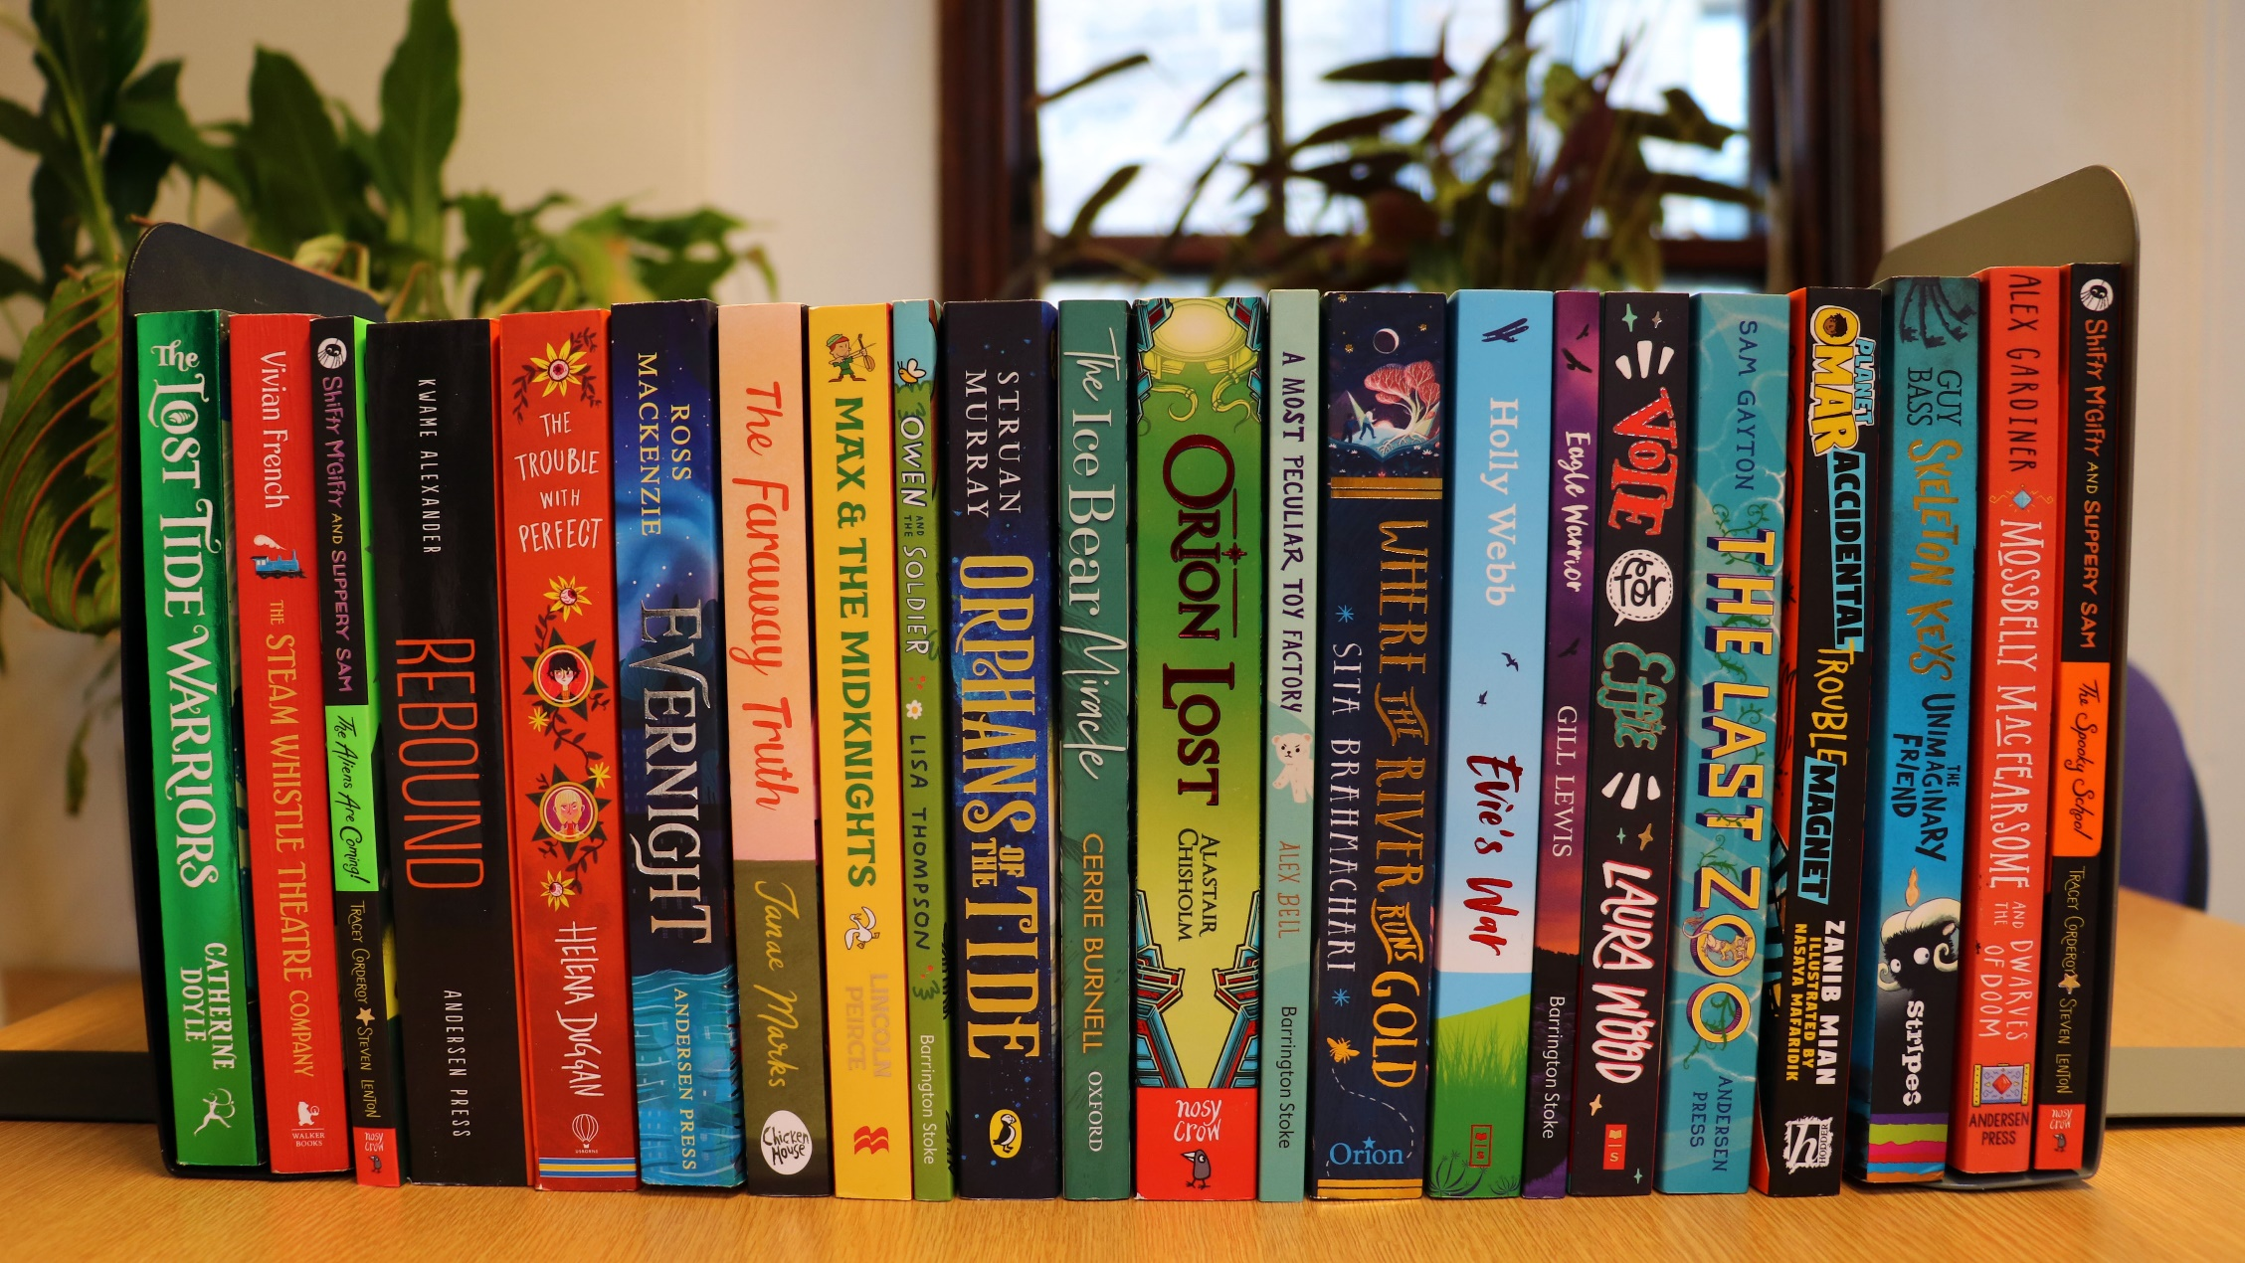

Running a staff book club
Key area: 1.2.5

Level: Gold

Resource created by Scottish Book Trust

Tips and ideas for setting up and running a staff book club

scottishbooktrust.com

/scottishbktrust

@scottishbktrust

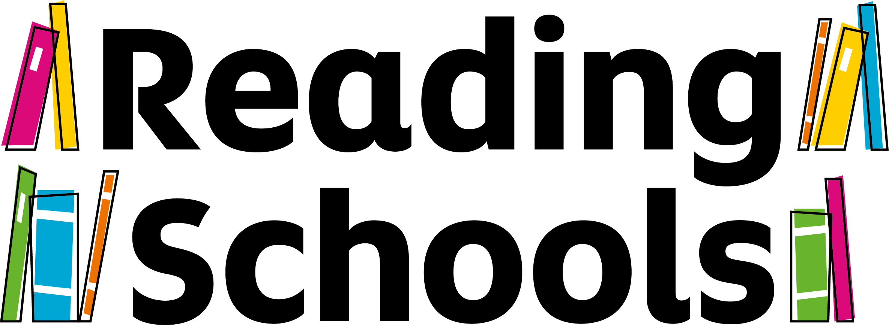
Contents
About this resource 1
Why set up a staff book club? 2
Test yourself and self-evaluation 2
Sourcing books 3
The logistics 5
Running a meeting 6
Book recommendations 8

About this resource
Running a staff book club is one activity you can run in your school to contribute to your Gold Reading Schools accreditation. You must also sustain core and silver level activities. For Gold accreditation, the framework states that:
“At gold level schools should confirm they are creating opportunities for staff to explore, share and discuss contemporary children’s.”
Running staff book club shows that you are dedicated to increasing staff knowledge of children’s literature in your setting. This knowledge can be used to:
- Make informed and tailored recommendations
- Introduce pupils to a diverse range of formats and genres
- Inform lesson planning and project planning
- Create a support network and reading community across your school or setting.
This resource contains a self-evaluation tool to help you assess your current knowledge of children’s literature, and help you identify potential gaps in your knowledge. You can return to this activity at any point during your staff book club to help you reflect on your professional development.
This resource also contains suggestions for running your book club, as well as activities to help keep the enthusiasm going.
Remember: the key to any successful book club is finding the right format, time and place to suit you and your colleagues. And, of course, reading great books. Use and adapt this resource as you see fit.

Why set up a staff book club?
A staff book club is a great way to create a network of readers amongst staff. It increases your knowledge of children’s books, but more importantly, holding a staff book club can be great fun! Gathering to talk about reading and books, over a cuppa and some cake, is a great way to spend time with colleagues and creates a supportive and dedicated space for book-chat only.
Research
Recent research has also shown that increasing your knowledge of contemporary children’s literature is vital to teaching pupils to read for pleasure. Research undertaken by The Open University as part of their Reading Rich pedagogies project found that knowledge of a variety of children’s texts was essential to supporting the development of children as readers. You can find out more about why developing your knowledge of children’s book is so important in our article summarising the research.
Be a reading role model
By setting up a staff book club, you are also actively sharing your reading life in your school setting and acting as a reading role model. It can be very powerful for pupils to see teachers’ reading lives; you are modelling to the pupils the importance of creating a reading identity, as well as modelling good reading habits such as trying new and unfamiliar titles or genres.
Relevance
By staying abreast of recently published books and reading them in your book club, you are ensuring the books you read are relevant to young people’s lives. Reading contemporary titles is vital to ensure your recommendations are relevant to young people’s current experience and concerns, such as digital technology, climate change, the refugee crisis or diversity. These issues will resonate with children and young people, and they are far more likely to read (and continue to read) books they connect to.

Test yourself and self-evaluation
The first step in setting up a book club is to test your current knowledge; to self-evaluate and assess where your current gaps in knowledge are. This will help you and your colleagues decide where to focus your reading time, but also highlight any strengths and knowledge already within the group. The activity below can be completed individually, or as a group activity at your first meeting.

The 5-minute challenge
Set a timer for 5 minutes, and challenge yourself or your team to write down all the children’s authors you can think of. Initially, you might like to focus just on fiction authors but you can include non-fiction authors too. You can complete this activity alone, or in small groups or pairs.
At the end of the time, reflect on the activity. How did you find the activity? Was it easy or hard? Do you have a range of authors across genres e.g. humour, horror, sci-fi, or are they all from the same genre? If working in groups, ask the groups to share how they found it.
As an extension activity, highlight or circle all the authors who have had a book published in the last two years. This will help you assess whether your knowledge is of contemporary children’s literature, or if you are using familiar favourites. Contemporary titles are important to ensure your recommendations are relevant to young people’s current experience and concerns, such as digital technology, climate change, the refugee crisis or diversity.
The 1-minute challenge
This activity is the same as the above, but as the time is greatly reduced, this task is more challenging. Set a timer for 1 minute, and write down all the children’s poets and illustrators you or your staff can think of.
Delivering this activity with teachers, we know that naming children’s poets can often be challenging. However, most schools do teach poetry throughout the year, and it is important that you are presenting pupils with a broad variety of engaging and interesting poets. Contemporary children’s poetry is often very accessible, and very enjoyable to share together.
Again, reflect on how you found this task, or ask groups to share how they found it.
A great icebreaker
As well as being a great way to test your knowledge and self-assess your current knowledge, these two activities are a good icebreaker activity for your book group. It is a great way to start conversations about books and authors and get discussion flowing.

Sourcing books
Sourcing books with limited (or no) budget can seem like a big obstacle in setting up your book club. Here are some top tips for sourcing books for you book club.
Throw the rulebook out the window
The first, and possibly most important thing to say, is that you do not all need to read the same book. This is a common format for book groups, but if you cannot source multiple copies of the same book, then don’t. In fact, to either pair read or read completely different books is a much better use of staff reading time. It has a number of benefits:
- You hear about more titles that are new each meeting or session, as everyone is reading something different.
- You can tailor what you read to your interests, your identified knowledge gap, or the interests of your current class.
- You can plan reading strategically as a group, ensuring that across the group you are reading a variety of genres.
- It is much more cost effective if you are purchasing books (as books can be added to classroom libraries or library stock after being read).
Local library service
Contacting your local library as well as your local schools library service, and finding out what support and books they can offer is always a great starting point. Remember you do not need to purchase books for your book club unless you want to. Most library services regularly update their stock with the latest titles, so you can still read contemporary children’s and young adult fiction. Find out what your library service can offer- your school library service might even have sets you can borrow if you do want to read the same book!
Review your current stock
Before purchasing any books, evaluate what you already have in your school, either your library or classroom library. What books do you already have available? When did you last purchase new books for your setting? Are there any books from your current school stock you would like to borrow and read? This might be an opportunity to read books that you know are popular with your pupils (and see what all the fuss is about!) or explore different genres in your current stock that you might not usually read or share with pupils.
Whilst you are reviewing your stock for you book club, this would also be the perfect opportunity to explore whether your current stock covers a variety of genres, and whether you feel the stock reflects the interests and experiences of your pupils. Ask staff to work with pupils to create a list of genres from each class, and feed this into a master list of genres from all year groups. This is also a good way to get a sense of pupil’s interests, and what they might be reading outside of class. Set your group a challenge to read one book from each of the genres pupils have identified and see if you can find them in your current stock.
Books for free
There are ways to access a limited amount of books for free, through competitions and giveaways. You can win a copy of each book featured in Scottish Book Trust’s #ChildrenBookChat on Twitter, by retweeting and engaging with the content. Twitter is a great place for giveaways, so keep an eye on publishers’ and authors’ Twitter feeds to win copies of upcoming titles. You can also enter our monthly Schools Book of the Month competition, to win one of multiple copies of our featured title.
You can also request PDF or digital copies of upcoming titles through NetGalley.com in exchange for a review. Many UK publishers use this site to gather feedback from learning professionals. You can also contact publishers directly to see if they have any pre-publication copies (proof copies) of books, which they can send to your book group.

The logistics
The logistics of setting up a book club can seem challenging, but there are a variety of different approaches and formats you can choose for your book club. You only need to meet regularly in person if this is what suits you and your group.
Let’s get physical
The most well-known format for a book club is to meet once every month or two to talk about the books you have read. And if this suits your colleagues and they are enthusiastic, then go for it! You could meet during a chosen lunchbreak, or outside of school hours if this suits you better. Remember to take advantage of libraries and local bookshops as a space to hold your meeting. There is nothing better than being surrounded by books whilst talking about them, and feeling completely immersed. Bookseller can also give great insights into new arrivals, and love hosting and supporting book groups, often offering discount for group orders.
Meet virtually
Meeting in person might not work for you, but you could still meet virtually. This might allow you to be more flexible on time and work around commitments many staff may have such as childcare. Meeting virtually might also allow you to invite staff from schools within your cluster, and create a book group that runs across a number of schools. Use whatever platform works best for you all (perhaps one you have experience of through blended learning).
If you are looking for tips and ideas of how to structure a virtual meet, you might like to attend a Scottish Book Trust Book Discovery session, which is an online book recommendation session.
Get interactive
You do not even need to meet up at all if that does not work for you and your colleagues! Get interactive and create a book club display either in the staffroom or around school for staff to add comments, reviews and thoughts on the books they are reading or have read. This is a great way to share your thoughts on a book, and to hear about new titles that your colleagues are enjoying.
If a physical, interactive board does not work for you, then go digital for this too! You can create a Jam Board on Google or a Wakelet board for each meeting, asking staff to drop in photos, comments or reviews. You could also use WhatsApp to post and share thoughts on books- perhaps setting aside a time to share reviews and photos.
Create a book club station
Another option might be to create a book station in your staff room. This could be a book display that you regularly update and rotate for colleagues to enjoy and interact with new books, and you could add a review card for each book from members of the book club. You could leave bookmarks for colleagues to take away too, with spaces for their thoughts on the display books that can be kept inside the book and passed to the next reader.
Meet on Twitter
Twitter is a great place to meet, share and have conversations about books. You could set up a book club twitter account and link to your school library or school account, or create a hashtag to tag all your book club comments on. You can use Twitter and other social media platforms to share what staff are reading, their thoughts on books, and show the wider community how much you value reading. Remember to tag any authors or poets in your tweets and let them know your thoughts on the book- many will be delighted to hear about your book club and respond!
Combine approaches
Equally, you don’t have to use just one of the approaches suggested here. You could use a combination or trial different approaches over a few months to see which works best for your staff and colleagues.

Running a meeting
Here are just a few different activity ideas (besides all of the wonderful book chat) that you might like to include in your meetings. These are great for sharing at an initial meeting and breaking the ice as people get to know each other, but are also great for dropping into regular meetings just to keep the discussion varied and exciting.
Book Jenga
Book Jenga is a great way to start conversations. Play like normal Jenga, except each block has a question on it relating to children’s literature, your reading, or book projects you use in school. It’s a way to facilitate conversations between staff and share ideas. Our Book Jenga resource has starter questions for you to use to help you create your own!
Book discovery
This is a great way to theme your meetings, asking everyone to bring a book to “discover” on a certain topic or theme. Hopefully, staff will discover new titles through the book group! Ask each staff member to bring a book that links to a certain theme or topic, and maybe set a challenge such as a 60-second-sell where they have to convince others to read it in just 60 seconds. Scottish Book Trust runs Book Discovery sessions on a range of topics if you are looking for inspiration. Themes you could explore are:
- Books to engage reluctant readers
- Picture books for older readers
- Diverse representation in picture/chapter books
- Books that explore STEM
- Books for a future class project
Book discovery offers a great opportunity to explore themes or genres identified as a gap in staff knowledge (see Test yourself and self-evaluation at the beginning of this resource). It would be worth doing this activity with staff first, then plan your book discovery themes.
Hook a book
This is a great activity to introduce a variety of new books, and help your group think about the genres they might be drawn towards.
Choose the first lines from some recent children’s books- this activity is to see whether that first line hooks you into reading! Ask staff to number each line from 1-5 (1 being very much like to read, 5 being definitely not). Discuss the lines and the scores that everyone gave. Does it fit with your usual reading habits? Or was there something that surprised you? Encourage staff to go away and find out more about these books.
Book matching
Book matching will help you think about book projects and integrating books across the curriculum (especially if you are working in a primary school). Select a variety of books and share the book jackets and blurbs with colleagues. Hand out topic cards and see if colleagues can match the topic with the books. Discuss ideas for class activities, and how you could link the book to learning in different subjects.
Book journey
A fun activity that always gets the creative juices flowing! Select a paragraph from a children’s or young adult fiction novel. Read it aloud to the group, and ask them to respond creatively to what happens next. They can write, tell a story verbally, draw or even make something in response to the paragraph! This is a fun activity to set at the end of book group, and come back to at the beginning of your next session. Everyone will respond differently, and use their imagination to take them on a different journey. To find out what happens in the book, though, everyone will need to read it!

Book recommendations
If you are looking for book recommendations, here are a few places to start:
- Scottish Book Trust publishes a book discovery guide every 6 months
- Scottish Book Trust has book lists for a range of ages
- First Minister’s Reading Challenge has book lists for your classroom- perfect for secondary staff. You can download a book list for:
  - Your art classroom
  - Your music classroom
  - Your P.E. classroom
  - Your geography classroom
  - Your history classroom
  - Your modern studies classroom
  - Your science classroom
- Download the Scottish Book Trust Bookzilla app to explore genres and set reading challenges
- Authors Live is a partnership run between Scottish Book Trust and BBC Scotland Digital Learning, featuring the best UK authors in live-streamed events. Some authors you will know and love, some will be new to you!
- Look at the long and shortlists of UK book prizes such as Bookbug Picture Book Prize, Scottish Teenage Book Prize, Waterstones Children’s Book Award and the CILIP Carnegie and Kate Greenaway Award.
- Speak to your local librarian to find out what is new in your local library
- Speak to a local book seller to hear about new titles
- Read Why You Should Read Children’s Books, Even Though You Are So Old and Wise by Katherine Rundell
- Get in touch with Scottish Book Trust via Twitter @ScottishBkTrust or schools@scottishbooktrust.com if you are looking for a specific recommendation.

