

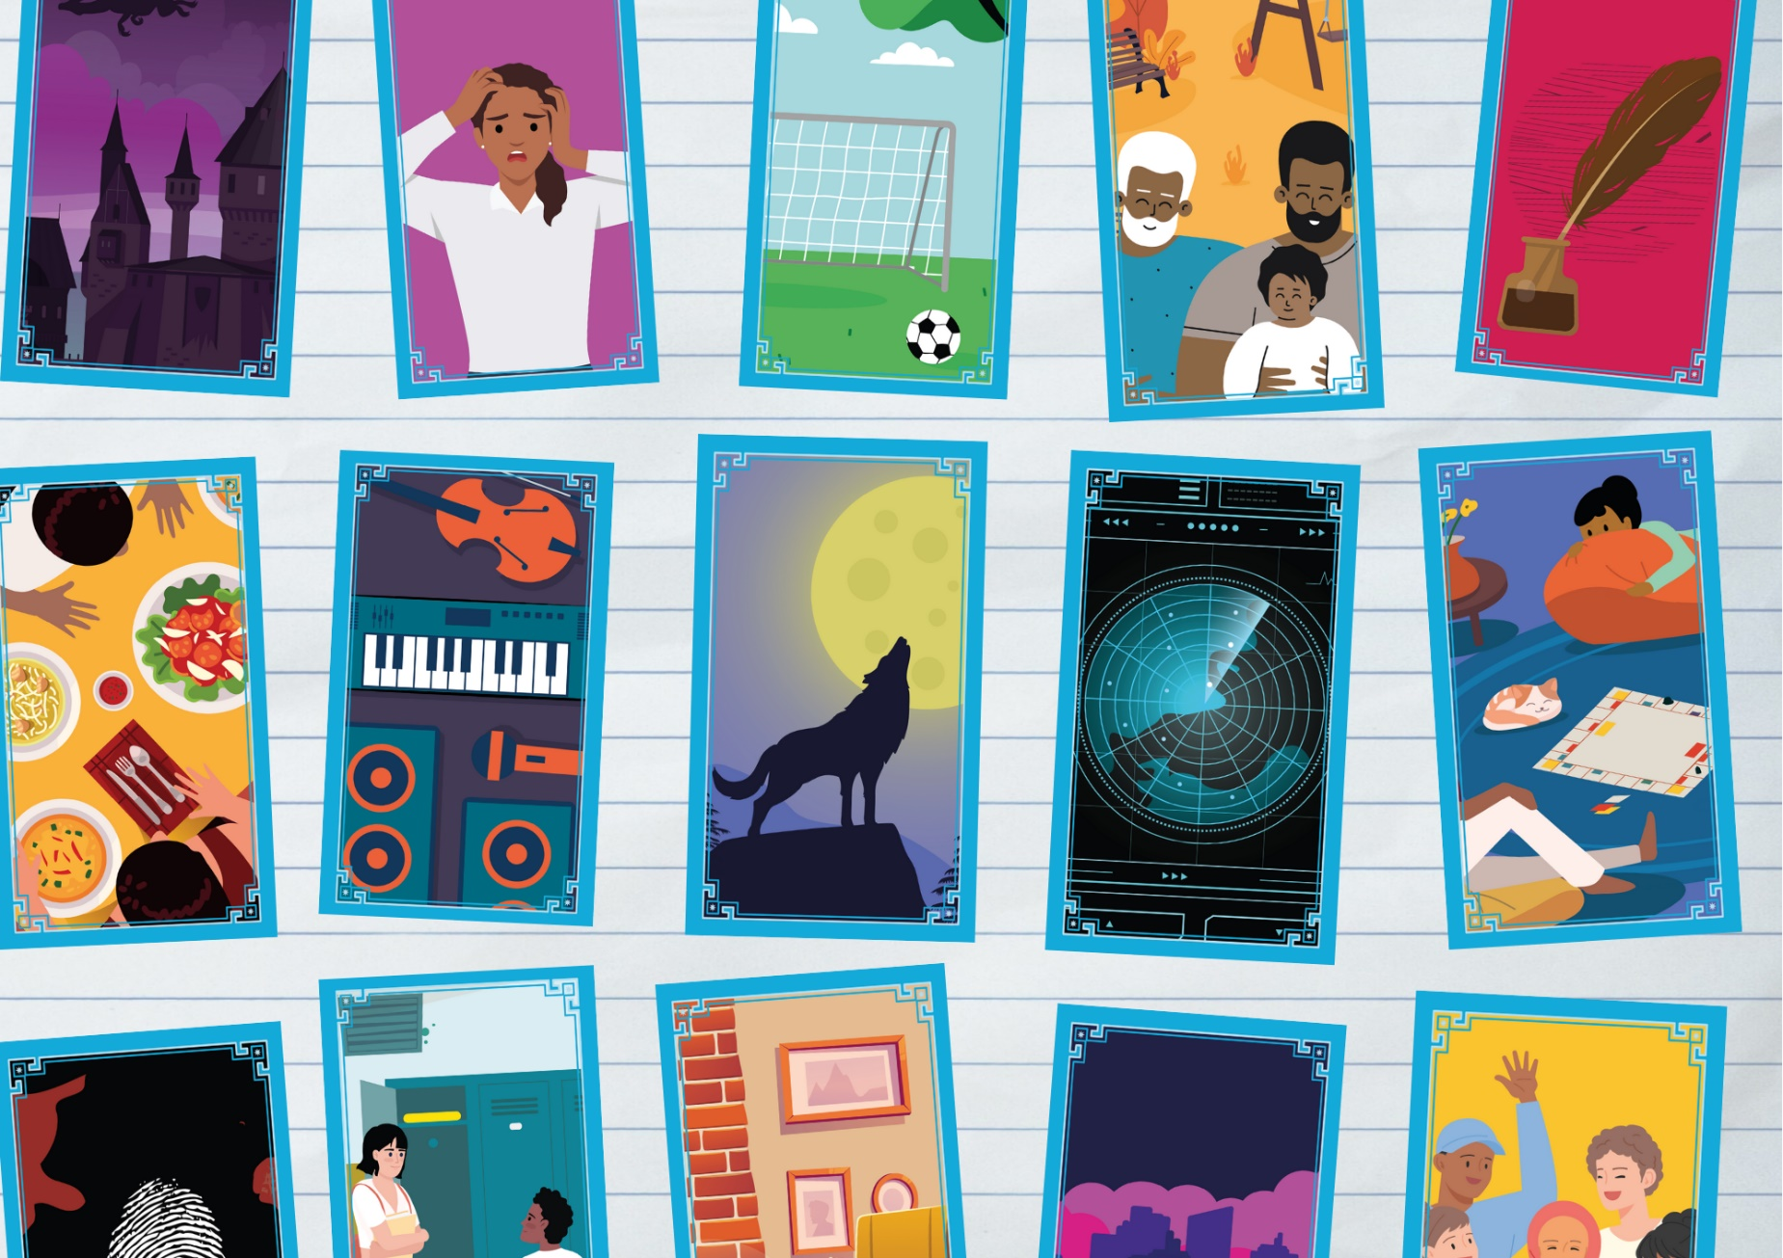

# Story Deck activities for creative writing

Activities for using Story Deck to prompt creative writing

## Age: 11-18

## Resource created by Scottish Book Trust



scottishbooktrust.com



Scottish Book Trust is a registered company (SC184248)

and a Scottish charity (SC027669).

## Contents

About this resource 2

Introducing the Story Deck 2

Creative writing activities 3

Solo activities 3

Group activities 11

Further resources 14

## About this resource

Story Deck is a set of cards that has been developed by [Scottish Book Trust](https://www.scottishbooktrust.com/) to spark structured conversations with young people about the stories they enjoy, including books, TV shows, films, music, video games and more. The goal of this is to help prompt discussion between adults and young people, supporting young people to develop language around their preferences, and the adults to be able to offer tailored recommendations. We have designed these cards to support anyone who works with young people aged 11–18, and they are based on three years of research with young people and librarians about young people and reading for pleasure.  
  
The activities in this pack have been designed to help you use Story Deck to prompt creative writing. If you would like resources to introduce Story Deck, see the [Story Deck resources webpage on the Reading Schools website](https://www.readingschools.scot/story-deck).

## Introducing the Story Deck

When using the Story Deck for the first time, it’s important to remember:

* None of the cards have a “correct” meaning, theme or genre. They are all completely open to interpretation. Don’t correct pupils, instead ask them to explain or explore what they see in the cards.
* It’s okay if pupils have strong reactions, including not liking certain cards or talking about stories they haven’t enjoyed. It’s also important that no one feel judged for anything they *do* like.

## Creative writing activities

### Solo activities

#### Activity 1: Freewriting

LIT 3-20a/4-20a, LIT 3-21a/4-21a, LIT 3-25a/4-25a, LIT 3-28a/4-28a  
Ask pupils to draw a card at random. Set a timer for five minutes and ask them to free write all their thoughts about the card. They could write a list of things that they see on the card, what they think of their card, what they think the card represents, etc. The most important thing is to keep the pen moving and not overthink it!

##### For pupils who want a challenge

* After finishing the freewriting, ask pupils to underline any phrases or ideas they like the idea of and make them the title for your next piece of writing
* Set your timer for longer periods

#### Activity 2: Two versions

LIT 3-20a/4-20a, LIT 3-26/4-26a, ENG 3-27a/4-27a, LIT 3-28a/4-28a,  
LIT 3-29a/4-29a, ENG 3-31a/4-31a   
This activity is adapted from [Brian Conaghan’s creative writing lessons](https://www.scottishbooktrust.com/learning-resources/brian-conaghans-creative-writing-lessons). Ask pupils to choose one of the cards. Now, either ask them to pick, or let them draw from a hat two different genres. For example:

* Drama
* Sci-fi
* Romance
* Thriller
* Adventure
* Western
* Fantasy

You could also invite them to investigate or research other genres. If you’re in the library you could look at some book blurbs for inspiration. The aim of this activity is to write two different versions of a story based on the same card. How could one card be used in a Western genre? How could it also be used in a romance genre?  
  
For example, for this card:



**Romance:** At the press conference announcement of a new film, two long-time rivals discover they are to act together for the first time... **Sci-fi:** When an alien crash lands on Earth, translators from around the world rush to be the first to translate their alien language.  
  
For pupils who want a challenge

* Ask pupils to think about combining two different genres

#### Activity 3: Exploring tone

LIT 3-20a/4-20a, LIT 3-23a/4-23a, LIT 3-25a/3-25a, LIT 3-26a/4-26a,   
ENG 3-27a/4-27a, LIT 3-28a/4-28a, ENG 3-31a/4-31a  
This activity is adapted from [Brian Conaghan’s creative writing lessons](https://www.scottishbooktrust.com/learning-resources/brian-conaghans-creative-writing-lessons). Define and discuss the following tones of writing:

* Humorous
* Serious
* Conversational
* Formal

What do your pupils associate with each tone? How would a writer create this tone in their work? Now, ask pupils to choose a card and map out how the card would be seen in these different tones. For example:

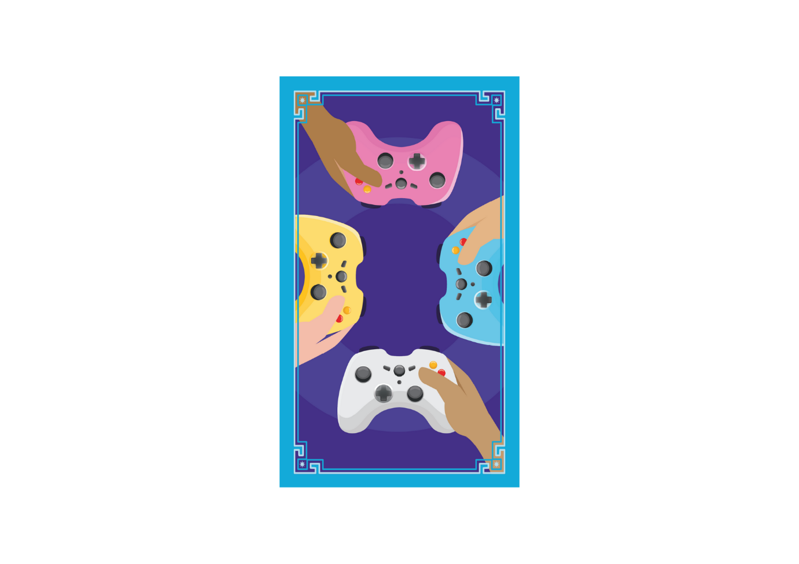

**Humorous:** whoever loses this game of Mario Kart has to tell Mum they broke her favourite chair!  
  
**Serious**: We woke up in an arena with no memory of how we got there. This game’s stakes are higher than we thought...  
  
**Conversational**: We played a lot of games that summer, but I didn’t realise then that that would be the last time we’d play together.  
  
**Formal**: The report in the newspaper stated that before she went missing, she was the youngest CEO of a gaming company in history.

##### For pupils who want a challenge

* Combine this with the previous activity to play with both genre and tone

#### Activity 4: Sparking personal writing

LIT 3-20a/4-20a, LIT 3-25a/4-25a, LIT 3-26/4-26a, LIT 3-28a/4-28a,   
ENG 3-30a/4-30a  
Ask pupils to draw a card at random. Give them some time to look at it. Does it spark any memories? Or does it remind them of somewhere they’ve been or someone they know? Perhaps it reminds them of a TV show, film or video game they’ve watched or played, a book they’ve read or a song they’ve listened to. Ask them to write down everything they can associate with that card in terms of their own experience or memories.  
  
This activity is adapted from our [Guide to personal writing resource](https://www.scottishbooktrust.com/learning-resources/a-guide-to-personal-writing). **Please note**: pupils may be facing circumstances that mean the reflection involved in personal writing can put them in the difficult position of confronting traumatic experiences. If you’re worried about a pupil in your class, [Mind’s website has a list of resources and organisations](https://www.mind.org.uk/for-young-people/how-to-get-help-and-support/useful-contacts/) that can help support young people with their mental health. **We advise you use your discretion about delivering personal writing**, and adapt activities in this resource with the children you work with in mind.

#### Activity 5: What do they see?

LIT 3-20a/4-20a, LIT 3-26a/4-26a, ENG 3-27a/4-27a, ENG 3-31a/4-31a  
Ask pupils to choose a card. Now, ask them to write a list of what they think someone who was in that card would:

* See
* Feel
* Hear
* Smell
* Taste

Explain how these details can help develop a scene and setting. For future activities, you can ask them to come back to this list as a ready-made setting for a story. You can also find a group version of this activity later in this resource.

#### Activity 6: Draw three

LIT 3-20a/4-20a, LIT 3-26/4-26a, ENG 3-27a/4-27a, LIT 3-28a/4-28a,   
ENG 3-31a/4-31a  
Ask the pupils to choose three cards that they like. If you don’t have enough sets, you can display [the Story Deck key on your screen](https://www.readingschools.scot/story-deck/how-to-use). Now tell them that from those cards they have to choose which one represents character, which one represents setting and which one represents plot.   
  
Remember: it’s about their interpretation rather than there being a “correct” way to use each of the cards. See an example below!

|  |  |
| --- | --- |
| **Card** | **Story element** |
| Card 47 which shows a person wearing headphones and sunglasses | Character: a DJ |
| Card 28 which shows a crow on a branch | Setting: a fantasy land |
| Card 15 which shows a rucksack on a hilltop beside a sign pointing in multiple directions | Plot: a quest to find a special magical instrument |

##### For pupils who want a challenge

* Try not to choose a person card for character, a landscape card for setting or an object card for plot!
* Draw random cards instead of three favourites

#### Activity 7: Story Deck stones

LIT 3-20a/4-20a, LIT 3-24a/4-24a, LIT 3-25a/4-25a, LIT 3-26/4-26a, LIT 3-28a/4-28a  
This idea is adapted from our [How to make poetry stones resource](https://www.scottishbooktrust.com/learning-resources/how-to-make-poetry-stones). Ask pupils to go through the cards using the [Story Deck image key](https://www.readingschools.scot/story-deck/how-to-use), writing down a one-word summary of each card based on their own interpretations.  
  
They can then use these words to create poetry stones. If you don’t have stones, they can write the words on separate cards or post it notes. The challenge is then to create a poem using these words!

#### Activity 8: 50 Word Fiction

LIT 3-20a/4-20a, LIT 3-26/4-26a, LIT 3-28a/4-28a  
Look up the current prompt for our monthly [50 Word Fiction competition on the Scottish Book Trust website](https://www.scottishbooktrust.com/50-word-fiction). As the pupils to decide which card they think fits this month’s theme the best. Now, use our [Using 50 Word Fiction to support creative writing in school](https://www.scottishbooktrust.com/learning-resources/using-50-word-fiction-to-support-creative-writing-in-school) to create, and submit, your own 50 word stories!

Activity 9: Make a zine  
LIT 3-20a/4-20a, LIT 3-24a/4-24a, LIT 3-26/4-26a, EXA 3-02a/4-02a   
Print copies of the [Story Deck image key](https://www.readingschools.scot/story-deck/how-to-use), or photocopy cards, and use our [How to make a zine video and template](https://www.scottishbooktrust.com/articles/how-to-make-a-zine) to learn how to make your own zine. Your zine could be:

* Collage or drawings inspired by their interpretation of the card
* A short story or poem in response to a card
* A six-page story or comic that uses images of the cards as each panel

#### Activity 10: Create a plot diagram

LIT 3-20a/4-20a, LIT 3-25a/4-25a, LIT 3-26/4-26a, LIT 3-28a/4-28a,   
ENG 3-31a/4-31a  
A plot diagram is a graph which shows the different elements of a narrative. A story often has five key points:

##### Exposition

This is the set up of the story, including who the key characters are, the setting and any key background information. To write this section you might ask yourself:

* Who is my main character?
* What kind of world do they live in?
* What is their life like?

##### Conflict

This is the part of the story where something happens that changes the character’s everyday life. To write this section you might ask yourself:

* What would challenge this character, or completely change their life?
* If that happened, what would they need to do next?

##### Rising action

This is where the story builds tension as it leads to the climax, this section often includes a series of problems that prevent the character from achieving what they need to in the story. To write this section you might ask yourself:

* What blockades or problems could stop my character from achieving their goal?

Climax  
This is where the tension of the story is at its highest and the main conflict is resolved. To write this section you might ask yourself:

* Where has this story been building to?
* What will happen to the main character?
* How can I combine the events of the story with the character’s own internal journey?

Falling action  
This is what happens directly after the climax and helps move the story towards its resolution. To write this section you might ask yourself:

* Now that everything has been revealed, what will help bring us to the conclusion of the story?

Resolution  
This is where the story ends – the plot concludes, the main conflict is resolved and any loose ends are tied up. To write this section you might ask yourself:

* How does this story end?
* What happens to each character?
* Are there any unanswered questions?

Using this map from [Backstage.com](https://www.backstage.com/magazine/article/what-is-rising-action-of-a-story-75562/) ask pupils to draw their own plot diagram. Ask them which of the Story Deck cards they think represents each of the five elements of their story. For a simplified version, you could remove the rising action and falling action and instead focus on exposition, conflict, climax and resolution.  
  
A plot diagram. 

The exposition is card 17 which shows a dragon and castle. 

The conflict is card 24 which shows three vials of liquid or potions. 

The rising action is card 15 which shows a rucksack on a hilltop beside a sign pointing in multiple directions. 

The climax is card 44 which shows a cage. 

The falling action is card 32 which shows a variety of weapons including swords, axes and a bow and arrow. 

The resolution is card 42 which shows two people hugging.

### 

### Group activities

Activity 1: Keep it a secret  
LIT 3-02a/4-02a, LIT 3-04a/4-04a, LIT 3-07a/4-07a, LIT 3-20a/4-20a, LIT 3-26/4-26a, LIT 3-28a/4-28a  
Everyone in the group must draw a card – but keep it secret from everyone else! Then, they write an opening paragraph about that card (you could use Activity 1: Freewriting or Activity 4: What do they see? to help them frame what they write). Once everyone is ready, they take it in turns to read what they have written aloud, and everyone has to guess what card they were writing about.  
  
Activity 2: Consequences  
LIT 3-02a/4-02a, LIT 3-04a/4-04a, LIT 3-06a/4-06a, LIT 3-09a/4-09a  
Deal the deck so that everyone has an equal number of cards. Look at your cards but don’t show them to anyone else. The first player sets up the story by playing a card and saying a sentence linked to that card. Players then take it in turns to add another sentence or line to the story. For example:

|  |  |
| --- | --- |
| **Card** | **Story** |
| Card 29 which shows a group of people cheering | Player 1: “Our story begins when a group of friends have to go on a school trip.” |
| Card 33 which shows a sonar screen showing a country being scanned | Player 2: “However, they don’t know they’re being watched by a super-secret organisation, who is tracking their whereabouts at all times…” |
| Card 25 which shows a hooded person in front of a computer | Player 3: “One of the group realises that their phone has been hacked. Surely, that’s the reason they’ve all received the same text message, inviting them to play a new game?” |

Players can play whatever card they would like from their hand, so long as they come up with a way to tie it into the previous line of the story.

Activity 3: Sense profiles  
LIT 3-02a/4-02a, LIT 3-04a/4-04a, LIT 3-07a/4-07a, LIT 3-20a/4-20a, LIT 3-26/4-26a, LIT 3-28a/4-28a  
Put your class or group into groups of three and give each card a random card. In the group, each person picks a sense from:

* See
* Feel
* Hear
* Smell
* Taste

Each person writes a paragraph about their sense in relation to the card – e.g. what someone in that card might see, feel, hear, smell or taste. Once they’ve finished writing their paragraphs, all three members of the group come together to compare their writing. How were they similar? Did they have any differences?  
  
You can leave some time for each group to introduce their card to the entire class or group, going through each sense profile they wrote.

Activity 4: Card swap  
LIT 3-02a/4-02a, LIT 3-04a/4-04a, LIT 3-07a/4-07a, LIT 3-20a/4-20a, LIT 3-26/4-26a, LIT 3-28a/4-28a  
Once your pupils have a created a piece of creative writing, put them in pairs to swap their writing. After they’ve read each other’s writing, they can tell their partner what cards they would use to describe the other person’s piece.

#### Activity 5: Reading recommendations

LIT 3-02a/4-02a, LIT 3-04a/4-04a, LIT 3-07a/4-07a, LIT 3-11a/4-11a  
If you’re pupils have done Activity 2: Card swap, ask them to show these cards to a librarian or teacher and ask them for some recommended books they can read to help them get some writing inspiration.

## Further resources

### Story Deck

For more inspiration for using Story Deck in your school or library, see the [How to use Story Deck page](https://www.readingschools.scot/story-deck/how-to-use) on the [Reading Schools website](https://www.readingschools.scot/)

### Creative writing

For more [creative writing resources](https://www.scottishbooktrust.com/learning-and-resources/creative-writing-for-schools), see our creative writing resources:

* [Creative writing activities for upper primary](https://www.scottishbooktrust.com/learning-resources/creative-writing-activities-for-upper-primary)
* [Creative writing for secondary](https://www.scottishbooktrust.com/learning-resources/creative-writing-for-secondary)
* [Brian Conaghan's creative writing lessons](https://www.scottishbooktrust.com/learning-resources/brian-conaghans-creative-writing-lessons)
* [Young Scots Writer o the Year Award](https://www.scottishbooktrust.com/writing-and-authors/young-scots-writer-o-the-year-award)
* [Creative writing in Scots](https://www.scottishbooktrust.com/learning-resources/creative-writing-in-scots)
* [Writing poetry in Scots](https://www.scottishbooktrust.com/learning-resources/writing-poetry-in-scots)
* [Using 50 Word Fiction to support creative writing in school](https://www.scottishbooktrust.com/learning-resources/using-50-word-fiction-to-support-creative-writing-in-school)
* [How to make poetry stones](https://www.scottishbooktrust.com/learning-resources/how-to-make-poetry-stones)
* [How to make a zine](https://www.scottishbooktrust.com/articles/how-to-make-a-zine)

We also have the [Young writers section of our website](https://www.scottishbooktrust.com/writing-and-authors/young-writers) which supports young people with up-to-date opportunities, advice and writing inspiration!