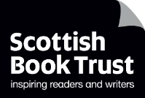

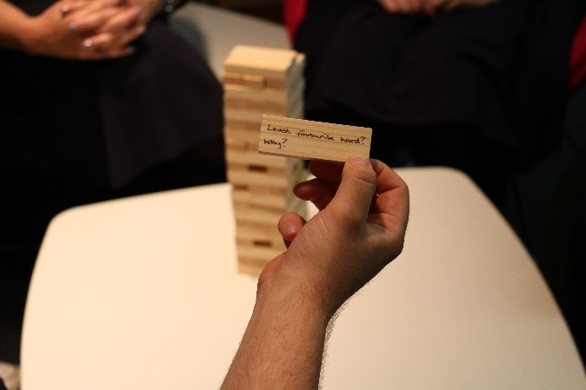

# How to play Book Jenga

A guide to playing Book Jenga

## Key Area: [2.3.3 – Creating learner social networks](https://www.readingschools.scot/resources/creating-social-networks)

## Level: Core and above

## Resource created by Scottish Book Trust



scottishbooktrust.com



Scottish Book Trust is a registered company (SC184248)

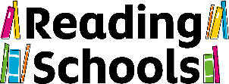and a Scottish charity (SC027669).

## Contents

About this resource 2

Creating your set 2

How to play 2

Ideas for questions 3

Further resources 6

## About this resource

Book Jenga was created by secondary school librarian, Deena Wren, winner of our [Learning Professional Award](https://www.scottishbooktrust.com/learning-and-resources/scottish-book-trust-awards/previous-learning-professional-award-winners). Book Jenga is a great and fun way to get talking about books and reading! You can write, or adapt, the questions to suite the age group or contexts of the children you work with.  
  
Playing Book Jenga can support delivery of [Key Area 2.3.3 – Creating learner social networks](https://www.readingschools.scot/resources/creating-social-networks).

## Creating your set

You will need:

* A set of Jenga blocks
* A pen
* Your chosen questions (see page x)

Charity shops are a great place to buy sets of Jenga, or other wooden blocks. Now, all you need to do is write a different question on each wooden block.

## How to play

You play book Jenga by building your tower and taking it in turns to pull out a block and answer the question on it. You can either answer the question yourself, or ask everyone in the group to answer the question before moving on to the next one. The used block is then placed on top of the tower. Gradually the tower builds and becomes less stable. As with all Jenga, the aim is not to topple the tower. The game ends when the tower falls!

## Ideas for questions

You can create your own book and literacy questions with your pupils, or you can use the questions from our list below.

* Name a book you wish you could see on the big screen?
* Who would you cast in the lead role, or roles, in an adaption of your favourite novel?
* Recommend a graphic novel.
* Best film adaption of a novel?
* Favourite dialect word.
* Recommend a ghost story.
* Favourite fictitious detective?
* Best TV series based on a book?
* Recommend a love story.
* Fiction or non-fiction?
* Least favourite word and why?
* Do you have a favourite book festival?
* Recommend a fantasy novel.
* Quote some Shakespeare.
* Recommend a Scottish novel.
* What songs and rhymes do you remember from childhood?
* Recite the lyrics to a song.
* Recite some poetry.
* What’s the genre you most want to try next?
* Recommend a sci-fi novel.
* Recommend an animal story.
* Two books for a desert island. What and why?
* Do you have a favourite publisher?
* Have you ever met an author?
* Recommend some non-fiction.
* Where is your favourite library?
* Favourite word and why?
* Think of a character who faces a difficult decision. How would you solve this problem?
* Recite a limerick or rhyme.
* Funniest think you have ever read?
* Favourite scots word?
* Favourite book as a child?
* Online or bookshop?
* Who is your favourite author?
* If you could meet any author, past or present, who would it be?
* What is your favourite genre?
* Last favourite book character?
* Best and worst book to read aloud?
* Character you wish was really your friend?
* What is your favourite genre?
* Least favourite book character?
* Where do you gravitate to in a bookshop?
* Recommend a classic story?
* Which author would you like to be stuck in a lift with?
* Best author event you’ve attended?
* Who if your favourite heroine?
* Recite a nursery rhyme.
* Who is your favourite poet?
* Print or e-books?
* Recommend a magazine or book journal.
* Worst film adaption of a novel?
* Best. Book. Ever. Why?
* Book you just couldn’t finish?
* Book you’ve re-read the most?
* Saddest thing you have ever read?
* Funniest thing you have ever read?
* Best monster in a story?
* Where is your favourite bookshop?
* Favourite picture book?
* Scariest thing you have ever read?
* What are you currently reading?
* Favourite series of books?
* Which character would you most like to be stuck in a lift with?
* Favourite heroine?
* Book that made you laugh out loud?
* Most relatable character?
* Favourite magazine or newspaper?
* Best TV series based on a book.
* Name three publishers.
* Book you were most excited to buy.
* Favourite book cover.
* Book you would like to see a sequel to.
* Best short story.

## Further resources

* For more ideas for delivering Key Area 2.3.3, see our guide to [Creating learner social networks](https://www.readingschools.scot/resources/creating-social-networks) on the Reading Schools website
* For more fun activities to do with your pupils, see the [Quick and fun activities](https://www.readingschools.scot/resources/quick-and-fun-activities-and-resources) on the Reading Schools website
* For more ideas for groups, clubs or games, see our [Running reading groups and events resource](https://www.scottishbooktrust.com/learning-resources/create-a-reading-culture-get-your-school-reading) on the Scottish Book Trust website