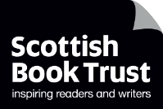

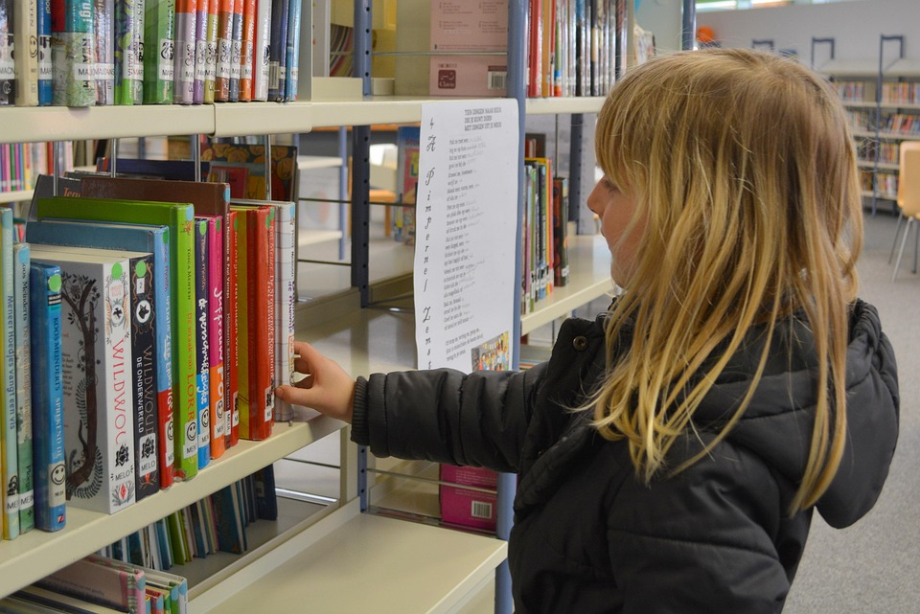

# Running a staff book group

Tips and ideas for running a staff book group

## Key Area: [1.2.5 Staff knowledge of contemporary children’s literature](https://www.readingschools.scot/resources/1-2-5-staff-knowledge-of-contemporary-children-s-literature)

## Level: Gold

## Decorative imageResource created by Scottish Book Trust

scottishbooktrust.com



Scottish Book Trust is a registered company (SC184248)

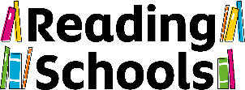and a Scottish charity (SC027669).

## Contents

About this resource 2

Why run a staff book group? 2

How to source books 3

How to structure your book group 5

Further resources 6

## About this resource

This resource explores how to run a staff book group with your colleagues. The focuses of this resource are:

* Why running a staff book group improves staff knowledge and pupils’ reading for pleasure
* How to source texts to read
* How to structure your staff book group

## Why run a staff book group?

Running a staff book group is a great way to develop staff’s knowledge of children’s literature. Not only is this covered under Key area 1.2.5 ([Staff knowledge of contemporary children’s literature](https://www.readingschools.scot/resources/1-2-5-staff-knowledge-of-contemporary-children-s-literature)), but it will also support other key areas, such as:

* [1.2.3: Staff being seen as readers themselves](https://www.readingschools.scot/resources/visible-staff-role-modelling-across-the-school)
* [2.3.2 – Staff led meaningful conversations around books](https://www.readingschools.scot/resources/staff-meaningful-conversations-around-books)

The [National Literacy Trust’s Reading trends report](https://literacytrust.org.uk/research-services/research-reports/children-and-young-peoples-reading-in-2023/) stated that, when asked, children included the following as motivations to read:

* Having books recommended to them
* Seeing characters that are like them
* Hearing people in their lives talk about books
* Seeing people that they look up to reading or talking about books

Exploring contemporary texts also ensures that texts are up to date, relevant and more representative of different lived experiences. As we’ve seen, children are more likely to read when they see characters like them in books or texts. Whilst representation is not perfect, contemporary texts are much more likely to represent pupils who are BPOC, LGBTQ+, disabled or neurodiverse or from other marginalised groups.

By strengthening your knowledge of contemporary children’s literature, you can offer your pupils text recommendations that are relevant to their personalities, interests and reading identities. A staff book group is a great way to share this knowledge across your entire staff. In the article [“Teachers' knowledge of children's literature: the cornerstone of reading for pleasure”](https://www.scottishbooktrust.com/learning-and-resources/teachers-knowledge-of-children-s-literature-the-cornerstone-of-reading-for-pleasure), Professor of Education Theresa Cremin says:

‘*Teachers with a rich and wide knowledge of children's literature and other texts, and a working knowledge of the young as readers, are best placed to help their pupils unlock the many and varied benefits of reading for pleasure*.’

## How to source books

### You don’t have to read the same thing!

The first rule of a staff book group is: **you don’t all have to read the same book**! Instead, use your staff book group as an opportunity to meet regularly, discuss what you’ve read and pick up some recommendations.   
  
This approach not only takes the pressure off having to source and read a specific book by a certain date but also allows you to share and learn about a much wider range of texts, children’s authors and illustrators.   
  
Explore what you’ve got  
Look at your school, or class library, or any other books in your school. For your first meeting, you could pull them all out and put them face up on a table, allowing everyone to look at what you already have. This is also a great way to notice any gaps you may have in terms of representation, format or genre.

Ask your local library or bookshop for recommendations  
You could ask what children’s books they like, or what books or texts are most children borrowing or buying from the library or shop.

Ask your pupils for recommendations  
Learn directly from your pupils, or your [Reading Leadership Group](https://www.readingschools.scot/resources/reading-leadership-group), about what books they are already reading. You could set up a suggestion box for pupils, or an online form where they can submit their recommendations.

### Use our Teen book discussion guides

If you work with upper primary pupils or in a secondary school, see our [Teen book discussion guides](https://www.scottishbooktrust.com/learning-resources/teen-book-discussion-guides). These have been created to help you run a book group with pupils, but you could also use them for a staff book group!

Use our Book Discovery Guide or book lists  
Our [Book Discovery Guide](https://www.scottishbooktrust.com/learning-resources/book-discovery-guide) offers up-to-date recommendations of children’s books, including Scottish texts and recommendations based upon children’s interests. Our [book lists](https://www.scottishbooktrust.com/book-lists) are designed to offer you recommendations for the young people you work with, and are filterable by age and theme.

### Watch Authors Live

Our [Authors Live on demand](https://www.scottishbooktrust.com/authors-live-on-demand) broadcasts are filmed with world-class children’s authors and illustrators. In each broadcast, you can hear a bit more about the author and their work, as well as a reading or activity based on one of their books. This can be a great way for you to discover some new names!

### Explore different formats and genres

Chapter books or novels aren’t everyone’s cup of tea, so we encourage you to explore different kinds of texts. This could include:

* Graphic novels and comics
* [Magazines or newspapers](https://www.scottishbooktrust.com/articles/all-reading-is-good-reading-comics-and-magazines)
* [Audiobooks](https://www.scottishbooktrust.com/articles/all-reading-is-good-reading-audiobooks)
* [Manga](https://www.scottishbooktrust.com/articles/all-reading-is-good-reading-manga)
* [Gamebooks](https://www.scottishbooktrust.com/articles/all-reading-is-good-reading-gamebooks)

## How to structure your book group

### In-person or online

As well as having a traditional in-person book group, you could also explore online options. That could be hosting it on Teams or Zoom or looking at other online spaces where you can share recommendations such as a Wakelet.

### Books in your staffroom

Create a station in your staffroom where people can borrow books. You can also leave some blank post-it notes for people to add their own review or thoughts.

### Book Jenga

Why not play Book Jenga? This game, created by secondary school librarian Deena Wren, is just like regular Jenga, except every brick has a conversation prompt to get you chatting about books, reading and your preferences. See our [How to play Book Jenga resource](https://www.readingschools.scot/resources/how-to-play-book-jenga) to get started!

### First lines

Each share the first 1-3 lines of a book. This can be one you’ve read or one you have in your school. Everyone can keep track of which they do, or don’t, like the sound of. This is also a great way to prompt discussion – which lines were you drawn to? Why? Does it fit with the types of books or text you normally read?

### 60 second sell

Ask everyone to sell a book they’ve read recently to everyone else in the group. The only catch is – you only have sixty seconds!

## Further resources

* For more ideas for delivering Key Area 1.2.5, see our guide to [Staff knowledge of contemporary children’s literature](https://www.readingschools.scot/resources/1-2-5-staff-knowledge-of-contemporary-children-s-literature) on the Reading Schools website
* For more information on the importance of staff knowledge of contemporary children’s literature, see our articles [“Teachers' knowledge of children's literature: the cornerstone of reading for pleasure”](https://www.scottishbooktrust.com/learning-and-resources/teachers-knowledge-of-children-s-literature-the-cornerstone-of-reading-for-pleasure) and [“How teachers can put the right book in the right hand”](https://www.scottishbooktrust.com/articles/how-teachers-can-put-the-right-book-in-the-right-hand)
* For book recommendations, see our [Book Discovery Guide](https://www.scottishbooktrust.com/learning-resources/book-discovery-guide) or [Book lists](https://www.scottishbooktrust.com/book-lists) on the Scottish Book Trust website