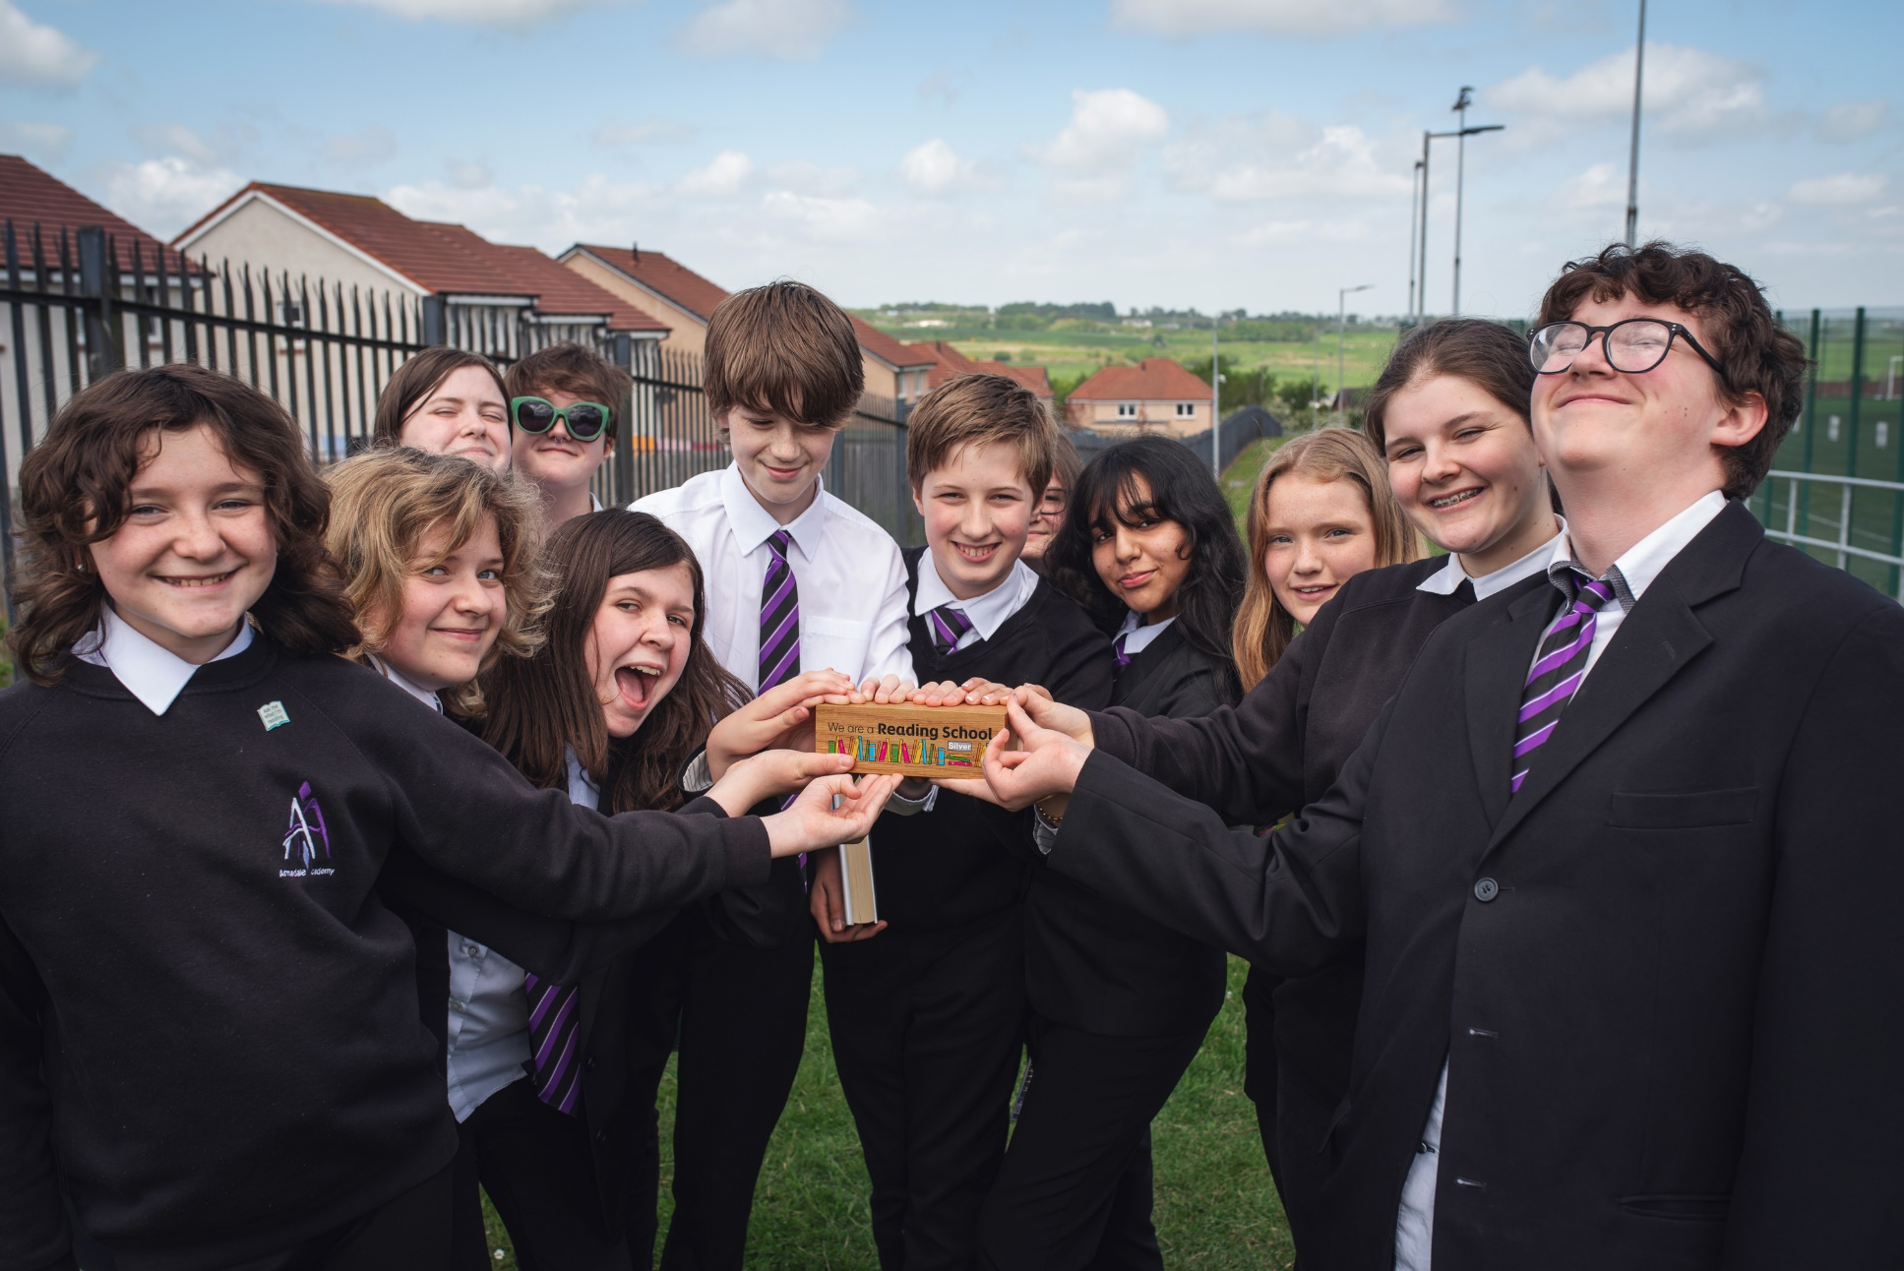

# Communicating your Reading Schools achievements

A resource to support the ways in which you can communicate your achievements and celebrations

## Decorative imageKey Area: [3.2.1 Rewarding progress and recognising personal achievements](https://www.readingschools.scot/resources/rewarding-progress-and-recognising-personal-achievements)

## Level: Core, Silver, Gold

## Resource created by Scottish Book Trust

scottishbooktrust.com



Scottish Book Trust is a registered company (SC184248)

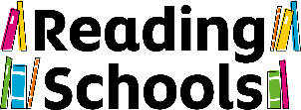and a Scottish charity (SC027669).

**Contents**

About this resource 1

How to write a press release 3

Appendix 4

Example press release 6

## About this resource

This resource has been created by Caroline Young, Marketing and PR Manager at Scottish Book Trust.  
  
We know that you want to shout about your success with Reading Schools, and contacting your local paper or broadcaster is a great away to demonstrate to your local community all that you have achieved. By sharing your stories, you can also help encourage other schools to follow your lead and achieve their trophies too.  
  
This guide is designed to help you put together your information on Reading Schools, with tips on how to ensure your wording is correct when you communicate your accreditation publicly. You can also find some tips on sending out photographs and how to structure a press release.

### What is Reading Schools?

When you are putting together your communications, use the following to describe Reading Schools:  
  
The Reading Schools programme, developed by Scottish Book Trust, is an accreditation programme for schools that are committed to building a reading culture for their learners and communities.  
  
The programme supports schools to build a reading culture, where every pupil is encouraged to feed their imagination through books.  
  
There are three levels of accreditation – Core, Silver and Gold.

### About Scottish Book Trust

When communicating about Reading Schools, you should give credit to Scottish Book Trust.  
  
We should be styled as “Scottish Book Trust” not “The Scottish Book Trust” and referred to as ‘Scotland’s national charity changing lives with reading and writing’.  
  
We should also be described as ‘a national charity that transforms lives through reading and writing.’

### Types of communication

You can get in touch with the council press office in your local authority who can advise on contacts with local press. It’s a good idea to keep them aware and involved in any comms for your school.

If you know of a local paper that may be interested, you can send an email to the editor or education reporter with a brief paragraph on what news you believe would be of interest. This could be the school being visited by an author, achieving a new Reading Schools level of accreditation, or hosting a special reading event.

If you have a special event happening, you could ask the local paper to send a photographer or a reporter to the event to speak to pupils.

You could also submit some photos, as long as permissions are in place, to see if they would be interested in covering your event.

To formalise your communications, you could put together a formal press release to send to local media, which will provide them with all the relevant information so that they can publish it as is. This would be a great way of promoting your school’s accreditation.

## How to write a press release

At the top of the email write “PRESS RELEASE” in block capitals, followed by “FOR IMMEDIATE RELEASE” if this is the case, or “EMBARGOED UNTIL” plus relevant date and time.   
  
Write a short, catchy headline without exclamation marks or exaggerations.   
  
Your press release should be around 400 to 500 words and written in the third person. The following structure is a good guideline:  
  
Summarise the release in the first line – include the who/what/when/why/where as relevant.    
  
One or two paragraphs with further details and context, e.g. information about your school and the Reading Schools programme, and what you have been doing to achieve your trophy.   
  
A short quote or two – one from the headteacher or the teacher leading on the Reading Schools, as well as one of your Reading School ambassadors.

At the end of the release - write ‘ENDS’ and then insert Notes to Editors at the end of the release – this is information about your organisation and about Scottish Book Trust. (Please find this information in Appendix 1 and 2).   
  
Do not forget to include clear contact details, such as an email address and the school’s website if you have one.

### Distributing your press release

It is best to paste the text of the press release into the body of the email rather than sending it as an attachment. Find out the publication day and print deadlines of your local papers and send them the release in plenty of time beforehand.     
  
If you would like a list of press contacts in your local area, please email [caroline.young@scottishbooktrust.com](mailto:caroline.young@scottishbooktrust.com).

### Photography

Don’t overcrowd them with too many elements or have excessive branding.  
  
Taking photos outside often comes out better, otherwise make sure the room is well lit.  
  
Do not send anything larger than 4mb (ideally 1 or 2 mb as they will ask if they need a larger file).    
  
Include a photo caption to be included, e.g. ‘Pupils from [school name] celebrate winning their Gold Reading Schools trophy.’  
  
As ever, make sure you have appropriate permissions from your pupils’ parents or carers before sharing photography with press.

## Appendix

### Appendix 1 – wording on Reading Schools

The Reading Schools programme, developed by Scotland’s national charity changing lives with reading and writing, supports schools to build a reading culture, where every pupil is encouraged to feed their imagination through books.

### Appendix 2 – Note to Editors

Include alongside information about your school and the author. 

#### Scottish Book Trust

Scottish Book Trust is a national charity that believes everyone living in Scotland should have equal access to books. Our work provides opportunities to improve life chances through books and the fundamental skills of reading and writing. Access to books and a love of books bring many important benefits from family bonding and advancing children’s learning, to unlocking creativity, helping employability and improving mental health and wellbeing. Scottish Book Trust aims to support all communities across Scotland, with particular focus on those who are vulnerable and under-represented.

Our programmes and outreach work include:

* Gifting books to every child in Scotland to ensure families of all backgrounds can share the joy of books at home, through Bookbug and Read, Write, Count
* Working with teachers to inspire children to develop a love of reading, creating innovative classroom activities, book awards and author events such as Authors Live with the BBC
* Supporting and nurturing Scotland's wide-ranging literary talent, both emerging and established through our training, awards and writing opportunities including New Writers Awards
* Creating events to share books and connect writers with communities, including Book Week Scotland
* Providing support to people living with dementia and their carers through Reading is Caring

In addition to the funding we receive from the Scottish Government and Creative Scotland, we need the constant support of trusts and foundations, corporate sponsors and individual donors.

Find us online at [scottishbooktrust.com](https://www.scottishbooktrust.com/). Follow [@scottishbktrust on Twitter](https://x.com/scottishbktrust/), [@scottishbooktrust on Instagram](https://www.instagram.com/scottishbooktrust) or like [Scottish Book Trust's Facebook page](https://www.facebook.com/scottishbktrust).

## Example press release

### FOR IMMEDIATE RELEASE

### Edinburgh primary is the first in the city to be named as a Reading School

Canal View Primary in Wester Hailes has become the first school in Edinburgh to be given the prestigious Reading School accreditation by Scottish Book Trust.  
  
The successful Reading Schools programme, developed by Scotland’s national charity changing lives with reading and writing, supports schools to build a reading culture, where every pupil is encouraged to feed their imagination through books.   
  
Reading for pleasure is central to supporting wellbeing, improving attainment across the curriculum, and boosting critical thinking, creativity, empathy and resilience.   
  
Canal View Primary is one of over 400 schools in Scotland to have been accredited through the programme and having achieved the first level, the school is now working towards progressing to silver status. The third, and top level, to be achieved is gold status.   
  
**Susannah Jeffries, Depute Head Teacher of Canal View Primary School said**: ‘We are so excited to be recognised as the first accredited Reading School in Edinburgh. Our whole school community is so proud that, in Edinburgh - the first ever UNESCO City of Literature – we are the first school to receive this award. We are also absolutely delighted to represent our community in Wester Hailes in such a positive way!’  
  
**Samuel, the primary seven Reading Leader** said: ‘Everyone’s worked hard to get the Reading School accreditation, especially the Reading Leaders. It’s great that everyone gets to share what they like to read as a whole school. I am proud and grateful that I could help the team get the award and spread the reading bug to everyone in our school.’

**Marc Lambert, CEO of Scottish Book Trust, said**: ‘We are thrilled that Canal View Primary has achieved the honour of being the first school in Edinburgh to be accredited as a Reading School.   
  
‘A Reading Schools accreditation is a fantastic accomplishment for pupils and teachers alike, and achieving this status is a way of demonstrating a school’s commitment to developing vibrant reading cultures and the many benefits this brings.’

* ENDS

### Notes to editors

Please direct all media requests to Caroline Young, Marketing and PR Manager at Scottish Book Trust at [caroline.young@scottishbooktrust.com](mailto:caroline.young@scottishbooktrust.com) or on 07846 195 905.

### Scottish Book Trust

Scottish Book Trust is a national charity that believes everyone living in Scotland should have equal access to books. Our work provides opportunities to improve life chances through books and the fundamental skills of reading and writing. Access to books and a love of books bring many important benefits from family bonding and advancing children’s learning, to unlocking creativity, helping employability and improving mental health and wellbeing. Scottish Book Trust aims to support all communities across Scotland, with particular focus on those who are vulnerable and under-represented.

Our programmes and outreach work include:

* Gifting books to every child in Scotland to ensure families of all backgrounds can share the joy of books at home, through Bookbug and Read, Write, Count
* Working with teachers to inspire children to develop a love of reading, creating innovative classroom activities, book awards and author events such as Authors Live with the BBC
* Supporting and nurturing Scotland's wide-ranging literary talent, both emerging and established through our training, awards and writing opportunities including New Writers Awards
* Creating events to share books and connect writers with communities, including Book Week Scotland
* Providing support to people living with dementia and their carers through Reading is Caring

In addition to the funding we receive from the Scottish Government and Creative Scotland, we need the constant support of trusts and foundations, corporate sponsors and individual donors.

Find us online at [scottishbooktrust.com](http://scottishbooktrust.com/). Follow [@scottishbktrust on Twitter](https://twitter.com/scottishbktrust), [@scottishbooktrust on Instagram](https://www.instagram.com/scottishbooktrust/?hl=en) or like [Scottish Book Trust's Facebook page](http://www.facebook.com/scottishbktrust).