

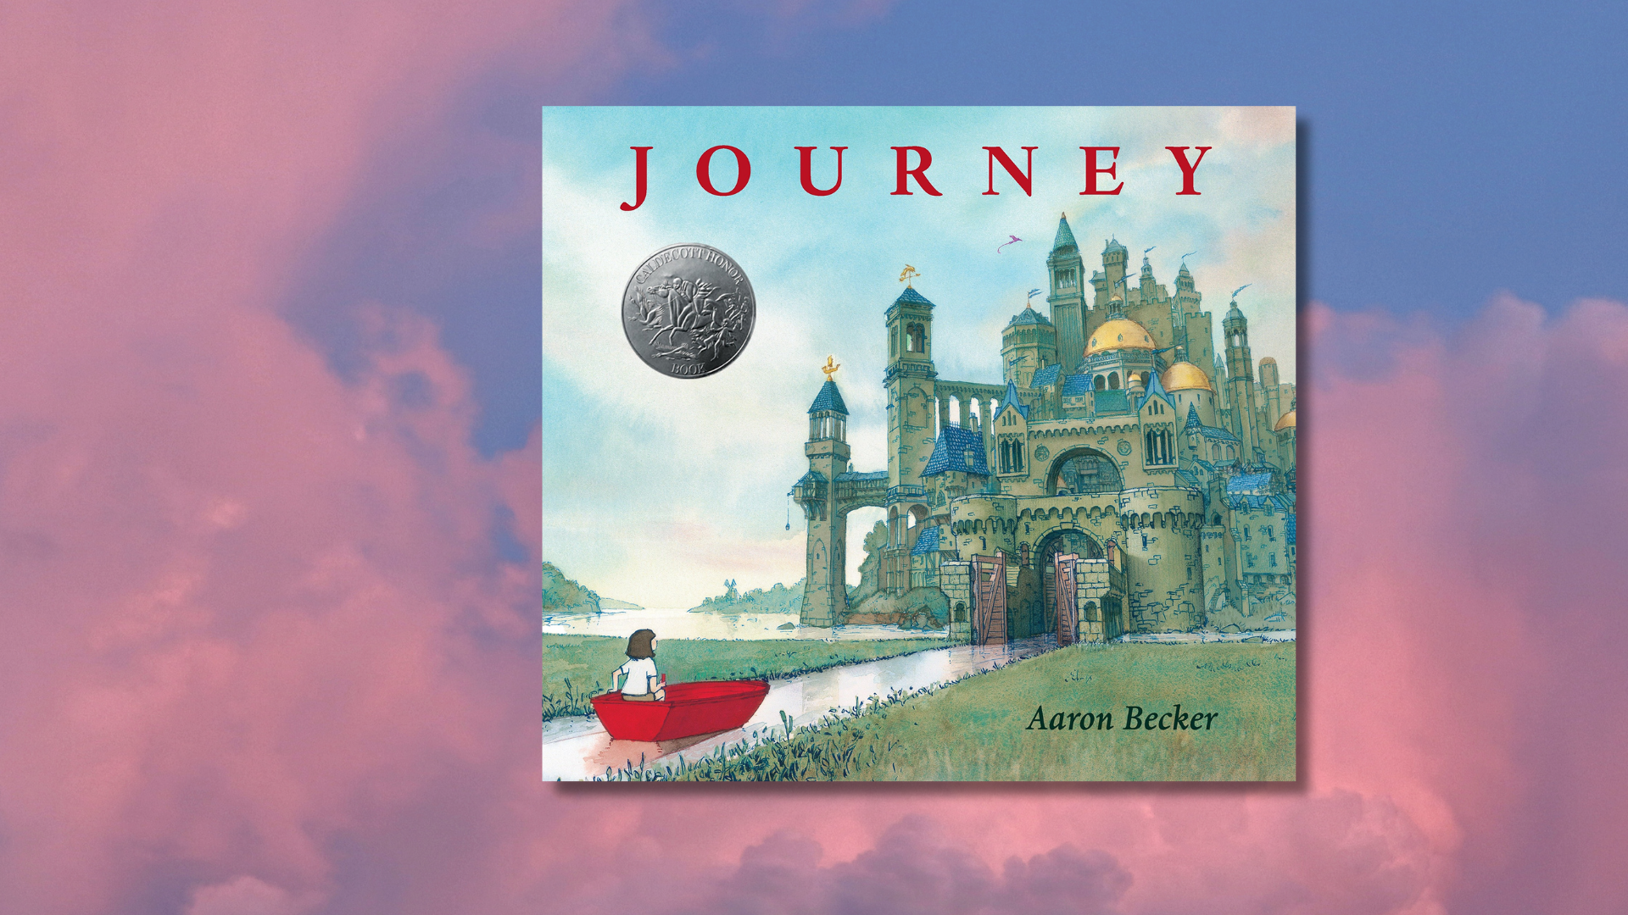

# Using *Journey* by Aaron Becker for a cross-curricular book project

Whole school activities inspired by Aaron Becker’s *Journey*

## Age 5-12

## Decorative imageCFE Levels Early, First and Second

## Resource created by Scottish Book Trust

scottishbooktrust.com



Scottish Book Trust is a registered company (SC184248)

and a Scottish charity (SC027669).

## Contents

About this resource 2

About *Journey* 3

Introducing the book to your class or school 3

Literacy and English activities 3

Health and wellbeing activities 7

Expressive arts activities 7

Technologies activities 10

Social studies activities 11

Further resources 11

## About this resource

The resource contains differentiated cross-curricular activities for Early, First and Second levels, adaptable to use as part of a whole school core book project involving ideas to support:

* Literacy
* Expressive arts
* Health and wellbeing
* Technologies
* Social Studies

If you are taking part in [Reading Schools](https://www.readingschools.scot/), the activities in this resource could support delivery of Key Area:

* 1.2.2: Learner role modelling
* 1.5.1: Access to high-quality books
* 2.2.2: Interdisciplinary book projects
* 2.3.4: Opportunities for learners to respond to what they’re reading

## About *Journey*

*Journey* is a wordless book, meaning that the story and meaning are conveyed through its images. With all our resources, we highly recommend that you **read the book** before using it with your class and use your best judgement on whether teaching about this topic is appropriate for the children you work with. *Journey* is particularly engaging for reluctant readers, or readers who have a barrier to reading such as having English as an additional language. For more information, see our resource on [Using wordless picture books in schools and libraries](https://www.scottishbooktrust.com/learning-resources/using-wordless-picture-books-in-schools-and-libraries) or our resource on [Supporting children with English as an additional language](https://www.scottishbooktrust.com/learning-resources/supporting-children-with-english-as-an-additional-language).

## Introducing the book to your class or school

To introduce the book, we recommend holding a book launch with either your class or whole school. You could do this by holding an assembly where you:

* Explain that a book has arrived in the post or has been found near the school. Have the book wrapped and select a pupil to uncover and reveal what it is.
* Create a red door on the wall and ask them where it might lead. Explain that they are going to go through a red door in a book and each class will take part in the adventure.
* Link to learning about journeys, a PowerPoint or pictures with refugees, evacuees or space travel and discuss journeys into the unknown. Pupils could also be given envelopes with one of these pictures to contribute ideas.

Now explain that you are going to be reading a wordless picture book where they will all be involved in telling the story rather than being read to. You will be creating a story together and every class has a part to play.

## Literacy and English activities

### Activity 1: Title activity

LIT 0-02a/1-02a/2-02a, LIT 0-07a/1-07a/2-07a  
Clearly display the front cover, have younger children sitting around you or display it onto a larger screen. Using open questions, begin to gather their initial ideas:

* Let the children think about the one-word title: *Journey*
* What do they think it means?
* What do they think the story might be about based on the cover alone?
* Are there any clues to help and do they hint at what might happen?

For older children, put them into groups and ask them to discuss:

* Where do they think this is book is set?
* Who do they think the girl might be?
* What do they think is about to happen?

Allow the pupils time to share and discuss ideas with the class.

### Activity 2: Storyline activity

LIT 0-07a/1-07a/2-07a  
As the story unfolds, begin to establish basic questions to use with each page. Allow the children time to study each picture and practice looking for clues.

* What do you see? Look again, what else do you see?
* Are there any clues showing what the story might be about?
* Is there anything different or unusual?
* Are there any characters? Who do you think they might be?
* How do you think the girl is feeling? How do you know this?
* Do you ever feel this way?

For older children, you could encourage a deeper discussion about the text:

* How does the lack of colour in the pictures make you feel?
* How do you think the girl is feeling? How do you know?
* Why do you think the author chose red for the crayon?
* What do we usually associate with the colour red?
* Can you imagine what sounds there might be in these places?

### Activity 3: Storytelling

LIT 0-09a/1-09a/2-09a, LIT 0-10a/1-10a/2-10a  
Using pictures as prompts, have pupils retell the story in their own words. This could be recorded and shared with other classes, at assembly or with parents. You could also explore:

* Paired reading – asking older pupils to read with young pupils. For more information on this, see our [Paired reading toolkit](https://www.scottishbooktrust.com/learning-resources/paired-reading-toolkit).
* Different groups or pairs could record individual spreads from the book and add to QR readers for others to listen to.
* Digital storytelling, pupils create video with audio and music to retell the story.

### Activity 4: Creative writing

LIT 0-13a/1-13a/2-13a, LIT 0-20a/1-20a/2-20a, LIT 0-26a/1-26a/2-26a,   
ENG 0-19a/1-19a/2-19a, ENG 0-31a/1-31a/2-31a  
Whole school  
Create an adventure starting in Nursery/P1. Complete a page of a story using pupil ideas. Include a link to be followed by the next class (just like the book) and have each class add their own piece to continue the story. This could be displayed around the school, on classroom doors or on walls around the hall.

#### Early Level

* Have pupils draw or model their own doors first, or use a door drawn on the wall to stimulate their imagination of travelling to a special place.
* Bring in a magic (red) carpet as a special prompt to engage pupils in talking about where they might like to travel on a magical journey.
* Download [our resource to make your own story cube](https://www.scottishbooktrust.com/learning-resources/make-your-own-story-cube) and use it to inspire creative writing ideas.
  + Who might it belong to and where did it have come from?
  + What if it came to life and had magic powers?
* A familiar journey, e.g: their journey to school be used. Create a journey stick with items they find to support a story map and writing activity.

#### First Level

* Have a collection of photos and pictures showing unusual doors:
  + Where do they lead you to?
  + What kind of world would you be in?
  + What happens there?
* What would it be like to travel somewhere different on a magic carpet or in a balloon?
  + Where would you go?
  + What might you see from above?
  + Who would you meet?
  + Is anyone with you?
* Create another scene from the story, would you introduce another colour and what would it be?
* Write a character profile for the girl in the story. What do you know about her?

#### Second Level

* Write a narrative version of the story and give the characters names.
* With a partner or in a small group, begin to imagine dialogue or speech bubbles for the characters. What do you imagine they said? Use a comic style storyboard to create the story involving this speech.
* Script: turn your dialogue writing into a piece of script, involving stage directions and performance for a drama activity.
* Using photos, models or their own drawings of doorways, imagine a world beyond the door and create a new adventure there.
* Write a newspaper report about the girl going missing or being captured.
* Create a poem that leads the reader through the adventure.
  + This could also be created from early to upper stages as a follow-on activity.

## Health and wellbeing activities

### Early Level

HWB 0-01a, HWB 0-04a

During circle time, using emotion cards, take turns to think of a time when they might have felt like this**.** Choose an item from the book (a boat, magic carpet), take turns to talk about the special places they would like to travel to.

### First and Second Level

LIT 1-01a/2-01a, LIT 1-04a/2-04a   
Discuss different emotions, making a collection of words that can describe these emotions. Talk about how body language (posture and gestures) can be used to express feelings and the impression they can give. Have the children offer examples of when different emotions are often used.

## Expressive arts activities

### Visual art

#### Whole school

EXA 0-02a/1-02a/2-02a, EXA 0-05a/1-05a/2-05a

Create a display with each class adding to the collage or each class could create a frame from the book to reflect the girl’s journey as you travel round school. Hold an exhibition of the artwork at the end. Classroom doors could be designed to show where the girl went and inspire an exciting adventure behind them.

#### Early Level

EXA 0-02a, EXA 0-05a

* If you had a magic crayon, what would you draw with it? Create a picture using design software or digital technology then label or write a sentence about it.
* Create a model door to display in class and use in a writing activity.
* Working with a partner, take turns to draw a circle or squiggle and let the other complete the shape.

#### First Level

EXA 1-02a, EXA 1-05a

* Design or make a model door that will lead you into a world of adventure.
* Using 2 pieces of A4 paper, draw a background picture of an imaginary place or somewhere special on one piece and create a door on the other to attach on top. Where do you go when you open the door?
* Using watercolour techniques, create your own pictures. [Watch Aaron Becker on the Ready Set Draw! website](https://kidlit.tv/2016/07/ready-set-draw-watercolor-journey) (8 minutes, 31 seconds) for ideas.
* Explore drawing small or large circles and turning them into something new.
* Paint/stick some different circles on paper or go outdoors and draw some chalk circles. Use a magic crayon to travel in and around the circles, connecting them with a line in one colour. Take photos to display in class.

#### Second Level

EXA 2-02a, EXA 2-05a

* 3D models: (*these could be displayed on a background from the book*).
  + Create your own version of a bird the girl might meet
  + Design your own hot air balloon using paper and junk to create.
* Use watercolour to create an imaginary world or background beyond the door.
* Research watercolour artists and their techniques. Create a display of their work or paint your own picture in a similar style.
* Photograph different backdrops, print in sepia and add a coloured object to the picture just like the book.
* Computer drawing programmes can be used to support less confident pupils in drawing activities and can add to engagement for others.

### Drama

#### Early Level

EXA 0-13a

* Emotions: change face and body position to reflect the different emotions portrayed in the story. (Music could be added to create effect).
* Recreate the story through mime. Perform the actions of the girl in the story, e.g. drawing the door, rowing the boat, falling through the air, riding the bike.
* Create a special area in the classroom with different props to support imagination and allow the pupils to create an imaginary world to travel to.

#### First Level

EXA 1-13a

* In pairs, mime drawing an object with a magic crayon and make it ‘come to life’. Perform the mime for the rest of the class to guess what it is.
* Create different scenes from the book with a character in action, for example the bird flying free or trapped. Extend by creating a sequence of actions.

#### Second Level

EXA 2-13a

* Using props, e.g. a ladder or stepping stones, develop a mime incorporating the prop to enter another world.
* Statues, recreate scenes from the story that demonstrate character actions and emotion e.g. the girl stealing the bird. Others can guess the scene.
* Practise the motions of the flying machine parts. Create a moving sequence.

## Technologies activities

### Early Level

TCH 0-01a, TCH 0-09a  
Consider the different forms of transport used by the girl on her journey.

* How many are there? Can you think of others that sail, fly, use wheels?
* Make sets with those that move in the same way, create a display and write about how they move.

### First Level

TCH 1-01a, TCH 1-09a

* Design one of the vehicles used by the girl and write about how it works.
* Invent your own flying machine. Think about how it will move and label the parts.

### Second Level

TCH 2-01a, TCH 2-09a

* The Emperor had an elaborate flying machine, can you identify the different methods of powering it? Make a list of movement words with their definitions. Create your own machine with at least one working part using construction materials and junk and draw a cross section of your machine like the one in the book.
* Create a book trailer to inspire others to read the book. You can find out more in our book trailer learning resource.
* In small groups, make a short video with narration based on *Journey*. [*Little Boat*,](https://www.literacyshed.com/little-boat.html) an animation of a small boat making a journey.

## Social studies activities

### Whole school

SOC 1-06a/2-06a

The book is open to individual teacher interpretation and has endless possibilities for further learning about people in society and history:

* Discussions around refugees and children being uprooted from their homeland to live in a new country.
* Research about: space, religious or historical journeys.

## Further resources

* Our resource on [10 things to do with any book](https://www.scottishbooktrust.com/learning-resources/10-great-activities-to-do-with-any-book) or [10 things to do with any book outdoors](https://www.scottishbooktrust.com/learning-resources/10-things-to-do-with-any-book-outdoors) could be used to extend some of activities in this resource
* For more text recommendations and ideas for pupils who have English as an additional language see our [Supporting children with English as an additional language resoure](https://www.scottishbooktrust.com/learning-resources/supporting-children-with-english-as-an-additional-language)
* For more suggestions of wordless books, see our [10 wordless wonders book list](https://www.scottishbooktrust.com/book-lists/10-wordless-wonders) or our [Using wordless books in schools and libraries resource](https://www.scottishbooktrust.com/learning-resources/using-wordless-picture-books-in-schools-and-libraries)
* We have other cross-curricular book project resources, including:
  + [*Tidy* by Emily Gravett](https://www.scottishbooktrust.com/learning-resources/using-tidy-for-a-cross-curricular-book-project) (recommended for 5–12-year-olds)
  + [*Arrival* by Shaun Tan](https://www.scottishbooktrust.com/learning-resources/the-arrival-cross-curricular-book-project) (recommended for 12–18-year-olds)
  + [*The Hunger Games* by Suzanne Collins](https://www.scottishbooktrust.com/learning-resources/using-the-hunger-games-for-a-cross-curricular-project) (recommended for 12–18-year-olds)