# Reading Schools ELC framework

This framework has been developed in direct reference to the ***Quality Improvement Framework for the Early Learning and Childcare Sectors***[1], with each quality indicator heading housing a number of corresponding key areas.

Using the steps below, begin your Reading Schools ELC journey, making sure your children are informing your action plan and that their needs, ability and interests are being considered throughout.

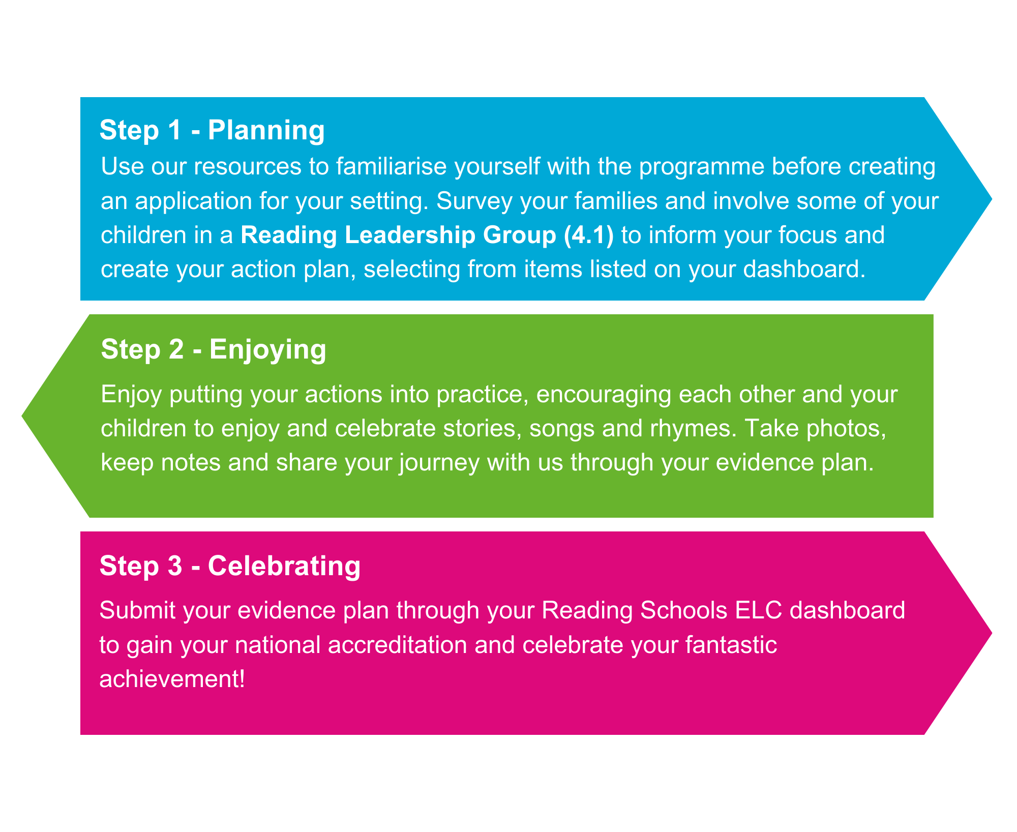

We would ask that each setting considers this framework as a *whole*, identifying opportunities to capitalise on existing setting activities and priorities, ensuring practice is

embedded and supportive, while also looking for new opportunities to develop where appropriate.

In creating your action plan, you will find ‘*Required*’ and ‘*Custom*’ actions for each key area; Required actions are what we would expect a setting to be routinely undertaking in promoting stories, songs and rhymes, emerging literacy and reading for enjoyment. Custom actions provide an opportunity for settings to further deepen their engagement and bring their own ideas to the process, by either selecting one (or more) of the suggested actions, or suggesting your own.

## 1. Leadership

### Key Area 1.1 – Staff are readers themselves

We expect Reading Schools ELC Settings to demonstrate how all staff in the setting show that they are readers themselves.

The following evidence is required:

* Comments or observations on each completed action
* Provide a range of quotes from staff across the setting on what they did to role model reading and what impact it made
* Upload photos of staff being seen as readers themselves

#### Quality Improvement Framework Indicators

This section ties in with the Quality Improvement Indicators:

* Leadership – Staff skills, knowledge, values and deployment

#### Required actions

Staff should show that they are readers themselves, in the below three required actions.

* Display staff’s favourite children’s and adult books. Share with children, parents and carers
* Give children opportunities to see staff enjoying their own books
* Give children opportunities to see staff use environmental print (i.e. everyday life print, including signs, labels, logos, packaging, and shop signs)

### Key Area 1.2 – Staff understand the impact of reading for pleasure

We expect Reading Schools ELC Settings to support staff to develop their knowledge around reading for pleasure.

The following evidence is required:

* Comments or observations on each completed action
* Provide a few quotes from staff across the setting on how their knowledge around reading for pleasure developed

#### Quality Improvement Framework Indicators

This section ties in with the Quality Improvement Framework Indicators:

* Leadership – Staff skills, knowledge, values and deployment

#### Required actions

ELC Settings should support staff development by completing the following four required actions:

* A staff representative should undertake the Reading Schools ELC Introductory learning and share with colleagues. This can be done at online sessions (live or recorded) or through our E-module
* A staff representative should explore the learning resources and webinars for early years / Bookbug on the Scottish Book Trust website and share learning with colleagues
* Staff should use the Bookbug app, song and rhyme library and wider Scottish Book Trust resources to widen knowledge around reading for pleasure. Staff should also share this knowledge with colleagues
* Actively engage with the Reading Schools ELC channel in Scottish Book Trust’s MSTeam to share learning and ideas

#### Custom actions

For best practice, ELC Settings should support staff in at least one of the below ways, or in another way that suits their setting:

* Read more widely about the pedagogy and research around reading for pleasure
* Engage with colleagues and share work via social media or face-to-face meetings etc
* Work collaboratively with another ELC Setting to develop your reading for pleasure practice
* Engage in further training opportunities for staff around sharing stories, songs and rhymes with children and their families where possible and appropriate, e.g. Bookbug Session Leader Training, Bookbug for the Home training

### Key Area 1.3 – Staff knowledge of contemporary children’s literature

We expect Reading Schools ELC Settings to support staff to develop their knowledge and awareness around contemporary children’s literature.

The following evidence is required:

* Comments or observations on each completed action
* Provide a few quotes from staff across the setting on how their knowledge of contemporary children's literature developed
* Upload photos of how you ensured access to contemporary children's literature for staff

#### Quality Improvement Framework Indicators

This section ties in with the Quality Improvement Framework Indicators:

* Leadership – Staff skills, knowledge, values and deployment

#### Required actions

ELC Settings should ensure that staff have access to contemporary children’s literature in the below three required actions:

* Provide physical areas for staff discussion, e.g. an interactive display board in communal areas
* Take part in Scottish Book Trust Book Discovery sessions, Bookbug or other online professional community sharing platform, e.g. social media or the Scottish Book Trust’s MSTeam.
* Make staff aware of contemporary children’s literature through signposting to new book lists and other appropriate resources, e.g. use of the Bookbug app

**Custom actions**

For best practice, ELC Settings should ensure that staff have access to contemporary children’s literature in at least one of the below ways, or in another way that suits their setting:

* Invite your local librarian to talk to staff about new books and ensure they have a library card
* Gift a contemporary children's book to each staff member and encourage them to share books across the team
* Arrange a staff trip to a local bookshop to speak to booksellers about contemporary children’s titles
* Use book recommendation resources for children based on their needs and interests
* Provide online spaces for discussion with other ELC Settings where possible

### Key Area 1.4 – Monitoring change and impact

We expect Reading Schools ELC Settings to use meaningful data to guide them and track progress. ELC Settings can use publications and toolkits as per their local literacy policies to help consider what is working well and areas for development. For example, CIRCLE Nursery Literacy Rich Environment Tool, GIRFEC, SHANARRI wellbeing indicators or similar.

The following evidence is required:

* Confirm you have used the Reading Schools ELC attitude surveys
* Comments or observations on how you have monitored the impact of your Reading Schools ELC programme
* Confirm you will take part in the Scottish Book Trust evaluation once your accreditation has been confirmed

#### Quality Improvement Framework Indicators

This section ties in with the Quality Improvement Framework Indicators:

* Leadership – Leadership of continuous improvement

#### Required actions

ELC Settings should track their progress by completing the following two required actions:

* Demonstrate that staff are considering whether children value reading and book sharing for pleasure and are able to share their opinion and thoughts. Record this using personal learning plans, learning journals, individual educational plans, individual activity plans, learning records, floor books, speech bubbles, displays or a similar resource to document a child’s learning journey
* Monitor the impact of your Reading Schools ELC Settings programme in ways most suited to your setting and activities

## 2. Children thrive and develop in quality spaces

### Key Area 2.1 – Reading-rich environment

We expect Reading Schools ELC Settings to show how they have provided appealing and comfortable spaces to enjoy books, stories, songs and rhymes and make reading visible in the setting.

The following evidence is required:

* Comments or observations on each completed action
* Upload photos of your reading areas / displays

#### Quality Improvement Framework Indicators

This section ties in with the Quality Improvement Framework Indicators:

* Children thrive and develop in quality spaces – Quality, safety and maintenance of spaces
* Children thrive and develop in quality spaces – Children influence and affect change

#### Required actions

Settings should provide appealing and relaxing reading areas in collaboration with children, provide opportunities for children to share books with adults who will be responsive to how the child wants to enjoy the book, and use displays at children’s eye level to promote reading in the below four required actions:

* Create inviting reading areas throughout the setting, indoors and outdoors, including quiet spots, cosy corners and shared reading areas
* Provide a range of stories, songs and rhymes that look appealing in both an indoor and outdoor library, ensuring both libraries have high-quality reading materials
* Displays and labels should include pictures and a variety of writing with consistency across the setting (handwritten, large print, children’s writing, braille, drawing, writing in different languages and scripts)
* Include relevant reading materials in play areas, e.g. recipe books and menus at snack areas, magazines in hairdressers / doctors / vets, order forms and price lists in shops, transport books in construction if it matches interest, weather maps, calendars etc.

#### Custom actions

For best practice, ELC Settings should provide appealing and relaxing reading areas in collaboration with children, and use displays at children’s eye level to promote reading in at least one of the below ways, or in another way that suits their setting:

* Make stories, songs and rhymes available during routine throughout the day
* Incorporate stories, songs and rhymes into special events / current topics and create displays, e.g. Christmas and other celebrations, festivals, Burns Night, Harvest Festival

### Key Area 2.2 – National events and celebrations

We expect Reading Schools ELC Settings to build on reading routines and take part in national reading celebrations to generate excitement around reading.

The following evidence is required:

* Comments or observations
* Upload photos of your events / initiatives

#### Quality Improvement Framework Indicators

This section ties in with the Quality Improvement Framework Indicators:

* Children thrive and develop in quality spaces – Children influence and affect change

#### Required actions

ELC Settings should generate excitement around reading by taking part, attending or

celebrating at least one initiative below that suits their setting:

* Bookbug Week
* Book Week Scotland
* World Book Day / Night
* National Children’s Picture Book Day
* National Poetry Day
* Other / local events and celebrations

### Key Area 2.3 – Access to authors

We expect Reading Schools ELC Settings to give all children the opportunity to engage with authors, writers, illustrators or storytellers.

The following evidence is required:

* Comments or observations, including details of the author events children have engaged with
* Upload photos of author events

#### Quality Improvement Framework Indicators

This section ties in with the Quality Improvement Framework Indicators:

* Children thrive and develop in quality spaces - Quality, safety and maintenance of spaces

**Custom actions**

Settings should give all children the opportunity to engage with authors (writers, illustrators or storytellers) in at least one of the following ways:

* Watching videos or listening to stories, songs and rhymes read by authors on the Bookbug app, Scottish Book Trust's online song and rhyme library, Authors Live or through other media
* Arranging an author / illustrator visit or residency
* Connecting with authors directly e.g. through publishers, social media

## 3. Children play and learn

### Key Area 3.1 – Peer role modelling

We expect Reading Schools ELC Settings to show how children visibly promote reading and recommend books to one another.

The following evidence is required:

* Comments or observations on each completed action
* Provide a few responses from children across the setting, or detail observations that have been made around role modelling reading. Observations should consider children’s communication beyond their verbal responses
* Upload photos of children role modelling reading

#### Quality Improvement Framework Indicators

This section ties in with the Quality Improvement Framework Indicators:

* Children play and learn – Play and learning
* Children thrive and develop in quality spaces – Children influence and affect change

#### Required actions

Children should be supported to act as reading role models in the below four required actions:

* Talk about / communicate their feelings about the stories, songs and rhymes they have enjoyed, in small groups, with friends and in conversation with staff
* Talk about / use expressive arts to share stories, songs and rhymes they have enjoyed with their peers in small and larger groups
* Create learner-led recommendation lists for display, e.g. make favourite book displays or learner-led shelf recommendations
* Share recommendation notes / bookmarks in books, e.g. thumbs up / down, smiley face rating, or add to a floor book

#### Custom actions

For best practice, children should act as reading role models in at least one of the below ways, or in another way that suits their setting:

* Bring a book / reading material in from home to share throughout the day or at story time, e.g. books from their Bookbug bags
* Returning children select and plan the library for the new starts
* Take part in a paired reading project with a local primary school for children who will be moving on to Primary 1

### Key Area 3.2 – Access to high-quality reading materials

We expect Reading Schools ELC Settings to provide up-to-date reading materials relevant to the needs, interests and experiences of all children.

The following evidence is required:

* Comments or observations on each action completed
* Provide a few responses from children across the setting, or detail observations that have been made around their thoughts on the reading materials available to them. Observations should consider children’s communication beyond their verbal responses
* Upload photos demonstrating the variety of reading materials you provide

#### Quality Improvement Framework Indicators

This section ties in with the Quality Improvement Framework Indicators:

* Children play and learn – Learning, teaching and assessment
* Leadership – Leadership of continuous improvement

#### Required actions

ELC Settings should make sure that children have access to contemporary and diverse reading materials relevant to their needs, interests and experiences by completing these

six required actions:

* Provide children with easy access to a maintained library ­­– at child level with accessible displays.
* Involve children in the selection of books and other reading materials.
* Regularly update reading materials to ensure they are contemporary, diverse and relate to current themes, stage, needs, interests and experiences of children. Reading material can include old favourites.
* Encourage children to broaden their reading experience through sharing a variety of books and reading materials at story time, chosen by children and staff.
* Where appropriate, support bilingual children by ensuring reading materials are available in different languages and can be borrowed to use at home.
* Provide additional support for children such as sensory, tactile and interactive books.

#### Custom actions

For best practice, ELC Settings should make sure that children have access to contemporary and diverse reading materials relevant to their needs, interests and experiences in at least one of the below ways, or in another way that suits their setting:

* Provide access to the Bookbug songs and rhymes app and encourage parents and carers to use the app at home
* Provide story sacks (homemade packs containing a book and objects for retelling and acting out the story) in the setting
* Visit the local library and / or school library, e.g. for a Bookbug session

### Key Area 3.3 – Regular opportunities to read and share books for pleasure

We expect Reading Schools ELC Settings to ensure all children have regular time to access stories, songs and rhymes of their own choosing and access to staff who demonstrate the adult-child interaction skills required to support the oral language foundations that children need to develop early language and literacy skills.

The following evidence is required:

* Comments or observations on completed actions
* Provide photos of reading areas and the variety of materials available to the children

#### Quality Improvement Framework Indicators

This section ties in with the Quality Improvement Framework Indicators:

* Children play and learn – Play and learning
* Children play and learn – Learning, teaching and assessment

#### Required actions

ELC Settings should ensure that all children have regular time to enjoy stories, songs and rhymes of their own choosing in the below three required actions:

* Plan approaches to reading material selection that are child-centred and responsive to children’s interests and life experiences
* Regular story, song and rhyme time in a dedicated space, e.g. Bookbug sessions where possible with a responsive adult who can support interaction and language learning
* Ensure there are manipulatives and props available to reflect reading materials

### Key Area 3.4 – Interdisciplinary book projects

We expect Reading Schools ELC Settings to offer exciting and engaging exploratory projects based around stories, songs and rhymes that will inspire children to read.

The following evidence is required:

* Comments or observations on completed actions
* Upload photos or examples

#### Quality Improvement Framework Indicators

This section ties in with the Quality Improvement Framework Indicators:

* Children play and learn – Play and learning
* Children play and learn – Curriculum

#### Required actions

ELC settings should use story, song and rhyme projects to inspire children to engage with the material by completing the below two required actions:

* Children should have regular opportunities to engage in exploratory, inquiry-based experiences that reflect their interests and developmental stages. These experiences should be embedded in everyday practice and supported through responsive, play-based approaches
* Provide an opportunity for children to share their experiences with their peers and families

### Key Area 3.5 – Modelling reading behaviours

We expect Reading Schools ELC Settings to give all children the opportunity to hear a story, song or rhyme aloud to widen their reading experience on a regular basis.

#### Required evidence

The following evidence is required:

* Comments or observations on actions completed
* Upload photos

#### Quality Improvement Framework Indicators

This section ties in with the Quality Improvement Framework Indicators:

* Children play and learn - Learning, teaching and assessment

#### Required actions

ELC Settings should give all children the opportunity to hear a story, song or rhyme aloud on a daily basis to widen their reading experience, by completing the below three required actions:

* Routinely share stories, songs and rhymes aloud with individuals or small groups in play, following the child’s lead and responding to the child’s cues and comments
* Routinely share stories, songs and rhymes aloud with larger groups of children, indoors and outside
* Highlight environmental print (i.e. everyday life print, including signs, labels, logos, packaging, and shop signs) around the setting, on walks or visits to shops

#### Custom actions

For best practice, ELC Settings should give all children the opportunity to hear a story, song or rhyme aloud on a daily basis to widen their reading experience, in at least one of the below ways, or in another way that suits their setting:

* Use the Bookbug app watch stories songs and rhymes presented in new ways
* Invite guest storytellers to your setting. A guest storyteller could be a member of the wider staff team or school, catering assistants, your lollypop person, librarians, parents and carers, or members of the community e.g. public library staff, sportspeople, local figures, or other role models

### Key Area 3.6 – Opportunities for children to respond to what they’re reading

We expect Reading Schools ELC Settings to allow all children to respond to what they’re reading in a variety of engaging ways that best suit their needs.

The following evidence is required:

* Comments or observations, on completed actions
* Upload photos or examples

#### Quality Improvement Framework Indicators

This section ties in with the Quality Improvement Framework Indicators:

* Children play and learn – Play and learning
* Leadership – Leadership and management of staff and resources
* Leadership – Staff skills, knowledge, values and deployment

#### Required actions

Settings should ensure that all children have the opportunity to respond to stories, songs and rhymes by completing the below four required actions:

* Use interest-based activities, letting children take the lead and celebrate their interests by being responsive e.g. dress up, play, expressive arts.
* Hold a vote for favourite stories, songs and rhymes
* Support and encourage children’s creative responses, allowing them the freedom to choose their own materials and methods
* Provide items such as small world manipulatives, puppets, or story stones to match current picture books

## 4. Children are supported to achieve

### Key Area 4.1 – Reading leadership group

We expect Reading Schools ELC Settings to form a reading leadership group that creates and inputs into your action plan as well as meeting regularly to discuss progress and ideas.

The following evidence is required:

* Comments or observations, including details of who was in the group and how the children’s input was encouraged
* Upload a photo of a meeting

#### Quality Improvement Framework Indicators

This section ties in with the Quality Improvement Framework Indicators:

* Children are supported to achieve – Wellbeing, inclusion and equality
* Leadership – Leadership and management of staff and resources

#### Required actions

The leadership group must complete the following three required actions:

* Include children, responding to their interests, wants and enquiries
* Include ELC Setting staff such as Early Years Practitioners, teachers, support staff, local librarians, local school librarians and Senior Management Team where possible
* Communicate regularly, and implement plans: e.g. use of leadership display walls / floor books and newsletters

#### Custom actions

For best practice, the leadership group should complete at least one of the ways below , or another way that best suits your setting:

* Invite families or partners from within the community to join your leadership group
* Invite families to complete the attitude survey and incorporate their responses into your planning

### Key Area 4.2 – Staff instigate meaningful conversations around stories, songs and rhymes

We expect staff at Reading Schools ELC Settings to engage with all children individually to support reading for pleasure.

The following evidence is required:

* Comments or observations, including details of how staff across the setting are finding out about children’ interests, making book recommendations and encouraging them to try new things
* Provide a few responses from children across the setting, or detail observations that have been made around conversations with staff have supported their reading choices. Observations should consider children’s communication beyond their verbal responses

#### Quality Improvement Framework Indicators

This section ties in with the Quality Improvement Framework Indicators:

* Children are supported to achieve – Wellbeing, inclusion and equality
* Children are supported to achieve – Children’s progress
* Children play and learn – Play and learning
* Leadership – Leadership of continuous improvement

#### Required actions

Staff should ensure they know about children's interests, have regular conversations with them and carry out regular high-quality observations to understand about their favourite stories, songs and rhymes and allow all children to respond in the below four required actions:

* Record children’s thoughts and feelings about stories, songs and rhymes in a way that suits your setting e.g. on floor books / personal learning plans, journals, or accessible displays
* Facilitate opportunities for children to interact and communicate during reading time / other times by using adult-child interaction strategies that allow children to communicate, and being responsive to what the learner is interested in
* Support individual children with strategies for choosing a story, song or rhyme they might enjoy
* Provide regular recommendations for individual children, reflecting their interests, ability, identities and preferences (e.g. additional support needs (ASN), English as an additional language (EAL) etc.)

### Key Area 4.3 – Raising the profile of reading and book sharing with families

We expect Reading Schools ELC Settings to involve children’s families in building their reading culture.

The following evidence is required:

* Comments or observations on actions completed
* Provide a range of quotes from families that attended the events / took part in the initiatives
* Upload photos of family events / initiatives

#### Quality Improvement Framework Indicators

This section ties in with the Quality Improvement Framework Indicators:

* Children are supported to achieve – Nurturing care and support
* Children are supported to achieve – Wellbeing, inclusion and equality

#### Required actions

ELC Settings should encourage children’s families to take part in reading and book sharing activities. They should offer help to build families’ confidence and skills to share stories, songs and rhymes with their children in the following four required actions:

* Bookbug Explorer bags – make the most of the Bookbug Explorer bags by attending a gifting webinar, sharing resources and encouraging the use of the bags at home
* Communicate with families about the setting’s reading journey and signpost appropriate resources, e.g. the Bookbug app
* Create recommended reading lists and displays for families and encourage families to contribute to reading lists e.g. in their language and culture
* Support families in how to make book sharing a time to interact and bond with their child by using the book to talk about the pictures, being mindful of parents’ own language and literacy skills e.g. hosting or signposting to regular Bookbug sessions

#### Custom actions

For best practice, ELC Settings should engage and involve families, as well as share information about stories, songs and rhymes in at least one of the below ways, or in another way that suits their setting.

* Create lending libraries for staff, parents and carers, e.g. in the reception area.
* Run workshops for families, e.g. Bookbug sessions.
* Promote bedtime books and / or story sacks for home borrowing, reflecting the needs of your families.
* Share tips and advice with families on the benefits of book reading for developing their child’s interaction, language and communication to support their literacy skills.
* Share ideas with families of further ways they can share books at home, e.g. making up photo books or using wordless books and talking about the pictures.
* Encourage families to join their local library for access to books, ebooks and audiobooks.
* Invite families into the setting, where possible and appropriate, e.g. to share their favourite books during story time, interdisciplinary / mini project sharing sessions, Bookbug Explorer bag gifting events, an evening reading by the campfire, or book-themed stay and play.

### Key Area 4.4 – Celebrating progress and recognising personal achievements

We expect Reading Schools ELC Settings to encourage and celebrate the engagement of all children with stories, songs and rhymes.

The following evidence is required:

* Comments or observations on each completed action
* Upload photos showing how you have celebrated Quality Improvement Framework Indicators

This section ties in with the Quality Improvement Framework Indicators:

* Children are supported to achieve - Nurturing care and support
* Children are supported to achieve – Wellbeing, inclusion and equality
* Children play and learn – Play and learning

#### Required actions

ELC Settings should celebrate all children’s engagement with stories, songs and rhymes in the below two required actions.

* Observations recorded in personal learning plan and / or journals
* Hold a celebration assembly or party around stories, songs and rhymes

#### Custom actions

For best practice, ELC Settings should celebrate all children’s engagement with stories, songs and rhymes in at least one of the below ways, or in another way that suits their setting.

* Gift books, e.g. for Christmas or transition to school
* Hold a joint event with a partner school, library or setting
* Provide opportunities for children to select the story for group time
* Celebrating and encouraging with small reading-related tokens such as bookmarks, certificates, stickers etc

1. [Quality improvement framework for the early learning and childcare sectors | Inspection frameworks | Inspection and review | Education Scotland](https://education.gov.scot/inspection-and-review/inspection-frameworks/quality-improvement-framework-for-the-early-learning-and-childcare-sectors/)