

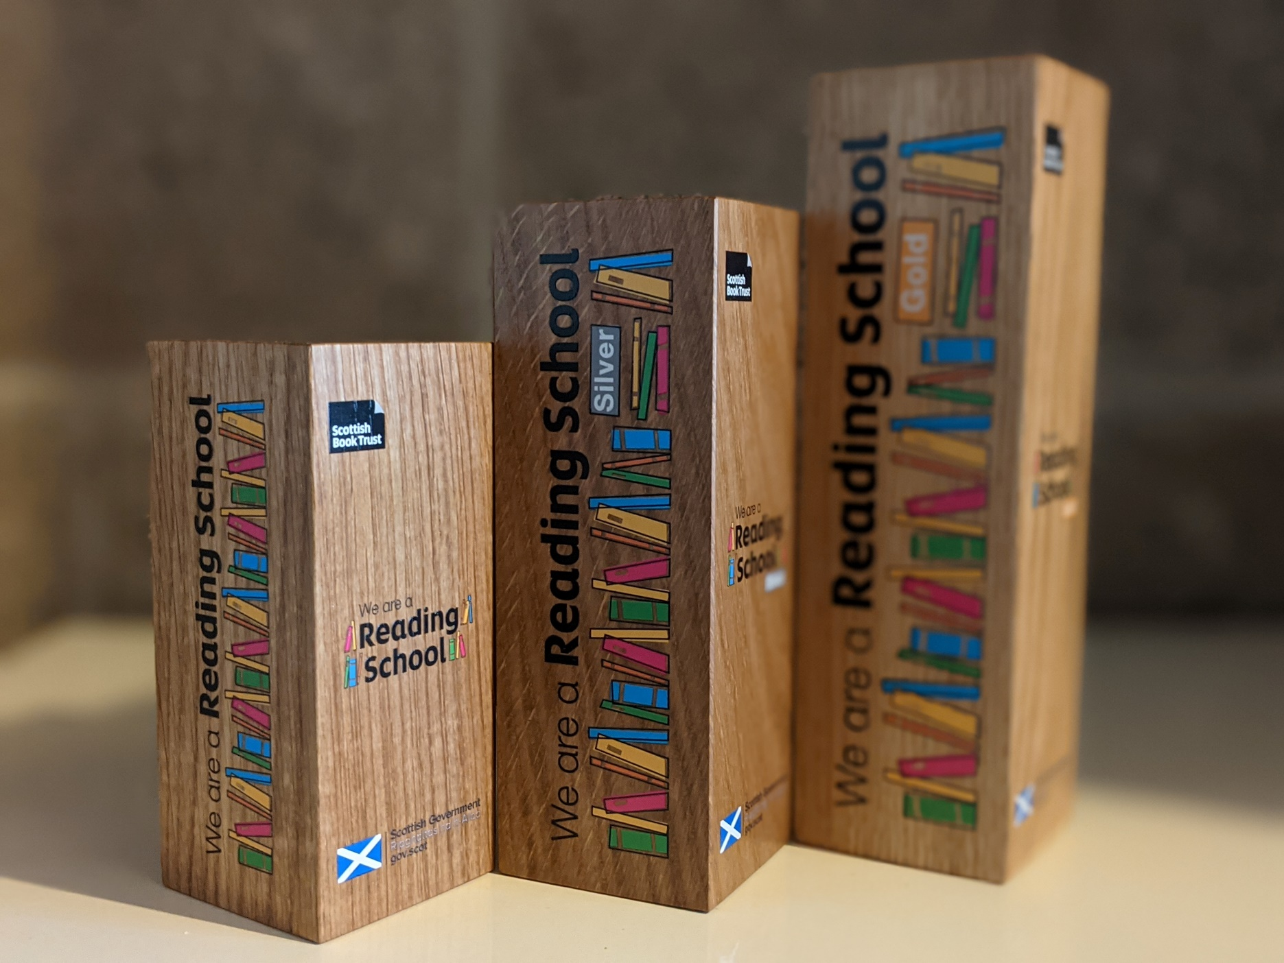

# Reading Schools reaccreditation

This resource is for both recently accredited Reading Schools and accredited Reading Schools nearing their three-year expiry, who are looking to apply for the next level or reaccredit at their existing level to maintain their accreditation status.

**Key Area: 1.3.1 Whole school action plan** **Level: Core, Silver and Gold** **Resource created by Scottish Book Trust**

scottishbooktrust.com



Scottish Book Trust is a registered company (SC184248)

and a Scottish charity (SC027669).

## Contents

Contents 2

About this resource 2

Next steps following accreditation 3

The five R’s of reflection 4

Quick wins 5

Reading Schools reflection audit 7

## About this resource

This resource has been created to support schools planning their Reading Schools reaccreditation.

Once accredited, schools retain their Reading Schools level (whether Core, Silver or Gold) for a period of three years.   
  
Schools that achieve Core or Silver accreditation can, at any time, move on to the next level of accreditation, or they can choose to reaccredit at their current level at the end of their three-year validity period.   
  
For Gold schools, they should sustain their current level of activity and can choose to reaccredit – at any level – at the end of their three-year validity period to retain their status as a Reading School.

To assist with ongoing planning, we have created a reflection document that contains prompts to identify existing activities you can reasonably maintain, alongside starting points for developing new ideas for learners, staff, families and community partners.   
  
This resource can be used to reaccredit at Core, Silver or Gold accreditation, and is for internal use within your setting.

## Next steps following accreditation

Throughout the Reading Schools journey we encourage regular reflection on what you feel is, or is not, working for your school. Once you have achieved your accreditation, it’s important to ensure your reading culture continues to thrive and remain accessible for new learners and staff.   
  
When planning, we encourage you to consider what you can reasonably expect to maintain over a longer period. While large, complex and encompassing events can be great for drawing attention to reading for pleasure and making a “big splash” in your school community, regular and simple activity can ensure that reading and stories are mainstreamed and continue to play a significant role in school life.

When considering the challenges and successes of your journey to Reading Schools accreditation, focusing on a few reflective questions can help to understand what you can continue, what should be adapted and what may need to be dropped altogether. We suggest using the following questions as a guide:

* What has been the most impactful change or activity you have implemented for your Reading Schools accreditation and how will you sustain this after your award?
* What elements of your Reading Schools activity could you do differently next time? Think about: improvements, community feedback, how easy it was to manage - were you too ambitious, or could you be more ambitious next time?
* What are your other key school or learning priorities, and can reading for pleasure complement that ongoing work? (e.g., numeracy, STEM, Health & Wellbeing, Rights Respecting Schools, Eco Schools, Digital Schools Scotland, LGBT Chartership)

## The five R’s of reflection

Following the five R’s can provide a reassuring structure to your annual reflective process, and moving through these stages at a steady pace ensures the reading culture remains a vital and inclusive priority in your setting while also readying you for either progressing to a new accreditation or reaccrediting at your current level in three years’ time.

This reflective process should ideally happen alongside wider strategic planning for the upcoming academic year.

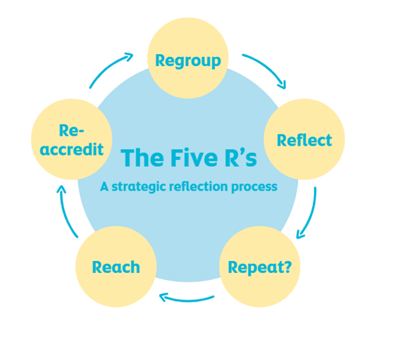

**Regroup** Gather your strategic key players together, including your learners

**Reflect** Spend time evaluating your journey so far and the impact observed

**Repeat?** Establish what you can continue, adapt or omit entirely

**Reach** Identify ways to deepen engagement and embed reading for pleasure

**Reaccredit** Commence your application for Reading Schools accreditation

It’s important to remember that Reading Schools has been mapped to [HGIOS 4](https://education.gov.scot/inspection-and-review/inspection-frameworks/how-good-is-our-school-fourth-edition-hgios-4/), and both your submission evidence and reflection can be valuable when considering your wider school improvement and inspection planning. Using this approach will allow you to capitalise on your school’s existing priorities, bringing them into your ongoing Reading Schools activity and establish reading for pleasure alongside and in conjunction with those priorities.

## Quick wins

**Consider where you can keep things simple and achievable.** It might be that you previously held an author event in your school but cannot afford to repeat this every year. Why not access our [Authors Live On Demand Library](https://www.scottishbooktrust.com/authors-live-on-demand) or plan [live broadcasts](https://www.scottishbooktrust.com/learning-and-resources/authors-live) into your termly calendar and host a watch party? Look for ways to create easy and fun solutions in collaboration with your learners.

**It doesn’t always have to be “in person”.** Your family and community engagement activities don’t always need to be event-driven, you could create and maintain virtual spaces to encourage participation in your reading culture, such as a Facebook group, MS Team or Google workspace. You might want to consider creating content to share publicly, like vlogs or podcasts, which can be placed on your school website or a video sharing platform for free. You can find resources created in collaboration with [Into Film Scotland](https://www.intofilm.org/scotland) to support the [use of creative media alongside your reading culture](https://www.readingschools.scot/resources/creating-a-book-trailer-with-into-film-scotland-april-2025-recording).

**Don’t act in isolation.** Maintaining and embedding a whole-school reading culture is the responsibility of the whole school, and support is available from the wider [community of Reading Schools across Scotland](https://www.readingschools.scot/community). Ensure that responsibility is shared fairly across your staff and learner team, make strategic decisions in collaboration with wider school management, and evidence the impact and value of your Reading Schools journey to maintain it as a school-wide priority. Join our [live shared practice and online support sessions](https://www.readingschools.scot/clpl) or catch up with recordings in our [Resources](https://www.readingschools.scot/resources) section to hear from learning professionals across the country undertaking similar work within their settings. Consider joining the [Scottish Book Trust’s Schools Network](https://forms.office.com/e/DCjVwaC6La): a private Microsoft Team for learning professionals to meet colleagues, share news and best practice, and help shape our programmes to support your work and goals. You could also consider joining or setting up a similar group for your own associated school group or local authority colleagues.

**Reading Schools reflection audit**

This document has been designed to help you reflect on your Reading Schools journey, establish successes and identify areas for further development. Central to your Reading Schools status is activity that can be repeated and developed year-on-year for every cohort in your school, establishing a thriving learner-led reading culture that is at the heart of your school community.

Use this document in conjunction with the [Reading Schools Framework](https://www.readingschools.scot/framework) to ensure your ongoing activities continue to meet the key area criterion to help with your reaccreditation and sustaining your Reading Schools status.

Complete the fields to develop an ongoing action plan for your school’s reading culture. **This is for your internal use.**

#### Key points to remember:

* **Sustainable** – **can your activity be repeated and sustained?** *Big events can draw attention to reading for pleasure but also consider regular activity that continually promotes and encourages readership.*
* **Learner-led** – **do your learners continue to have an active role in driving reading for pleasure?** *Make sure your reading leadership group has an ongoing purpose by including them in your plans and having them help to inform the development of your reading culture.*
* **Support** – **do you have support across the school?** *The focus is on whole-school culture building, so make sure your plans have the support of colleagues and senior leadership. If possible, continue to have reading for pleasure as a priority in your School Improvement Plan.*
* **Monitoring** – **have you considered how you will record impact?** *Having a means to record your impact is crucial. You can use the* [*Reading Schools attitude surveys*](https://www.readingschools.scot/resources/attitude-surveys) *to continue gauging the interests of your school community, but also consider the wider impacts on your other recording methods, such as attendance, attainment and health and wellbeing.*

|  |  |  |  |  |  |
| --- | --- | --- | --- | --- | --- |
| **1.2 Leadership of learning** | | | | | |
| Key areas:  **1.2.1 Reading leadership group**  **1.2.2 Learner role modelling**  **1.2.3 Staff being seen as readers themselves**  **1.2.4 Staff development**  **1.2.5 Staff knowledge of contemporary children’s literature** | | | | | |
| **Key area** | **What we did** (e.g. a very brief outline) | **What worked** (e.g. good learner engagement, attitude improvement) | **What didn’t** (e.g. poor engagement, expensive, laborious) | **Next steps** (e.g. sustain, improve, replace, cycle every few years) | **Responsible** (e.g. staff member, leadership group, pupil, SMT etc.) |
| **1.2.1 Reading leadership group** |  |  |  |  |  |
| **1.2.2 Learner role modelling** |  |  |  |  |  |
| **1.2.3 Staff being seen as readers themselves** |  |  |  |  |  |
| **1.2.4 Staff development** |  |  |  |  |  |
| **1.2.5 Staff knowledge of contemporary children’s literature** |  |  |  |  |  |
| Notes: | | | | | |

|  |  |  |  |  |  |
| --- | --- | --- | --- | --- | --- |
| **1.3 Leadership of change** | | | | | |
| Key areas:  **1.3.1 Whole school action plan**  **1.3.2 School environment**  **1.3.3 National events and celebrations** | | | | | |
| **Key area** | **What we did** (e.g. a very brief outline) | **What worked** (e.g. good learner engagement, attitude improvement) | **What didn’t** (e.g. poor engagement, expensive, laborious) | **Next steps** (e.g. sustain, improve, replace, cycle every few years) | **Responsible** (e.g. staff member, leadership group, pupils, SMT etc.) |
| **1.3.1 Whole school action plan** |  |  |  |  |  |
| **1.3.2 School environment** |  |  |  |  |  |
| **1.3.3 National events and celebrations** |  |  |  |  |  |
| Notes: | | | | | |

|  |  |  |  |  |  |
| --- | --- | --- | --- | --- | --- |
| **1.5 Management of resources to promote equity** | | | | | |
| Key areas:  **1.5.1 Access to high quality reading materials** | | | | | |
| **Key area** | **What we did** (e.g. a very brief outline) | **What worked** (e.g. good learner engagement, attitude improvement) | **What didn’t** (e.g. poor engagement, expensive, laborious) | **Next steps** (e.g. sustain, improve, replace, cycle every few years) | **Responsible** (e.g. staff member, leadership group, pupils, SMT etc.) |
| **1.5.1 Access to high quality reading materials** |  |  |  |  |  |
| Notes: | | | | | |

|  |  |  |  |  |  |
| --- | --- | --- | --- | --- | --- |
| **2.2 Curriculum** | | | | | |
| Key areas:  **2.2.1 Regular opportunities to read for pleasure**  **2.2.2 Interdisciplinary book projects** | | | | | |
| **Key area** | **What we did** (e.g. a very brief outline) | **What worked** (e.g. good learner engagement, attitude improvement) | **What didn’t** (e.g. poor engagement, expensive, laborious) | **Next steps** (e.g. sustain, improve, replace, cycle every few years) | **Responsible** (e.g. staff member, leadership group, pupils, SMT etc.) |
| **2.2.1 Regular opportunities to read for pleasure** |  |  |  |  |  |
| **2.2.2 Interdisciplinary book projects** |  |  |  |  |  |
| Notes: | | | | | |

|  |  |  |  |  |  |
| --- | --- | --- | --- | --- | --- |
| **2.3 Learning, Teaching and Assessment** | | | | | |
| Key areas:  **2.3.1 Modelling reading behaviours**  **2.3.2 Staff-led meaningful conversations around books**  **2.3.3 Creating learner social networks**  **2.3.4 Opportunities for learners to respond to what they’re reading**  **2.3.5 Access to authors** | | | | | |
| **Key area** | **What we did** (e.g. a very brief outline) | **What worked** (e.g. good learner engagement, attitude improvement) | **What didn’t** (e.g. poor engagement, expensive, laborious) | **Next steps** (e.g. sustain, improve, replace, cycle every few years) | **Responsible** (e.g. staff member, leadership group, pupils, SMT etc.) |
| **2.3.1 Modelling reading behaviours** |  |  |  |  |  |
| **2.3.2 Staff-led meaningful conversations around books** |  |  |  |  |  |
| **2.3.3 Creating learner social networks** |  |  |  |  |  |
| **2.3.4 Opportunities for learners to respond to what they’re reading** |  |  |  |  |  |
| **2.3.5 Access to authors** |  |  |  |  |  |
| Notes: | | | | |  |

|  |  |  |  |  |  |
| --- | --- | --- | --- | --- | --- |
| **2.5 Family learning** | | | | | |
| Key areas:  **2.5.1 Raising the profile of reading with families** | | | | | |
| **Key area** | **What we did** (e.g. a very brief outline) | **What worked** (e.g. good learner engagement, attitude improvement) | **What didn’t** (e.g. poor engagement, expensive, laborious) | **Next steps** (e.g. sustain, improve, replace, cycle every few years) | **Responsible** (e.g. staff member, leadership group, pupils, SMT etc.) |
| **2.5.1 Raising the profile of reading with families** |  |  |  |  |  |
| Notes: | | | | |  |

|  |  |  |  |  |  |
| --- | --- | --- | --- | --- | --- |
| **2.7 Partnerships** | | | | | |
| Key areas:  **2.7.1 Partnerships within local community** | | | | | |
| **Key area** | **What we did** (e.g. a very brief outline) | **What worked** (e.g. good learner engagement, attitude improvement) | **What didn’t** (e.g. poor engagement, expensive, laborious) | **Next steps** (e.g. sustain, improve, replace, cycle every few years) | **Responsible** (e.g. staff member, leadership group, pupils, SMT etc.) |
| **2.7.1 Partnerships within local community** |  |  |  |  |  |
| Notes: | | | | |  |

|  |  |  |  |  |  |
| --- | --- | --- | --- | --- | --- |
| **3.2 Raising Attainment and Achievement** | | | | | |
| Key areas:  **3.2.1 Rewarding progress and recognising personal achievements**  **3.2.2 Monitoring progress** | | | | | |
| **Key area** | **What we did** (e.g. a very brief outline) | **What worked** (e.g. good learner engagement, attitude improvement) | **What didn’t** (e.g. poor engagement, expensive, laborious) | **Next steps** (e.g. sustain, improve, replace, cycle every few years) | **Responsible** (e.g. staff member, leadership group, pupils, SMT etc.) |
| **3.2.1 Rewarding progress and recognising personal achievements** |  |  |  |  |  |
| **3.2.2 Monitoring progress** |  |  |  |  |  |
| Notes: | | | | |  |