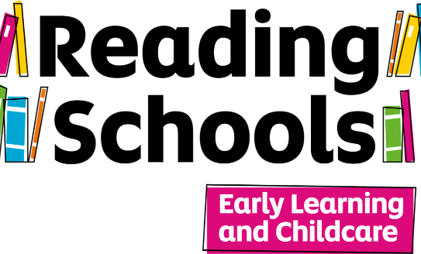

**Reading Schools Early Learning and Childcare (ELC)**

**Self-evaluation template**

**About Reading Schools and Reading Schools ELC**

Research proves that reading for pleasure has positive impacts on learners' attainment across the curriculum, health and wellbeing, critical thinking, creativity, empathy and resilience.

Reading Schools aims to help every school and ELC setting in Scotland build and sustain the **whole-setting reading cultures** that foster these impacts.

Reading Schools offers:

* An **accreditation for** **every school and setting**, recognising the great work you're doing to support reading for pleasure
* A **coherent structure** for all your reading initiatives and activities, providing focused and clear direction
* A framework mapped to the Quality Improvement Framework for the Early Learning and Childcare Sectors, to assist with **quality improvement** and Care Inspectorate inspections
* Professional **development and leadership** opportunities for your staff
* A way to develop **learner voice**, leadership skills and confidence
* Opportunities for **collaboration** within and between schools and settings
* Pathways to **engaging your families** and the **wider community**
* **Training and support** from Scottish Book Trust for all schools taking part

|  |  |  |  |  |
| --- | --- | --- | --- | --- |
| **Setting** |  | | | |
| **Lead staff member/s** |  | | | |
| **Your setting's current level** | We are at the very beginning of building our setting’s reading culture | The foundations are in place, but we want to build on them | We have been deepening reading engagement and want to develop this further | We have a well-established reading culture in place |

**The Reading Schools ELC framework**

[The Reading Schools ELC framework](https://www.readingschools.scot/uploads/store/mediaupload/920/file/Reading%20Schools%20ELC%20Framework.docx) details the Key Areas that we consider crucial to building and sustaining a whole-setting reading culture. The Key Areas are mapped against [The Quality Improvement Framework for the Early Learning and Childcare Sectors](https://education.gov.scot/inspection-and-review/inspection-frameworks/quality-improvement-framework-for-the-early-learning-and-childcare-sectors/) . Under each of the Key Areas we detail the actions necessary to become a Reading School ELC and build a sustainable reading culture in your setting.

* The Reading School ELC accreditation comprises the foundational work key to building a reading culture in settings and is focused around reading routines, the setting environment, family engagement and the celebration of stories, songs and rhymes.

**How to use this self-evaluation template**

This template is designed to help your reading leadership group to:

* Assess to what extent a reading culture is currently embedded within your setting
* Decide how to prioritise your approach to the Reading Schools ELC award and the areas you would like to focus on over the course of the session

Please note, **you do not need to submit this form to Scottish Book Trust** - it is for planning purposes only.

Once you have used the self-evaluation template, you can fill in the box below.

**Reading School ELC**

|  |  |  |
| --- | --- | --- |
| The Reading School ELC accreditation comprises the foundational work key to building a reading culture in your setting and is focused around reading routines and the setting environment.  Settings wishing to be accredited as a Reading School ELC should fulfil each of the below criteria. For each point only one example of practice is required. | | |
| **Criteria** | **Current status** | **Notes/comments** |
| Demonstrate how all staff in the setting show that they are readers through, for example, badges, signs, book lists, talks or other means. |  |  |
| Attend/watch a Scottish Book Trust Reading Schools ELC CLPL and use Scottish Book Trust resources to widen staff knowledge around reading for pleasure. |  |  |
| Make staff aware of contemporary children’s literature, songs and rhymes through signposting to book lists and other appropriate resources. |  |  |
| Build in a monitoring process to ensure the children’s needs and interests are informing your setting’s activity, together with the impact the activity is having. |  |  |
| Provide appealing and comfortable spaces to read in the setting environment; involve learners in the design of these; have reading displays. |  |  |
| Take part in national reading events and celebrations. |  |  |
| Give children across the setting the opportunity to see and engage with authors (writers, illustrators or storytellers). |  |  |
| Show how children visibly promote reading and recommending books, stories, songs and rhymes to one another through, for example, badges, signs and artwork, talks or other means. |  |  |
| Provide up-to-date reading materials relevant to the needs, interests and experiences of the children; involve the children in the selection of these. |  |  |
| Ensure the children have regular time to enjoy stories, songs and rhymes of their own choosing. |  |  |
| Run at least one book, story, song or rhyme-related project each year (an interdisciplinary project for all children in the setting) |  |  |
| Give all the children the opportunity to hear a text aloud. |  |  |
| Allow the children to respond to the stories, songs and rhymes they’re enjoying in a variety of engaging ways that best suit their needs. |  |  |
| Form a reading leadership group who input into a Reading Schools ELC Action Plan. This group must be informed by your children and include key staff who will meet regularly to discuss progress and ideas. |  |  |
| Engage children individually in meaningful conversations around books, stories, songs and rhymers to support their reading for pleasure. |  |  |
| Engage with the children’s families to highlight reading for pleasure, including maximising the opportunities around gifting the Bookbug Toddler bags. |  |  |
| Recognise and celebrate the reading achievements of all children through, for example, certificates, parties, assemblies or other means. |  |  |