
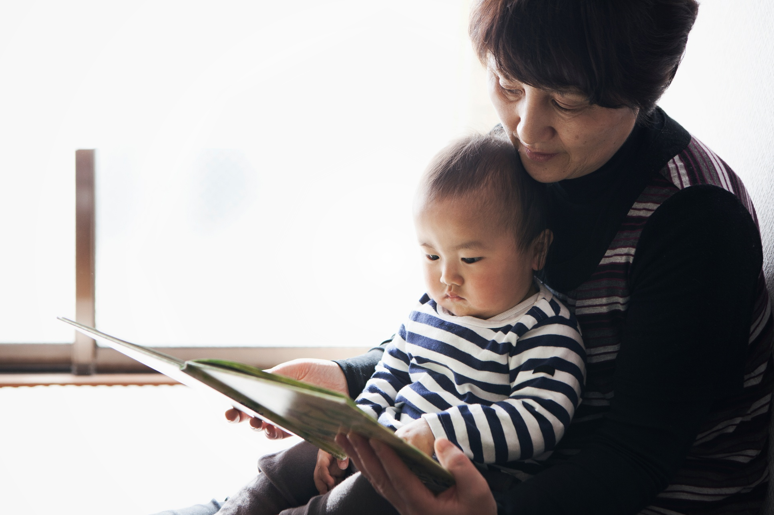

Shared Reading Resource
A printable resource with top tips and book suggestions to support reading aloud in your classroom.

Key Area: 2.3.1

Level: Early to Senior Phase


Resource created by Scottish Book Trust

scottishbooktrust.com

Scottish Book Trust is a registered company (SC184248)
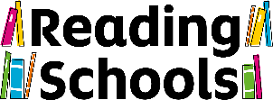
and a Scottish charity (SC027669).

Contents
About this resource 2
Research 3
Choosing a book to read aloud 3
Top tips 4
Examples of classroom practice and research 6
Read aloud book recommendations 7
Further resources 9
References 9

About this resource
This resource can be used as part of your Reading Schools journey to provide tips, advice and recommendations for sharing books aloud with your learners. You will also find book recommendations for reading aloud. We always recommend that you read the books recommended before using them with your class and use your best judgement about whether they are appropriate for the children and young people in your class. Thank you to our guest speakers Vivian French, Deborah MacDonald and Yvonne Manning for sharing their reading aloud advice at a Shared Practice CLPL session, some of which is included here.

Research
Research has found that a robust reading for pleasure (RfP) pedagogy encompasses four practices: reading aloud, independent reading time, book talk and recommendations in a highly social reading environment (Cremin et al., 2014).

Reading aloud is an important and impactful practice within this pedagogy. Shared reading creates a social bond and a sense of community. Reading different genres or types of text such as poetry, non-fiction or song lyrics can encourage pupils to try something new. Listening to stories and engaging with storytime has been found too: support both children’s and teacher’s wellbeing; improve reading attainment; and increase enthusiasm and positivity towards books and reading. Reading aloud also acts as a scaffold, allowing children to access and engage with challenging themes, ideas and language that they wouldn't otherwise be able to.​

Choosing a book to read aloud
- Choose books that match your learners’ interests. You could incorporate book voting into the classroom or get to know learner interests through book surveys. Or try out a few texts with older readers and see which engages the class the most. (Don’t be afraid to abandon a read aloud text if it isn’t engaging your learners).
- Use a variety of texts and genres e.g. sci-fi, mystery, poetry, non-fiction, song lyrics. You could try different formats, such as adventure gamebooks where learners could vote to decide what the character should do next.
- Practise reading an extract of the book out loud – you will soon get a sense of whether the language is too descriptive, or you might find yourself stumbling over the rhythm. Books that take you straight into the story will engage your listeners more than books that start with long descriptive passages.
- Choose a book you enjoy – your enthusiasm will be contagious!

Top tips

Before you begin…
- Read your chosen book first to familiarise yourself with the text. Pick out different characters and experiment with how you will voice them (you can also ask your learners for ideas for how each character speaks).
- Pick out moments where you might want to interact with your learners. This could be playful, sharing stories aloud can prompt funny and silly interactions. Or you might choose to stop and ask a question to help your learners engage with the story, understand the language used, connect the character’s experiences with their own, or reflect on a new fact learned. Be mindful that lots of interruptions will break the flow of the story, so, particularly with younger learners, you may want to ask a ‘raise your hands if…’ question rather than prompting a wider discussion.
- Listening and looking? Think about what you want your learners to be doing as you read aloud. Will they sit on the carpet close to you so they can see the pictures? Will they be joining in with actions – moving their bodies along with the story? If they’re older, will they be sitting at their desks or on comfy cushions? Can they doodle or draw while they listen to help keep their focus? You could have a conversation with them to learn what helps them engage with the reading.
- Think about props if you’re feeling ambitious. Do you have puppets you could use or something to make a recurring sound in the story? Will you dress-up? Will you share the story alongside a colleague?

As you read aloud…
- Make it visible. If you’re reading a picture book, or illustrated non-fiction, make sure everyone can see the illustrations – you could try using a visualiser if you have one. You could play around with reading the text first then showing the images, or vice versa. This works particularly well for picture books where the images and words don’t match up (e.g. in picture book Go Go Dodo!)
- Be expressive! Show enthusiasm for the story in the way that you read it. Some bits are meant to be read really quickly, some moments will need you to slow right down. Change the volume of your voice – sometimes you’ll need to be really, really loud, other times you’ll need to be really, really quiet.
- Use your body! Whilst it can be hard to use your body at the same time as holding a book, you can still make yourself big or small or crouched or tall. If you’re reading to older leaners, think about standing up, gesturing and moving around as you read.
- Pause for effect. This could be a dramatic pause, or a chance for learners to catch up with what’s happening in the story.
- React as if it’s a surprise! Even if it’s the millionth time you’ve read a story, react and respond as if it’s the first time! Your engagement and investment in the story is catching!
- It’s okay to skip bits. Respond to your learners – if you’re coming up to a descriptive passage in the story and you can sense they’d benefit from skipping to the action, give yourself permission to do that.

After you’ve finished…
- Take a moment to give learners a chance to think and process what they’ve heard.
- Book talk! Book talk is very different to teacher-led comprehension or literacy activities. It can be social, informal and led by pupils, and focuses on likes/dislikes and personal responses to the text. You can find out more about book talk here on our Reading Schools page here.

And then…
- Don’t wait too long before the next read! If you’re reading a book over a longer period of time, shorter but more frequent reading will keep learners engaged, as well as quick recaps of what’s happened previously before you start reading aloud.
- Reflect on what’s working and what could be tried differently – time of day, seating arrangements, indoor/outdoor setting. Finding a routine for reading aloud is important and many teachers read after transitions, but it can also happen impromptu – reading a poem in the queue for assembly, for example.
- Build on learner engagement, let the young people lead. Do learners want to read their own poems next? Do they have a text suggestion? Whilst we encourage reading aloud without any subsequent learning activities attached to the experience, be led by your learners’ engagement and response. You can find creative ways to use books to prompt learning across the curriculum using our list of books with Scottish Book Trust resources. Or you could be inspired by the examples of classroom practice below.
- Who’s reading next? You could invite in family members or do a teacher swap where each teacher reads to a different class. Get staff across the school involved in shared reading and think about different times it could take place, for example, at assemblies.

Examples of classroom practice and research
In 2023, 20 primary schools in England took part in The Farshore Storytime in School research project which set out to test the impact of daily storytime at school on children’s interest in reading and their motivations to read for pleasure. The ‘Storytime in Schools’ 2023 Farshore project found 20 minutes of Storytime each day led to:​
- Increased enthusiasm and positivity towards books and reading​
- Increased attainment in both reading and comprehension​
- Improved well-being among children and their teachers
You can find examples of reading aloud in classroom practice as part of the Teachers as Readers Open University project here. These include:
- The Poet-tree project by Sadie Philips. Reading poetry out loud was met with enthusiasm in this primary setting. It only took 3 days of the teacher reading from A Poem for Every Day of the Year before the children began to volunteer to read aloud themselves.
- Tell Me in Story-time by Benjamin Harris. Benjamin Harris found that stopping less often and choosing a book aligned with his learners’ interests had a positive impact on story-time.

Read aloud book recommendations
Try using these top tips with one of the suggestions below. You could choose a text type that you might not often read aloud.

Picture books
Picture books can be enjoyed by all ages. Rhyme and rhythm make picture books really great for reading aloud. For ideas, you could use the picture books included in our Read Write Count with the First Minister bags, or have a look at our list of recently published picture books. Some picture books we enjoy sharing are:
- Don’t Trust Fish by Neil Sharpson, illustrated by Dan Santat
- I Am the Subway by Kim Hyo-eun, translated by Deborah Smith
- Two Little Dicky Birds by Anna Brooke and Carly Gledhill
- Ada Twist, Scientist by Andrea Beaty, illustrated by David Roberts
- Tuesday by David Wiesner (almost wordless text)

Fiction
Chapter books, middle grade fiction, verse novels, short story anthologies, classic texts, YA, adventure gamebooks, graphic novels and manga can all be enjoyed as read aloud texts. Using a visualiser for graphic novels and manga means that everyone can enjoy the story. Choose a text, genre or format that matches the interests of your learners. Or, for older learners, you could read extracts from different texts to spark their interest in independently reading the books. You can explore all our recommended booklists online here.

Non-fiction
As is the case with fiction, choose a non-fiction book that excites your learners and relates to their interests. Non-fiction books lend themselves to being read in sections so you can dip in and out of them. You could also explore brochures, magazines, and newspaper articles. There’s lots of fantastic non-fiction texts that can spark wonder, curiosity and discovery. You could get ideas from our booklist of fantastic non-fiction for 6-8 year olds, fantastic non-fiction for 9-11 year olds.
Some recommended non-fiction texts for reading aloud are:
- Who Lives Here? by Alexandra Milton
- Killer Underwear Invasion: How to spot fake news, disinformation and conspiracy theories by Elise Gravel
- The Wolves of Currumpaw by William Grill
- Lore of the Land: Folklore and Wisdom from the Wild Earth by Claire Cock-Starkey and Samantha Dolan
- Owning it: Our disabled childhoods...in our own words, edited by Jen Campbell, James and Lucy Catchpole, illustrated by Sophie Kamlish

Poetry
There are so many silly, funny, moving and reflective poems that are written to be read out loud, but if you’re not familiar with poetry for children and young people, it can be hard to know where to start. If you’re working with Primary children, a great place to start is our Introducing and exploring poetry resource. This resource is full of examples of poets reading their own work, including Joseph Coehlo, Kate Wakeling, Rachel Plummer, and Michael Rosen. You can also read along to recorded children’s poems on the Children’s Poetry Archive. Find our booklist of poetry for teens and young adults here.
Some poetry collections you might like to try are:
- Wain by Rachel Plummer
- The Lost Words by Robert Macfarlane, illustrated by Jackie Morris
- Being Me: Poems about Thoughts, Worries and Feelings by Liz Brownlee, Matt Goodfellow and Laura Mucha
- Mat O’Shanter: A Cautionary Tale by Simon Lamb, illustrated by Ross MacRae
- Tomorrow is Beautiful: Poems to comfort, uplift and delight, chosen by Sarah Crossan
- Let Me Tell You This by Nadine Aisha Jassat

Further resources
- Scottish Book Trust resources: Sensory Storytelling
- Scottish Book Trust resources: Scottish Book Trust booklists
- Scottish Book Trust resources: Quick drama activities for performing picture books
- External resources developed by Ailie Finlay: Multi-sensory storytelling
- External resources from Starcatchers: Collaborative storytelling ideas

References
Reading for Pleasure Pedagogy: Open University Adapted from pages 94-97 Cremin, T., Mottram, M., Collins, F., Powell, S. and Safford, K. (2014) Building Communities of Engaged Readers: Reading for pleasure, London/New York: Routledge.

