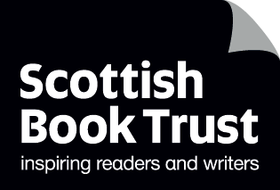
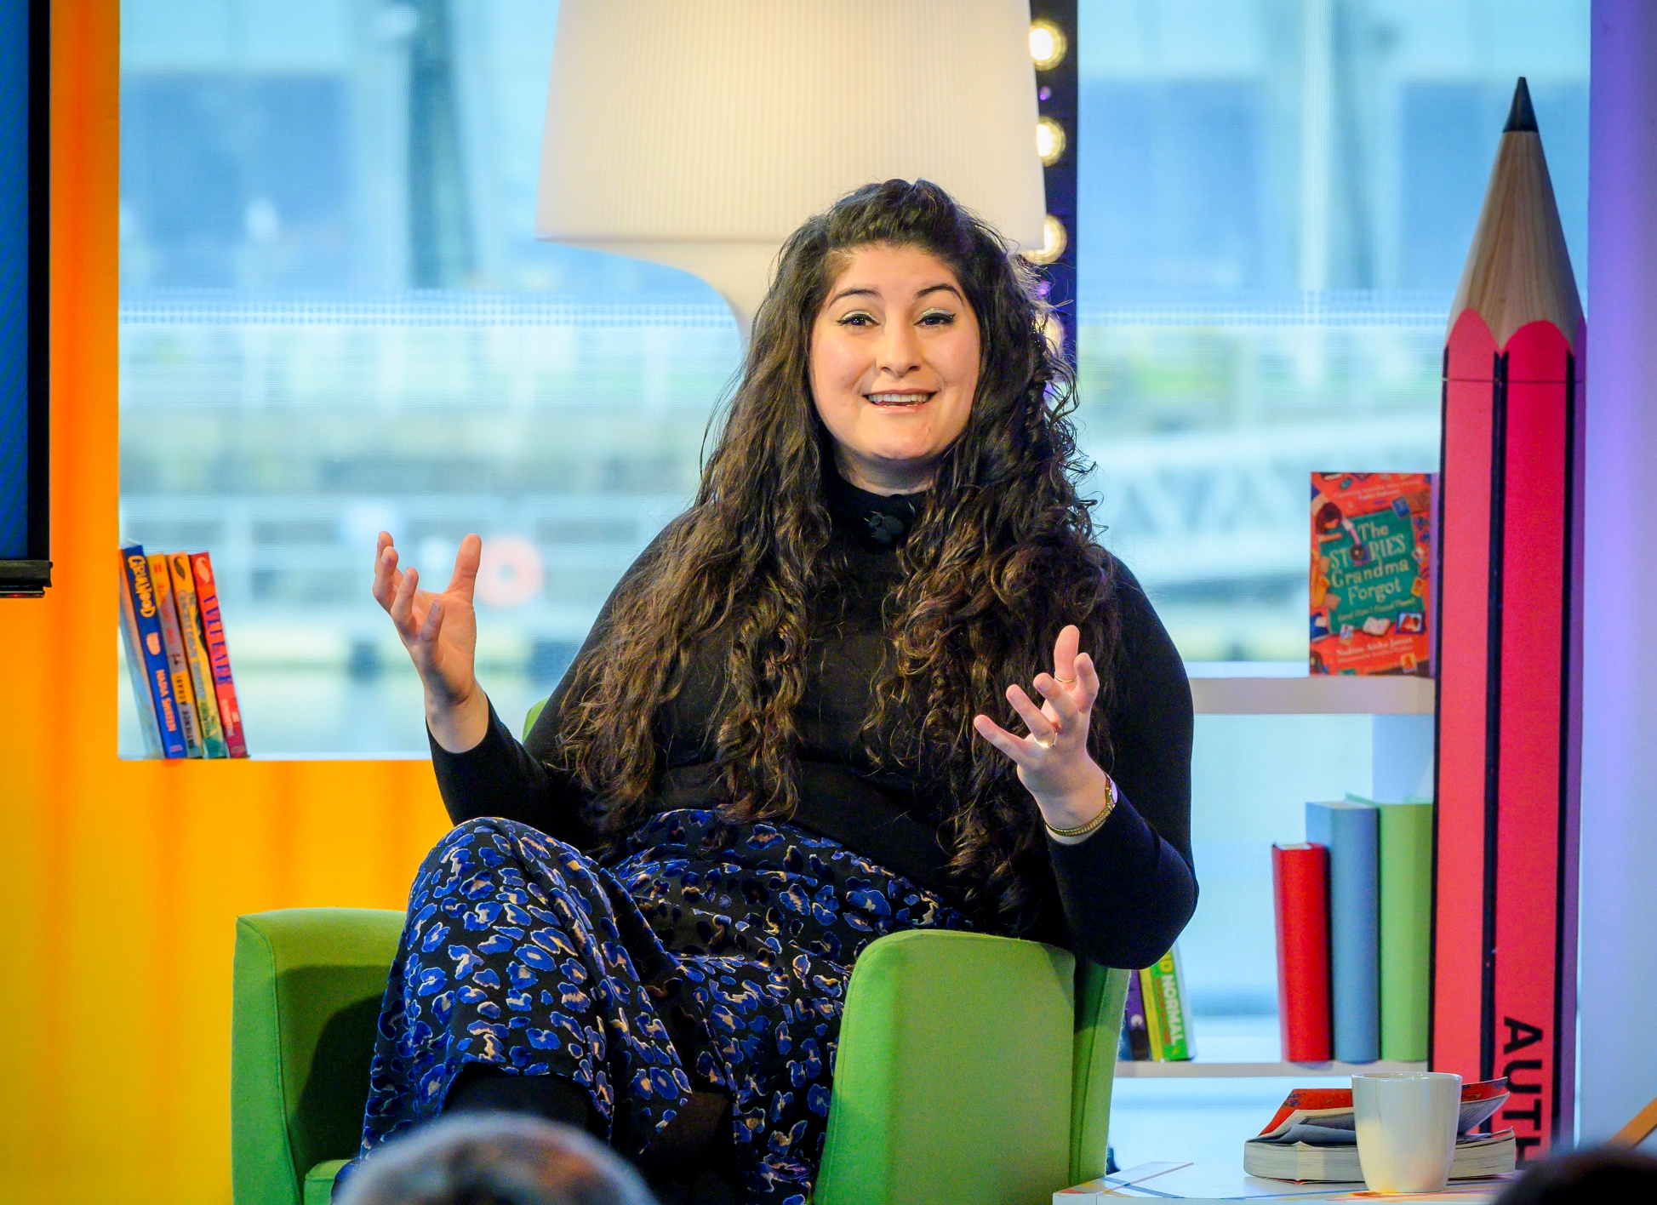

Nadine Aisha Jassat’s reader challenges
Set your pupils a reading challenge tailored to their reading interests

Ages: 12+

Suitable for: librarians, teachers

Resource created by Nadine Aisha Jassat


scottishbooktrust.com

Scottish Book Trust is a registered company (SC184248)
and a Scottish charity (SC027669).

Contents
About this resource 2
How to use these challenges 2
About Nadine Aisha Jassat 3
Reading Schools 4
Reader challenges (plain text) 4
Reader challenges (printable) 7
Further resources 130

About this resource
This resource gathers six different reader challenges which you can set pupils based upon their experience of reading, personal interests and hobbies. The six challenges are:
- For those who are keen readers
- For those who are new to reading
- For those not sure where to start
- For those who like get lost in their imagination
- For those who would rather be on the football pitch
- For those who are curious about the world

This resource contains the challenges both as plain text (see page 5), and as printable bookmarks (see page 8).
How to use these challenges
We recommend that you use these somewhere where pupils can access books that they can borrow. This could be your school or class library, or you could visit your local library. We recommend reaching out to your librarian ahead of time because they can give pupils tailored recommendations based upon their interests, preferences, hobbies and personalities.
If you are using your class library, you might want to take the books out of their shelves and lay them on a table face-up. It’s easy for books to become “background noise”, so this can help them feel fresh again – and it allows the pupils to really look at the covers.
Explain to the pupils they’re going to be receiving a challenge to try from an author, Nadine Aisha Jassat. You could check ahead to see if your school or local library has any copies of her books, or watch her Authors Live broadcast as an introduction. If you are taking part in Reading Schools, you could explain to the pupils that this is part of gaining your accreditation.
Print the bookmarks out and allow pupils to self-identify with which prompt they think best suits them. They can then glue their printed bookmark to card to make it more durable. Ask them to try to find a book from your school or local library to borrow with their bookmark inside. Again, your librarian can help with recommendations!

About Nadine Aisha Jassat
Nadine Aisha Jassat is an ambassador of the Reading Schools programme, working with our secondary schools, supporting our young reading leaders and embarking on a whole host of reading adventures with us! She is an Edinburgh-based author of books and poetry for children and teenagers, notably The House At The Edge of the World, The Hidden Story of Estie Noor (nominated for a Carnegie medal and longlisted for the Jhalak Prize), The Stories Grandma Forgot and Let Me Tell You This.
Nadine says: ‘I firmly believe that storytelling is about telling the stories you want to tell, in your own words and on your own terms. I believe that about reading, too – that it’s not about the books you feel you should read, but about the books you want to read, in a format that works best for you. I hope that these reading prompts help to open up the world of stories more broadly for you, whether that’s what you’re reading, writing, or just talking and thinking about! Here’s one final challenge … If you were going to make a prompt of your own to go on a bookmark, just like these, what would it be?’

Reading Schools
If you are taking part in Reading Schools, the activities in this resource could support delivery of Key Area:
- 1.2.2 – Learner role modelling
- 1.5.1 – Access to high-quality reading materials
- 2.2.1 – Regular opportunities to read for pleasure
- 2.3.1 – Staff-led meaningful conversations about books

Reader challenges (plain text)

For those who are keen readers
Think of a book you absolutely love, or one where you wish there was a different ending. How would you write what the characters do next in the story, after the final page is turned? Have a go at writing or drawing what happens next or seeing if you could describe it out loud as if telling your friend a story!

For those who are new to reading
It’s always good to try something new. Have a go at reading a type of book you’ve not read before, or in a new format – like a graphic novel or listening to an audiobook. When you’ve finished write a three-line book review of what you thought of it. Don’t love writing? You could also make your own illustration of what the cover would be like if you designed it or draw a comic strip of your favourite scene in the book.

For those not sure where to start
Grab the first book with a title that interests you and open it to a random page and a random line. Take inspiration from that line, or even just a random word, and start a new story, poem, or drawing inspired by it. For example, the first line of Jane Eyre by Charlotte Bronte is: ‘There was no possibility of taking a walk that day.’ What if you replaced the activity of walking with something else – what would there be no possibility of doing in your imaginary story world, and why?

For those who love to get lost in their imagination

Think of a book or type of book – like fantasy, horror, or romance – that you absolutely love. Imagine you’re the author of books like that in future. What would your book be called? What would the cover look like? What would the plot be about, or who would be the characters? Have a go at bringing your ideas to life, for example: writing a scene, mapping out the plot or drawing a portrait of one of your characters.
For those who would rather be on the football pitch
Next time you’re on the football pitch, either alone or with friends, have a go at kicking the ball between you (or against something where it will bounce back to you if you’re on your own). With each kick, you have to tell a line of the story (this can be in your head rather than out loud if you prefer if you’re on your own!). You could start with a non-fiction story, for example talking about the biography of one of your favourite players or describing the last match you watched. Start at the beginning, don’t overthink it, and with each kick of the ball add a line of what happened next.

For those curious about the world
Books don’t just have to be about fiction, and reading doesn’t have to just be in a book! If you like learning about the world, or finding facts about a particular topic, why not explore non-fiction? Is there a subject you’re really interested in – for example a particular sport, a period from history, animals or art? Can you give yourself a challenge to discover five new facts about that subject, or to borrow a book or read a news article on that subject that you haven’t before? If you wanted an extra challenge, could you even try writing an article about what you’ve learned – just like a journalist?

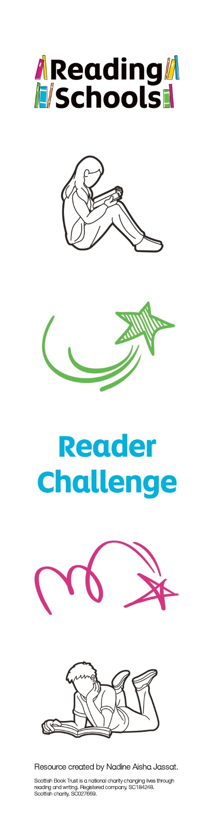
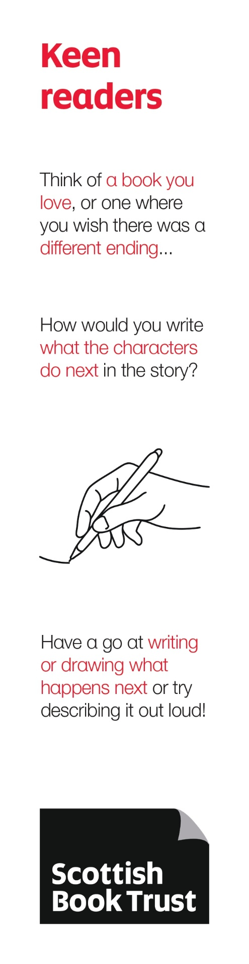
Reader challenges (printable)

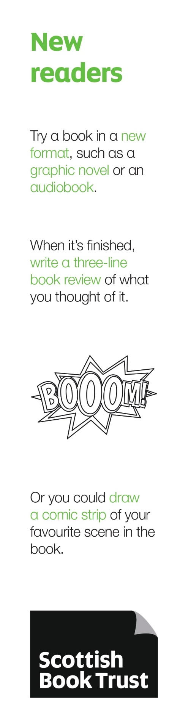
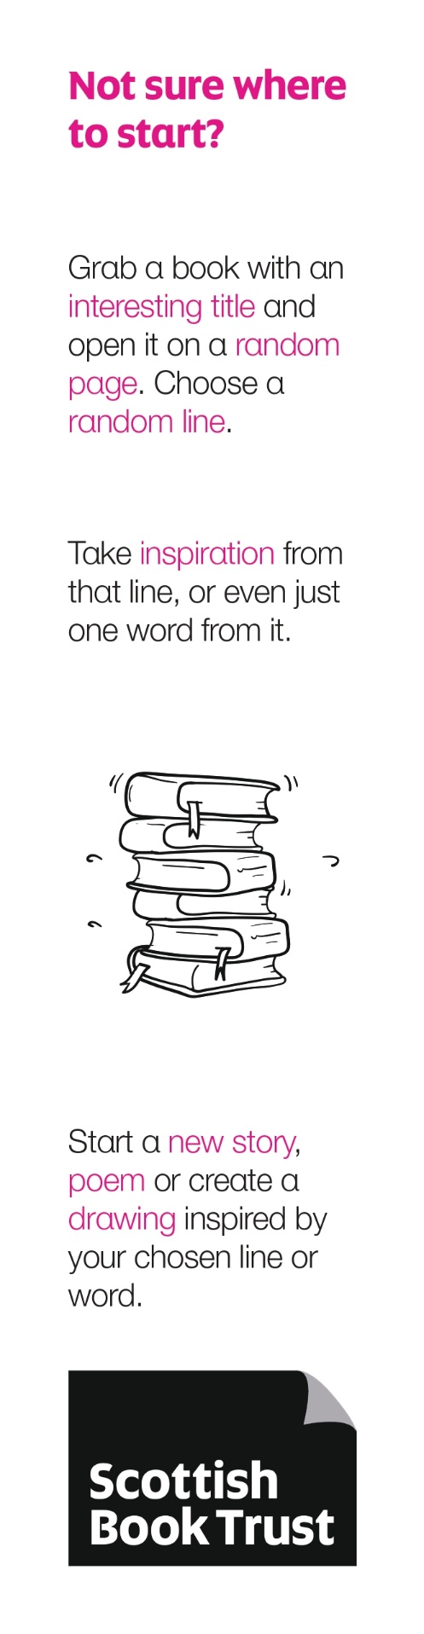
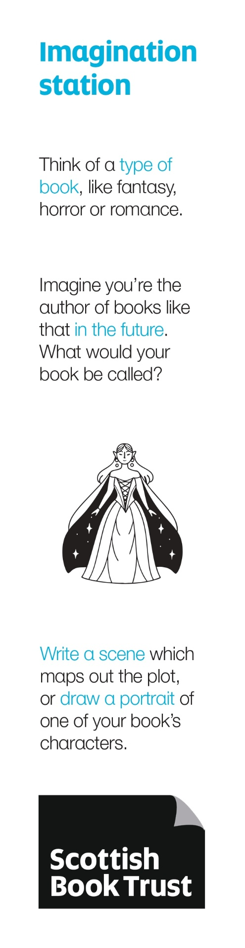
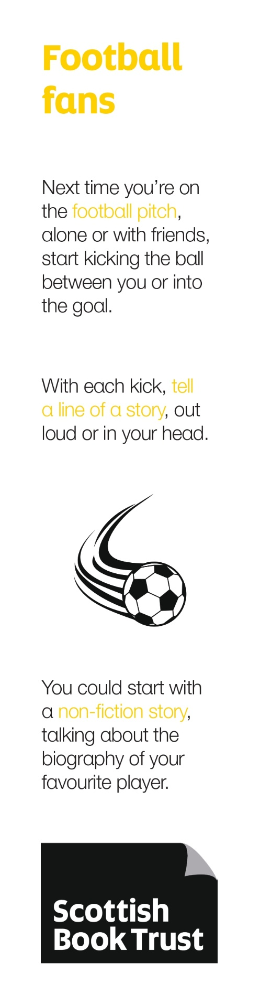
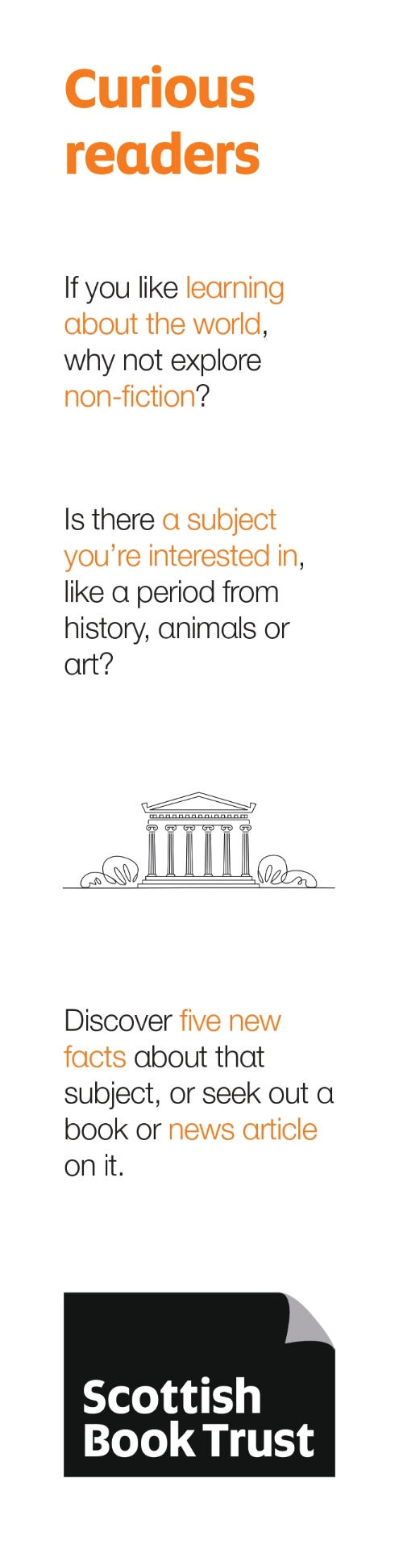

Further resources
- Find out more about our Reading Schools Ambassadors on the Reading Schools website
- For more resources to support pupils to learn about their identity as readers, see our Discovering my reading identity resources
- Watch Nadine Aisha Jassat on Authors Live on Demand on the Scottish Book Trust website

