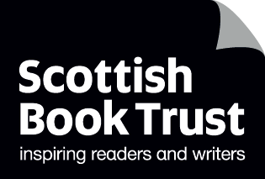
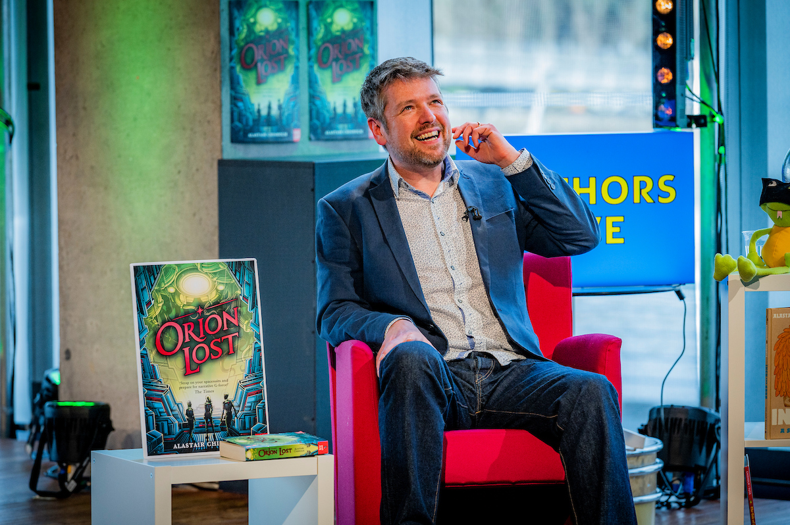

Alastair Chisholm’s storytelling prompts
Creative writing prompts

Ages: 7+

Suitable for: librarians, teachers

Resource created by Alastair Chisholm


scottishbooktrust.com

Scottish Book Trust is a registered company (SC184248)

and a Scottish charity (SC027669).

Contents
About this resource 2
About Alastair Chisholm 3
Alastair’s introduction 3
Reading Schools 4
Activity descriptions 4
Activity 1: What happened next? 6
Activity 2: The story game! 7
Activity 3: Write the sequel 8
Activity 4: A day in the life 9
Printable comic template 1 10
Printable comic template 2 11
Written story template 12
Printable bookmark challenges 14

About this resource
This resource gathers different fun activities to spark pupils’ creative writing. From coming up with a sequel, writing the diary entry of a computer game villain, or making your own storytelling fortune teller, these activities will help pupils come up with ideas in a playful and imaginative way!
In this resource, you’ll find a description of each activity, as well as supporting printable activity sheets. We have also created a companion PowerPoint which you can download from the Reading Schools website. The PowerPoint allows you to display the prompts from each activity on your classroom’s board.
This resource contains printable bookmarks which you can find on page 14 to 17!

About Alastair Chisholm
Alastair Chisholm is an ambassador for the Reading Schools programme, working with our primary schools, supporting our young reading leaders on embarking on a whole host of reading adventures with us! He is an award-winning author of books published by Nosy Crow, Walker Books, Hachette, Barrington Stoke and more, with books including I Am Wolf, Reek, Orion Lost, Adam-2, Inch and Grub and others.

Alastair’s introduction
Please read Alastair’s introduction aloud to your pupils. You could also print it out and give it to pupils or families.

Why do we read?
There are lots of answers. Reading is practical. Reading is an essential life skill for understanding the world. Reading builds your vocabulary and helps you communicate with others.
But for me as a reader and writer, the most important reason is this: reading is fun.
Reading is a way to access stories, and I love stories. I love reading them, hearing them, watching them – and, of course, writing them!
As a boy, I loved making up stories. Stories about the books I’d just read, asking what happened next? Stories about funny, made-up characters. Stories I acted out with my Lego and my toy cars. I fell in love with the idea of stories. And I loved reading, because books were where the stories lived, and if I could read… I could find more.
And I’m not alone. Humans have told stories from the day we learned to talk. We’ve even been called the Storytelling Apes. Telling stories is literally one of the things that makes us human.
So, for this resource, I want to help you realise that you too are storytellers. The books you read were written by someone just like you. One day, it could even be you.
This is my challenge to you all – create stories! Share them! Enjoy them! And then … go and find more. Find books, comics, audiobooks, anything you like – but read them, love them, tell the world about them, and take part in a tradition that is as old as humans themselves. And above all, have fun.
Good luck!
Alastair

Reading Schools
If you are taking part in Reading Schools, the activities in this resource could support delivery of Key Area:
- Key Area 2.2.2 – Interdisciplinary book projects
- Key Area 2.3.4 – Opportunities for learners to respond to what they’re reading

Activity descriptions

Activity 1: What happened next (page 6)
LIT 1-20a, LIT 1-26a, ENG 1-31a
This activity provides five different opening lines that pupils can use to create a piece of creative writing. On the accompanying PowerPoint, you can find all five opening lines displayed so that pupils can refer back to them, or you can print page 6.

Activity 2: The story game! (page 7)
LIT 1-09a, LIT 1-20a, LIT 1-26a, ENG 1-31a
In this activity, pupils will make a fortune teller they can use to come up with story ideas. On the accompanying PowerPoint, you’ll find step-by-step instructions to folding your fortune teller. Find the printable fortune teller template on page 7.

Activity 3: Write the sequel (page 8)
LIT 1-20a, LIT 1-26a, ENG 1-31a, EXA 1-04a
This activity encourages pupils to think about a story they already enjoy and then think about what happens next. On the accompanying PowerPoint, there’s prompts for discussing some of their favourite stories before they use the printable activity sheet – which you can find on page 8.

Activity 4: A day in the life (page 9)
LIT 1-20a, LIT 1-24a, LIT 1-26a, ENG 1-31a, EXA 1-04a
This activity encourages pupils to think about a character and imagine a day in their life! On our PowerPoint we have included a list of all the characters, or you can print the list on page 9. We have also included printable templates that pupils can use for storytelling which you can find on pages 10 to 13.

Activity 1: What happened next?
I’m going to give you five lines from the start of a story. My challenge to you is: can you carry on the story?
Story prompts:
- Option 1: I ran for the doorway as lightning flashed all around.
- Option 2: ‘Why are you looking in my book?’ demanded Ellie.
- Option 3: The engines roared behind me and we blasted into space.
- Option 4: The forest was silent, but I knew something was following me.
- Option 5: My phone pinged… and it was her.

But before you start, wait!
Close your eyes. Imagine you are right inside the story.
- What do you think is happening?
- What can you see?
- What can you hear?
- Is there a smell?
- How would it feel to be there?
- Is it exciting? Scary? Happy? Sad?

Try to imagine it as hard as you can and then… write it down!

Activity 2: The story game!
Using the template below, cut out and make this Story Fortune Teller.
Tell your fortune three times to pick out what kind of story (comedy, magic, adventure or scary), who is in the story (a grumpy fairy, a secret agent, a goldfish or a broken robot), and where the story takes place (a haunted castle, a stormy sea, the moon, or your own school!).
Use your answers to start writing a story or create a comic!

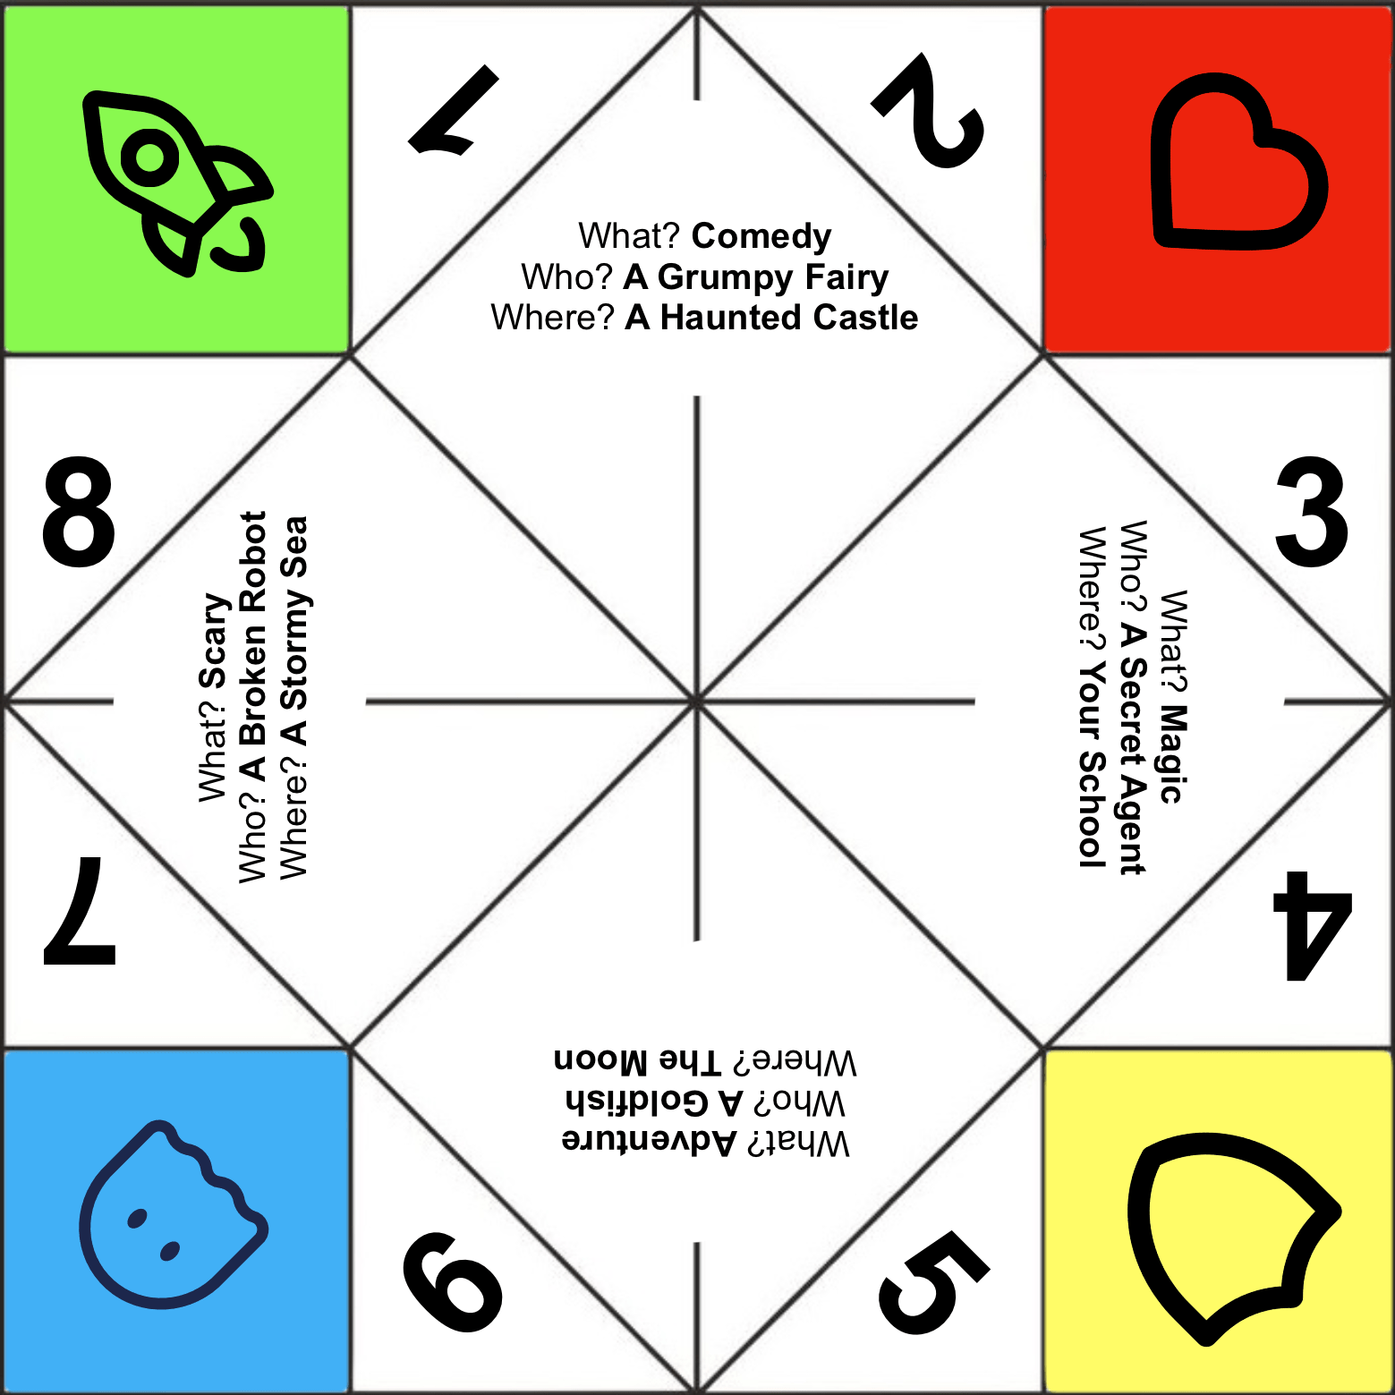

Activity 3: Write the sequel
A great way to start storytelling is to find a story you already love and then ask yourself: what happened next? Write in (or draw) a book you love and then write (or draw) what you think might happen next in the story.

The story I loved is…
And then!
And then…
What happens next?
Who is in it?
Where is it set?
What is the title?
…AND THIS IS THE SEQUEL!

Activity 4: A day in the life
Can you imagine being someone completely different? Pick one of these characters and imagine how your day would be. Write a story, or a diary entry, or draw a comic!

- A lost alien
- A unicorn herder
- A computer game villain
- A dinosaur who is scared of everything
- A grumpy princess
- A mouse living in a sporran
- The king of Asteroid City

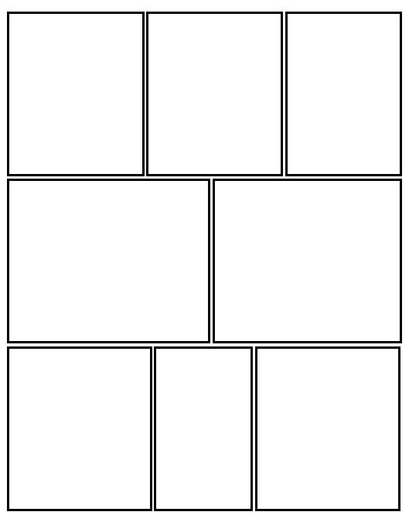
Printable comic template 1

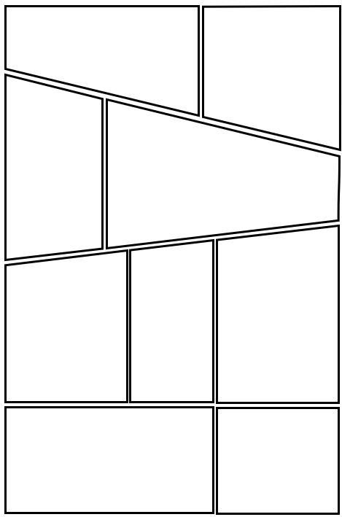
Printable comic template 2

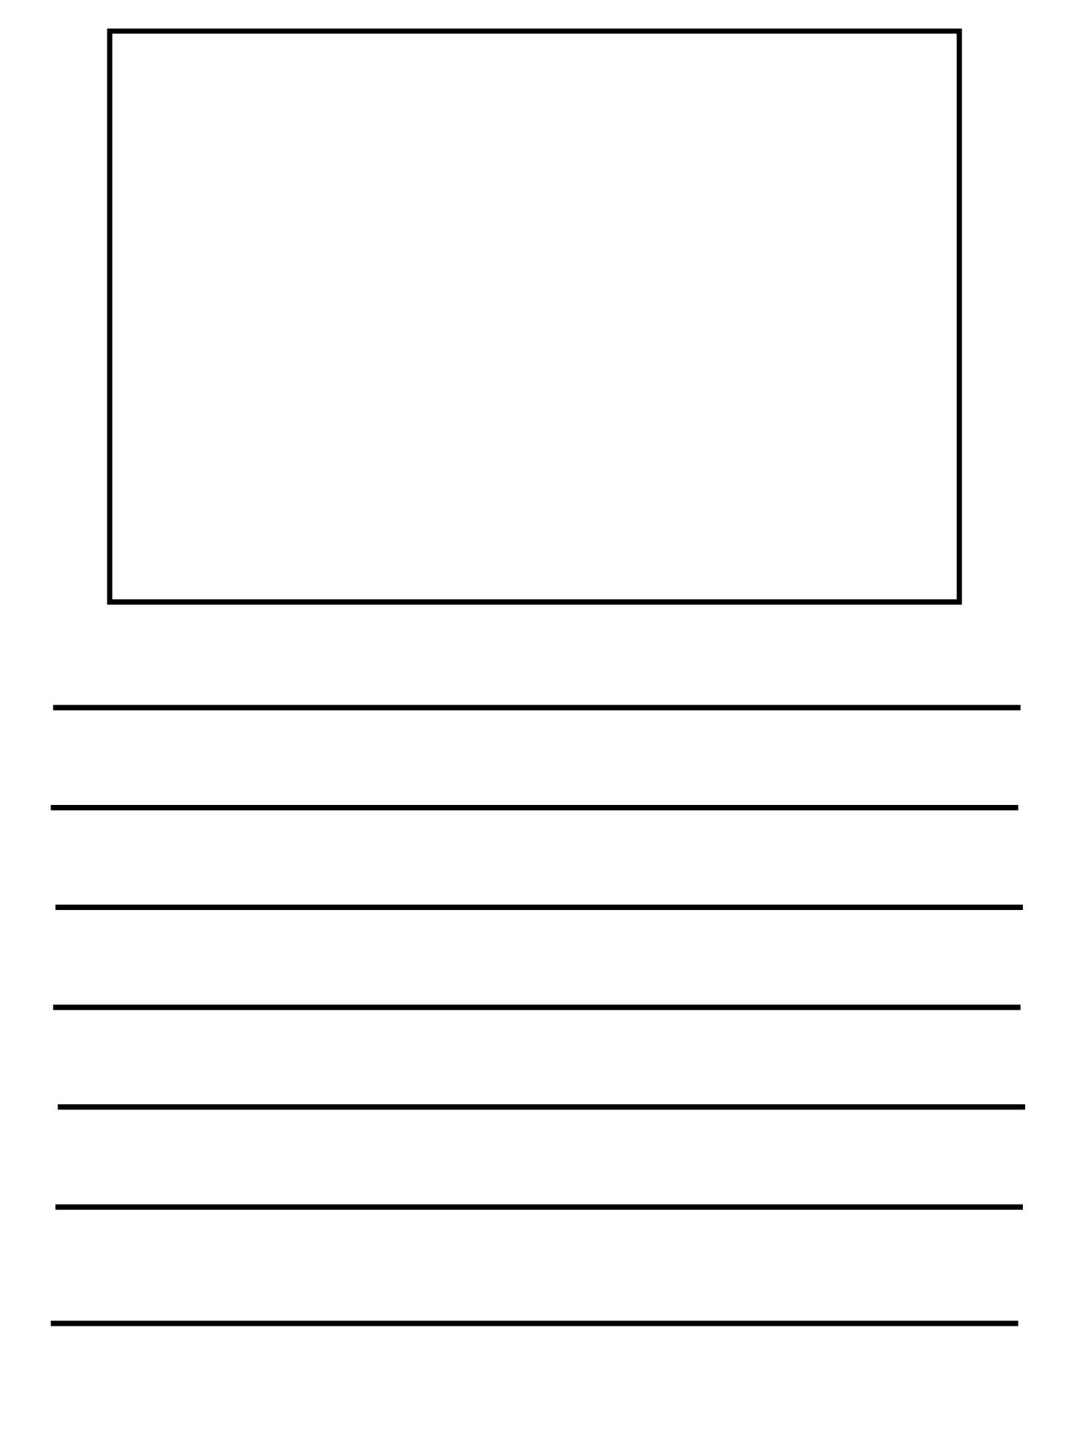
Written story template



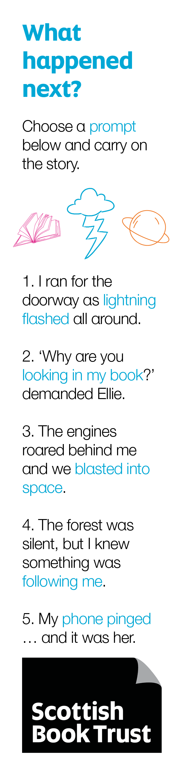
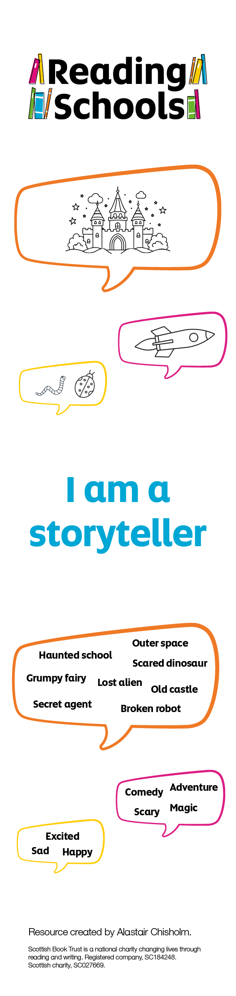
Printable bookmark challenges

