
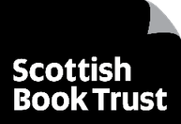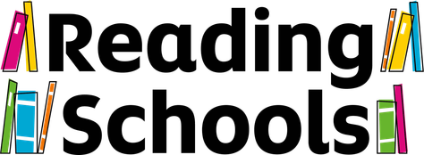

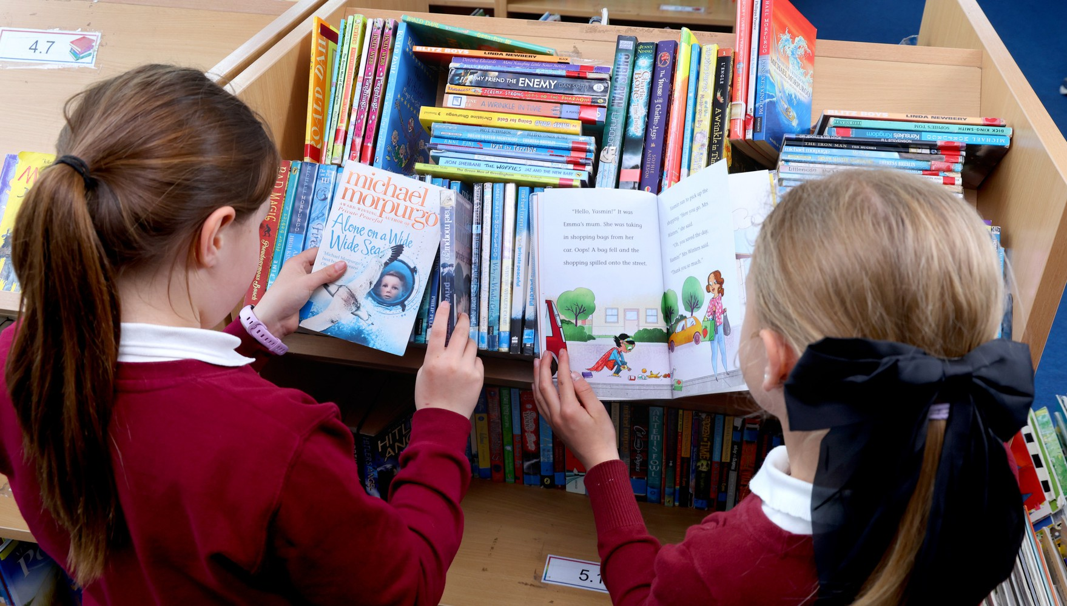

Reading Schools
Evaluation authored by Éadaoín Lynch
May 2026
Report presented by Scottish Book Trust
Evaluation 2024–25

scottishbooktrust.com



1

Contents
Background 2
Context 2
Aims 3
Methodology 3
Findings 4
Impact survey 4
Process survey 11
What worked well 21
Areas for improvement 21
Conclusion 23

Background

Context
Reading Schools was first developed in 2019, created as an accreditation programme that aims to help schools build and sustain a reading culture. It is funded by the Scottish Government and delivered by Scottish Book Trust. There is no cost to schools for taking part.
Reading Schools was originally designed by Scottish Book Trust, with a working group of teachers, school leaders, literacy leads, local authority representatives from education and library services, Education Scotland and academics. Scottish Book Trust worked with Regional Improvement Collaboratives for education to deliver the programme in their areas.
This is an evaluation of Scottish Book Trust’s Reading Schools programme during 2024/25. This year was the third year of the national roll out of Reading Schools,

involving 1,154 settings located across every Local Authority – this makes up almost 50% of all schools in Scotland. This report explores learning around the delivery of Reading Schools, and the outcomes achieved.
We continue to develop the Reading Schools programme, informed by the experiences of Scotland’s schools and making necessary improvements to ensure the journey to accreditation is accessible, achievable and meaningful.

Aims

- To embed effective reading for pleasure in school settings
- To develop schoolchildren into successful learners and confident individuals through reading for pleasure’s support of attainment, wellbeing and creativity
- To nurture a lifelong love of reading
- To develop schoolchildren as responsible citizens through reading for pleasure’s support of empathy, resilience and critical literacy

Methodology

As part of the accreditation process, the Reading Schools team issued a survey to all schools registered, exploring their experience of the programme (the ‘Process’ survey).
This received 194 responses.

A second survey was issued to schools which received accreditation, focusing on the impact of the programme (the ‘Impact’ survey).
This received 293 responses.
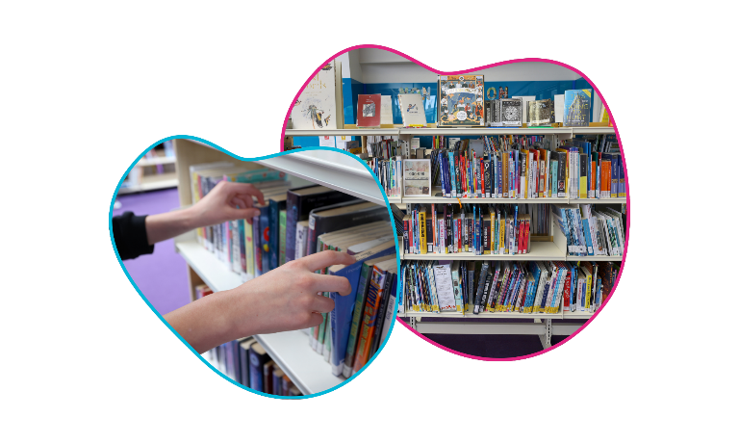
Both surveys close at the end of the school year (over the summer), and a prize draw randomly selects one respondent from each to receive a book voucher for their school as token of thanks.

Findings

Impact survey

About you
Out of 293 responses, half (50.51%) identified as a class teacher, followed by head/deputy head teacher (16.72%) and school librarian (9.9%).
The vast majority of respondents were from primary schools (82.01%), followed closely by secondary schools (14.19%).
In terms of geographic spread, there was representation from every local authority save one (Comhairle nan Eilean Siar), with the greatest number of responses from South Lanarkshire (13.06%), Highland (8.93%) and North Lanarkshire (6.87%).

The difference it makes
Respondents were then asked to indicate how Reading Schools activity affected their pupils:

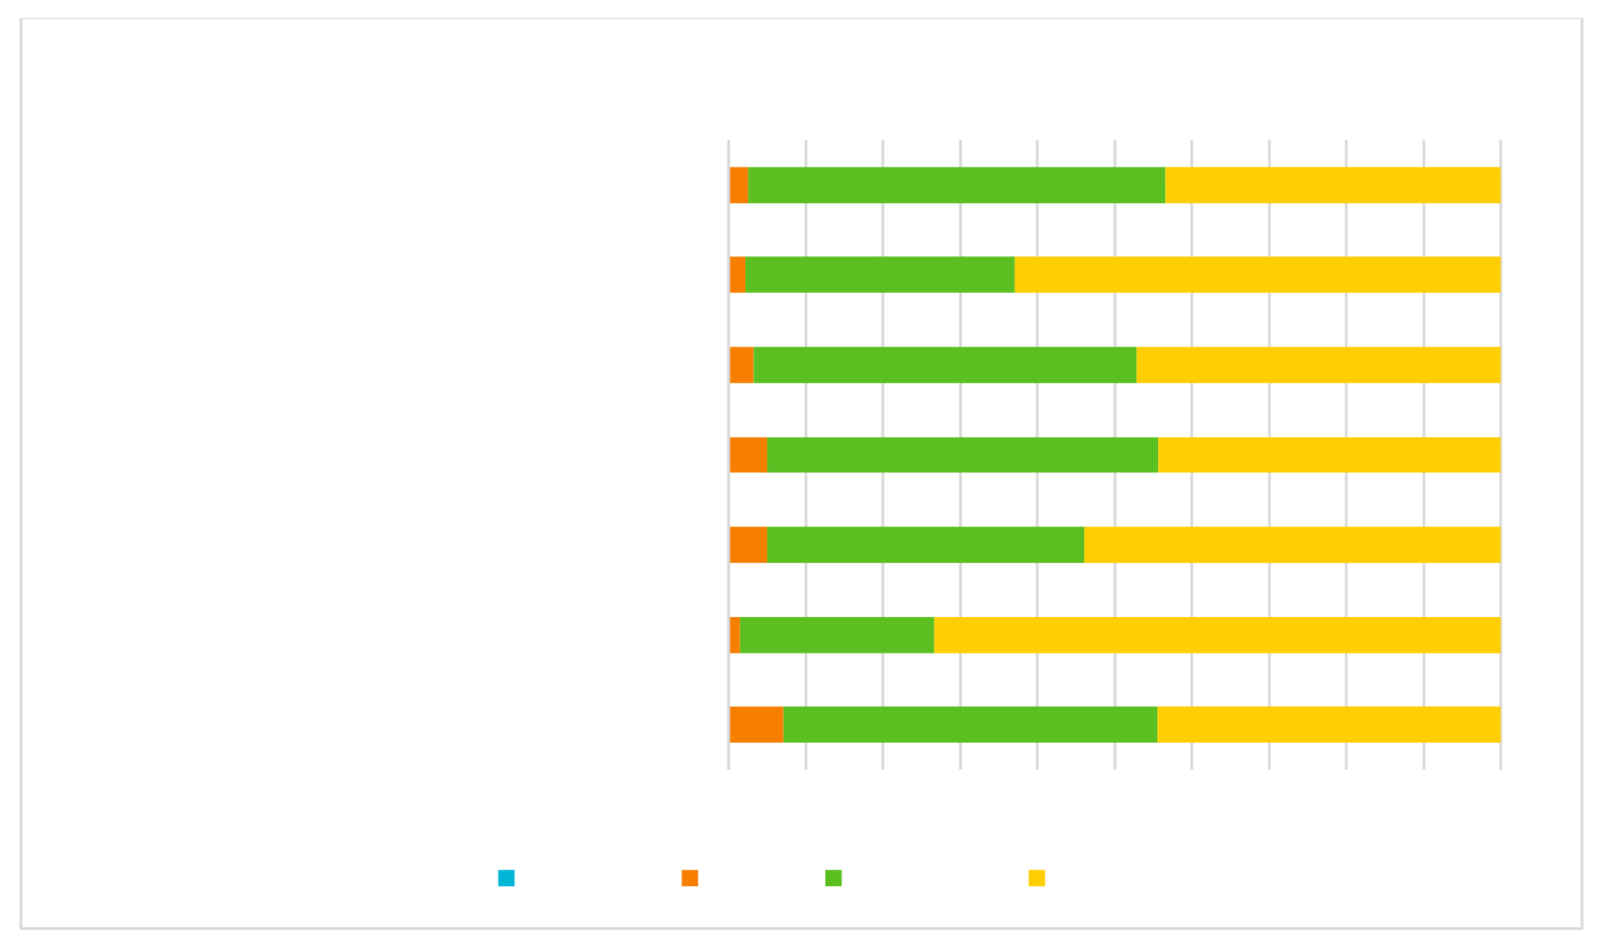
As a result of our Reading Schools activity:
Pupils are confident in their reading choices

Pupils are able to choose and find books they enjoy
Pupils enjoy reading Pupils identify as ‘readers’ Pupils read regularly and widely Pupils have their voice heard
Pupils connect with others around reading

0% 10% 20% 30% 40% 50% 60% 70% 80% 90%100%
Not at all A little Quite a lot A lot
(Total number of responses: 281)

Schools were unanimous in the positive effects of Reading Schools activity, with all indicators of enjoyment, connection and confidence scoring high. Take for instance ‘Pupils have their voice heard’ – 73.31% said ‘A lot’, followed closely by ‘Quite a lot’ at 25.27%.
There were zero responses under the first option, ‘Not at all’.

Respondents were then asked to indicate how Reading Schools activity may have changed the level of reading for pleasure among particular groups of their pupils:
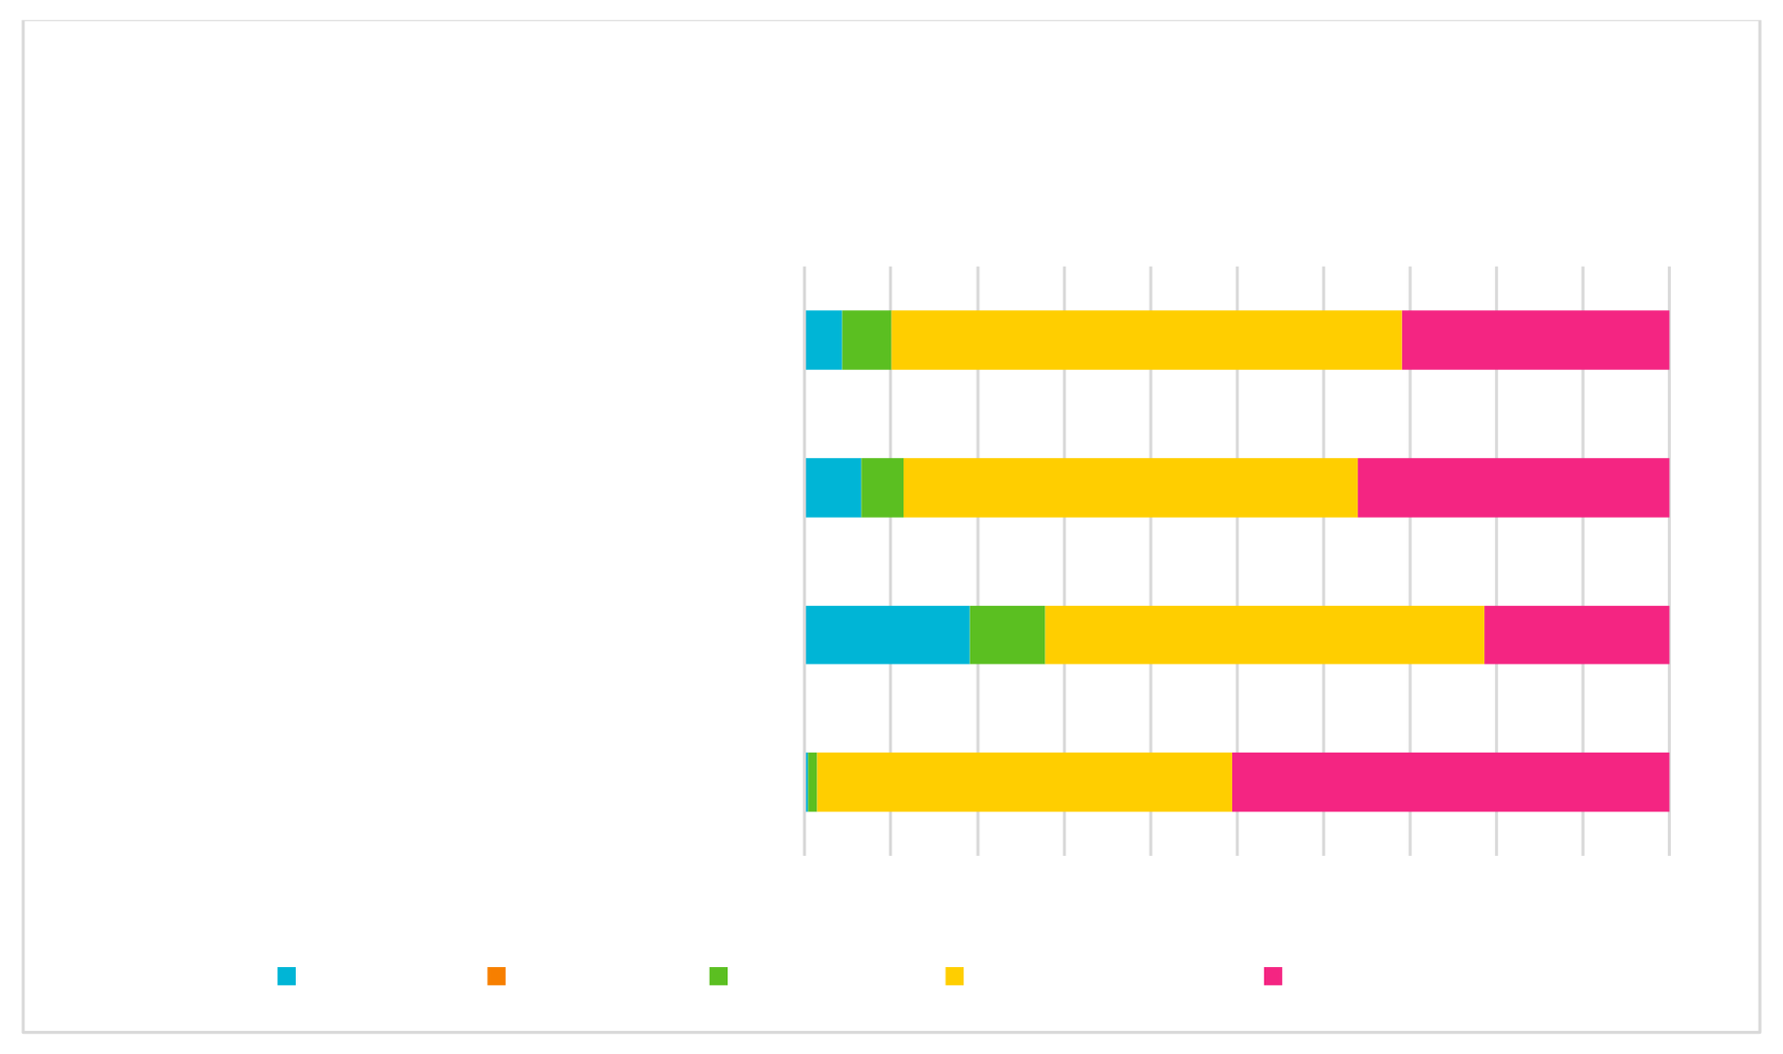
Have you noticed any changes in the level of reading for
pleasure amongst particular groups of pupils because of the Reading Schools programme?
Pupils with additional support needs
Pupils identified as socioeconomically
disadvantaged
Pupils with English as an additional language
Pupils who were not previously enthusiastic
readers
0% 10% 20% 30% 40% 50% 60% 70% 80% 90%100%
Not sure A decline No impact A little increase
A big increase
(Total number of responses: 280)
The largest increase was reported among pupils who were not previously enthusiastic readers: 50.54% indicated ‘A big increase’, with a further 48.01% who observed ‘A little increase.’
Moreover, 36.03% observed ‘A big increase’ among pupils identified as
socioeconomically disadvantaged, and 52.57% indicated ‘A little increase’. There were zero responses under the second option, ‘A decline’.

Learners and citizens
As part of Reading Schools’ programme aims, the survey asked respondents to reflect on how reading for pleasure contributed to attainment, creativity, wellbeing among other factors:
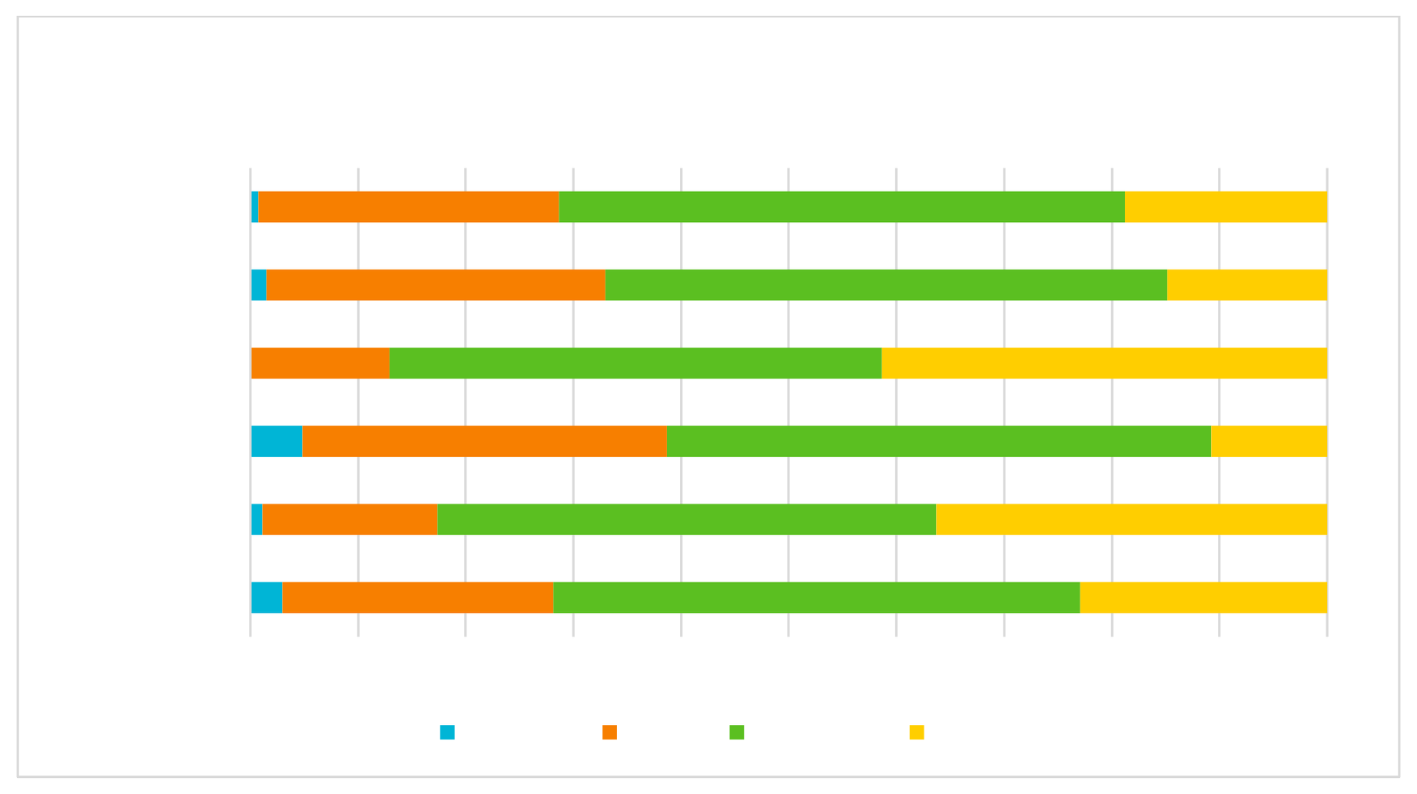
Do you feel that reading for pleasure through Reading Schools
has contributed to pupil:
Attainment

Critical literacy
Wellbeing Resilience Creativity Empathy
0% 10% 20% 30% 40% 50% 60% 70% 80% 90% 100%
Not at all A little Quite a lot A lot
(Total number of responses: 272)
Schools indicated that reading for pleasure had the highest contribution to pupil
wellbeing, with 41.33% reporting ‘A lot’, and 45.76% ‘Quite a lot’.

After wellbeing, reading for pleasure contributed highest to creativity (‘A lot’, 36.30%; ‘Quite a lot’, 46.30%), empathy ( ‘A lot’, 22.96%; ‘Quite a lot’, 48.89%) and attainment (‘A lot’, 18.75%; ‘Quite a lot’, 52.57%).

To understand more about how Reading Schools affected attainment, the survey prompted respondents to reflect on more specific contributions:

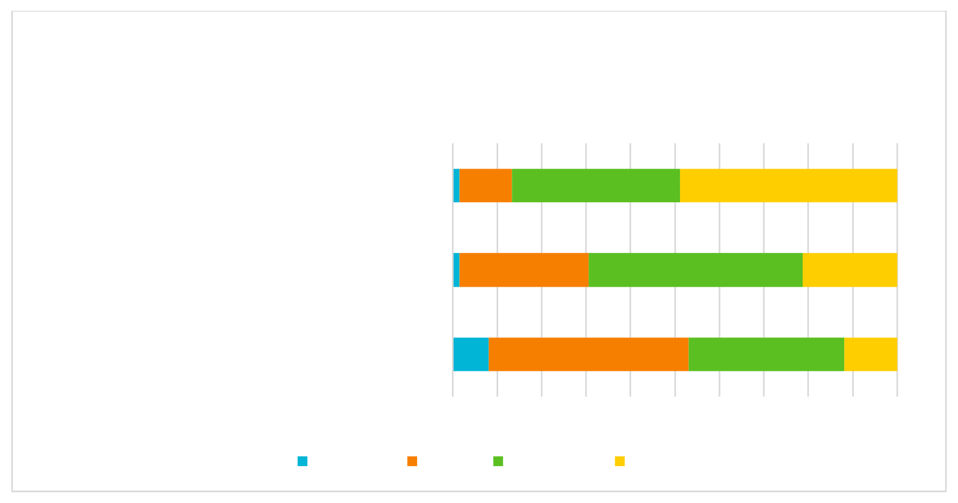
We would like to understand how taking part in Reading
Schools has affected attainment in your school. Please tell us the extent to which you agree with the following statements:
Reading Schools programme helped us to
recognise and reward pupils’ achievements
Reading Schools has contributed to improved
attainment at school

Reading Schools has contributed to reducing or closing the poverty related attainment gap
for pupils
0% 10% 20% 30% 40% 50% 60% 70% 80% 90%100%
Not at all A little Quite a lot A lot
(Total number of responses: 271)
The strongest indicator of attainment was how Reading Schools helped teachers to recognise and award pupils’ achievements ‘A lot’ (48.89%), ‘Quite a lot’ (37.78%) or ‘A little’ (11.85%).
Reading Schools reportedly contributed to improved attainment ‘Quite a lot’ for most respondents (48.13%), and contributed ‘A little’ to reducing or closing the poverty-related attainment gap (45.00%).

Professional practice

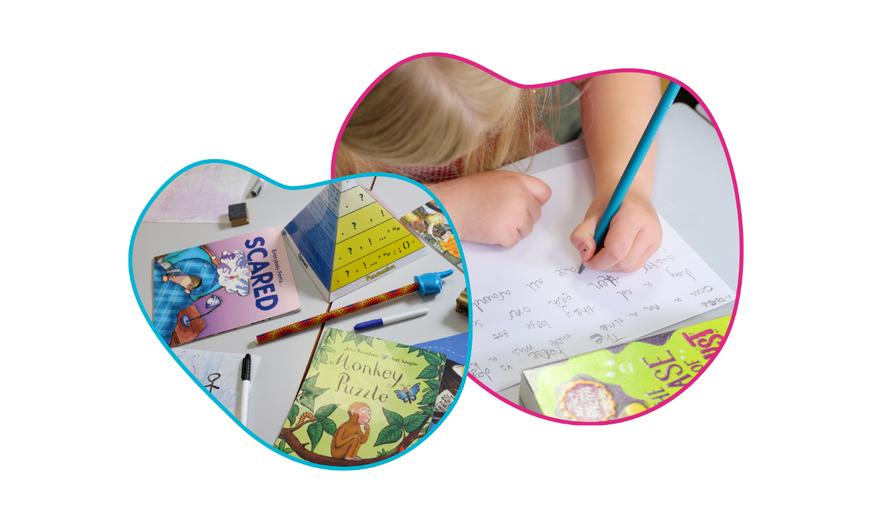
Reading Schools as a programme aims to embed effective reading for pleasure in school settings; as such, there needs to be buy-in from school staff to understand, promote and model good reading practice.

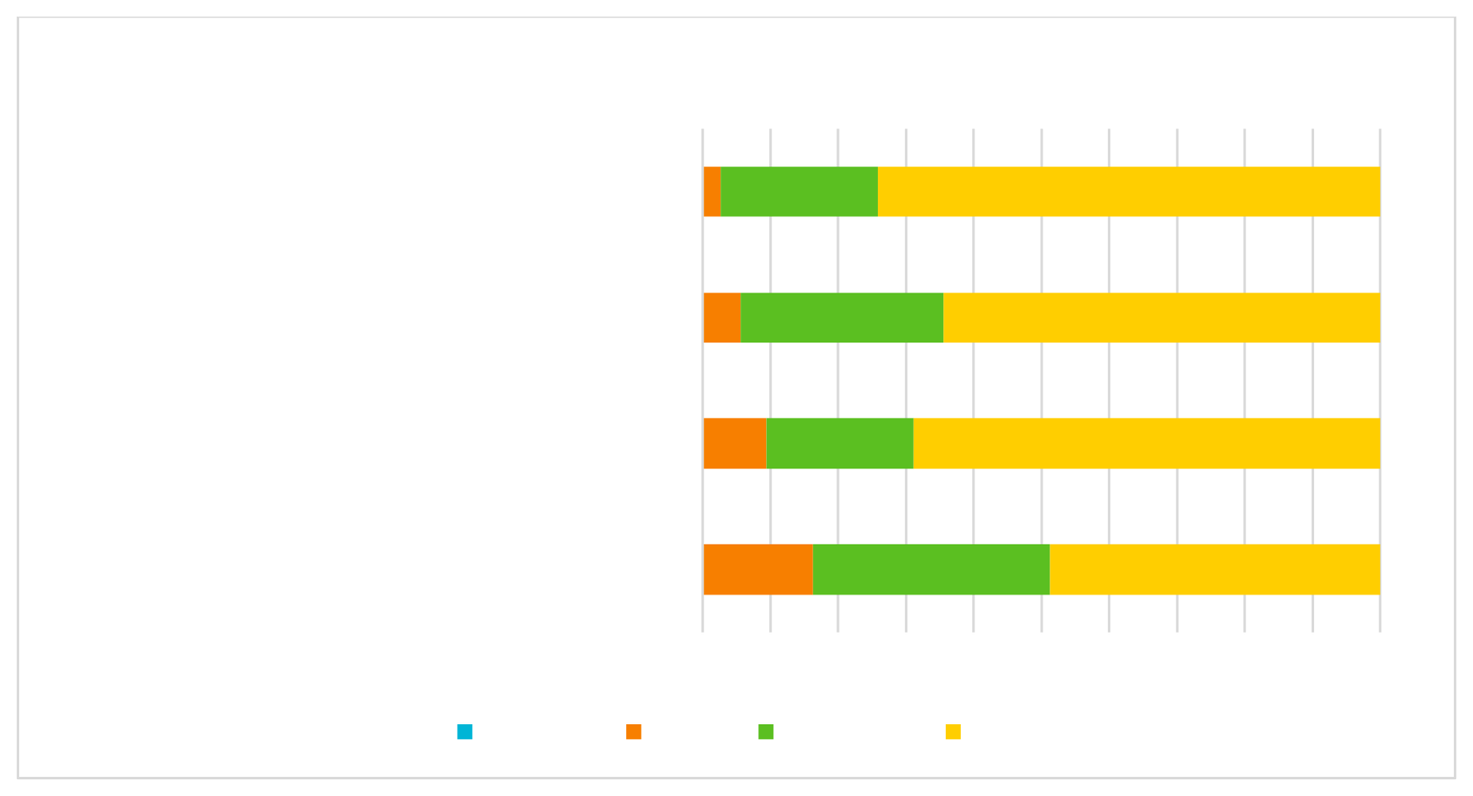
Because of Reading Schools:
Staff recognise the value of reading for pleasure
School staff are showing pupils that they are
readers

School staff are reading aloud to class/ assemblies
It has contributed to professional development
0% 10%20%30%40%50%60%70%80%90%100%
Not at all A little Quite a lot A lot
(Total number of responses: 267)
According to survey respondents, staff recognise the value of reading for pleasure ‘A lot’ (74.16%) due to the process of Reading Schools. One respondent shared the uplifting insight:
‘Our staff have been great and really recognising the value of reading for pleasure. We have much more book chat and some staff have started reading more children's books to improve their own knowledge.’
Staff are showing pupils they are readers ‘A lot’ (64.42%), and they are reading aloud to class/assemblies ‘A lot’ (68.91%).

A combined 83.77% reported that Reading Schols has contributed to staff professional development ‘Quite a lot’ and ‘A lot’.

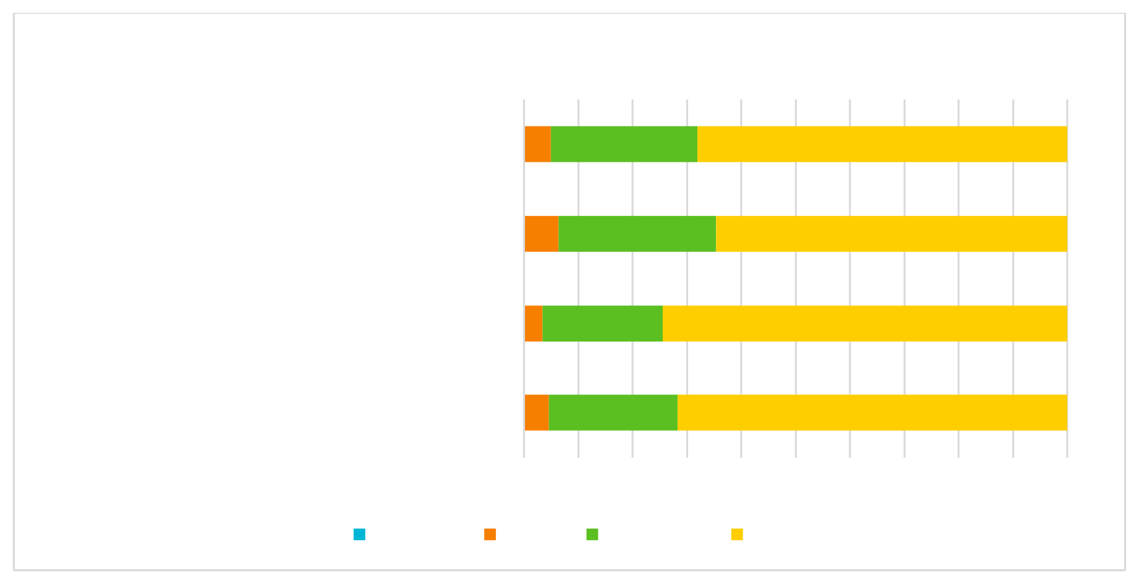
Because of Reading Schools:
Staff use reading for pleasure with pupils
We are benefitting from a Reading Leadership
Group

There are safe and comfortable places for reading in our school

Reading is important within the school community

0% 10% 20% 30% 40% 50% 60% 70% 80% 90%100%
Not at all A little Quite a lot A lot
(Total number of respondents: 267)
The majority of responding schools indicated that there are safe and comfortable spaces for reading in the school (‘A lot’, 74.44%; ‘Quite a lot’, 22.18%), and that reading is important within the school community (‘A lot’, 71.70%; ‘Quite a lot’, 23.77%).
Similar stats are reported for how Reading Schools has prompted staff to use reading for pleasure with pupils (‘A lot’, 68.05%; ‘Quite a lot’, 27.07%).
Again, there were zero responses under the first option, ‘Not at all’.
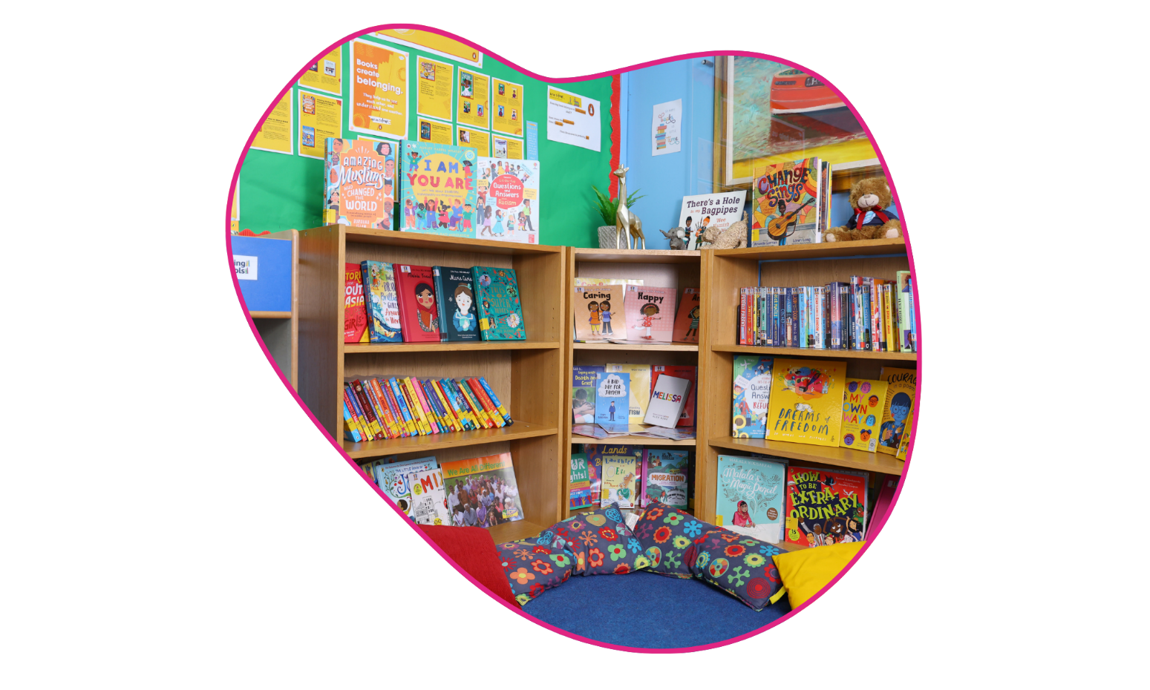
There was further positive feedback in respondents’ reflections on the question, ‘Has Reading Schools engaged staff across the school, beyond those directly involved in it?’:

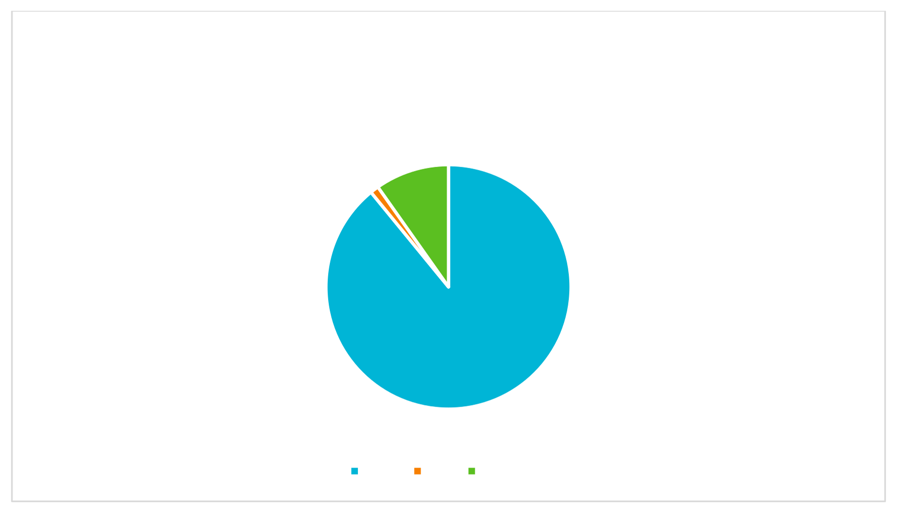
Has Reading Schools engaged staff across the school,
beyond those directly involved in it (e.g. beyond your
classroom, or beyond the English department)?
9.77%
1.13%
89.10%

Yes No Not sure
(Total number of responses: 266)
The vast majority of respondents (89.10%) reported that Reading Schools has engaged staff across the school. A key factor reported in the feedback was the importance of collective investment in reading for pleasure:
‘This was a whole school achievement. All classes were involved in the planning and delivering of our reading rich culture. All classes were invested and interested in the progress we were making and the impact it was having on our learners.’
The survey finally asked schools to reflect on the impact Reading Schools may have had on families and communities:
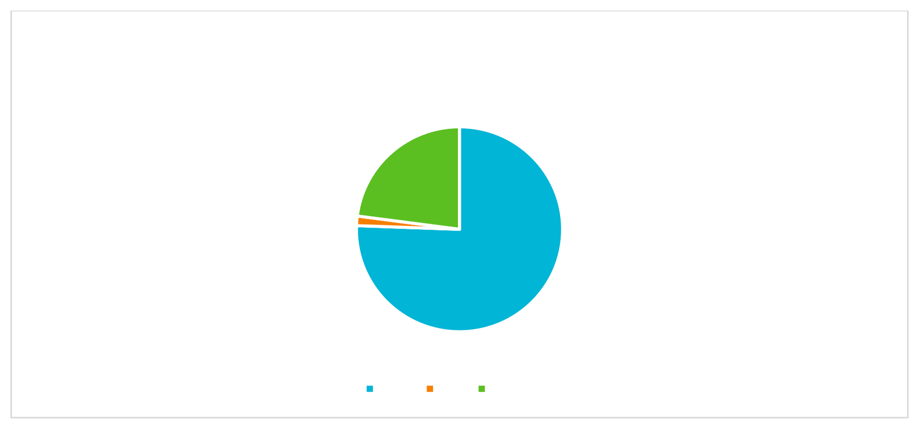
Has Reading Schools had an impact more widely on families
and communities?
22.93%
1.50%
75.56%
Yes No Not sure
(Total number of respondents: 266)

The vast majority indicated ‘Yes’ (75.56%), Reading Schools has impacted families and communities more widely. Comments indicated a widespread effect from the work of Reading Schools:
- ‘Most certainly, as families have entered into our literacy classes and I have also noticed more positive sentiments from pupils regarding their family life since the pupils themselves has grown more confident and happy. :)’
- ‘We have seen an improvement in parental engagement in the school as a result of Reading events such as reading cafes and the school readathon.’
- ‘Families have been in our school a lot more this session. The feedback about
events attended and online games/quizzes and competitions, has been incredible. This is an area that our school has seen a huge benefit and keen to continue.’
- ‘Parents are seeing the value of reading more and are commenting on how much their children are enjoying reading at home. Many parents have asked for book recommendations from staff for their children to read at home.’

Process survey

About you
Out of 193 responses, nearly half (42.49%) identified as a class teacher, followed by school librarian (15.03%) and head/deputy head teacher (13.47%).
The vast majority of respondents were from primary schools (71.13%), followed closely by secondary schools (22.68%).
In terms of geographic spread, there was representation from every local authority save three (Comhairle nan Eilean Siar, Aberdeen City & West Dunbartonshire), with the greatest number of responses from South Lanarkshire (11.92%), Highland (10.36%) and North Lanarkshire (7.25%).
Scottish Book Trust sought to understand where on the journey towards accreditation the responding schools were:

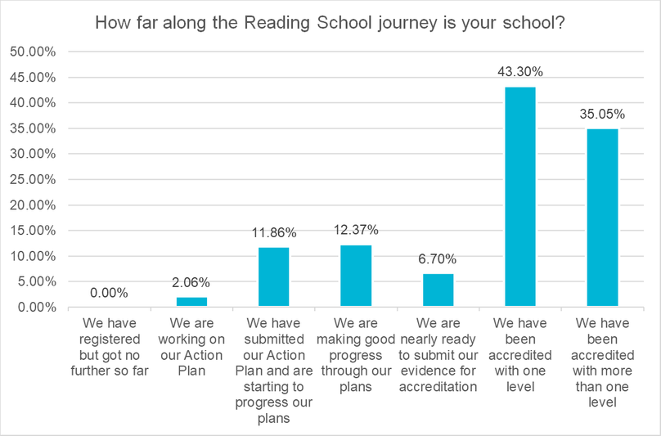

(Total number of responses: 194)
Most respondents (43.30%) have been accredited with one level (Core, Silver, or Gold), and some of those have also been accredited with more than one level (35.05% of responses total).
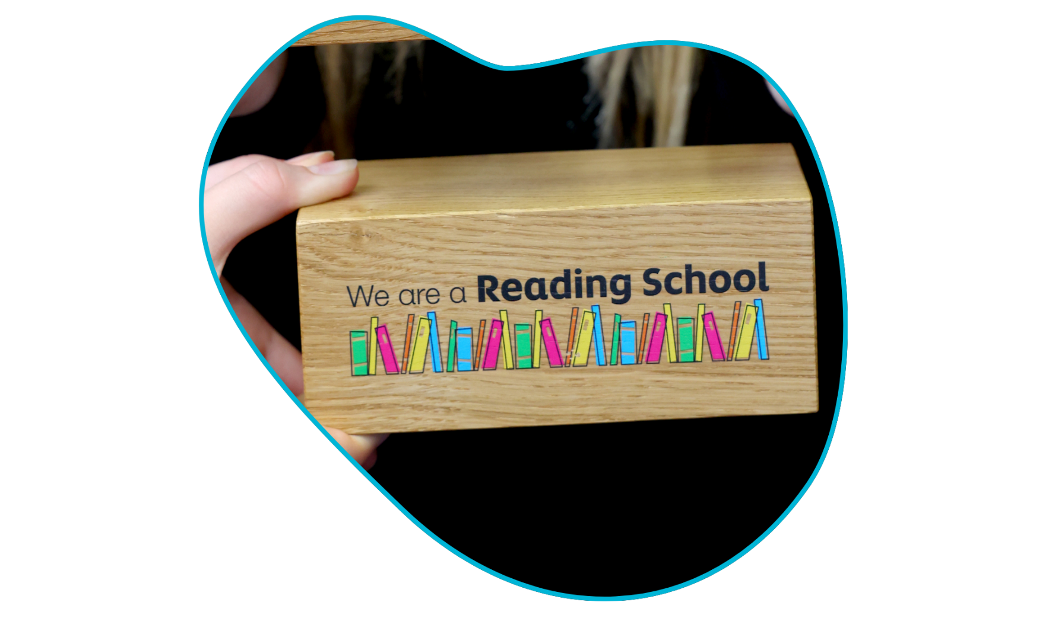
1 in 10 respondents (11.86%) have submitted their action plan and are starting to progress their plans, the first step towards accreditation.

Your experiences

Respondents were then asked to indicate how they would rate the Reading Schools programme on a scale of 1 (Poor) to 5 (Very good). From 170 responses, the average rating was 4.6, Very good.
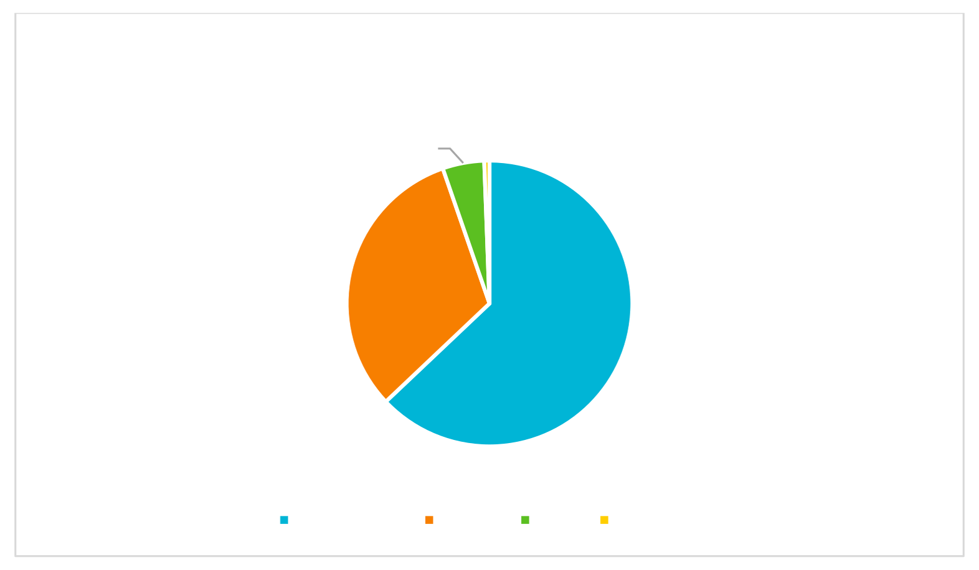
How would you rate your experience of the Reading
Schools programme?
0.59%
4.71%
31.76%
62.94%
Very good Good Fair Not good
(Total number of responses: 170)
Over 90% of respondents indicated their experience of Reading Schools was ‘Good’ or ‘Very good’. Their comments noted particular strengths in the programme team’s ‘clear instructions and great support’:
- ‘The Reading Schools programme has given the school a framework, purpose and motivation to promote reading for enjoyment across the school community. The Reading Schools framework gave the reading leadership group direction, but it also gave us a rationale that we could present to management, pupils, staff and families’
- ‘Access to ideas/example/models widely available and very useful. Website is great and staff respond promptly and with good feedback’
- ‘The excitement and enthusiasm the Reading Schools programme generates is
so uplifting! The accreditation keeps us moving forward and reading for pleasure has gone from strength to strength in our school because of this’
In addition to the positivity of each school’s experience, SBT asked after the adaptability and relevance of Reading Schools to primary and secondary settings:

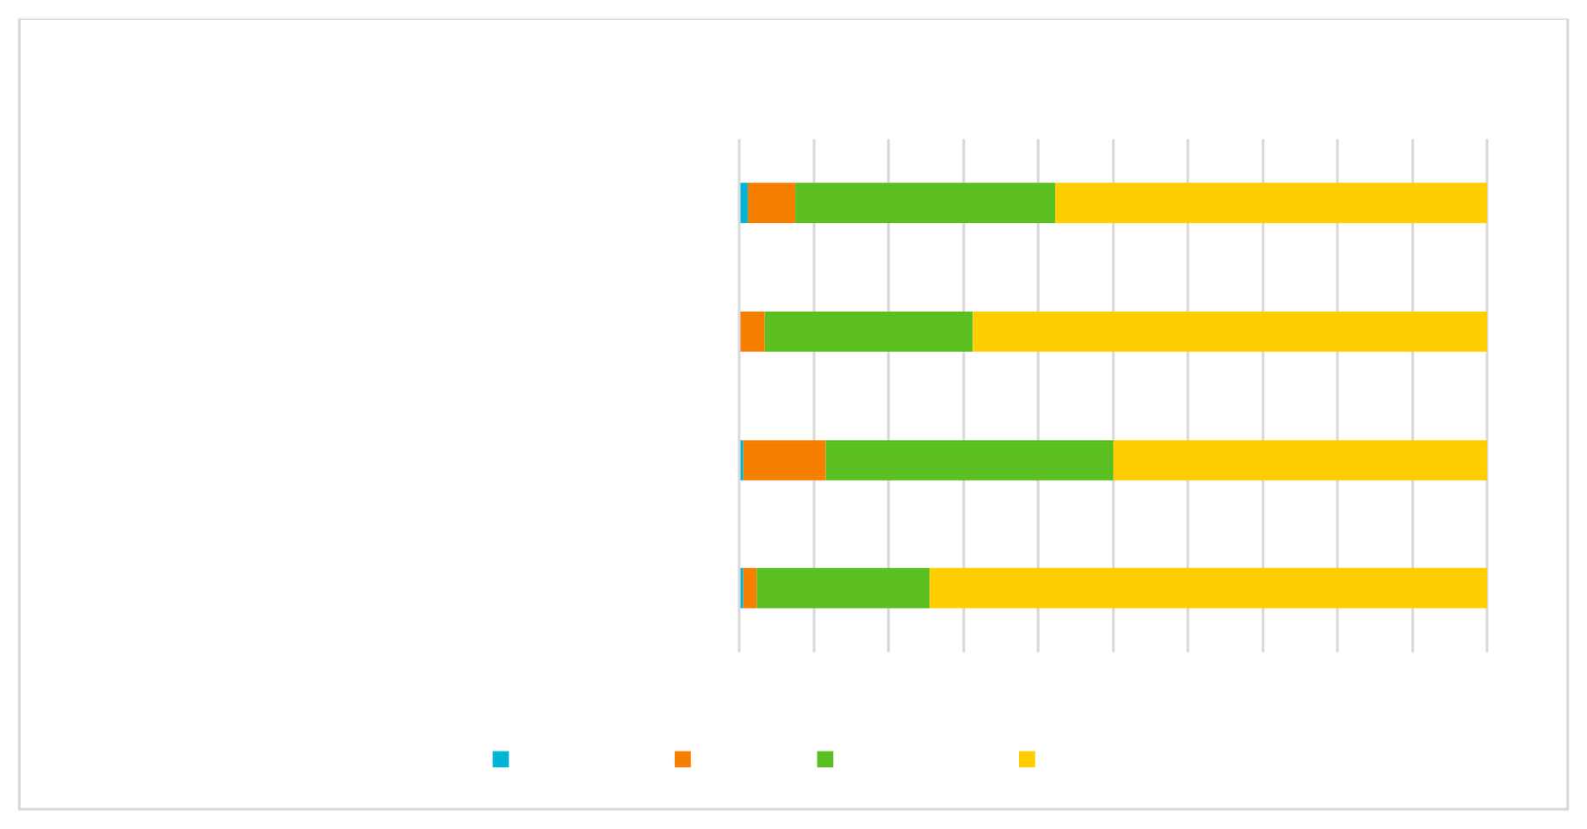
To what extent do you agree with these statements:
Reading Schools is flexible to the needs of my
school

I feel supported by knowledgeable and responsive staff at Scottish Book Trust

Reading Schools is designed with the needs of my school in mind

The Reading Schools programme is inspiring and exciting

0% 10% 20% 30% 40% 50% 60% 70% 80% 90%100%
Not at all A little Quite a lot A lot
(Total number of responses: 173)

Majority answers indicated that schools feel supported by knowledgeable and responsive staff at Scottish Book Trust ‘A lot’ (68.79%), that the programme is inspiring and exciting (‘A lot’, 74.57%), that it’s flexible to the needs of the school (‘A lot’, 57.80%; ‘Quite a lot’, 34.68%) and designed with the needs of the school in mind (‘A lot’, 50%; ‘Quite a lot’, 38.37%).
Comments further solidified these positive examples in feedback:

- ‘The enthusiasm it has generated around reading in our school is fantastic.
The resources are up to date and accessible. Fantastic responses from anyone at SBT I have contacted’
- ‘If it weren't for participating in Reading Schools, I would not have stepped up to lead reading for pleasure across the school. I wouldn't have felt empowered to do that and remained passionate, but only shared that with my current pupils’
- ‘It was easy to decide which aspects of the awards we would work towards
because the format was well laid out and there were a lot of areas to choose from. Scottish Book Trust has loads of great resources which I hadn't looked at in depth before, so it was good to take time and go through these to see what was on offer. The children were enthused by the range of activities on

offer, so it made it easier to motivate them through the process of achieving the award’
Some respondents also indicated the issues they faced in trying to attain Reading Schools accreditation:
- ‘Some of the criteria to meet felt it would be easier in a primary school as
opposed to a secondary school setting (or a school where there was currently no library provision)’
- ‘I think the Reading Schools programme has been designed for bigger schools’
- ‘Travel and budget restrictions were quite challenging’
- ‘Much is expected in terms of links with local library - this is difficult as we struggle to get parent helpers in to support us on trips there. Money isn't always
available for new books - we have been lucky that school fair monies have been used recently to update stocks but not all schools will have that support’

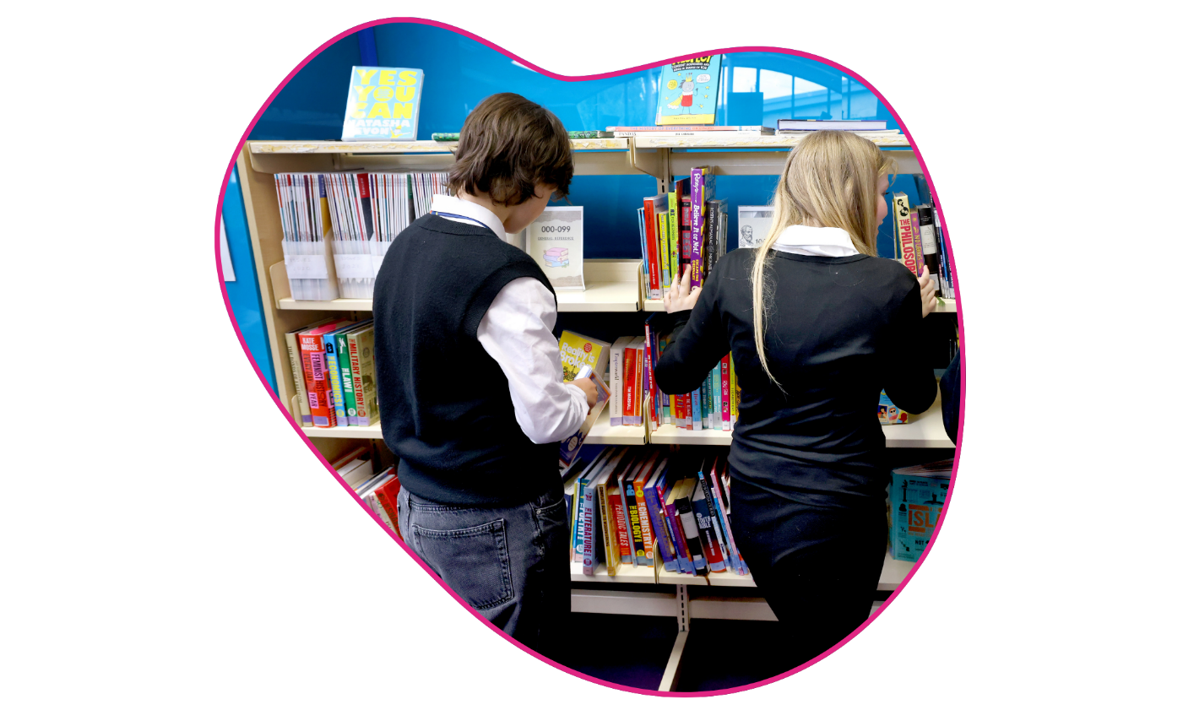
As part of iterative evaluation, the Reading Schools programme team continually take on such feedback and use it to help improve process and delivery. In response to these concerns, it is important to note that the Reading Schools accreditation is very flexible to small and rural schools (including single-staff or sub-10 learner settings) and explicit about no expectation for schools to invest budget in activities unless they wish to, as it is not a requirement to achieve accreditation. (For more on this, please see the ‘Areas for improvement’ section below.)

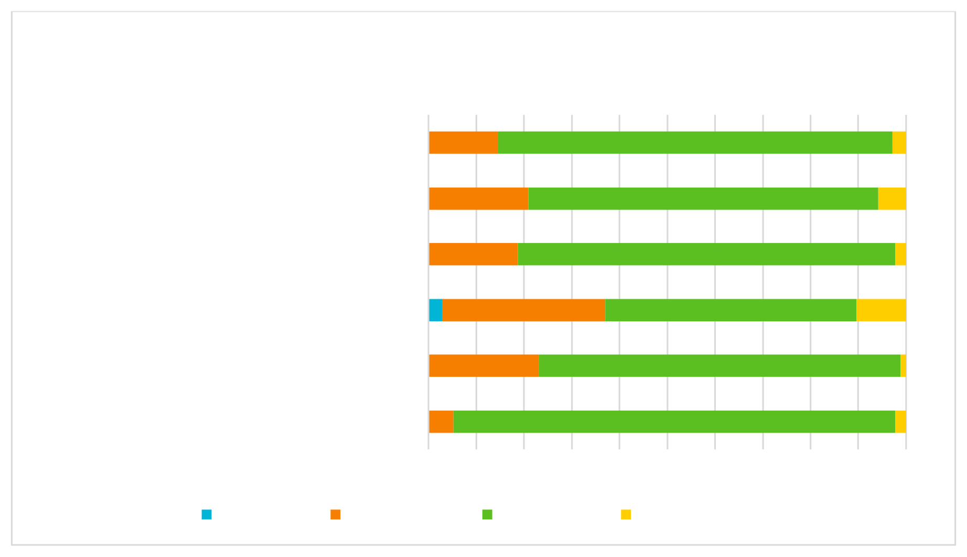
How do you feel about the following aspects of the Reading
Schools programme?
The status accreditation provides

The framework mapped to HGIOS 4

Collaboration with others across your school
A sense of community with other Reading Schools
The opportunities for families to engage Opportunities to give pupil voice
0% 10% 20% 30% 40% 50% 60% 70% 80% 90%100%
Not useful A little useful
Very useful
N/A Did not use
(Total number of responses: 173)
When asked about which aspects respondents found ‘Very useful’, the majority indicated: opportunities to give pupil voice (92.44%); the status accreditation provides (82.56%); collaboration with others across the school (78.95%); and opportunities for families to engage (75.72%).
Comments shed further light on what respondents valued most in the programme:

- ‘Families has been a particular highlight as this has been a department and school aim for a while but Reading Schools forced us to really consider a plan as to how to engage them. Criteria from Reading Schools encouraged IDL between faculties who worked together for a shared aim. HGIOS4 is fundamental to our school and being able to see direct links made justifying events and getting the support of SLT to make reading for pleasure a school priority, easier’

- ‘This accreditation shows that we are working to close the attainment gap between most deprived and least deprived. Involving families is deepening our relationships with the wider school community which will be continued’

The survey then prompted respondents to reflect in an open comment box, ‘What do you think works well about Reading Schools?’ It received 158 responses, with

consistent emphasis on how clear, flexible and collaborative the process is, the usefulness of the action plan and collecting evidence, and the focus on reading for pleasure.
In the words of one school,

‘The Reading Schools framework is something that works well, because it provides a recognisable and coherent rationale for reading for enjoyment initiatives across the school community.

The administrative process around Reading Schools is simple, clear and easy to access. The templates for self-evaluation, action plan and evidence plan follow a clear path for completion. The action plan was a live document that we used and referred to regularly during our journey towards submitting evidence.

The Reading Schools website and dashboard are clear and easy to use. The dashboard is well constructed and simple to navigate, and it was easy to allow several members of the leadership group to upload evidence.

The other thing that worked well about Reading Schools was that here were no deadlines for completion which meant that there were no stresses associated with meeting timescales.

The Reading Schools team were good at sending gentle email reminders to helped to retain our focus.’

There is a clear through-line among responses that values user-friendly processes and collaboration with the Reading Schools team.

Similarly, the survey asked ‘Is there anything that has not worked well for you and your school?’ 134 responses were submitted, and focused primarily on challenges of
time constraints (particularly in terms of staff capacity) and the burden of required evidence:

- ‘Keeping on top of uploading evidence as it is time consuming in a busy school’
- ‘We are a very small school with only 1 class and 1 teacher so I felt our
evidence couldn’t be as broad as others as it was the same teacher and pupils involved’
- ‘The pressure to achieve the next level within the time frame of one year only. The overlap of where to post our evidence led to confusion. The difficulty of encouraging other schools to engage with us’
- ‘Some things are not as easily applicable to a secondary school, particularly a large one, than to a primary school’
For more information on how the programme has developed to accommodate these concerns and enhance accessibility - particularly increasing the 1-year window to 3 years, and adjusting activity according to school size - please see the ‘Areas for improvement’ section below.

To that end, the survey then asked respondents to reflect on ‘How could Reading Schools be improved to make it more useful for your school?’ 128 responses were submitted. By far the biggest focus in responses was on evidence:
- ‘A conversation/visit to evidence actions’
- ‘Possibly some of the uploading - we started by collating everything on a word document/PPT/Canva but obviously as everything is in different sections we had to filter it out. I understand why the action points need to be broken down but possibly the comment, quote, picture, document etc could be refined’
- ‘Maybe some adaptations for very small schools. We were asked to add evidence about our use of P1 book bags, but we have no P1s’
- ‘It was challenging to find the time to gather and upload evidence, but this will
be easier next time now that I am familiar with the process’

Respondents then reflected on what resources would support their participation in Reading Schools. 91 responses were received, and by far the greatest emphasis was on books:

- ‘Money for more books! The program does not work unless the children can access the right books. You can have a library full of books but it needs to be what the kids actually want to read’
- ‘Local library support is not available to us despite numerous attempts to engage’
- ‘I'd really like a digital version of the story deck - or the chance to buy more sets as I think that's an amazing resource’
- ‘Information about how pupils can access "library books." or free books like a library with advice for them’

Going forward

Respondents were prompted to look ahead: ‘Do you think the programme is worthwhile? And will you continue to engage in it? If so, why?’
156 responses were submitted to this open question – the overwhelming answer was ‘Yes’:
- ‘Absolutely - this has encouraged all children and staff to read more for enjoyment which consequently will help in all areas of the curriculum. More reading opportunities is always a positive and the kids have thoroughly enjoyed this’
- ‘The programme is worthwhile as it requires a consistent, year long, focus on the award. It is not a tick box exercise and encourages people to share their opinions and gather impact data throughout. We will continue to engage and have already started planning for our Gold award! We want to keep the momentum up and the excitement around reading going, and so we will continue to make progress’
- ‘Yes, it has provided us, as a school a focus point to help promote reading for pleasure and enjoyment. It has also helped strengthen our links within the community and with parents/carers around our love of reading’
- ‘Yes, absolutely! in our school, the project come out from school library and
we have used it as an opportunity to promote reading and library itself, to give

pupils a chance to have a voice, to engage other department. For staff it was an additional motivation to support reading for pleasure and for pupils a chance to discover books’
Some comments mentioned barriers to further engagement, namely, the time and capacity required:
- ‘I was very lucky as my Headteacher gave me time off timetable to organise activities and promote reading schools. I don't think this will be happening in all schools and the workload involved may seem too daunting’
- ‘We would love to continue however due to time spent uploading evidence this may not be possible’
- ‘Our continuation is to be determined based on funding and time’
- ‘Yes the programme is worthwhile but very time consuming providing

evidence. Yes we will continue as long as we have the staff available to take it forward’

What worked well

Schools were unanimous in the positive effects of Reading Schools activity, with all indicators of enjoyment, connection and confidence scoring high.
The largest increase in reading for pleasure was reported among pupils who were not previously enthusiastic readers (‘A big increase’, 50.54%) and pupils identified as socioeconomically disadvantaged (‘A big increase, 36.03%).
Due to the process of Reading Schools, staff recognise the value of reading for pleasure ‘A lot’ (74.16%). The vast majority of respondents (89.10%) reported that Reading Schools has engaged staff across the school.
Schools reported that reading for pleasure had the highest contribution to pupil wellbeing, followed by creativity, empathy, and attainment. The strongest indicator of attainment was how Reading Schools helped teachers to recognise and award pupils’ achievements.
Reading Schools has impacted families and communities more widely: ‘Families have been in our school a lot more this session. The feedback about events
attended and online games/quizzes and competitions, has been incredible. This is an area that our school has seen a huge benefit and keen to continue.’

Areas for improvement

Some schools noted the challenges posed by the process of accreditation – particularly assembling and uploading evidence – were restrictive:
‘It is a great programme with many valuable aspects that are all so important. It is very difficult to lead and make the impact you want in some ways due to time and funding’
More noted the barriers to participation due to their own capacity constraints:

‘It is a great programme, however the work load is too much with no additional time available staff use their own time and while this has its place, we can be working a minimum of 50 hours a week between our main role and looking to fit this is. Staff have so many responsibilities and after school clubs, this

takes a massive chunk of time and increases, certainly my stress levels, considerably’
Further feedback indicated the process being more applicable to primary schools than secondary schools; travel and budget restrictions; some finding the website hard to navigate; and challenges of gathering sufficient evidence as a small or rural school with limited staff and pupils or community engagement.

Responsive action

As part of iterative evaluation cycles, the Reading Schools programme team continually reflect on feedback and incorporate it to their process and delivery going forward.
Regarding programme flexibility, particularly the old 1-year timescale applied to schools pursuing the next accreditation level, an expansion was confirmed in September 2025 to a 3-year timescale, to further support settings working comfortably on subsequent accreditation at a sustainable pace for promoting embedded culture change.
In response to comments around Reading Schools being unsuitable for, or inconsiderate of, small and rural schools, the programme team launched ‘Start and Spark’ support sessions specifically for small, rural and island schools, and made a concerted effort to ensure small schools are represented in PL sessions and shared practice events.
Where changes cannot be made, Reading Schools maintains transparency in the reasons why – e.g. some settings fed back that their participation was inhibited due to prohibitive costs; the Reading Schools programme incurs no other cost than time, unless a school or setting chooses to invest in a particular area (such as reading space furnishings, book stock and storage). The programme has been developed to ensure free access to resources, online training and support.
Additionally, there have been requests for alternative evidence submission methods (such as Sway presentations, phone calls, visits/inspections); however, submitting evidence online via the Reading Schools website remains the exclusive

route in order to standardise the process of submission and review, ensure ethos alignment, consistency, and a robust, transparent, accountable and auditable accreditation system.

Conclusion

Reading Schools continues to be a high-quality and highly successful development and accreditation programme.
It embeds effective reading for pleasure in school settings, as demonstrated by positive feedback from participating schools:
‘The excitement and enthusiasm the Reading Schools programme generates is so uplifting! The accreditation keeps us moving forward and reading for pleasure has gone from strength to strength in our school because of this’
It develops pupils as responsible citizens through reading for pleasure’s support of empathy, resilience and critical literacy; schools reported that the programme contributed ‘Quite a lot’ or ‘A lot’ to critical literacy (67.03%), resilience (61.34%) and empathy (71.85%).
It develops pupils into successful learners and confident individuals through reading for pleasure’s support of attainment, wellbeing and creativity: schools reported that the programme contributed ‘Quite a lot’ or ‘A lot’ to pupil attainment (71.32%), wellbeing (87.09%) and creativity (82.60%).
Moreover, they reported that as a result of Reading Schools activity, pupils are confident in their reading choices (‘Quite a lot’ (54.09%) or ‘A lot’ (43.42%)) and they enjoy reading (‘Quite a lot’ (49.64%) or ‘A lot’ (47.12%)).
‘this has encouraged all children and staff to read more for enjoyment which consequently will help in all areas of the curriculum. More reading opportunities is always a positive and the kids have thoroughly enjoyed this.’
The intention and hope with meeting these short-term goals is to nurture each child’s lifelong love of reading by providing support and resource both at school
and at home. 23

