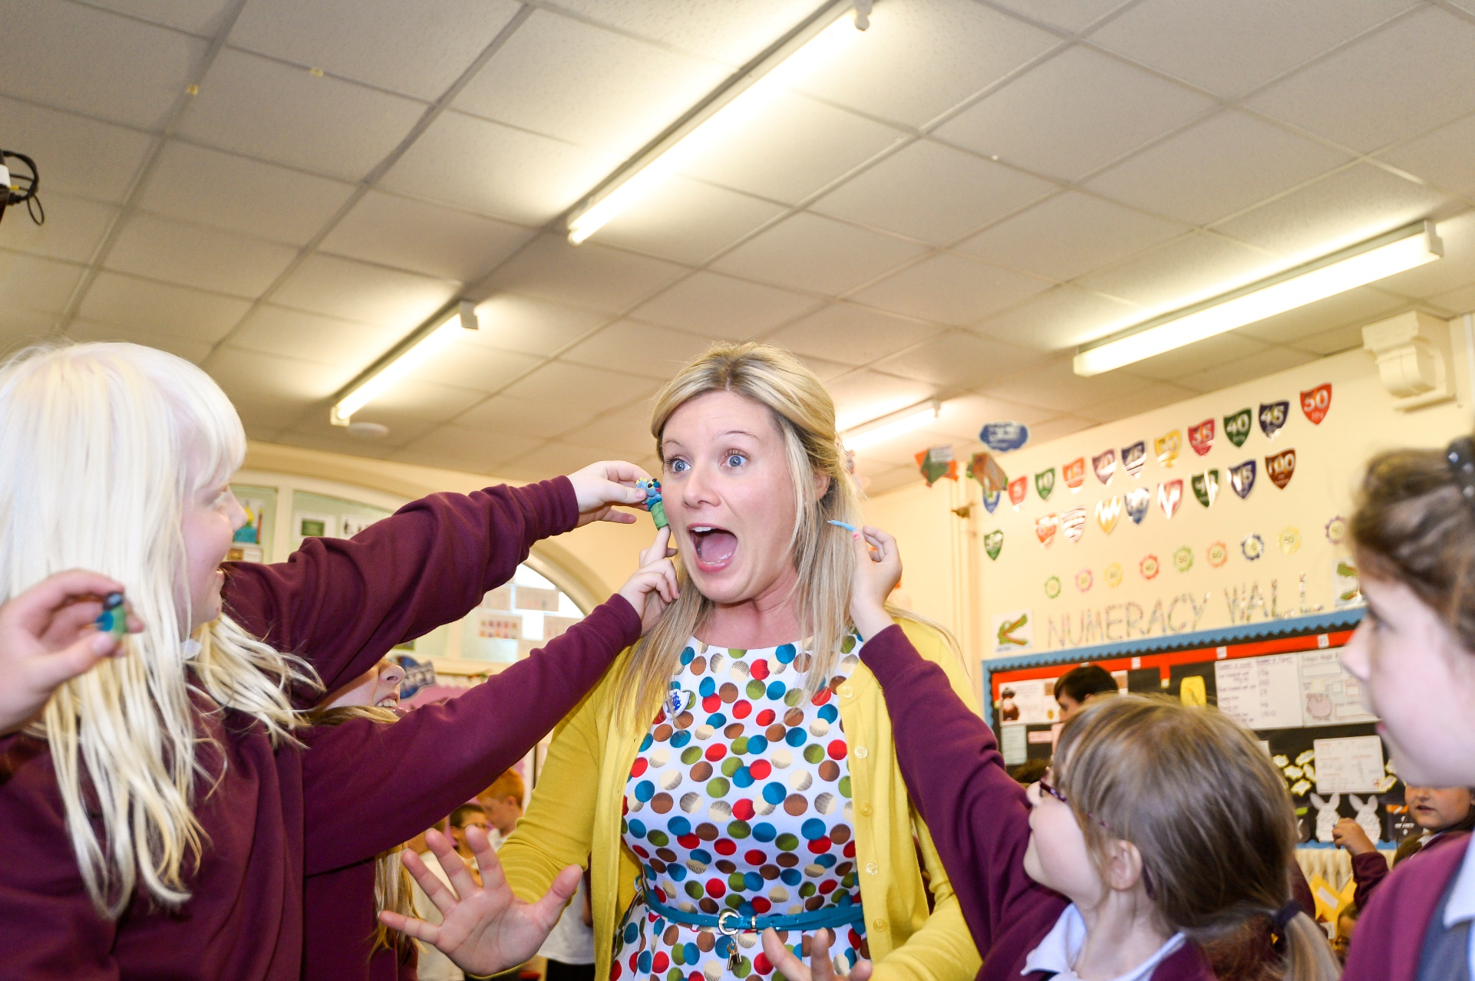
Resource created by Scottish Book Trust

Reading dares learning resource

Key Area: 2.3.2, 2.3.3

Level: Core

Classroom activity plan designed to inspire children to engage with reading in new and exciting ways


scottishbooktrust.com

/scottishbktrust

@scottishbktrust




Contents
Collaborative reading dares activity 2
Categorised word lists 3
Suggested reading dares
Primary 8
Secondary 11
Less confident readers 15
Dares suitable for a whole group 16
Helpful resources 18

About this resource
This lesson plan and resource challenges you and your learners to undertake reading dares. To motivate children to read, it's important to try and create a personal reading journey for them; this lesson plan can increase their awareness of their likes and dislikes, as well as their knowledge of the diverse range of books available. For instance, they can dare each other to try graphic novels, autobiographies, picture books for older readers and books based on video games.
Dares can also help children attach a sense of fun to reading and uncouple it from the context of assessed work. By encouraging children to choose a dare that they find interesting, achievable and enjoyable, you can help to set them on the path to becoming lifelong readers.
These activities when working towards your Reading Schools accreditation to meet Key Areas 2.3.2 Meaningful conversations about books and 2.3.3 Creating social networks.

Collaborative reading dares activity
LIT 1-11a/LIT 2-11a, LIT 3-11a, LIT 1-01a/LIT 2-01a, LIT 3-01a, LIT 1-02a, LIT 2-02a, LIT 3-02a
Before you begin the group activity, have a discussion with your class about their reading habits and the kinds of texts they enjoy and would recommend to others. Discuss the importance of challenging themselves and having as much fun with reading as possible.
Explain to your pupils that they are going to work together to write their own reading dares to challenge themselves and others in their class, including their teacher! Talk about how you could make the challenges fun and encourage people to want to take part. Discuss the meaning of the word ‘dare’ and you can use our list of suggested reading dares (at the end of this resource). The dares they make up can be as creative and entertaining as they like as long as they are achievable, have an element of challenge and encourage people to engage with books and reading!
Print the categorised word lists provided on page 3 onwards of this resource (you can adapt them as you wish). The words are divided into the following 9 categories: places; times; people; clothes; genres/subjects; adjectives; things; amounts, and verbs. The idea is to arrange them in separate pots for pupils to pick from.
Divide your pupils into groups (3, 4 or 5 would be ideal) and provide them with a large sheet of paper to write down their dare ideas. Explain that they will receive 3 pots containing words with different themes; they can take it in turns to pick a word from each of the pots and use them as inspiration to write an interesting reading dare. They can choose to involve one or more of the words depending on the scenario and how creative they want to be! Once they have used some of those themed words, they can move around the classroom in a carousel approach or simply swap their theme pots with another team.
At the end of the group task, pupils can write out their ideas for a class reading dare box. They can pick out dares for themselves or others and record their achievements in a class book or photo display.
Differentiation for less confident pupils
If you want to have more control over the dares that pupils undertake, you can use the list of suggested reading dares at the end of this resource.
Many of these dares can be set for a whole class, meaning every pupil undertakes the same dare. This can work well for less confident pupils, or as a precursor to pupils coming up with their own dares.

People
teacher | sidekick | grandparent | librarian
Harry Potter | hero | villain | head teacher
Hagrid | child | sibling | Shopkeeper
Gollum | best friend | neighbour | Sherlock Holmes
Peter Pan | hairdresser | mechanic | superhero
Frodo | pirate | sports person | parent
Santa Claus | spy | bus driver | detective

Times
weekday | morning | Saturday | months of the year
Sunday | every day | half an hour | days of the week
Wednesday | middle of the night | Tuesday | 10 minutes
1 minute | night | every hour | 15 minutes
before bed | before breakfast | Monday | evening
weekend | hours of the day | Thursday | Friday
afternoon | lunchtime | 30 seconds | 3 days

Things
treasure | teddy bear | Pokémon
flag | pavement | LEGO
matchsticks | megaphone | rainbow
map | foot | bus
cardboard | glass | bubble wrap
duvet | post box | train
car | mug | television
chart | Internet | bookmark
game | list | poster
scene | sign | review

Clothes
socks | woolly hat | coat
jumper | top hat | bag
tartan | costume | t shirt
shoes | disguise | dress
mask | tie | skirt

Places
island | Europe | shop
cinema | library | room
school | supermarket | day out
home | cafe | Africa
local shop | post office | train station
lunch hall | Arctic/Antarctic | America
street | pavement | park
sports centre | beach | mountain
garden centre | museum | bookshop

Genres/subjects
horror | blog | sci-fi
newspaper | adventure | poetry
magazine | guide | picture book
short story | travel | craft
true crime | biography | crime

Verbs
wear | discover | hate
experiment | speak | make
eat | cook | relax
volunteer | recommend | upcycle
dance | cycle | hide
run | leave | give
share | shout | build
sing | skip | climb
read | loan | swap
find | decorate | write
draw | read out | perform
pretend | make up | watch

Amounts
50 words | 140 characters | 1 page
10cm | small | massive
metre | big | tiny
mile | tall | short
100 pages | 5 words | long
10 pages | 50 pages | heavy

Adjectives
fun | angry | excited
silly | safe | afraid
secretive | happy | thoughtful
lonely | content | sad
surprised | confused | boring

Suggested reading dares
In the main reading dares lesson plan (above), children are tasked with coming up with their own dares. However, if you want to have a bit more control over what pupils are daring each other to do, you can provide them with some of the example dares listed here.
There are a number of different options available to you in using this resource:
- You can ask your whole class/book group to do the same dare;
- You can ask individual children to choose a dare;
- This can be a precursor to children coming up with their own dares, if this is the right option for your group.
We’ve divided the suggested dares into different categories, but there’s obviously lots of overlap between the categories.
Primary
Find a poem that makes you laugh
Visit the library and ask for a recommendation
Guerilla poetry - hide poems/quotes around your school for people to find
Read a book that helps you to learn a new skill
Recommend your favourite book to a teacher
Watch a film based on a book
Read the book your favourite film is based on
Stand up in assembly and share a book recommendation
Visit your library and borrow a book written by someone with the same first name or initials as you
Learn a poem by heart
Read a comic/graphic novel
Write a story about your friends
Take a book out of the library and start reading it straight away – finish this evening!
Dare your parent or guardian to read your favourite book, and in return you read one they suggest
Draw a picture of how you imagine your favourite character from a book to look
Write a song about your favourite character/book
Write a letter to your favourite book character
Read the ending first in the next book you’ll read
Read instead of watching TV for a week
Read first thing in the morning during for a week
Recommend a book to a relative of another generation.
Don’t say no to your younger sibling’s request of read-aloud stories all week
Volunteer to read out a page from your book to the rest of the class
Volunteer to tidy your class or school library
Put a sign on your desk saying what you’re reading right now
Read a book set in a country you would like to go to
Have a book group at school and share your favourites
Read a book featuring your favourite sport or activity
Recommend a book to a family member
Read a book recommended by a family member (maybe your grandad or grandma)
Read a spooky story at night time
Do a book swap with a friend
Write a deleted scene for your favourite film or TV series
Read an illustrated book
Write a note to an anonymous reader, put it in a book and leave the book somewhere for a person to find
Without your teacher knowing, include a quote from a book in class
Re-enact your favourite scene from a book
Re-write your favourite scene from a TV show and get friends to read it out/act it out.
Write an article about the top five computer games with great storylines.
Write a comic based on your favourite computer game or film
Read a comic that isn’t about superheroes
Find a book you liked when you were younger and read it again
Read the first page of five different books and read the one you like best
Borrow a book for one of your friends
Run a book of the month scheme in your class
Find a wordless picture book and share it with someone younger than you
Spend 15 minutes every day reading
Perform a poem to your class
Read a comic book then have a go at writing your own comic strip featuring the same characters
Read a newspaper article
Write to an author whose work you enjoy
Make and wear a T-shirt celebrating your favourite book
Bury a time capsule with your favourite book in it, write a note to the person who’ll dig it up one day saying why you love it
Bake fairy cakes and decorate them with book titles/quotes/pictures
Pretend to be a famous book character for a day and see if anyone guesses what you’re doing.
Design an alternative book cover for one of your favourites.
In the library, keeping your eyes closed (or with a blindfold!)- have a friend spin you round and pick a book without looking. This is the next book you will read!
Find a kind, funny or inspiring quote in a book you like, write it in your best handwriting and put in a place where you will see it daily. Every day you will look at this and be reminded of something good. If you find more than one quote, write them all out- you could event draw a picture to go with them!
Make a poster to advertise your favourite book
Make up a joke about a favourite book or character and tell it to a friend.
Put together or make a collection of objects which could belong to a character from a book. See if your friends can guess the character!
Make your own reading den either at home or at school and take a photo of it.
Sneak up to someone while they are reading a book and try and read a whole page without them noticing!
Write a piece of fanfiction based on your favourite book.
Walk around your school playing a game of I Spy, but the only items you can spy have to be from a book you know. For example, if you see a teacup (like in Alice in Wonderland), or toy/picture of a fairy (like in Peter Pan)
Use a quote from your favourite book in everyday conversation and see if anyone notices!
Call your teacher, a member of your family or a friend the name of a favourite book character for a day
Secondary
Find a poem that makes you laugh
Visit the library and ask for a recommendation
Guerilla poetry - hide poems/quotes around your school for people to find
Read an autobiography
Read a book that helps you to learn a new skill
Decorate your classroom door as a book cover
Organise a reading flashmob in your school
Share a ‘bookface’ selfie
Watch one of Scottish Book Trust’s Authors Live events
Recommend your favourite book to a teacher
Watch a film based on a book
Read the book your favourite film is based on
Post a list of your top five books on social media
Speak only in Harry Potter quotes for an hour
Stand up in assembly and share a book recommendation
Visit your school library and borrow a book written by someone with the same first name or initials as you
Learn a poem by heart
Read a comic/graphic novel
Read a book which has caused controversy or been banned somewhere in the world
Watch one a performance poets on YouTube
Take a book out of the library and start reading it straight away – finish this evening!
Dare your parent or guardian to read your favourite book, and in return you read one they suggest
Write a song about your favourite character/book
Read the ending first in the next book you’ll read
Read instead of watching TV for a week
Read first thing in the morning for a week
Recommend a book to a relative of another generation
Don’t say no to your younger sibling’s request of read-aloud stories all week
Volunteer to read out a page from your book to the rest of the class
Volunteer to tidy your class or school library
Put a sign on your desk saying what you’re reading right now
Read a book set in a country you would like to go to
Have a book group at school and share your favourites
Read a book featuring your favourite sport or activity
Recommend a book to a family member
Read a book recommended by a family member (maybe your grandad or grandma)
Read a spooky story at night time
Do a book swap with a friend
Write a deleted scene for your favourite film or TV series
Read an illustrated book
Do a YouTube/social media book review
Write a note to an anonymous reader, put it in a book and leave the book somewhere for a person to find
Without your teacher knowing, include a quote from a book in class
Re-enact your favourite scene from a book in your drama class
Re-write your favourite scene from a TV show and get friends to read it out/act it out.
Write an article about the top five computer games with great storylines.
Write a comic based on your favourite computer game or film
Read a comic that isn’t about superheroes
Find a book you liked when you were younger and read it again
Read the first page of five different books and read the one you like best
Hold an extreme reading competition
Hold a lucky book dip
Borrow a book for one of your friends
Run a book of the month scheme in your class
Find a wordless picture book and share it with someone younger than you
Spend 15 minutes every day reading
Perform a poem to your class
Read a comic book then have a go at writing your own comic strip featuring the same characters
Read a newspaper article
Write to an author whose work you enjoy
Make and wear a T-shirt celebrating your favourite book
Bury a time capsule with your favourite book in it, write a note to the person who’ll dig it up one day saying why you love it
Bake fairy cakes and decorate them with book titles/quotes/pictures
Design an alternative book cover for one of your favourites
In the library, keeping your eyes closed (or with a blindfold!)- have a friend spin you round and pick a book without looking. This is the next book you will read!
Ask some of your teachers to bring in photos of their bookshelves and make a quiz
Find a kind, funny or inspiring quote in a book you like, write it in your best handwriting and put in a place where you will see it daily. Every day you will look at this and be reminded of something good. If you find more than one quote, write them all out- you could event draw a picture to go with them!
Make a poster to advertise your favourite book
Make your own reading den either at home or at school and take a photo of it
Sneak up to someone while they are reading a book and try and read a whole page without them noticing!
Write a piece of fanfiction based on your favourite book
Use a quote from your favourite book in everyday conversation and see if anyone notices!
Think of a funny book title pun – have a competition in your class!
Call your teacher, a member of your family or a friend the name of a favourite book character for a day
Make a recommendations box for your classroom – you could take it round to other classes too!
Less confident readers
Visit the library and ask for a recommendation
Read an autobiography
Read a book that helps you to learn a new skill
Decorate your classroom door as a book cover
Watch one of Scottish Book Trust’s Authors Live events
Watch a film based on a book
Read the book your favourite film is based on
Read a comic/graphic novel
Write a story about your friends
Watch a performance poets on YouTube
Read instead of watching for a week
Read first thing in the morning for a week
Don’t say no to your younger sibling’s request of read-aloud stories all week
Read a book featuring your favourite sport or activity
Read a spooky story at night time
Do a book swap with a friend
Write a deleted scene for your favourite film or TV series
Read an illustrated book
Write an article about the top five computer games with great storylines
Write a comic based on your favourite computer game or film
Read a comic that isn’t about superheroes
Find a book you liked when you were younger and read it again
Read the first page of five different books and read the one you like best
Hold an extreme reading competition
Find a wordless picture book and share it with someone younger than you
Spend 15 minutes every day for a week
Read a comic book then have a go at writing your own comic strip featuring the same characters
Read a newspaper article
Dares suitable for a whole group
Email a list of your class’ favourite books in to the First Minister’s Reading Challenge
Ask some of your teachers to bring in photos of their bookshelves and make a quiz
Find a poem that makes you laugh
Visit the library and ask for a recommendation
Guerilla poetry - hide poems/quotes around your school for people to find
Decorate your classroom door as a book cover
Organise a reading flashmob in your school
Watch one of Scottish Book Trust’s Authors Live events.
Read a book which was made into a film
Stand up in assembly and share a book recommendation
Read a comic/graphic novel
Write a story about your friends
Watch a performance poets on YouTube
Read instead of watching TV during for a week
Read first thing in the morning during for a week
Recommend a book to a relative of another generation
Volunteer to read out a page from your book to the rest of the class
Volunteer to tidy your class or school library
Put a sign on your desk saying what you’re reading right now
Have a book group at school and share your favourites
Recommend a book to a family member
Do a book swap with a friend
Read an illustrated book
Do a YouTube/social media book review
Read a comic that isn’t about superheroes
Read the first page of five different books and read the one you like best
Hold an extreme reading competition
Hold a lucky book dip
Borrow a book for one of your friends
Run a book of the month scheme in your class
Spend 15 minutes every day reading for a week
Read a comic book then have a go at writing your own comic strip featuring the same characters
Read a newspaper article
Make your own reading den either at home or at school and take a photo of it
Think of a funny book title pun – have a competition in your class!
Email a list of your class’ favourite books in to the First Minister’s Reading Challenge
Write your own class book. You could choose a theme and work in groups, taking it in turns to write a chapter based on what the group before wrote
Make a recommendations box for your classroom – you could take it round to other classes too!
Helpful resources

A lot of the dares will involve pupils looking for books to read or recommend to others. To help with this, they can use our book lists: http://scottishbooktrust.com/reading/book-lists.

Some dares challenge pupils to write a comic. We have a resource to support pupils to write a comic book. We also have a resource to support pupils to write a film scene.

Finally, to help you create a reading culture in school, there are lots of exciting, tried and tested ideas in our creating a reading culture resource.

All these resources are available to download from the learning section of the Scottish Book Trust website.

We've highlighted in red the items which you may want to leave out if you want your pupils to think more creatively. These items are mainly examples of common texts that pupils can produce: they are therefore intended as a support for the less confident, but you may want to delete them and leave empty boxes in the table if you want to challenge your pupils to do more of the thinking.
We've highlighted in red the items which you may want to leave out if you want your pupils to do a bit more thinking. These items are examples of actions which are very commonly associated with reading and books: they are therefore intended as a support for the less confident, but you may want to delete them and leave empty boxes in the table if you want to challenge your pupils to do more of the thinking.

