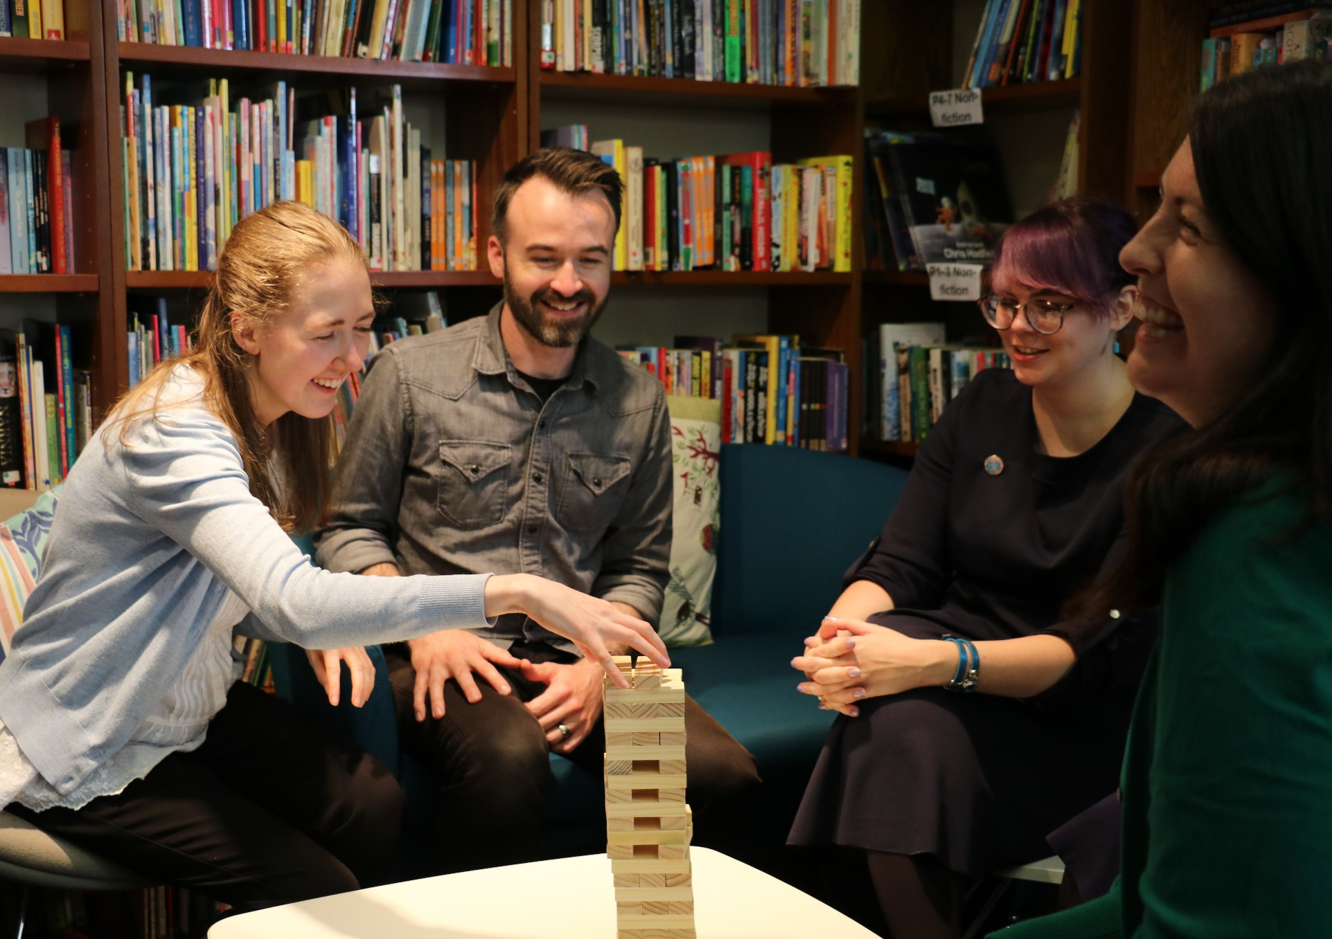
Resource created by Scottish Book Trust

How to play book Jenga
Key Area: 2.3.3

Level: Core

A guide to making and playing book Jenga

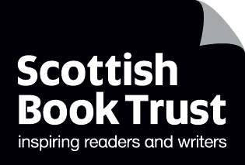
scottishbooktrust.com

/scottishbktrust

@scottishbktrust

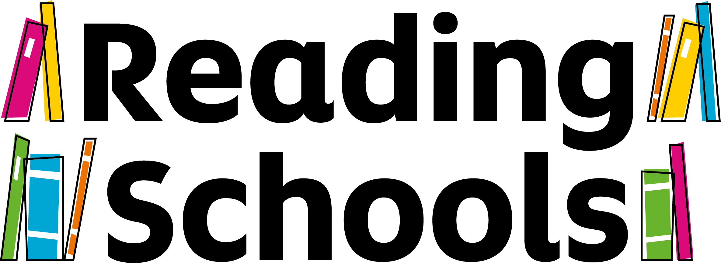

Contents
How to create book Jenga 2
How to play 2
Suggested questions 3

About this resource
Book Jenga is a great and fun way to get pupils talking about books, poems, reading and literature. It can be used with any age group and made more or less complex, as you require.
Book Jenga was a game brought to the attention of Scottish Book Trust by secondary school librarian Deena Wren, winner of our Scottish Book Trust Learning Professional Award. Deena has been playing book Jenga in her school for several years to encourage exciting and interesting conversations around books and reading.
We expect Reading Schools to facilitate learner social networks around reading to help them to discover their own reading identities. Playing Book Jenga can be used when working towards Key Area 2.3.3 Creating social networks.

How to create book Jenga
All you will need to create book Jenga is a set of Jenga blocks, a biro or fine liner pen, and your chosen questions! You can find suggested questions at the end of this resource.
You can buy unbranded Jenga/wooden blocks cheaply from a number of high street or online stores. You can write a different set of questions on each side of the wooden block.
Book Jenga is very versatile. You can use it for maths and numeracy activities as well as promoting reading and writing, and you can use it for other curriculum areas too. All you need is a set of questions to promote conversation!

How to play
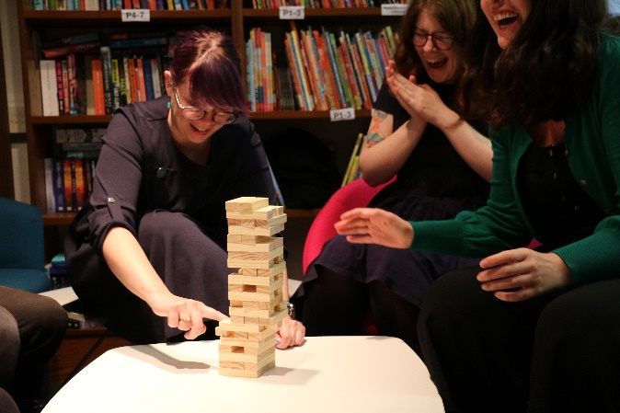
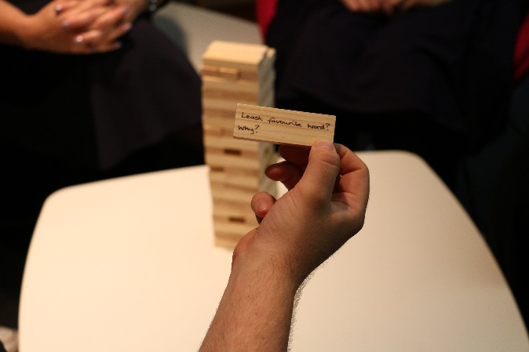
You play book Jenga by building your tower and taking it in turns to pull out a block and answer the question on it. You can play either by answering the question yourself, or by asking everyone in the group to answer the question before moving on to the next one. The used block is then placed on top of the tower. Gradually the tower builds and becomes less stable. As with all Jenga, the aim is not to topple the tower. The game ends when the tower falls!

Suggested questions
You can create your own book and literacy questions with your pupils, or you can use the questions from our list below.
- Name a book you wish you could see on the big screen?
- Who would you cast in the lead role, or roles, in an adaption of your favourite novel?
- Recommend a graphic novel.
- Best film adaption of a novel?
- Favourite dialect word.
- Recommend a ghost story.
- Favourite fictitious detective?
- Best TV series based on a book?
- Recommend a love story.
- Fiction or non-fiction?
- Least favourite word and why?
- Do you have a favourite book festival?
- Recommend a fantasy novel.
- Quote some Shakespeare.
- Recommend a Scottish novel.
- What songs and rhymes do you remember from childhood?
- Recite the lyrics to a song.
- Recite some poetry.
- What’s the genre you most want to try next?
- Recommend a sci-fi novel.
- Recommend an animal story.
- Two books for a desert island. What and why?
- Do you have a favourite publisher?
- Have you ever met an author?
- Recommend some non-fiction.
- Where is your favourite library?
- Favourite word and why?
- Think of a character who faces a difficult decision. How would you solve this problem?
- Recite a limerick or rhyme.
- Funniest think you have ever read?
- Favourite scots word?
- Favourite book as a child?
- Online or bookshop?
- Who is your favourite author?
- If you could meet any author, past or present, who would it be?
- What is your favourite genre?
- Last favourite book character?
- Best and worst book to read aloud?
- Character you wish was really your friend?
- What is your favourite genre?
- Least favourite book character?
- Where do you gravitate to in a bookshop?
- Recommend a classic story?
- Which author would you like to be stuck in a lift with?
- Best author event you’ve attended?
- Who if your favourite heroine?
- Recite a nursery rhyme.
- Who is your favourite poet?
- Print or e-books?
- Recommend a magazine or book journal.
- Worst film adaption of a novel?
- Best. Book. Ever. Why?
- Book you just couldn’t finish?
- Book you’ve re-read the most?
- Saddest thing you have ever read?
- Funniest thing you have ever read?
- Best monster in a story?
- Where is your favourite bookshop?
- Favourite picture book?
- Scariest thing you have ever read?
- What are you currently reading?
- Favourite series of books?
- Which character would you most like to be stuck in a lift with?
- Favourite heroine?
- Book that made you laugh out loud?
- Most relatable character?
- Favourite magazine or newspaper?
- Best TV series based on a book.
- Name three publishers.
- Book you were most excited to buy.
- Favourite book cover.
- Book you would like to see a sequel to.
- Best short story.

